VIETNAM GENERAL CONFEDERATION OF LABOR
TON DUC THANG UNIVERSITY
FACULTY OF INFORMATION TECHNOLOGY



BUI QUANG HOANG VIET – 520H0329
DAO DUY ANH – 520H0508

OBJECT-ORIENTED SOLUTIONS TO THE PROBLEM OF MINING CLOSED FREQUENT ITEMSETS FROM ACCUMULATED DYNAMIC UNCERTAIN DATABASES

INFORMATION TECHNOLOGY PROJECT

COMPUTER SCIENCE

HO CHI MINH CITY, 2026
VIETNAM GENERAL CONFEDERATION OF LABOR
TON DUC THANG UNIVERSITY
FACULTY OF INFORMATION TECHNOLOGY



BUI QUANG HOANG VIET – 520H0329
DAO DUY ANH – 520H0508

OBJECT-ORIENTED SOLUTIONS TO THE PROBLEM OF MINING CLOSED FREQUENT ITEMSETS FROM ACCUMULATED DYNAMIC UNCERTAIN DATABASES

INFORMATION TECHNOLOGY PROJECT

COMPUTER SCIENCE

Instructor
PhD. NGUYEN CHI THIEN

HO CHI MINH CITY, 2026
ACKNOWLEDGMENTS

We would like to express our deepest gratitude to our supervisor, Mr. Nguyen Chi Thien for his invaluable guidance, continuous support, and insightful feedback throughout the entire research process. His profound knowledge, patience and encouragement have been instrumental in helping us overcome this report and complete it successfully.
Without his dedicated supervision and constructive advice, this report and the entire project would not have been possible. We are truly grateful for the opportunity to learn from him and for all the time and the effort he has invested in us.

Ho Chi Minh City, January 10, 2026
Author
(Signature and full name)
Bui Quang Hoang Viet
Dao Duy Anh

THIS PROJECT WAS COMPLETED AT TON DUC THANG UNIVERSITY
I hereby declare that this is my own research project conducted under the scientific guidance of PhD. Nguyen Chi Thien. The research content and results in this project are truthful and have not been published in any form before. The data in the tables used for analysis, comments, and evaluations were collected by the authors from various sources, which are clearly cited in the references section.
Additionally, this project includes some comments, evaluations, and data from other authors or organizations, all of which are properly quoted and cited.
If any form of dishonesty is discovered, I take full responsibility for the content of my project. Ton Duc Thang University is not responsible for any copyright or intellectual property violations caused by me during the implementation of this project (if any)
Ho Chi Minh City, January 10, 2026
Author
(Signature and full name)
Bui Quang Hoang Viet
Dao Duy Anh

OBJECT-ORIENTED SOLUTIONS TO THE PROBLEM OF MINING CLOSED FREQUENT ITEMSETS FROM ACCUMULATED DYNAMIC UNCERTAIN DATABASES
ABSTRACT
In frequent pattern mining, items are considered fundamental elements for analyzing transactional data because they help reveal hidden relationships and meaningful associations within large transaction databases. Nevertheless, in many real-world scenarios, collected data is not always fully reliable or deterministic. Instead, it is often modeled as an uncertain database, where each item may appear with a specific probability. This characteristic makes the mining process more complex, especially when the database is accumulated and updated over time.
Mining closed frequent itemsets from accumulated dynamic uncertain databases introduces several major challenges. These challenges mainly come from the high cost of expected support calculation and the rapid expansion of the search space as the number of transactions and candidate itemsets increases. To address these issues, this project focuses on designing optimized algorithms and suitable data structures for directly mining Closed Frequent Itemsets (CFIs). By concentrating on closed patterns, the number of generated results can be reduced while still preserving essential information, thereby improving both storage efficiency and mining performance.
From an implementation perspective, this study develops a well-structured software solution based on Object-Oriented Programming (OOP) principles and appropriate Design Patterns. This architecture provides a flexible and maintainable foundation for implementing, comparing, and evaluating three advanced incremental mining algorithms:
- Inc-FPClose (Incremental FP-Close): An approach based on the tree-based structure (CFITree).
- Inc-CHARM (Incremental Uncertain CHARM): An approach based on the vertical list structure (U-List).
- Inc-DCHARM (Incremental Uncertain dCHARM): An approach based on the Diffset technique structure.
The experimental evaluation is conducted on standard benchmark datasets, including chess, mushroom, and BMS1. The results indicate that Inc-dCHARM provides better memory efficiency on dense datasets due to its optimized Diffset-based computation. Meanwhile, Inc-FPClose achieves the fastest processing time on thick datasets, while Inc-CHARM shows stable and effective performance when dealing with sparse data. Overall, the comparative results demonstrate that each algorithm has its own strengths depending on the characteristics of the input dataset.

TABLE OF CONTENTS
LIST OF FIGURES 5
LIST OF TABLES 6
LIST OF ABBREVIATIONS 7
CHAPTER 1 INTRODUCTION 8
1.1 Reasons for Choosing the Topic 8
1.2 Research Objectives 10
1.2.1 Core Project Requirements 10
1.2.2 Expected Outcomes 11
CHAPTER 2 THEORETICAL BACKGROUND AND MATHEMATICAL FOUNDATIONS 13
2.1 Core concept in Data Mining 13
2.1.1 Probabilistic Transactional Data Model 13
2.1.2 Uncertain Frequent Itemset Mining 14
2.2 Uncertain Data Modeling and Object-Oriented Mapping 16
2.2.1 The Item-Level Uncertainty Model 16
2.2.2 Item Independence Assumption and Joint Probability 17
2.3 Measures and Search Space Pruning Strategies 17
2.3.1 Metric Expected Support 17
2.3.2 Downward Closure Property (Anti-monotonicity). 18
2.3.3 Probabilistic CHARM Pruning Properties 18
2.3.4 Diffset Optimization (Memory-Optimized Vertical Approach) 19
2.4 The Uncertain Closed Itemset Constraint 19
2.4.1 The Redundancy Dilemma 19
2.4.2 Definition of Probabilistic Closed Itemset 20
2.4.3 Object-Oriented Closure Validation Strategies 20
CHAPTER 3 PROPOSED OBJECT-ORIENTED SOLUTION AND INCREMENTAL MINING ALGORITHMS 22
3.1 Object-Oriented Design (OOD) Architecture 22
3.1.1 The core abstraction 22
3.2 Proposed Vertical Mining Strategies for Incremental Data 23
3.2.1 Inc-CHARM Algorithms (Uncertain CHARM) 23
3.2.2 Inc-dCHARM Algorithms (Optimization using Diffsets) 23
3.3 Main contribution: Inc-FP-Close Algorithms (Pattern Growth Strategy) 24
3.3.1 Incremental State Management 25
3.3.2 Projected Database Construction 25
3.3.3 On-the-fly Subsumption Checking with CFITree 25
CHAPTER 4 EXPERIMENTAL SETUP AND EVALUATION 27
4.1 Computational Framework 27
4.2 Benchmark Data and Probabilistic Transformation 27
CHAPTER 5 CONCLUSION AND FUTURE 36
5.1 Summary of Contributions 36
5.2 Inherent Limitations 37
5.3 Future Research Directions To Development 38
REFERENCES 39

LIST OF FIGURES

Figure 3.1: Class diagram 24
Figure 4.1: Runtime Comparison according to MinSup threshold – Dataset: Chess 27
Figure 4.2: Runtime Comparison according to MinSup threshold – Dataset: Mushrooms 28
Figure 4.3: Runtime Comparison according to MinSup threshold – Dataset: BMS1 29
Figure 4.4: Peak Memory Comparison according to MinSup threshold - Dataset: Chess 29
Figure 4.5: Peak Memory Comparison according to MinSup threshold - Dataset: BMS1 30
Figure 4.6: Peak Memory Comparison according to MinSup threshold - Dataset: Mushrooms 30
Figure 4.7: Peak Memory Comparison on Chess Dataset 31
Figure 4.8: Peak Memory Comparison on Mushrooms Dataset 32
Figure 4.9: Peak Memory Comparison on BMS1 Dataset 32
Figure 4.10: Performance on Accumulated Chess Dataset (Fixed MinSup = 25%) 32
Figure 4.11: Performance on Accumulated Mushrooms Dataset 33
Figure 4.12: Performance on Accumulated BMS1 Dataset (Fixed MinSup = 0.1%) 33

LIST OF TABLES
Table 2.1: An illustrative example of a probabilistic transactional database BMS1 1
Table 4.1: Dataset Descriptions and Statistics 2

LIST OF ABBREVIATIONS
FIM | Frequent Itemset Mining
OOP  JDK  JVM  TID  ES  PCI | Object Oriented Programming  Java Development Kit  Java Virtual Machine  Transaction ID  Expected Support  Potential Closed Itemsets

INTRODUCTION

Reasons for Choosing the Topic
Discovering frequent itemsets is a vital operation in data mining, enabling businesses to decode customer preferences and optimize recommendation systems. While classical FIM algorithms have achieved significant success, they operate on the assumption of 100% data certainty. In practice, real-world data is highly stochastic due to several factors:
- Measurement Imperfections: Signal noise and hardware errors prevalent in IoT and sensor networks.
- Dynamic Environments: Continuous fluctuations in user interactions and streaming data.
- Predictive Modeling: Data generated from heuristic predictions or machine learning models rather than exact factual records.
To represent these cases more appropriately, this study relies on the concept of uncertain databases, in which each item is associated with an existential probability. Consequently, mining cannot depend only on simple occurrence counting; it must compute expected support to evaluate the statistical strength of each candidate itemset. This requirement motivates the development of object-oriented solutions capable of computing expected support dynamically and extracting closed itemsets without causing excessive memory consumption.
In addition, modern data sources frequently generate new records over time, leading to accumulated dynamic databases. Traditional mining approaches often have to rescan the entire historical database whenever new batches are added. This process is inefficient because it consumes unnecessary time and computational resources. Incremental mining is therefore required so that previously discovered results can be updated efficiently without repeatedly mining all past data from the beginning.
Another challenge is the large number of redundant itemsets produced when all frequent itemsets are reported. Closed Frequent Itemsets (CFIs) address this problem by providing a compact representation of frequent patterns. They reduce the output size while preserving the essential support information needed for analysis.
Many existing studies emphasize algorithmic improvement, but the software engineering perspective is often treated as secondary. In this research, Object-Oriented Programming (OOP) is considered an important design foundation because it supports modularity, maintainability, reuse, and extensibility when implementing complex data structures and mining algorithms. For that reason, the topic “Object-Oriented Solutions to the Problem of Mining Closed Frequent Itemsets from Accumulated Dynamic Uncertain Databases” is suitable for connecting mathematical data mining theory with a practical and scalable software architecture.

Research Objectives

Core Project Requirements
The primary aim of this project is to architect, implement, and rigorously evaluate Object-Oriented solutions for extracting Closed Frequent Itemsets (CFIs) from streaming uncertain environments. To achieve this, the study concentrate on core tasks:
- Theoretical contributions:
  - Build a comprehensive theoretical foundation covering frequent itemsets in data mining, the closure property of CFIs, uncertain databases, and dynamic incremental accumulated data.
  - Analyze the computation of expected support and the main difficulties involved in mining closed frequent itemsets from accumulated dynamic uncertain data, with reference to related approaches such as CHARM, DCHARM, DCI Closed, AprioriClose, and FP-Close.
- Problem statement and modeling:
  - Identify the input as an uncertain transaction database and the output as a set of closed frequent itemsets.
  - Define the key parameters, especially minimum support item probability.
  - Design the system with suitable design patterns so that class hierarchies, interfaces, and relationships among components such as Transaction, Itemset, Uncertain Database, and Dynamic Updater are clearly represented.
- Algorithm development and implementation:
  - Inc-FPClose: an approach based on the CFITree structure, following a horizontal mining strategy.
  - Inc-CHARM: an approach based on the U-List structure, following a vertical mining strategy.
  - Inc-dCHARM: an approach based on the Diffset technique to optimize memory usage.
- Empirical benchmarking and evaluation:
  - Construct a testing framework using standard datasets with different levels of density and sparsity, such as Mushroom, Chess, and BMSWebView1.
  - Evaluate algorithmic performance through critical metrics such as runtime, peak memory consumption, branch-and-bound pruning efficiency, uncertainty handling, and dynamic update capability.
- Summary and Conclusion:
  - Summarize the outcomes of the project and clarify the advantages and limitations of the proposed methods.
  - Suggest possible improvements and future research directions related to the topic.

Expected Outcomes
Upon completion, the project is expected to achieve the following results:
1. Theoretical Contributions:
- Provide a deep, mathematical synthesis of uncertain data mining, proving the effectiveness of Closed Frequent Itemsets, Uncertain data modeling using expected support, Dynamic database updates.
- Demonstrate how these concepts can be integrated into a unified framework.
2. Technical and Engineering Contributions:
- Deliver a fully functional, high-performance Java library for CFI mining that strictly adheres to OOP principles, ensuring future extensibility.
- Provide comprehensive UML models (Class diagrams, Flowcharts) that map mathematical algorithms into clear software engineering blueprints.
3. Practical Applications:
- Offer scalable solutions readily applicable to real-world stochastic environments, such as sensor network noise filtering (IoT), decision support, market basket, analysis, probabilistic recommendation systems, and e-commerce behavior analysis.
- Empower data-driven decision-making systems by providing accurate, compressed patterns from high-velocity, uncertain data streams.".

THEORETICAL BACKGROUND AND MATHEMATICAL FOUNDATIONS

Core concept in Data Mining
In data of mining which is fundamentally the analytical process of discovering latent patterns, statistical correlations, and actionable knowledge from massive, complex datasets. Within the specific boundaries of this thesis, the research scope is strictly narrowed down to the algorithmic extraction of Closed Frequent Itemsets (CFIs). This extraction is performed over accumulated dynamic uncertain databases—a highly complex environment where data not only streams continuously but is also subject to inherent probabilistic variations and noise.

Probabilistic Transactional Data Model
To rigorously formulate the mining algorithms, it is imperative to establish a standardized mathematical notation for the database structure. The traditional deterministic (Boolean) model, which relies on the binary presence of an item (0 or 1), is insufficient for real-world scenarios such as sensor networks or predictive systems. Therefore, this study adopts the uncertain data model:
- Universal Itemset: For example $I=\left\{I_{1,},I_{2},I_{5},I_{4}…,I_{n}\right\}$ denote a finite universe of distinct items (e.g., commercial products, web pages, or sensor events).
- Uncertain Transaction: A transaction, denoted as $t_{k}$, is uniquely identified by a Transaction ID (TID). Unlike deterministic models, each item $x$ within $t_{k}$ is strictly associated with an existential probability $P(x,t_{k}$) , where $0<P\left(x,t_{k}\right)≤1$ . This numerical value quantifies the confidence or likelihood of the item's actual presence in that specific transaction.
- Database Formulation: $D=\left\{t_{1,},t_{2},t_{3},t_{4}…,t_{n}\right\}$ represent the complete set of transactions at a given time ,a dynamic accumulated database, the database evolves over time through incremental updates (e.g.,insertionof new transactions or batches), and mining results can be stable efficiently without reprocessing the entire database.
- Dynamic Accumulation Mechanism: In the context of a dynamic data stream, $D$ is continuously expanding. New transaction batches (denoted as $ΔD$ are appended sequentially over time. An optimal incremental mining system must possess the capability to update the discovered patterns efficiently based on $ΔD$ ,explicitly avoiding the computationally expensive process of rescanning the entire historical database $D$.
BMS1 Transaction | Probabilistic Items (Item, Probability)
T1 | 10307(0.86) , 10311(0.78), 12487(0.64)
T2 | 12559(0.46)
T3 | 12695(0.69), 12703(0.53), 18715(0.64)
T4 | 10311(0.65), 12387(0.53), 12515(0.67), 12691(0.78), 12695(0.88), 12699(0.51), 12703(0.59), 12823(0.70), 12831(0.57), 12847(0.42), 18595(0.97), 18679(0.46), 18751(0.51)
T5 | 10291(0.57), 12523(0.83), 12531(0.85), 12535(0.77), 12883(0.87)
Table 2.1: An illustrative example of a probabilistic transactional database BMS1

Uncertain Frequent Itemset Mining
Unlike deterministic FIM, where an item either exists or does not exist in a transaction, Uncertain Frequent Itemset Mining assigns an occurrence probability to each item. Such uncertainty may result from noise, incomplete collection processes, or measurement errors. Therefore, deterministic support is replaced by expected support.

a) Item probability (p)
This value expresses the probability that an item x ∈ I appears in transaction tⱼ, denoted as: $p\left(x,t_{j}\right)$.
Example, if item A appears in transaction t₁ with probability 0.8, then: $p\left(A,t_{1}\right)=0.8$

b) Transaction representation
This represents the probability that an item $i∈I$ appears in a transaction $t_{j}$​, denoted as: $p\left(x,t_{j}\right)$.

c) Probabilistic presence of an Itemset
For an itemset X, the probability that X occurs in a transaction tⱼ is computed as:
$$P\left(X⊆t_{j}\right)= \prod_{x ∈ X}{P(x,}t_{j})$$

d) Mathematical Formulation of Expected Support
The expected support of itemset X in the probabilistic database D is defined as:
$$eSup(X)= \sum_{t_{j} ∈ D}{P\left(X⊆t_{j}\right)}$$

e) Frequent Itemset Definition
Given a user-defined minimum support threshold minSup, itemset X is considered frequent if and only if:
$eSup(X) ≥minsup$ x |D|

g) Closed Frequent Itemset
In standard FIM, an itemset is frequent when its support satisfies the minimum threshold. However, reporting all frequent itemsets can create a large number of redundant results. Closed Frequent Itemset Mining reduces redundancy by keeping only frequent itemsets that are not subsumed by larger itemsets with the same support. An itemset X is closed if there exists no proper superset $Y⊃X$ such that:
$$Support\left(X\right)=Support\left(Y\right).$$

Uncertain Data Modeling and Object-Oriented Mapping
In real-world domains such as IoT sensor networks, biological sequencing, and predictive e-commerce analytics, collected data is frequently noisy and stochastic. The uncertain database framework is therefore used to represent probabilistic characteristics more accurately than conventional deterministic data structures.

The Item-Level Uncertainty Model
Conventional deterministic databases operate on a strict binary premise: an item is either definitively present (probability of $1.0$) or completely absent (probability of $0.0$). Conversely, uncertain databases quantify the presence of each item using an existential probability metric. This thesis adopts the Item-level Uncertainty Model, mathematically and programmatically defined as follows:
- Probabilistic Item Representation: Let a transaction be denoted as $t_{j}$. An item $x$ within this transaction is modeled as a tuple $(x,p_{x}$), where $p_{x}$ = $P(x,t_{j}$) signifies the existential probability that item $x$ actually occurs within $t_{j}$
- Uncertain Transaction: An uncertain transaction $t_{j}$ is thus formulated as a localized collection of these probabilistic tuples:
$$t_{j}=\left\{\left(x_{1},p_{1}\right), \left(x_{2},p_{2}\right),\left(x_{3},p_{3}\right),…,\left(x_{k},p_{k}\right)\right\}$$
- Object-Oriented Implementation Mapping: At the software architecture level, this theoretical structure is parsed by the DataLoader utility. As the raw text stream is ingested, the extracted existential probabilities are not merely stored as raw arrays but are structurally encapsulated within the attributes of instantiated entities (e.g., maintaining a discrete probability mapping within the Transaction object). This robust object-oriented encapsulation strictly prepares the data for downstream expected support evaluations.

Item Independence Assumption and Joint Probability
When evaluating a composite itemset $X=\left\{x_{1,},x_{2},x_{3},x_{4}…,x_{n}\right\}$ the algorithm must determine the joint probability of all constituent items co-occurring within a specific transaction $t_{j}$.Given the combinatorial explosion and the prohibitive memory costs associated with storing complete joint probability distributions for every possible item combination, this research employs the Item Independence Assumption.
This statistical premise asserts that the occurrences of individual items within the same transaction are mutually independent events. Consequently, the existential probability of the entire itemset X residing in $t_{j}$ denoted as $P(X ⊆ t_{j})$ is formulated as the cumulative product of its constituent items' probabilities:
$$P(X ⊆t_{j})=\prod_{x ϵ X}{P\left(x,t_{j}\right)}$$
Where $P\left(x,t_{j}\right)=0$if any item x is entirely absent from $t_{j}$.
Algorithmic Execution Mapping: In the Java system, this fundamental equation acts as the core logic driving the probability computation methodologies. For instance, evaluating an array of candidate items involves initializing a probability accumulator variable at 1.0, which is then iteratively multiplied by the probability of each matched item mapped within the Transaction class. Furthermore, to aggressively mitigate the inevitable floating-point precision loss inherent in recursive multiplicative operations (Underflow), the predefined constant MathUtils.EPSILON is seamlessly integrated into all comparative conditional statements. This engineering decision guarantees absolute mathematical consistency between the theoretical probabilistic model and the empirical algorithmic execution.

Measures and Search Space Pruning Strategies

Metric Expected Support
In probabilistic environments, Expected Support replaces traditional frequency counting to evaluate the statistical significance of an itemset. It represents the cumulative sum of an itemset’s existential probabilities across all transactions within the database.
$$eSup\left(X\right)=\sum_{t_{j} ϵ D}{{P(X⊆t}_{j})}$$
Implementation Mapping: This value is precisely encapsulated within the eSup attribute of the Itemset object. Throughout the mining lifecycle, it is dynamically compared against the absolute minimum support threshold (minSupAbs = minSupRatio * totalTransactions) to determine the pattern's viability.

Downward Closure Property (Anti-monotonicity).
The expected support strictly satisfies the anti-monotonicity property, which forms the foundation of the branch-and-bound pruning strategy.
- Search Space Reduction Techniques: If an itemset $X$ is determined to be infrequent ($eSup\left(X\right)<minSup)$ then inherently, all possible supersets of $X$ will also yield an expected support strictly less than $minSup$.
- Action: The algorithm aggressively terminates any further recursive exploration along the branch containing $X$.

Probabilistic CHARM Pruning Properties
Unlike traditional deterministic algorithms that evaluate exact transaction ID sets, probabilistic mining demands equivalence checks based on Expected Support. Given two itemsets $X_{i}$ and $X_{j}$, let $X_{ij}$= $X_{i}∪X_{j}$. Under a predefined floating-point tolerance $ε ≤{10}^{-8}$, the search space is aggressively reduced via four conditions:
- Property 1: If $\left|eSup\left(X_{i}\right)-eSup\left( X_{ij}\right)\right|≤ε$ AND $\left|eSup\left(X_{j}\right)-eSup\left( X_{ij}\right)\right|≤ε$ → Replace $X_{i}$ with $X_{ij}$ and entirely eliminate $X_{j}$ from the search space.
- Property 2: If $\left|eSup\left(X_{i}\right)-eSup\left( X_{ij}\right)\right|≤ε$ BUT $eSup\left(X_{j}\right)≠eSup\left( X_{ij}\right)$→ Replace $X_{i}$ with $X_{ij}$ while retaining $X_{j}$
- Property 3: If $eSup\left(X_{i}\right)≠eSup\left( X_{ij}\right)$ BUT $\left|eSup\left(X_{j}\right)-eSup\left( X_{ij}\right)\right|≤ε$ → Retain $X_{i}$, generate $X_{ij}$, and eliminate $X_{j}$.
- Property 4: If $eSup\left(X_{i}\right)≠eSup\left( X_{ij}\right)$ AND $eSup\left(X_{j}\right)≠eSup\left( X_{ij}\right)$→ Retain both $X_{i}$ and $X_{j}$, and generate $X_{ij}$ for subsequent recursive evaluation.

Diffset Optimization (Memory-Optimized Vertical Approach)
To bypass the severe memory bottlenecks associated with storing massive probabilistic U-Lists, the Inc-dCharm algorithm leverages the Diffset technique. Instead of recording full transaction probabilities, it computes the probabilistic difference when expanding a parent itemset $X$ to a child itemset $XY$.
- Mathematical Formula: $Diff\left(XY,t_{j}\right)= P\left(X,t_{j}\right)-P(XY,t_{j})$
- Consequently, the support computation shifts from multiplication to subtraction:
$$eSup(XY)= eSup(X)-\sum_{t_{j} ∈ D }{Diff(XY,t_{j})}$$
- Implementation Mapping: This mathematical recovery is fully implemented in the getProb(int tid) method of the DiffNode class. By returning parent.getProb(tid) - diffs.get(tid), the system completely avoids storing the redundant probabilities of the child node.

The Uncertain Closed Itemset Constraint
A paramount objective of this research is to resolve the combinational "pattern explosion" problem by enforcing a rigorous closure constraint.

The Redundancy Dilemma
During the extraction pipeline, standard algorithms invariably produce a massive volume of redundant subsets. For instance, if the composite itemset {A, B} maintains an expected support of 10.0 and its subset {A} independently yields the exact same expected support of 10.0, it implies that whenever item A occurs, item B occurs concurrently with an identical probability. Reporting the subset {A} is technically obsolete; it is completely absorbed by {A,B}. Thus, only "Closed" itemsets are retained to ensure maximum data compression without any loss of intrinsic statistical information.

Definition of Probabilistic Closed Itemset
In a deterministic database, "closedness" relies on strict subset equivalence. In contrast, an uncertain database necessitates a probabilistic validation.
- Definition: A frequent itemset X is categorized as Closed if and only if there exists no proper superset Y $(Y⊃X)$ such that the expected support of X is probabilistically equivalent to the expected support of Y.
- Mitigating Floating-Point Anomalies: Because expected support is computed via continuous multiplications of double-precision floating-point numbers, executing absolute equality assertions (==) triggers severe rounding fallacies. To engineer a reliable solution, the constraint is integrated with a predefined tolerance constant MathUtils.EPSILON (${10}^{-7}$ or ${10}^{-8}$). Mathematically, an itemset X fails the closure test if:
$∃Y ⊃X where \left|eSup\left(X\right)-eSup\left(Y\right)\right|≤ε$.

Object-Oriented Closure Validation Strategies
To accurately identify closed itemsets without incurring immense computational overhead, the implemented system utilizes two distinct object-oriented validation mechanisms depending on the chosen algorithm:
A. Tree-based Subsumption Checking (Applied in Inc-FPClose)
Instead of executing post-processing, the IncFPCloseMiner performs on-the-fly validation utilizing the highly compressed CFITree (Closed Frequent Itemset Tree) structure.
- Execution: Before a newly discovered pattern $X$is stored, the method cfiTree.isSubsumed(X, targetSup) traverses the hierarchical tree paths. If it detects an existing parent node $Y$ that supersedes $X$ structurally while satisfying the ε - tolerance expected support constraint, $X$ is instantly classified as redundant and discarded.

B. Fast Post-Pruning via Length-Descending Sort (Applied in Inc-CHARM & Inc-dCharm)
For vertical list-based approaches, the abstract parent class MiningAlgorithm defines a highly optimized template method named filterClosedFast().
- Execution: This utility first sequences all discovered itemsets in strictly descending order based on their array length. Subsequently, it iteratively evaluates shorter itemsets against the longer, verified closed itemsets. If a shorter itemset is structurally validated as a subset of a longer itemset (using MathUtils.isSubsetSorted()) and the absolute difference in their $eSup$ falls below ${10}^{-7}$, the redundant subset is permanently purged.

PROPOSED OBJECT-ORIENTED SOLUTION AND INCREMENTAL MINING ALGORITHMS

Object-Oriented Design (OOD) Architecture
To address complex data mining problems involving multiple algorithmic variants, the system is designed based on core Object-Oriented Programming (OOP) principles such as inheritance, polymorphism, and encapsulation. The overall architecture adheres to the Separation of Concerns principle, clearly decoupling the Algorithm Layer from the Data Access Layer. Algorithms do not interact directly with physical files or databases; instead, they communicate through standardized objects, ensuring Loose Coupling.

The core abstraction
The architecture centers around the MiningAlgorithm abstract class, flexibly applying two classic design patterns: the Strategy Pattern and the Template Method Pattern:
- Template Logic and State Management: Mining Algorithm defines the the overall “skeleton” for the entire mining process. It provides a shared memory structure closedFrequent to store results and implements the post-processing pruning function filterClosedFast(). This function scans the list of frequent itemsets, compares their lengths and expected support values (with a tolerance of 10⁻⁷) to eliminate non-closed itemsets. Placing this function in the parent class eliminates code duplication across subclasses.
- Concrete Algorithm Strategies: Specific algorithms such as IncUncertainCharmMiner, IncDCharmMiner, and IncFPCloseMiner inherit from MiningAlgorithm. This architecture follows the Open-Closed Principle: when a new algorithm needs to be added, the system only requires creating a new subclass without modifying existing stable code.

3.1.2 Compact Data Modeling
The system uses lightweight entities to optimize memory usage:
- Transaction: Represent a transaction (e.g., t₁, t₂, t₃). Each object contains a transaction identifier (mtid) and a Map probs that stores the probability of each item within that transaction.
- Itemset: Represents a resulting itemset using a primitive int[] items array to save RAM and a double eSup variable to store the expected support.

Proposed Vertical Mining Strategies for Incremental Data
For dynamic data streams, the system proposes two vertical traversal algorithms to avoid repeatedly rescanning the database.

Inc-CHARM Algorithms (Uncertain CHARM)
- Data structure: The algorithm converts the database into vertical format using the UList class. Each UList represents an itemset and stores an array of items along with a Map (tidProb) containing transactions (t₁, t₂, …) and their corresponding probabilities.
- Incremental Update: When a new batch of data arrives, the mineIncremental() function simply appends the new transactions to the global state globalL1Tidset instead of rescanning all previous data.
- Merging and Probability Calculation: The Depth-First Search (DFS) process performs intersections between two UList structures. The joint probability of a new itemset XY in transaction tₖ is calculated as the product of the component probabilities: P(XY) = P(X) × P(Y). To optimize the search space, the system integrates the four pruning properties of CHARM based on comparisons of expected support (eSup) between parent and child itemsets.

Inc-dCHARM Algorithms (Optimization using Diffsets)
To overcome the high memory consumption of UList when transaction lists become very long, the IncDCharmMiner algorithm is proposed by leveraging strong use of Polymorphism:
- Polymorphic Architecture via ITidNode: Instead of using a single structure, the system defines the ITidNode interface. The first level of the search tree uses the TidNode class to store the full original probability list. However, from the second level onward, the algorithm generates DiffNode objects.
- U-Diffset Mechanism: The DiffNode class does not store the complete transaction list. It only contains a pointer (parent) to its parent node and a Map (diffs) that stores probability differences (diff = P(X) - P(X ∪ Y)).
- Dynamic Probability Retrieval: When the probability for a transaction tₖ is needed, DiffNode does not traverse an array but recursively calls the parent: parent.getProb(tid) - diffs.getOrDefault(tid, 0.0). This mechanism significantly reduces the RAM required to maintain nodes in the search tree.
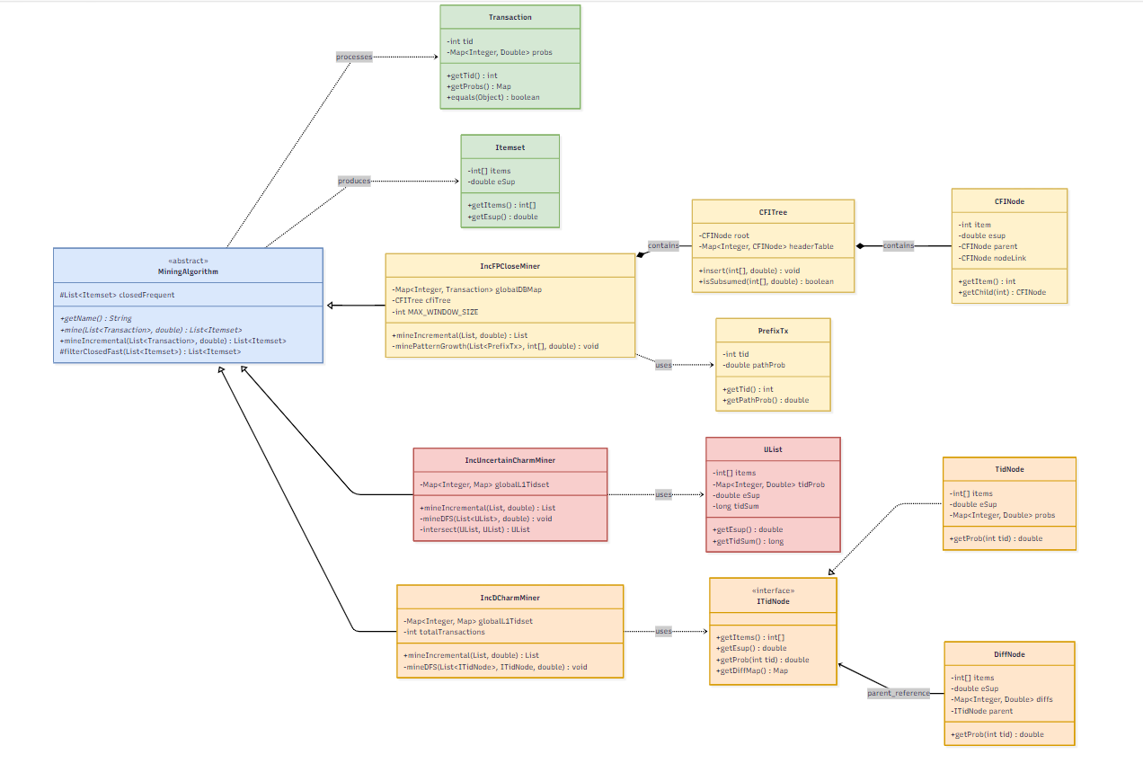
Figure 3.1: Class diagram.

Main contribution: Inc-FP-Close Algorithms (Pattern Growth Strategy)
This is the core solution of the research, specifically designed to handle dense, accumulated databases where vertical approaches are prone to memory exhaustion. Inc-FP-Close extends the traditional FP-Growth method while incorporating closed itemset properties and dynamic update capabilities.

Incremental State Management
The mining cycle begins with the mineIncremental function. This function acts as the outer loop manager: it receives new data batches (deltaDB), accumulates them into globalDBMap and the global frequency array globalItemCounts. It is also responsible for recalculating the new absolute support threshold (minSupAbs) and managing the Sliding Window mechanism to release outdated transactions, thereby preventing memory leakage as data continuously arrives.

Projected Database Construction
Instead of building a massive physical FP-Tree for uncertain data, the algorithm uses the recursive function minePatternGrowth to create local projected databases.
- Prefix Tracking: The system uses the PrefixTx class to store the transaction ID (e.g., t₁) and the accumulated probability of the current prefix (pathProb).
- Preventing Floating-point Underflow: During continuous probability multiplication across recursive levels, if the accumulated probability falls below the extremely small threshold (MathUtils.MIN_PROBABILITY), the system proactively removes that transaction from the recursive branch to avoid wasting computational resources.

On-the-fly Subsumption Checking with CFITree
The key performance breakthrough of Inc-FP-Close lies in the CFITree (Closed Frequent Itemset Tree) structure, which functions as an early-exit warning system:
- Header Table Lookup: Before deciding to explore a new itemset X, the system queries the isSubsumed function. This function jumps to the Header Table to find nodes containing the last item of X, then compares the expected support values.
- Bottom-up Traversal: To determine subsumption relationships, the isSubsetUpward function traverses upward from the leaf to the root. If the current node’s item is smaller than the searched item in the sorted array X, the function immediately returns false and exits early, significantly saving traversal cost.

EXPERIMENTAL SETUP AND EVALUATION

Computational Framework
To maintain absolute consistency across all performance benchmarks and avoid hardware-induced discrepancies, a standardized local workstation was deployed for executing the mining algorithms. The physical host was a Lenovo ThinkPad system equipped with a 12th-generation Intel Core i7 processor and 16 gigabytes of DDR4 memory, further supported by a dedicated NVIDIA MX550 graphics unit. On the software front, the incremental algorithms were entirely engineered in Java (JDK 25) using the Visual Studio Code environment. The underlying operating system coordinating the resource allocation was a 64-bit Windows 10 Pro architecture.

Benchmark Data and Probabilistic Transformation
Validating the proposed algorithms required diverse transactional records, which were procured from the widely recognized SPMF data mining library. Three distinct collections were selected to represent different extremes of data sparsity and density:
- The Mushroom Dataset: Derived from biological classifications, this dataset contains a high frequency of overlapping items, making it an excellent candidate for evaluating algorithmic behavior in dense data scenarios.
- The Chess Dataset: Representing endgame configurations, this collection is notoriously dense and highly combinatorial. It serves as an extreme stress test for memory consumption and the efficiency of the pruning strategies.
- The BMSWebView1 Dataset: In stark contrast to the previous two, this dataset captures real-world web traffic and e-commerce clickstreams. Its extremely sparse nature reflects typical user browsing habits, providing a practical evaluation metric for everyday business applications.
Synthetic Uncertainty Injection: Because the native SPMF files only provide deterministic transactions (where an item's presence is strictly binary), a preprocessing mechanism was mandatory to align them with the research's focus on uncertain databases. A synthetic probabilistic generator was applied to the raw data, assigning a randomized confidence score—ranging from 0.0 to 1.0 based on a Gaussian distribution—to every individual item. This step successfully mimics the stochastic nature of real-world data streams (e.g., sensor noise or predictive probabilities).
Dataset | Total Transactions | Unique Items | Transaction Length | Percentage of Density (%)
Mushroom | 8,416 | 119 | 23 | 19.33%
Chess | 3,196 | 75 | 37 | 49.33%
BMSWebView1 | 59,602 | 2,003 | 5.69 | 0.28%
Table 4.1: Dataset Descriptions and Statistics
4.3. Evaluation Process
The experimental design varies the minimum support threshold (MinSup) in order to examine how the algorithms scale when the mining task becomes easier or more difficult. Lower MinSup values normally expand the search space and produce more candidate patterns, while higher MinSup values reduce the number of valid closed itemsets.
The proposed Inc-FP-Close algorithm was compared with two existing incremental algorithms for closed frequent itemset mining, namely Inc-CHARM and Inc-dCharm. The comparison focused on three core performance dimensions:
- Runtime, measured as execution time in milliseconds.
- Peak memory usage, measured as the maximum RAM consumed during execution.
- Incremental update efficiency when new transaction batches are added to the accumulated database.
The experiments were repeated with decreasing MinSup values. This setup increases the level of difficulty step by step and makes it possible to observe algorithm behavior on both dense and sparse datasets.
4.4.1. Runtime Comparison
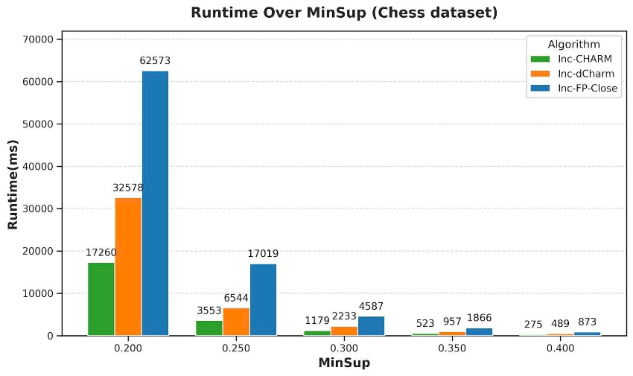
Figure 4.1: Runtime Comparison according to MinSup threshold – Dataset: Chess
For the dense Chess dataset, Inc-FP-Close generates a very large number of closed itemsets when the support threshold is low. At MinSup = 0.20, it discovers 57,809 closed itemsets. The result count then drops substantially to 14,789 at MinSup = 0.25, 4,456 at MinSup = 0.30, and only 679 at MinSup = 0.40. This rapid decrease shows that the closed itemset constraint can greatly reduce redundant patterns as the threshold becomes stricter.
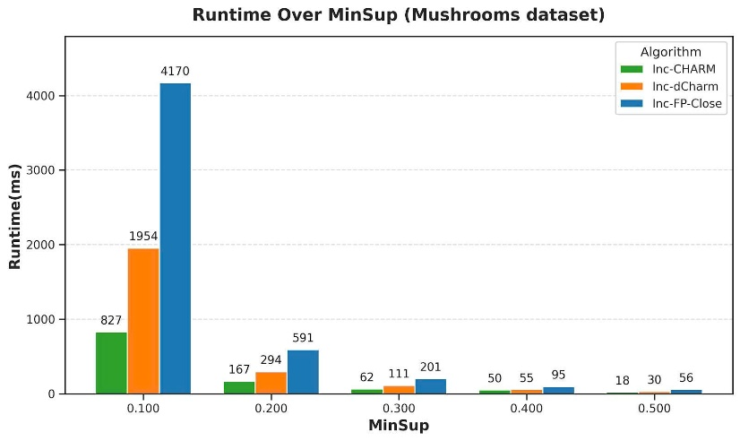
Figure 4.2: Runtime Comparison according to MinSup threshold – Dataset: Mushrooms
On the Mushroom dataset, Inc-FP-Close identifies 3,532 closed itemsets at MinSup = 0.10. When the threshold increases to 0.20, the number of closed itemsets falls sharply to 334, and it continues declining until only 12 closed itemsets remain at MinSup = 0.50. These results indicate that closure-based mining is effective for removing repetitive patterns in a medium-density dataset.
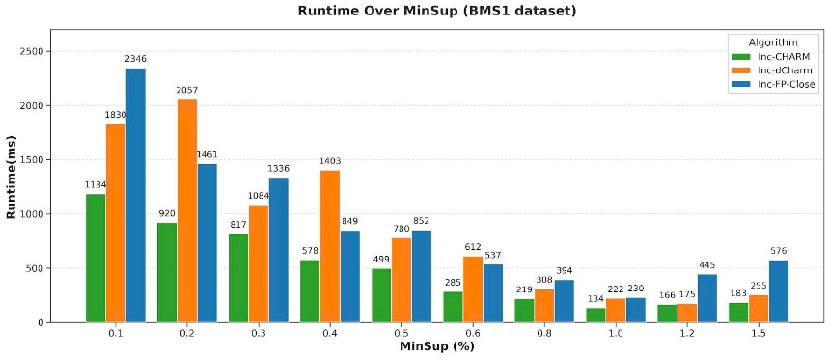
Figure 4.3: Runtime Comparison according to MinSup threshold – Dataset: BMS1
For the sparse BMS1 dataset, the number of closed itemsets is considerably lower than in the dense datasets. At MinSup = 0.1, the algorithm finds 1,030 closed itemsets, and this number decreases gradually to 20 at MinSup = 1.5. The sparsity of BMS1 naturally limits the number of frequent combinations, resulting in a smaller output space.
4.4.2. Peak Memory Usage Comparison
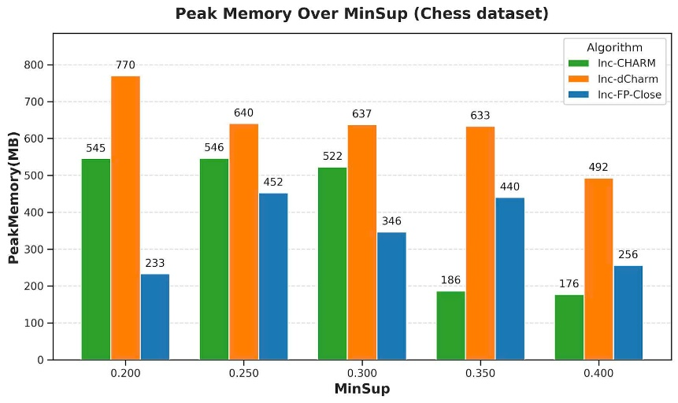
Figure 4.4: Peak Memory Comparison according to MinSup threshold - Dataset: Chess
On the Chess dataset, Inc-FP-Close records a high runtime when MinSup is low, reaching 62,573 ms at MinSup = 0.20. This value is considerably higher than the results of Inc-CHARM and Inc-dCharm. However, the runtime decreases quickly as MinSup increases. At MinSup = 0.40, Inc-FP-Close requires only 873 ms. This pattern suggests that the pattern-growth strategy and closure checking become much more efficient once the search space has been reduced.
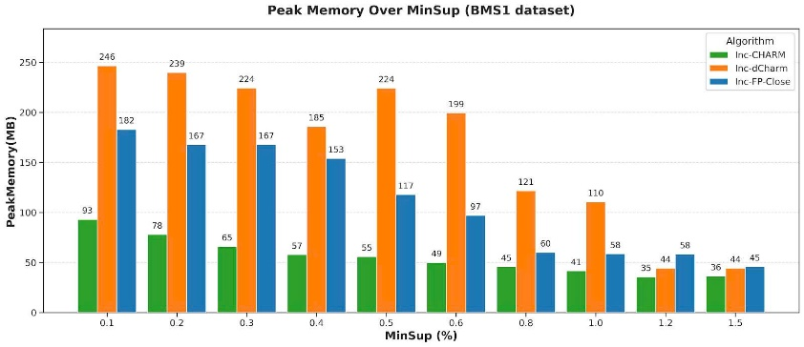
Figure 4.5: Peak Memory Comparison according to MinSup threshold - Dataset: BMS1
On the Mushroom dataset, Inc-FP-Close takes 4,170 ms at MinSup = 0.10, which is slower than the two comparison algorithms. Nevertheless, the execution time decreases significantly as the MinSup threshold rises, reaching only 56 ms at MinSup = 0.50. This demonstrates that the proposed method scales well as the number of valid patterns becomes smaller.
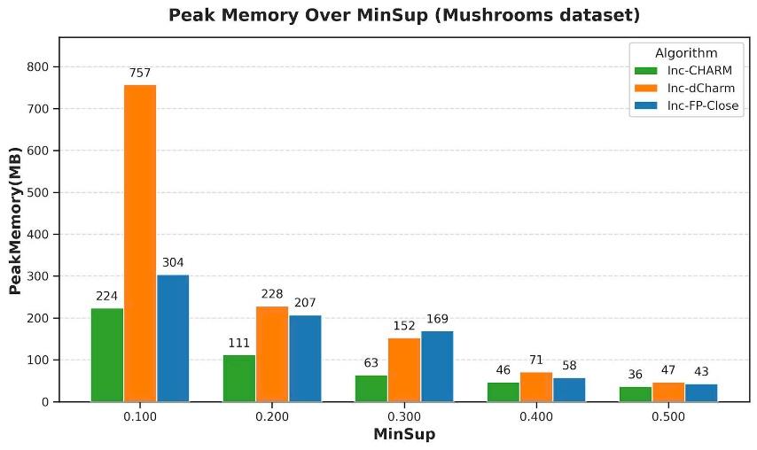
Figure 4.6: Peak Memory Comparison according to MinSup threshold - Dataset: Mushrooms
For BMS1, Inc-FP-Close also requires more time at low MinSup, with 2,346 ms recorded at MinSup = 0.1. Even so, its performance remains relatively stable across the tested threshold range, and the runtime stays acceptable when the support threshold is increased.
.
4.4.3. Incremental Performance on Accumulated Database
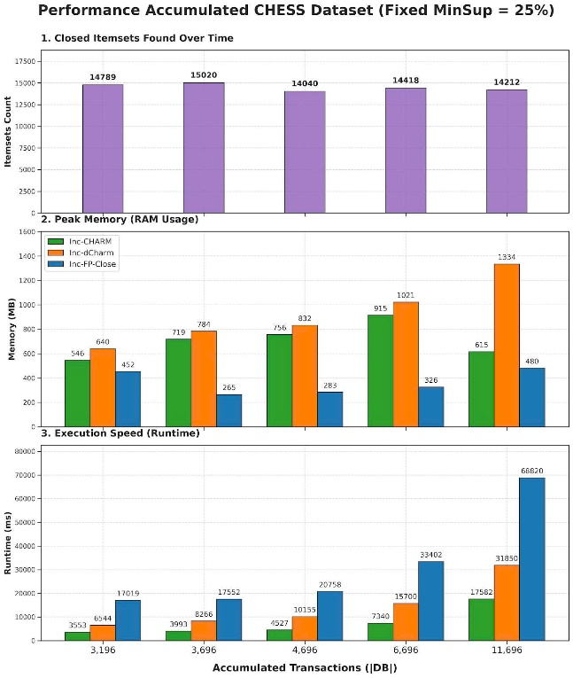
Figure 4.10: Performance on Accumulated Chess Dataset (Fixed MinSup = 25%)
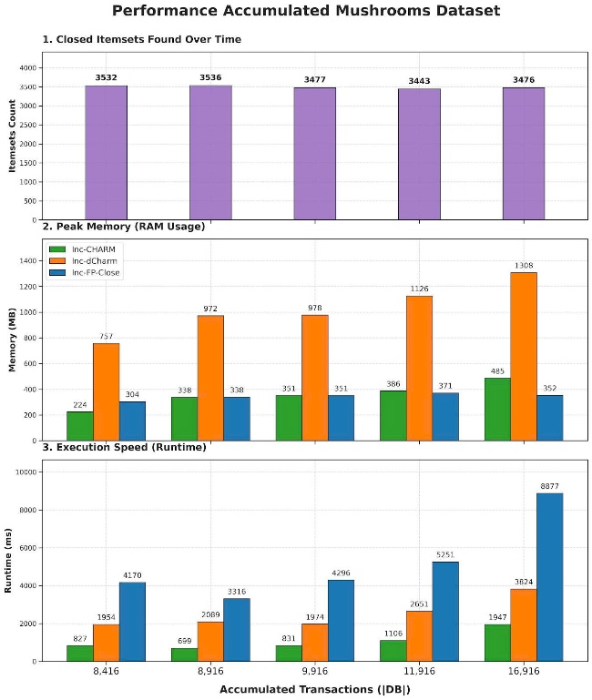
Figure 4.11: Performance on Accumulated Mushrooms Dataset

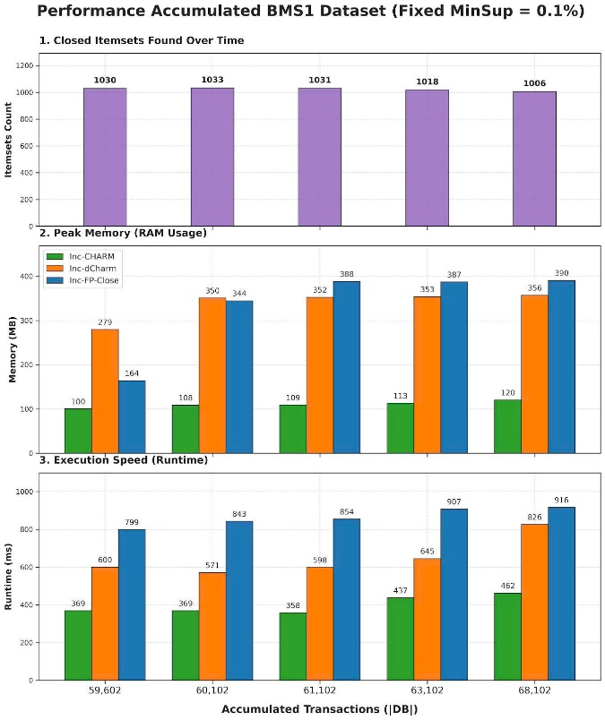
Figure 4.12: Performance on Accumulated BMS1 Dataset (Fixed MinSup = 0.1%)
Figures 4.10 to 4.12 illustrate how the algorithms behave when the database grows continuously through newly added transactions. Inc-FP-Close keeps its memory usage relatively stable even when the accumulated number of transactions increases. In the Chess dataset, it records the lowest memory consumption among the three evaluated algorithms. This evidence supports the effectiveness of the incremental update mechanism and the object-oriented implementation design for accumulated dynamic uncertain databases.
Overall Observation: The experimental results show that Inc-FP-Close achieves strong memory efficiency across all tested datasets while maintaining competitive runtime performance, especially when MinSup becomes higher. The integration of object-oriented design, pattern-growth mining, and closure-based pruning provides a practical solution for extracting closed frequent itemsets from accumulated dynamic uncertain databases.

CONCLUSION AND FUTURE

Summary of Contributions
Upon the completion of the research titled “Object-Oriented Solutions to the Problem of Mining Closed Frequent Itemsets from Accumulated Dynamic Uncertain Databases”, the study has yielded comprehensive theoretical and practical contributions as follows:
- Theoretical Contributions: The study systematically consolidated core concepts within the domain of uncertain data mining. It successfully articulated the mechanism of Expected Support as a replacement for traditional frequency counts in probabilistic environments. Furthermore, it provided a clear theoretical distinction and comparative analysis among vertical data formats (List-based/Diffset-based) and Pattern Growth approaches when applied to dynamic, incremental environments.
- System Development Achievements: A robust, highly cohesive Java library was successfully engineered, strictly conforming to Object-Oriented Programming (OOP) paradigms. By deploying architectural design patterns—specifically the Strategy Pattern and Template Method Pattern—the system guarantees a high degree of modularity, loose coupling, and maintainability, facilitating seamless integration of future mining algorithms.
- Experimental Findings: Extensive benchmarking was executed on various simulated dynamic datasets (MUSHROOMS, CHESS, and BMS1) using an incremental processing pipeline. The key empirical observations include:
- Inc-FP-Close: Demonstrated superior execution speed and outstanding stability when handling large, densely accumulated datasets, primarily due to its efficient on-the-fly subsumption checking via the CFITree.
- Inc-CHARM: Proven to be a highly stable baseline for vertical mining, executing fast intersections using the UList structure, though its performance moderately degrades as the transaction volume scales up exponentially.
- Inc-dCharm: While theoretically memory-efficient through its polymorphic DiffNode implementation, practical experiments revealed that the overhead of instantiating numerous difference objects on dense uncertain datasets (e.g., CHESS) actually increases peak memory usage, presenting a valuable trade-off discovery.

Inherent Limitations
Despite achieving the primary objectives, the current iteration of the research exhibits several inherent constraints:
- Memory-Speed Trade-offs in Uncertain Data: The implementation of Inc-dCharm highlighted a critical limitation: the polymorphic calculation of floating-point differences (Diffsets) across deep recursive trees incurs significant Java object overhead, making it memory-intensive on highly dense probabilistic datasets. Conversely, while Inc-FP-Close resolves speed bottlenecks via projection, it still demands substantial RAM to maintain the global database state and continuous conditional tree generations.
- Hardware Utilization: The current object-oriented architecture is predominantly designed for single-thread execution. The immense computational burden of expected support calculations during dataset accumulation has yet to leverage the full potential of multi-core processors.
- Lack of Real-time Purging Mechanisms: Although a MAX_WINDOW_SIZE logic was conceptualized to manage accumulated data, the system currently lacks a sophisticated, time-decay heuristic to automatically purge obsolete uncertain transactions without disrupting the global mining state.

Future Research Directions To Development
To address the aforementioned limitations and further elevate the utility of the proposed system, several strategic development trajectories are proposed for future work:
- Parallel and Distributed Computing: Refactor the core OOP framework to support multi-threading architectures (e.g., utilizing Java Fork/Join Pool) or integrate the algorithms into distributed computing ecosystems like Akka Framework. This would drastically accelerate matrix intersections and projected database generations.
- Real-world Application Deployment: Transition the algorithms from benchmark datasets to real-world, high-velocity uncertain environments, such as analyzing probabilistic clickstream data in e-commerce, sensor noise filtering in IoT networks, or financial fraud detection logs.
- Advanced Memory Optimization: Explore hybrid data structures that combine the fast subsumption capabilities of the CFITree with memory-mapped files or primitive arrays to completely bypass the JVM's object overhead, thereby making the system viable for low-RAM edge computing devices.
- Interactive Visual Analytics: Develop a comprehensive Graphical User Interface (GUI) or a web-based dashboard that allows data scientists to dynamically configure parameters (e.g., Expected Support, Epsilon tolerance) and visualize the evolution of closed frequent itemsets in real-time as new data batches arrive.

REFERENCES
- M. J. Zaki, "CHARM: An efficient algorithm for closed itemset mining,"
in Proceedings of the SIAM International Conference on Data Mining (SDM), 2002, pp. 457-473.
- N. Pasquier, Y. Bastide, R. Taouil, and L. Lakhal, "Discovering frequent closed itemsets for association rules,"in Proceedings of the International Conference on Database Theory (ICDT), 1999, pp. 398-416.
- C. C. Aggarwal,"Managing and mining uncertain data," Springer, 2009.
- C. K. Chui, B. Kao, and E. Hung,"Mining frequent itemsets from uncertain data", in Proceedings of the Pacific-Asia Conference on Knowledge Discovery and Data Mining (PAKDD), 2007, pp. 47-58.
- Zaki, M. J., & Gouda, K. (2001). Fast vertical mining using diffsets. (Technical Report) Philippe Fournier-Viger et al. provide implementations of dEclat and dCharm algorithms in the SPMF library.
- L. Szathmary, P. Valtchev, A. Napoli, and R. Godin, "Efficient Mining of Closed Frequent Itemsets with the dCHARM Algorithm," Annals of Mathematics and Artificial Intelligence, vol. 70, no. 1-2, pp. 87-120, 2014.
- D. Cheung, J. Han, V. Ng, and C. Y. Wong,"Maintenance of discovered association rules in large databases:An incremental updating technique,"
in Proceedings of the IEEE International Conference on Data Engineering,
1996, pp. 106-114.
- J. Han, M. Kamber, and J. Pei,"Data Mining: Concepts and Techniques,"
3rd ed., Morgan Kaufmann, 2011.
- G. Grahne and J. Zhu, "Fast algorithms for frequent itemset mining using FP-trees," IEEE Transactions on Knowledge and Data Engineering, vol. 17, no. 10, pp. 1347–1362, 2005.

