VIETNAM GENERAL CONFEDERATION OF LABOUR

**TON DUC THANG UNIVERSITY FACULTY OF INFORMATION TECHNOLOGY**

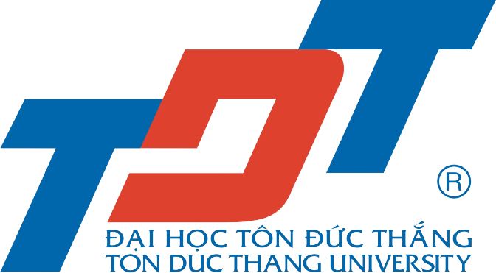

**FINAL ASSIGNMENT**

Management Information System

*Lecturer*: **HO THI THANH TUYEN**

*Authors*: **TRAN QUOC BAO – 521H0494**

**DO HOANG DUY – 521H0395**

**LE NGUYEN VIET HIEP – 521H0398**

**TRAN NGOC TU – 520H0592**

*Group*: **5**

*Academic year* **: 25**

**HO CHI MINH CITY, 2024**

VIETNAM GENERAL CONFEDERATION OF LABOUR

**TON DUC THANG UNIVERSITY FACULTY OF INFORMATION TECHNOLOGY**



**FINAL ASSIGNMENT**

Management Information System

*Lecturer*: **HO THI THANH TUYEN**

*Authors*: **TRAN QUOC BAO – 521H0494**

**DO HOANG DUY – 521H0395**

**LE NGUYEN VIET HIEP – 521H0398**

**TRAN NGOC TU – 520H0592**

Group: **5**

*Academic year* **: 25**

**HO CHI MINH CITY, 2024**

# ACKNOWLEDGEMENT

To complete this final project, we would like to express our gratitude to Ton Duc Thang University for providing the necessary facilities and to the teachers who have supported us throughout our studies at the TDT University. Moreover, we love to give thanks to our parents who gave us many chances to approach knowledge at TDTU and motivated, supported us a lot.

Especially, we would like to thank Ho Thi Thanh Tuyen for teaching us with great dedication and detail, so that we have enough knowledge that we used for this essay. Due to our limited experience and acknowledgement, we make sure that there are some mistakes in our work. We sincerely hope to receive feedback and constructive criticism from the teacher who instructed us. So that we can complete this essay more effectively.

We would like to express our heartfelt thanks and wishes teacher good health.

# 

# THE PROJECT IS COMPLETED AT TON DUC THANG UNIVERSITY

We hereby declare that this is the product of our project and is guided by Ho Thi Thanh Tuyen. The research contents and results in this topic are honest and have not been published in any forms before. The data in the tables for analysis, comments, and evaluation were collected by the author from different sources and clearly stated in the reference section. In addition, the project also uses a number of comments, assessments as well as data from other authors and other organizations, all with citations and source notes.

If any fraud is discovered, we will take full responsibility for the content of our project. Ton Duc Thang University is not involved in copyright violations caused by us during the implementation process (if any).

*Ho Chi Minh City, 30th November 2024 Authors*

*(Signatures and full names)*

*Tran Quoc Bao*

*Do Hoang Duy*

*Le Nguyen Viet Hiep*

*Tran Ngoc Tu*

# SUMMARY

This assignment for The coffee shop named “Coffee 5” that business aims to become a leading and trusted brand in the industry. It focuses on providing high-quality coffee products, competitive pricing, exceptional customer service, and innovative sales and marketing strategies. The current system faces limitations in payment options, order management, inventory tracking, and user experience. The proposed system addresses these issues through a range of improvements, including expanded payment capabilities, integrated order management, real-time inventory tracking, and a user-friendly interface. This system is expected to enhance customer experience, improve operational efficiency, and drive business growth.

# TABLE OF CONTENTS

ACKNOWLEDGEMENT 3

THE PROJECT IS COMPLETED AT TON DUC THANG UNIVERSITY 4

SUMMARY 5

TABLE OF CONTENTS 6

CHAPTER 1. ABOUT THE ORGANIZATION COFFE 5 APPROACHED. 8

1.1 Objectives and Misson 8

1.1.1 Objective 8

1.1.2 Misson 8

1.2 Industry and History 8

1.2.1 Industry 8

1.2.2 History 9

1.3 Size and Organization Chart 9

1.3.1 Size 9

1.3.2 Organization Chart 9

1.4 Business Area/Function 10

CHAPTER 2. CURRENT INFORMATION SYSTEM 11

2.1 Industry Structure and Target Market Share 11

2.1.1 Industry Structure 11

2.1.2 Target Market Share 11

2.2 Competitive Strategy for the next 10 years 12

2.2.1 Now to 2 years from now 12

2.2.2 Next 3 years to next 5 years 13

2.2.3 Next 6 years to next 10 years 13

2.3 The most important main activities/support activities in value chain of the system 14

2.3.1 Main activities 14

2.3.2 Sub activities 17

2.4 Analyze organization structure of 5 components of an information system: hardware, software, people, processes, and data. 17

2.4.1 Hardware 17

2.4.2 Software 18

2.4.3 People 18

2.4.4 Processes 18

2.4.5 Data 19

CHAPTER 3. ORGANIZATIONAL ISSUES 19

3.1 Existing Problems and Goals for the Future 19

3.1.1 Existing Problems 19

3.1.2 Goals for the Future 20

3.2 Components/Structures cause the problems 20

CHAPTER 4. PROPOSAL OF A NEW SYSTEM 21

4.1 USE Case and ERD 21

4.2 Improvements 25

4.3 Analyze and evaluate what new changes support the organization’s competitive strategy. 26

CHAPTER 5. CONCLUSION 26

5.1 Pros and Cons 26

5.1.1 Pros 26

5.1.2 Cons 27

5.2 Our Review 27

5.3 Lessons learned from the project 27

CHAPTER 6. SOURCE CODE 28

REFERENCES 29

# CHAPTER 1. ABOUT THE ORGANIZATION COFFE 5 APPROACHED.

## Objectives and Misson

### Objective

We provide a wide variety of premium coffee products and related accessories to satisfy our customers' diverse tastes and needs at competitive prices. We aim to deliver exceptional customer service and implement effective sales and marketing strategies to enhance customer satisfaction and business growth.

We aspire to be the leading and most trusted coffee business, known for our affordable prices, outstanding customer service, and innovative sales and marketing efforts. We aim to expand our market share, increase revenue, and boost profitability.

### Misson

*Product Excellence:* Offer a diverse selection of high-quality coffee beans, blends, and related accessories.

*Competitive Pricing:* Maintain affordable prices while ensuring premium quality.

*Exceptional Customer Service:* Provide reliable warranties, attractive after-sales support, and develop customer loyalty programs.

*Innovative Sales and Marketing:* Implement effective marketing campaigns and utilize various sales channels to maximize customer reach and engagement.

*Reputation Building*: Establish a reputable and trusted brand in the coffee industry.

*Market Expansion:* Focus on increasing market share, revenue, and profitability through continuous growth and innovation.

## Industry and History

### Industry

The coffee industry has embraced Information Systems to optimize operations and enhance customer experiences. POS systems streamline sales and track data, while mobile apps enable online ordering, loyalty programs, and personalized marketing. Cloud-based IS solutions also centralize processes, improve inventory management, and provide data analytics for strategic decision-making.

### History

Coffee originated in Ethiopia before spreading through the Arabian Peninsula and then to Europe and beyond, becoming a key part of social culture and global trade.

Traditional coffee shops initially relied on manual processes, but digital transformation revolutionized the industry. Early adoption of POS systems paved the way for tools like digital inventory management, CRM systems, and data analytics, enabling coffee businesses to streamline supply chains, enhance customer engagement, and remain competitive in a rapidly evolving market.

## Size and Organization Chart

### Size

The coffee business is structured as a small-to-medium-sized operation, with an owned website and collaborations with delivery apps like Bee and Grab to expand its reach.

Open 2 coffee shops located in HCM city. This allows for a blend of on-premise service and digital sales channels, catering to a broader customer base.

Recruit 10 employees and all must be professionally trained in all aspects.

### Organization Chart

* *Director:*

Owner

* *Departments:*

Sales and Marketing

Operations

Technical

IT Management

Accounting and Finance

Human Resources

## Business Area/Function

* *Owner*: Determine the direction, and strategy and make decisions to manage business activities based on MIS
* *Sales and Marketing:* Using MIS systems to track customer preferences, sales patterns, promotional effectiveness, advice, and take care of customers.
* *Operations:* Manage import and export, quality and quantity control.
* *Technical:* Monitor and schedule maintenance for coffee machines and equipment.
* *IT Manager:* Manages the website and all information systems, ensuring smooth online ordering and integration with internal systems.
* *Accounting and Finance:* Manages the financial operations of the business, tracking expenses, revenue and accountancy reporting.
* *Staff Department:* Manages employee recruitment, performance, and well-being, using MIS for workforce management.

# CHAPTER 2. CURRENT INFORMATION SYSTEM

## Industry Structure and Target Market Share

### Industry Structure

The coffee shop industry in Vietnam is highly dynamic and competitive, featuring both large multinational chains such as **Trung Nguyen** and **Highlands Coffee**, as well as smaller, independent local shops. The industry is shaped by evolving consumer preferences and growing demand for both *quality coffee* and *unique experiences*. Here is Porter's Five Forces analysis of the coffee shop industry in Vietnam, incorporating statistical insights:

* **Industry Rivalry (Very High):** The market is highly competitive, with domestic chains like The Coffee House and international brands like Starbucks competing alongside countless smaller cafes. Additionally, the unique Vietnamese coffee culture emphasizes leisurely consumption, making customer retention a challenge
* **The threat of new entrants (High):** Minimal capital requirements make it easier for new businesses to enter. Vietnam's thriving coffee culture further encourages new players to join the market.
* **Bargaining power of Buyers (High):** Vietnamese consumers are price-sensitive and value quality.
* **Bargaining power of suppliers (Moderate):** Vietnam is the world's largest producer of Robusta coffee and one of the top exporters of Arabica beans. The abundance of local supply gives coffee shop operators an advantage. However, premium coffee beans or specialty imports can increase dependency on suppliers
* **Threat of Substitutes (Moderate to High):** Instant coffee remains a popular and affordable alternative, with production reaching 154,000 metric tons in 2022. Traditional Vietnamese beverages like tea and street-side cafes also serve as substitutes

### Target Market Share

The target market aligns with cost-conscious customers while emphasizing affordability and quality, making the coffee shop appealing to a broader audience.

**Target Groups:**

* *Middle- to Low-Income Customers*:
  + Profile: Individuals who seek affordable yet quality coffee options, often balancing cost considerations with product satisfaction.
  + Needs: Economical pricing for daily coffee consumption. Consistent product quality and a reliable experience.
* *Tech-Savvy Consumers:* 
  + Profile: Young professionals, students, or freelancers who prefer using digital platforms for convenience.
  + Needs: Mobile-friendly services like online ordering and cashless payments. Access to deals and promotions through apps or social media.
* *Community-Oriented Customers:* 
  + Profile: Local residents who frequent the café for daily coffee or socializing.
  + Needs: Affordable daily options for a routine experience. A welcoming, community-focused atmosphere.

**Strategies:**

* *Cut Costs Without Compromising Quality:* Optimize the supply chain to negotiate better rates with suppliers, minimize unnecessary expenses like excessive packaging or overstocking.
* *Focus on Online Channels:* Utilize social media and e-commerce platforms for marketing and sales, highlight promotions like free delivery for online orders over a specific amount.
* *Maintain Quality:* Regularly train staff on quality standards, implement customer feedback systems to ensure continuous improvement.
* *Technology Integration*: Leveraging mobile apps for ordering, loyalty programs, and online marketing can attract tech-savvy customers.
* *Differentiation:* Focusing on a broader range of offerings allows for a more inclusive customer base and creates additional revenue opportunities.

## Competitive Strategy for the next 10 years

### Now to 2 years from now

* *Staff Training:* Train employees to ensure product quality and exceptional customer interaction. Provide barista, customer service, and product knowledge workshops.
* *Expand Menu Offerings:* Expand the menu beyond coffee to include tea, milk tea, and healthy beverages, catering to a wide range of customer preferences. Introduce seasonal or limited-edition items to generate excitement and encourage repeat visits.
* *Expand Online Sales:* Partner with popular delivery platforms such as ShopeeFood, Grab, and Be to increase accessibility. Offer exclusive discounts for online orders to incentivize digital sales and reach new customer segments.
* *Cost Optimization:* Strengthen supplier relationships to negotiate better pricing for quality ingredients. Optimize inventory management to minimize wastage and avoid overstocking.

### Next 3 years to next 5 years

* *Customer Engagement:* Use CRM systems to analyze customer behavior and personalize marketing campaigns.
* *Technology Integration:* Launch a mobile app featuring loyalty programs, personalized recommendations, real-time notifications (the latest shop updates, active discount programs, upcoming events or special store hours) and pre-order/payment options.
* *Brand Building:* Use creative campaigns and giveaways to foster brand loyalty and recognition. Collaborate with local influencers and social media personalities to increase brand visibility and attract younger audiences.

### Next 6 years to next 10 years

* *Menu Diversification:* Introduce premium seasonal specialties (e.g., limited-edition blends or holiday-themed beverages). Expand menu options with artisanal snacks or desserts to complement coffee offerings.
* *Market Expansion:* Open new branches in underserved regions or international markets. Explore franchising opportunities to scale operations effectively.
* *Sustainability Initiatives:* Adopt eco-friendly practices such as using biodegradable packaging and sourcing from sustainable farms. Launch campaigns promoting environmental awareness to enhance brand image and attract eco-conscious consumers.
* *Flexibility:* Continuously update, improve, and innovate to reflect market trends and changes.

## The most important main activities/support activities in value chain of the system

### Main activities

* + - 1. ***Inbound Logistics Sourcing and Quality Control of Raw Materials*:**

*Step 1: Supplier Selection.*

Establish relationships with reliable suppliers who consistently deliver high-quality ingredients, including coffee beans, milk, syrups, pastries, cups, etc.

*Step 2: Placing Orders.*

Determine the quantities needed based on current stock levels and place orders with suppliers.

*Step 3: Receiving Goods.*

Accept deliveries from suppliers, checking all shipments for accuracy and compliance with order specifications.

*Step 4: Quality Inspection.*

Inspect all received goods for quality, freshness, and any defects.

*Step 5: Storage.*

Store perishable items in refrigerated areas and dry items in designated spaces, ensuring proper organization and inventory management.

*Step 6: Inventory Monitoring.*

Track stock levels regularly and update inventory systems to prevent shortages or overstocking.

* + - 1. ***Operations Product Preparation and Quality Control:***

*Step 1: Order Placement.*

Receive orders from customers via the counter and online platform.

*Step 2: Preparation of Ingredients.*

Based on order specifications, grind coffee beans and measure milk, syrups, and other ingredients.

*Step 3: Drink and Food Preparation.*

Prepare beverages and food items following standardized recipes and customer preferences.

*Step 4: Customization.*

Adjust orders according to customer specifications

*Step 5: Quality Control Check.*

Verify the taste, presentation, and temperature of the prepared items before serving or packaging.

*Step 6: Hygiene Maintenance.*

Clean and sanitize all used equipment, utensils, and preparation areas to meet health standards.

* + - 1. ***Outbound Logistics Order Fulfillment and Delivery Efficiency:***

*Step 1: Assembling Orders.*

Gather and prepare all components of a customer’s order, whether for dine-in, takeout, or delivery.

*Step 2: Packaging.*

Use appropriate packaging to preserve the temperature and quality of the food and beverages

*Step 3: Verification.*

Double-check the order to ensure all items, including any customizations, are correctly included.

*Step 4: Delivery.*

For dine-in customers, serve orders promptly with attention to creating a welcoming environment.

For takeout or delivery, ensure items are dispatched on time and with proper tracking for customer convenience.

* + - 1. ***Marketing and Sales***

Analyze customer preferences, trends, and competitors to tailor marketing strategies.

*Step 2: Campaign Development.*

Create targeted promotions, loyalty programs, and seasonal campaigns to attract customers.

*Step 3: Customer Interaction.*

Engage with customers through in-store events, social media posts, and online feedback.

*Step 4: Monitoring and Feedback.*

Track campaign performance, collect customer feedback, and use data insights to refine future marketing efforts.

*Step 5: Partnerships.*

Collaborate with local businesses or organizations for joint promotions, increasing visibility.

* + - 1. ***Service: Customer Support and Relationship Management***

*Step 1: Customer Interaction.*

Ensure friendly service for each customer during their visit or interaction.

*Step 2: Handling Feedback and Complaints.*

Act promptly to address any customer complaints, aiming to resolve issues and turn negative experiences around.

*Step 3: Feedback Analysis.*

Gather and analyze feedback to identify areas of improvement.

*Step 4: Loyalty Program Management.*

Reward loyal customers with exclusive deals, discounts, or rewards points.

*Step 5: Post-Sale Engagement.*

Continue engaging customers through follow-up messages, surveys, or promotions to foster long-term relationships.

### Sub activities

* + - 1. ***Firm infrastructure***
* Develop business strategies, define goals, and ensure organizational structure supports efficiency.
* Manage finances and ensure compliance with all legal and regulatory requirements.
  + - 1. ***Human resource management***
* Recruit and onboard employees, providing training on operational and customer service standards.
* Conduct performance evaluations and foster a positive work environment to retain talent.
  + - 1. ***Technology management***
* Implement and maintain systems like point-of-sale (POS) and online ordering platforms.
* Use data analytics to refine business strategies and ensure equipment is regularly maintained.
  + - 1. ***Procurement***
* Select and negotiate with reliable suppliers for quality raw materials.
* Place orders and maintain strong relationships for continuous supply chain efficiency.

## Analyze organization structure of 5 components of an information system: hardware, software, people, processes, and data.

### Hardware

* *Web Servers:* High-capacity servers that host the e-commerce platform, ensuring the website handles large volumes of traffic efficiently.
* *Database Servers:* Specialized servers for securely storing and managing critical data, such as customer records, product catalogs, and transaction lo*gs.*
* *Network Infrastructure:* Routers, switches, and other networking devices provide reliable connectivity between various system components, ensuring smooth data flow.
* *Client Devices:* User devices such as desktops, smartphones, and tablets facilitate customer interactions with the platform

### Software

* *E-Commerce Platform:* Enables customers to order online through a web interface or mobile app.
* *POS Software:* Tracks sales, inventory, and customer preferences in real-time.
* *Inventory Management System:* Monitors stock levels, automates reorder processes, and integrates supplier details.
* *Customer Relationship Management (CRM) System:* Tracks customer interactions, manages loyalty programs, and personalizes marketing campaigns.
* *Payment Gateway Integration:* Handles secure online and in-store payments, ensuring encryption and compliance with regulations.

### People

* *Web Developers:* Maintain and update the e-commerce platform and mobile app.
* *Database Administrators:* Ensure efficient storage, retrieval, and security of all business data.
* *Baristas and Staff:* Use POS systems for daily operations, maintain customer relationships, and ensure product quality.
* *Marketing Professionals:* Create campaigns based on data-driven insights from CRM systems.
* *Logistics and Inventory Managers:* Oversee supply chain efficiency, coordinate with suppliers, and ensure stock availability.

### Processes

* *Order Management:* Covers customer order capture, payment processing, and fulfillment coordination.
* *Inventory Management:* Ensures stock levels are maintained, products are reordered as needed, and suppliers are efficiently managed.
* *Customer Relationship Management:* This includes acquiring new customers, retaining existing ones, and addressing their feedback and concerns.
* *Marketing and Promotion:* Encompasses planning and executing campaigns to attract and retain customers.
* *Analytics and Reporting:* Involves collecting and analyzing data to monitor business performance and identify trends.

### Data

* *Transactional Data:* Information on customer orders, payment records, and purchase histories.
* *Inventory Data:* Details of product availability, supplier deliveries, and stock turnover rates.
* *Customer Data:* Profiles, preferences, and interaction histories for personalized marketing.
* *Marketing Data:* Performance metrics from campaigns, including customer engagement rates.
* *Analytical Data:* Aggregated insights into sales trends, market demands, and operational efficiency.

# CHAPTER 3. ORGANIZATIONAL ISSUES

## Existing Problems and Goals for the Future

### Existing Problems

* *Limited Payment Options*: The existing system does not support international card payments, which limits access for tourists or international customers and reduces revenue potential.
* *Inefficient Order Management:* The old system lacks integration between the ordering process and kitchen staff, leading to order mistakes, delays in food and beverage preparation, and confusion during peak hours.
* *Lack of Real-Time Inventory Tracking:* Inventory updates are delayed and manually recorded, resulting in inaccurate stock counts, potential overstocking, or running out of popular items unexpectedly.
* *User Interface and User Experience Issues:* There are user interface and user experience issues, including interface lags and lack of responsiveness, no automatic adjustment to different displays or screen sizes, and reported bugs and stability issues.

### Goals for the Future

* *Expanded Payment Capabilities:* Enable international card acceptance (Visa, Mastercard, etc.) and other digital payment options to accommodate a wider range of customers and improve their experience.
* *Integrated Order Management System:* Introduce an integrated system that connects customer orders directly to the kitchen or preparation staff, ensuring more accurate and faster service, especially during peak hours.
* *Real-Time Inventory Management:* Implement a system that updates inventory in real-time as sales are made, providing accurate stock levels, reducing shortages, and improving overall supply chain efficiency.
* *Improved UI/UX:* Redesign the system for a more intuitive, responsive, and visually appealing interface. It will be optimized for different devices and screen sizes, ensuring a smooth user experience. The system will be stable, bug-free, and faster, with reduced lag and improved load times, ultimately enhancing both customer satisfaction and operational efficiency.

## Components/Structures cause the problems

**Limited Payment Options:**

* *Component Affected:* Payment System
* *Process*: The current process for handling payments is restricted to local payment methods, excluding international cards.
* *Data*: The system does not have the necessary data integration to process international transactions.
* *Hardware*: Payment terminals may not support various international payment methods or digital payment options.

**Inefficient Order Management:**

* *Component Affected:* Order Management System
* *Process*: Orders are not effectively communicated between the front-end (customer order entry) and the back end (kitchen staff), leading to errors and delays.
* *Data*: Lack of real-time data synchronization between ordering and kitchen preparation stages.
* *Software*: Existing software may not support integrated order management features, causing operational inefficiencies.

**Lack of Real-Time Inventory Tracking:**

* + *Component Affected:* Inventory Management System.
  + *Process*: Inventory updates are performed manually, often leading to delays and inaccuracies.
  + *Data*: Inventory data is not updated in real-time, resulting in outdated stock information.
  + *Hardware*: The absence of automated inventory tracking hardware (e.g., RFID tags, and barcode scanners) can contribute to these issues.

**User Interface and User Experience Issues:**

* + *Component Affected:* UI and UX.
  + *Process*: The user interface does not adapt automatically to different devices or screen sizes, leading to a suboptimal user experience.
  + *Software*: The existing software may be outdated, with reported bugs and stability issues that affect the overall performance.
  + *Hardware*: The system may not be optimized for newer hardware, causing performance lags and delays.

# CHAPTER 4. PROPOSAL OF A NEW SYSTEM

## USE Case and ERD

**Use Case Diagram**

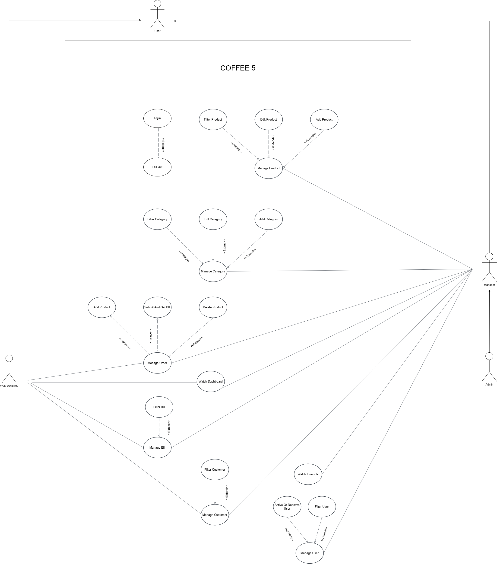

**Use Case Diagram (Separated)**

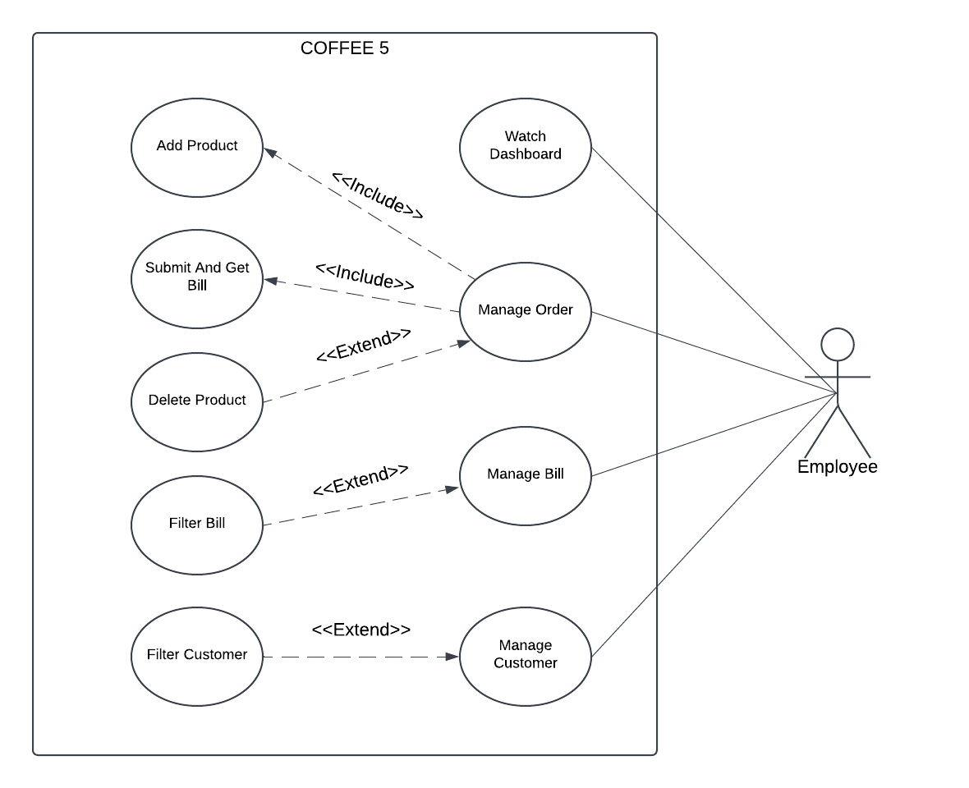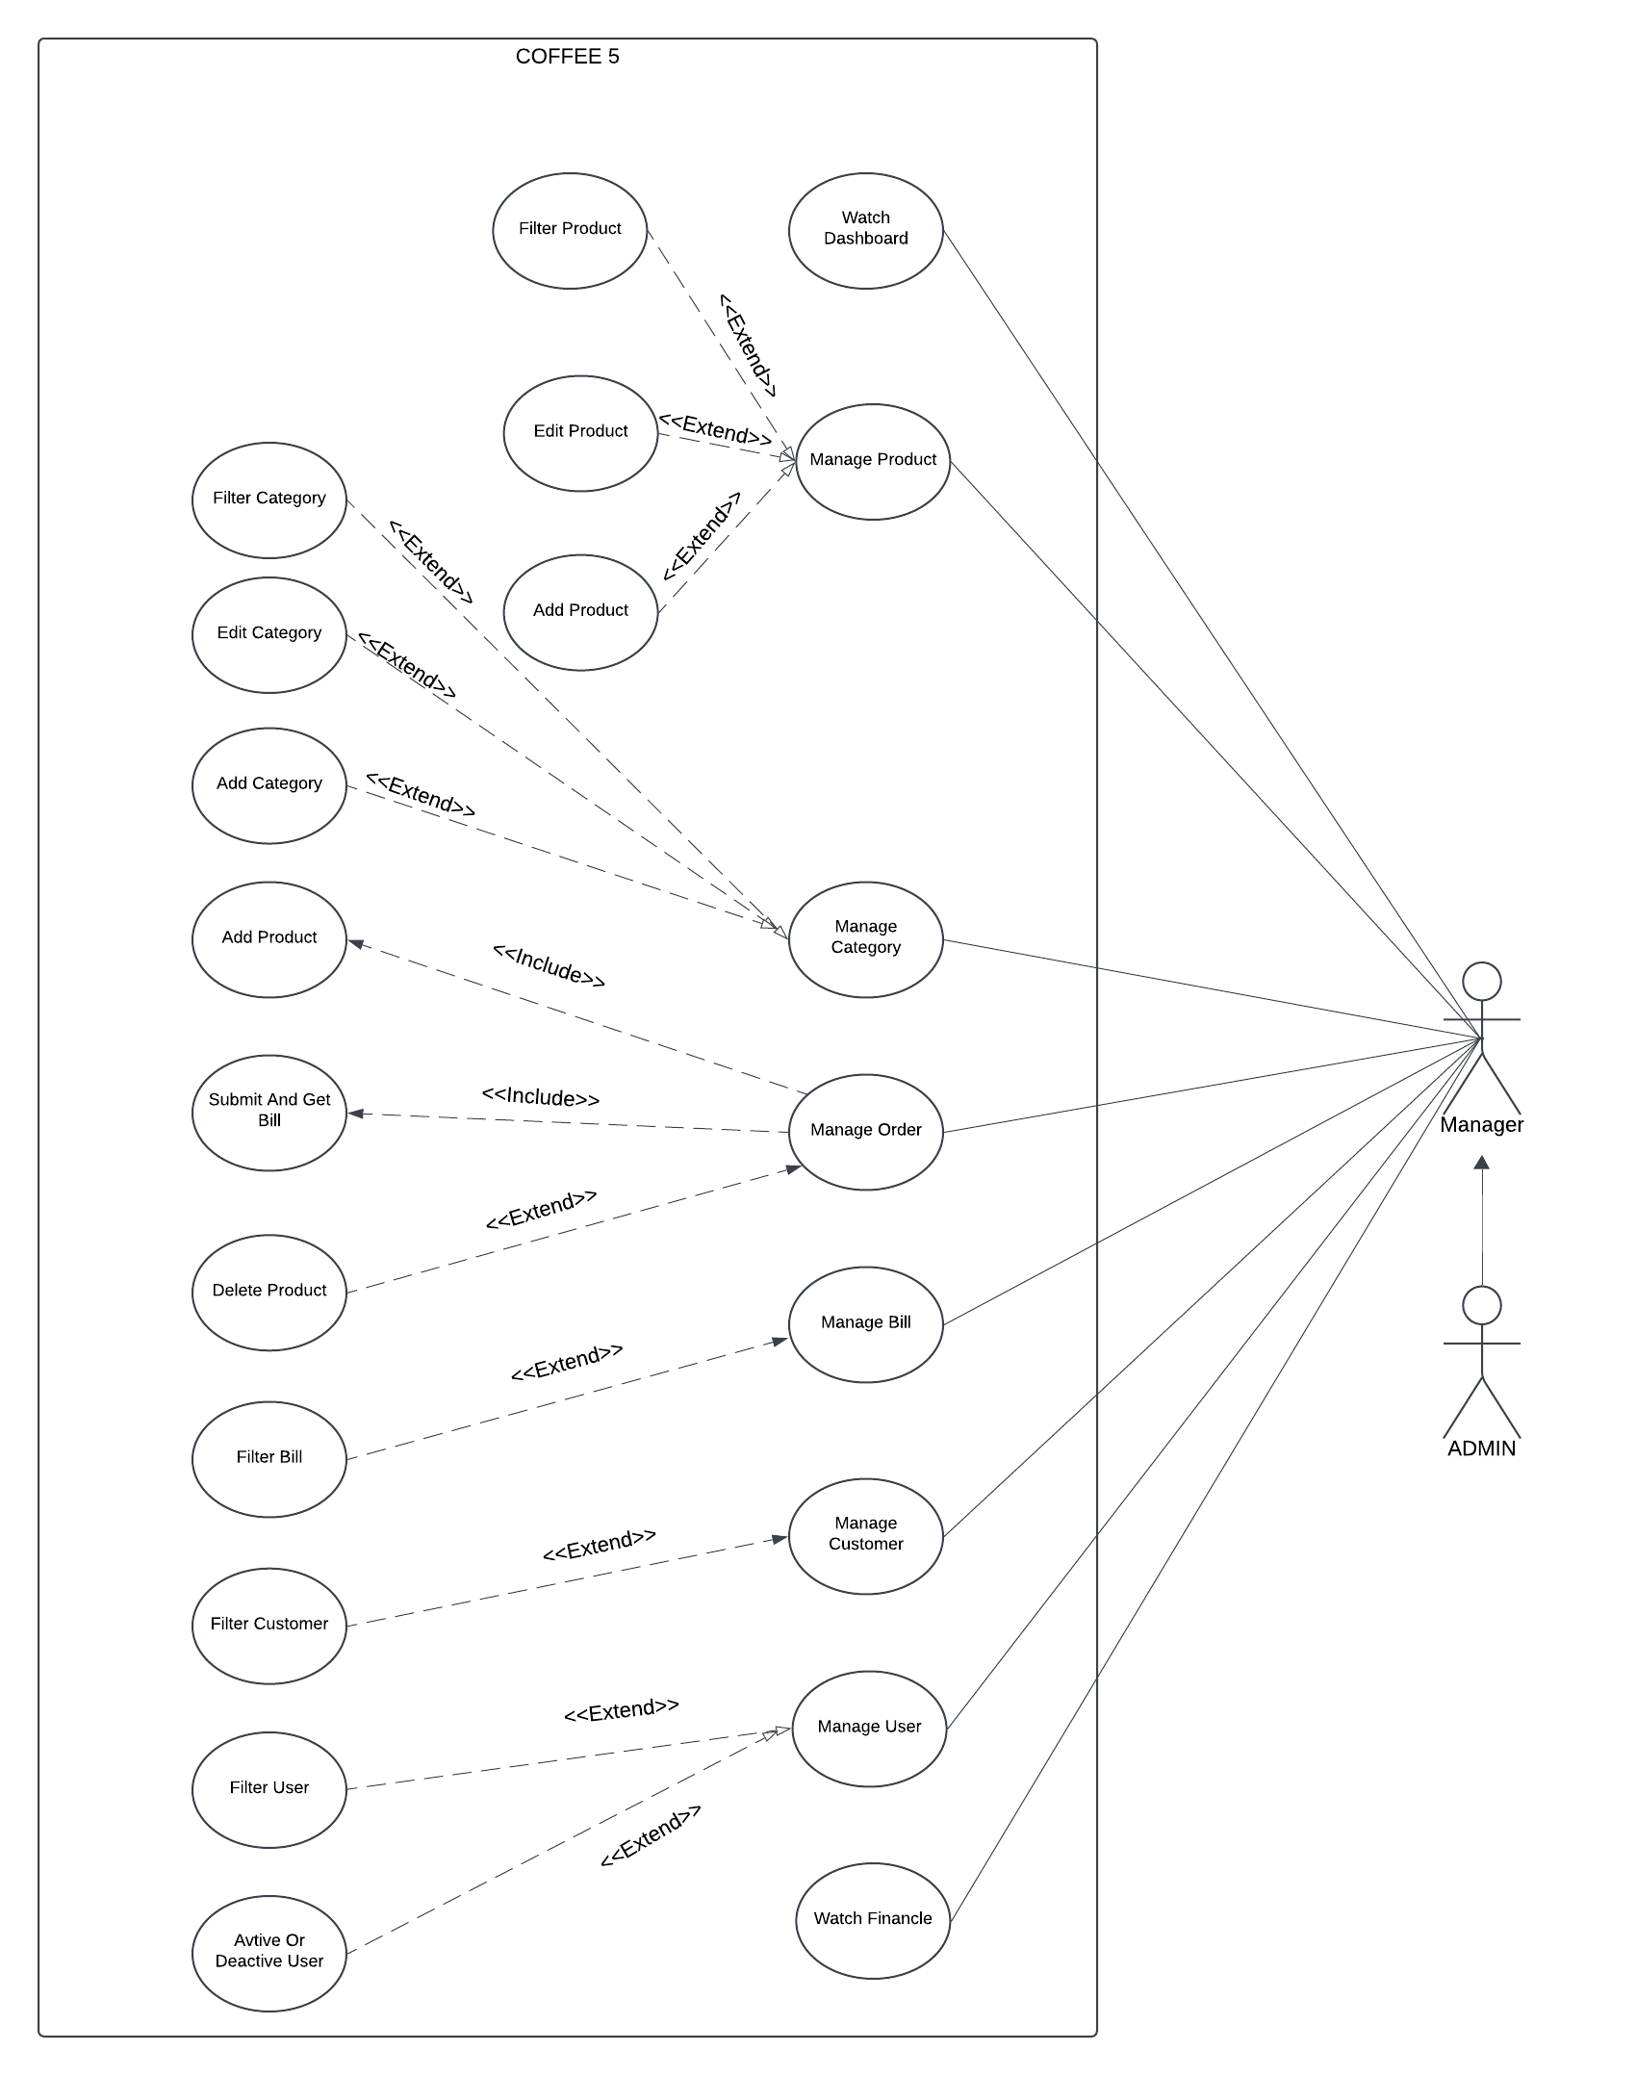

**Entity-Relationship Diagram (ERD)**

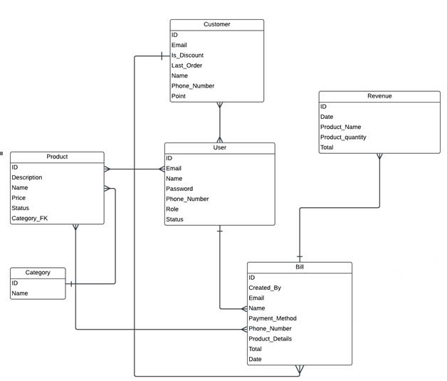

## Improvements

**Payment**:

* Previous: Manual or local payment methods only.
* New: Support for international cards and digital wallets.

**Order Management**:

* Previous: Orders were manually relayed to the kitchen.
* New: Orders are instantly synced to kitchen displays via OMS.

**Customer Engagement**:

* Previous: Limited customer interaction after sales.
* New: CRM tracks feedback, sends promotions and improves loyalty.

**Marketing**:

* Previous: Basic campaigns without targeting.
* New: Data-driven campaigns tailored to customer behavior.

## Analyze and evaluate what new changes support the organization’s competitive strategy.

**Enhanced Customer Experience**:

* Seamless payments and faster order processing improve satisfaction.
* Loyalty programs build long-term customer relationships.

**Cost Efficiency**:

* Real-time inventory reduces wastage and prevents overstocking.
* Integrated OMS minimizes errors, lowering operational costs.

**Market Expansion**:

* Payment upgrades attract international customers and tourists.
* Analytics enable better product offerings, catering to diverse preferences.

**Innovation and Branding**:

* A user-friendly interface and CRM ensure the brand is perceived as modern and cutomer-focused.

# CHAPTER 5. CONCLUSION

## Pros and Cons

### Pros

*Improved Operational Efficiency:*

* Process automation and real-time updates help save on manual labor costs, reduce the risk of errors, and improve overall productivity. - decrease the cost
* It makes it easy to add new features or update existing features, and quickly adapt to market changes - easy to maintain.

*Enhanced Customer Experience:*

* By addressing the issues with the user interface and user experience, the system became more intuitive and user-friendly, improving customer satisfaction and ease of use.

*Increased Revenue Potential:*

* Expanding payment options to include international cards and digital wallets allowed the business to cater to a wider range of customers, especially tourists, which led to increased revenue.

### Cons

*Implementation Costs:* The upgrade to the new system required significant investment in software, hardware, and staff training. This initial cost burden could be high for small businesses.

*Potential Over-Reliance on Technology:* While automation improves efficiency, the business may risk over-relying on technology, which could be problematic if there are technical failures or system downtimes.

## Our Review

The project demonstrated significant improvements in the overall efficiency and functionality of the system. The integration of real-time data management and international payment options addressed key limitations in the existing system. Despite the initial challenges with implementation, including costs and transition difficulties, the long-term benefits, such as smoother operations and better customer satisfaction, justify the changes. In particular, the improved UI/UX design and the more comprehensive payment system were well-received by both employees and customers. The project also highlighted the importance of providing adequate staff training to maximize the benefits of new technology.

## Lessons learned from the project

*Thorough Planning is Crucial:* A detailed evaluation of the current system and a clear roadmap for upgrading processes and technology can help avoid unnecessary disruptions during implementation.

*Employee Training is Key:* Even the best systems will face resistance if employees are not adequately trained. Investing in training ensures smooth adoption and reduces errors caused by unfamiliarity with new processes.

*Constant Monitoring and Feedback:* Post-implementation monitoring and feedback loops from staff and customers are essential to identify issues early and fine-tune the system for optimal performance.

*Balancing Technology with Human Touch:* While automation is beneficial, it is important to maintain a balance and ensure that employees still have the necessary skills and involvement in decision-making processes, particularly when systems fail or face downtime.

*Adaptability to Change:* The ability to adapt to technological advancements is key to staying competitive. Regular updates and system reviews help future-proof the business and ensure continued relevance.

# CHAPTER 6. SOURCE CODE

[Source code link](https://github.com/trnqbao/cafe-management-system)

# REFERENCES

**English**

* + - [1] [The Coffe Industry in Vietnam](https://standard-insights.com/blog/the-coffee-industry-in-vietnam/) - Standard Insights: [Accessed: Nov. 25th, 2024].
    - [2] [Components OF Information System](https://www.geeksforgeeks.org/components-of-information-system) – GeeksforGeeks. [Accessed: Nov. 25th, 2024].

**Vietnamese**

* + - [1] [Value Chain (Chuỗi giá trị) là gì?](https://blog.tomorrowmarketers.org/value-chain-chuoi-gia-tri-la-gi) - Tomorrow Marketers. [Accessed: Nov. 28th, 2024].
    - [2] [Chiến Lược Cạnh Tranh](https://vietnambiz.vn/chien-luoc-canh-tranh-competitive-strategy-la-gi-y-nghia-va-phan-loai-20190915004921939.htm) - Vietnambiz. [Accessed: Nov. 20th, 2024].