**ASSIGNMENT 1 FRONT SHEET**

|  |  |  |  |
| --- | --- | --- | --- |
| **Qualification** | **Pearson BTEC Levels 4 and 5 Higher Nationals in Computing** | | |
| **Unit number and title** | **Unit 15: Fundamentals of Artificial Intelligence (AI) & Intelligent Systems** | | |
| **Submission date** | 08/03/2024 | **Date Received 1st submission** | 08/03/2024 |
| **Re-submission Date** |  | **Date Received 2nd submission** |  |
| **Group number: 1** | **Student names & codes** | **Final scores** | **Signatures** |
| 1. Nguyen Hoang Thanh Nam – BS00499 |  | Nam |
| 2. Pham Anh Tuan – BS00304 |  | Tuan |
| 3. Hoang Anh Quy – BS00311 |  | Quy |
| **Class** | **DA06201** | **Assessor name** | **Nguyen Van Vu** |
| **Student declaration**  I certify that the assignment submission is entirely my own work and I fully understand the consequences of plagiarism. I understand that making a false declaration is a form of malpractice. | | | |

|  |  |  |  |  |
| --- | --- | --- | --- | --- |
| P1 | P2 | M1 | M2 | D1 |
|  |  |  |  |  |

**OBSERVATION RECORD**

|  |  |  |  |
| --- | --- | --- | --- |
| **Student 1** | Nguyen Hoang Thanh Nam | | |
| **Description of activity undertaken** | | | |
| Discuss the theoretical background of Artificial Intelligence (P1)  Evaluate the chart and model results (M2)  Building a DNN model (D1)  Techniques and skills used to develop DNN models and directions for improving accuracy (D1) | | | |
| **Assessment & grading criteria** | | | |
|  | | | |
| **How the activity meets the requirements of the criteria** | | | |
|  | | | |
| **Student signature:** | **Nam** | **Date:** |  |
| **Assessor signature:** |  | **Date:** |  |
| **Assessor name:** |  | | |
| **Student 2** | **Pham Anh Tuan** | | |
| **Description of activity undertaken** | | | |
| Build DNN model (P2)  Evaluate the chart and model results (M2)  Evaluate the chart and model results (D1) | | | |
| **Assessment & grading criteria** | | | |
|  | | | |
| **How the activity meets the requirements of the criteria** | | | |
|  | | | |
| **Student signature:** | **Tuan** | **Date:** |  |
| **Assessor signature:** |  | **Date:** |  |
| **Assessor name:** |  | | |
| **Student 3** | **Hoang Anh Quy** | | |
| **Description of activity undertaken** | | | |
| Evaluate the chart and model results (P2)  Critically analyze the foundation of Artificial Intelligence and the key impact factors of AI in complexity environments (M1)  Compare new result and previous result (D1) | | | |
| **Assessment & grading criteria** | | | |
|  | | | |
| **How the activity meets the requirements of the criteria** | | | |
|  | | | |
| **Student signature:** | **Quy** | **Date:** |  |
| **Assessor signature:** |  | **Date:** |  |

|  |  |  |
| --- | --- | --- |
| **❒ Summative Feedback: ❒ Resubmission Feedback:** | | |
| **Grade:** | **Assessor Signature:** | **Date:** |
| **Internal Verifier’s Comments:** | | |
| **Signature & Date:** | | |

Table of Contents

Introduction 9

P1 Discuss the theoretical background of Artificial Intelligence. 9

1. What is Artificial Intelligence? 9

2. How has Artificial Intelligence technology evolved? 10

3. What are the benefits of Artificial Intelligence? 10

4. What are the real-world applications of Artificial Intelligence? 11

5. What are the primary technologies of Artificial Intelligence? 12

P2 Build a DNN model and optimize that DNN model using Nadam optimization, early stopping, and batch normalization. 14

M1 Critically analyze the foundation of Artificial Intelligence and the key impact factors of AI in complexity environments 22

1 Advantages and Potential 22

2 Challenges and Risks 26

2.1 Ethics and Responsibility 26

2.2 Privacy and Security. 27

2.3 Artificial Intelligence bias. 27

M2 Replace Batch Normalization with SELU and try regularizing the model with alpha dropout 28

Building a DNN model 28

Evaluate the chart and model results 31

D1 Consider the theory of AI; develop a DNN model and the direction to improve accuracy. 32

Building a DNN model 33

Techniques and skills used to develop DNN models and directions for improving accuracy 35

Evaluate the chart and model results 37

Compare new result and previous result 38

Conclusion 39

References 41

Table of Figures

Figure 1: Import library 14

Figure 2: Load data 14

Figure 3: data properties 14

Figure 4: Description the dataset 1 15

Figure 5:Description the dataset 2 15

Figure 6: Source of Diabetes dataset 15

Figure 7: Show first 5 Target and samples 1 16

Figure 8: Show first 5 Target and samples 2 16

Figure 9: Convert data to DataFrame 16

Figure 10: info and shape 16

Figure 11: info and shape 17

Figure 12: Print first 5 Target and samples (DataFrame) 1 17

Figure 13: Print first 5 Target and samples (DataFrame) 2 17

Figure 14: Print first 5 Target and samples (DataFrame) 3 17

Figure 15: Extract features and target 18

Figure 16: Split data into train and test sets 18

Figure 17: Standardize features 18

Figure 18: DNN model with Batch Normalization 18

Figure 19: Nadam 19

Figure 20: Early stopping 1 19

Figure 21: Early stopping 2 19

Figure 22: Chart 19

Figure 23: Result of DNN and Batch Normalization 20

Figure 24: test set 20

Figure 25: Print MSE, RMSE, MAE, R^2 20

Figure 26: Save model 21

Figure 27: Load model 21

Figure 28: New data 21

Figure 29: Format new data 21

Figure 30: MSE, RMSE, MAE, R^2 of DNN and Batch Normalization 22

Figure 31: DNN model with Alpha dropout 1 28

Figure 32: DNN model with Alpha dropout 2 28

Figure 33: DNN model with Alpha dropout 3 29

Figure 34: DNN model with Alpha dropout 4 29

Figure 35: DNN model with Alpha dropout 5 29

Figure 36: DNN model with Alpha dropout 6 29

Figure 37: DNN model with Alpha dropout 7 30

Figure 38: Result of DNN and Alpha dropout 31

Figure 39: MSE, RMSE, MAE, R^2 of DNN and Alpha dropout 32

Figure 40: DNN model with Dropout 1 33

Figure 41: DNN model with Dropout 2 34

Figure 42: DNN model with Dropout 2 34

Figure 43: DNN model with Dropout 3 34

Figure 44: DNN model with Dropout 4 34

Figure 45: DNN model with Dropout 5 35

Figure 46: DNN model with Dropout 6 35

Figure 47: DNN model with Dropout 7 35

Figure 48: DNN model with Dropout 8 35

Figure 49: Result of DNN and Dropout 37

Figure 50: MSE, RMSE, MAE, R^2 of DNN and Dropout 38

# Introduction

This paper aims to show the fundamentals of artificial intelligence (AI) and intelligent systems, using the Python programming language and the TensorFlow library. AI is the simulation of human intelligence processes by machines, especially computer systems. AI has a wide range of applications and benefits across various sectors and aspects of life, such as healthcare, business, manufacturing, marketing, and education. However, AI also poses some challenges and risks, such as ethical, privacy, security, and bias issues. This report will discuss the theoretical background of AI, build and optimize a deep neural network (DNN) model using different techniques, and critically analyze the foundation and impact of AI in complex environments. The report is used the data from the diabetes dataset provided by the sklearn library to build DNN model.

# P1 Discuss the theoretical background of Artificial Intelligence.

## 1. What is Artificial Intelligence?

Artificial intelligence is the simulation of human intelligence processes by machines, especially computer systems. Specific applications of AI include expert systems, natural language processing, speech recognition and machine vision

**How does AI work?** As the hype around AI has accelerated, vendors have been scrambling to promote how their products and services use it. Often, what they refer to as AI is simply a component of the technology, such as machine learning. AI requires a foundation of specialized hardware and software for writing and training machine learning algorithms. No single programming language is synonymous with AI, but Python, R, Java, C++ and Julia have features popular with AI developers.

In general, AI systems work by ingesting large amounts of labeled training data, analyzing the data for correlations and patterns, and using these patterns to make predictions about future states. In this way, a chatbot that is fed examples of text can learn to generate lifelike exchanges with people, or an image recognition tool can learn to identify and describe objects in images by reviewing millions of examples. New, rapidly improving generative AI techniques can create realistic text, images, music and other media.

AI programming focuses on cognitive skills that include the following:

* **Learning**: This aspect of AI programming focuses on acquiring data and creating rules for how to turn it into actionable information. The rules, which are called algorithms, provide computing devices with step-by-step instructions for how to complete a specific task.
* **Reasoning**: This aspect of AI programming focuses on choosing the right algorithm to reach a desired outcome.
* **Self-correction**: This aspect of AI programming is designed to continually fine-tune algorithms and ensure they provide the most accurate results possible.
* **Creativity**: This aspect of AI uses neural networks, rules-based systems, statistical methods and other AI techniques to generate new images, new text, new music and new ideas

## 2. How has Artificial Intelligence technology evolved?

The development history of artificial intelligence (AI) is a journey spanning decades, from initial discoveries to today's remarkable advancements. Here's an overview of the development history of AI:

**Early Beginnings (1950s - 1960s):**

The 1950s marked the birth of AI, with pioneers like Alan Turing, John McCarthy, and Marvin Minsky leading the way. McCarthy coined the term "artificial intelligence" in 1956 at a Dartmouth conference. During this period, research focused on the theory of artificial intelligence and the development of logic-based rule systems.

**Boom and Bust (1970s - 1980s):**

AI faced challenges in the 1970s with reduced government funding and failures of projects like Douglas Lenat's Cyc project. However, by the late 1980s, interest in AI began to rise again as researchers explored Neural Networks and Expert Systems.

**Machine Learning and Neural Networks (1990s - 2000s):**

The 1990s and 2000s saw significant development in machine learning algorithms and neural networks, opening doors for AI applications in various practical fields. Algorithms like Support Vector Machines, Decision Trees, and Naive Bayes became popular, along with the emergence of tech giants like Google and Amazon heavily investing in AI.

**The Rise of Deep Learning (2010s - Present):**

The 2010s witnessed the explosion of Deep Learning, a form of deep neural network capable of learning from large datasets. Deep Learning brought remarkable advancements in image recognition, natural language processing, and many other AI applications.

Currently, AI continues to advance with progress in areas such as reinforcement learning, self-driving cars, smart healthcare, and various AI applications. Looking ahead, AI is expected to continue evolving with the integration of new techniques, opening up new potentials for life and work.

## 3. What are the benefits of Artificial Intelligence?

Artificial Intelligence (AI) offers a wide range of benefits across various sectors and aspects of life. Here are some of the key advantages:

* **Automation**: AI enables automation of repetitive tasks, freeing up human resources for more complex and creative work. This leads to increased efficiency and productivity in industries such as manufacturing, logistics, and customer service.
* **Improved Decision Making**: AI systems can analyze large volumes of data quickly and accurately to provide insights and support decision-making processes. This is particularly valuable in fields like finance, healthcare, and marketing.
* **Personalization**: AI algorithms can analyze user preferences and behaviors to provide personalized recommendations and experiences. This enhances customer satisfaction and engagement in sectors like e-commerce, entertainment, and content streaming platforms.
* **Enhanced** **Efficiency**: AI-driven optimization algorithms can streamline processes and resource allocation, leading to cost savings and resource efficiency. This is evident in areas like supply chain management, energy distribution, and urban planning.
* **Predictive** **Analytics**: AI enables predictive modeling and forecasting based on historical data, helping businesses anticipate trends, risks, and opportunities. This is beneficial in industries such as finance, insurance, and weather forecasting.
* **Healthcare** **Innovations**: AI facilitates advancements in medical diagnosis, treatment planning, and drug discovery through techniques like image recognition, natural language processing, and predictive analytics. This leads to improved patient outcomes and healthcare delivery.
* **Safety** **and** **Security**: AI-powered systems can enhance safety and security through surveillance, threat detection, and anomaly detection in various domains, including cybersecurity, transportation, and public safety.
* **Accessibility**: AI technologies can improve accessibility for people with disabilities by enabling voice recognition, text-to-speech, and other assistive technologies. This promotes inclusivity and equal opportunities in society.
* **Innovation:** Acceleration: AI fosters innovation by enabling rapid prototyping, experimentation, and optimization of new ideas and products. This drives technological advancements and economic growth across industries.
* **Environmental** **Sustainability**: AI can contribute to environmental sustainability by optimizing resource usage, reducing waste, and facilitating the development of renewable energy technologies. This supports efforts to address climate change and environmental challenges.

Overall, Artificial Intelligence has the potential to revolutionize various aspects of society and economy, driving progress and improving quality of life for people around the world.

## 4. What are the real-world applications of Artificial Intelligence?

Artificial Intelligence (AI) has a wide range of real-world applications across various industries and sectors. Here are some examples:

* **Virtual Assistants:** Virtual assistants like Siri, Alexa, and Google Assistant use AI algorithms to understand and respond to user queries, manage tasks, and provide personalized recommendations.
* **Image Recognition:** AI-powered image recognition systems are used in applications such as facial recognition, object detection, and medical imaging analysis. These technologies have applications in security, healthcare, retail, and autonomous vehicles.
* **Natural Language Processing (NLP):** NLP enables computers to understand, interpret, and generate human language. Applications include sentiment analysis, language translation, chatbots, and voice recognition systems.
* **Autonomous Vehicles:** AI algorithms power autonomous vehicles by enabling them to perceive their environment, make decisions, and navigate safely without human intervention. This technology has implications for transportation, logistics, and urban planning.
* **Healthcare Diagnosis:** AI-based systems are used for medical image analysis, disease diagnosis, treatment planning, and drug discovery. These technologies help improve accuracy, efficiency, and accessibility in healthcare.
* **Predictive Analytics:** AI enables predictive modeling and forecasting based on historical data. Applications include financial forecasting, demand forecasting, risk management, and predictive maintenance in industries such as finance, manufacturing, and utilities.
* **Recommendation Systems**: AI-driven recommendation systems analyze user behavior and preferences to provide personalized recommendations in e-commerce, content streaming, social media, and online advertising platforms.
* **Robotics:** AI plays a crucial role in robotics by enabling robots to perceive their environment, navigate autonomously, manipulate objects, and interact with humans. Robotic applications range from manufacturing and logistics to healthcare and service industries.
* **Fraud Detection:** AI algorithms detect fraudulent activities and anomalous behavior in financial transactions, cybersecurity threats, insurance claims, and online transactions, helping to prevent financial losses and enhance security.
* **Smart Cities:** AI technologies are used to optimize city operations, improve transportation systems, manage energy usage, enhance public safety, and provide better services to residents in smart city initiatives.
* These are just a few examples of how AI is being applied in the real world. As AI technology continues to advance, its applications will continue to expand and evolve, driving innovation and transforming various aspects of society and industry.

## 5. What are the primary technologies of Artificial Intelligence?

Artificial Intelligence (AI) encompasses a variety of technologies that enable machines to perform tasks that typically require human intelligence. Here are some of the primary technologies of AI

* **Machine Learning (ML):** Machine learning involves algorithms that enable computers to learn from and make predictions or decisions based on data. This includes supervised learning, unsupervised learning, and reinforcement learning techniques.
* **Deep Learning (DL):** Deep learning is a subset of machine learning that uses artificial neural networks with multiple layers to model complex patterns in large datasets. Deep learning has revolutionized AI in areas such as image recognition, natural language processing, and speech recognition.
* **Computer Vision:** Computer vision involves the use of AI algorithms to interpret and analyze visual information from images or videos. This includes tasks such as object detection, image classification, facial recognition, and image segmentation.
* **Expert Systems:** Expert systems are AI programs that mimic the decision-making abilities of a human expert in a specific domain. These systems use knowledge representation and inference engines to solve complex problems and provide recommendations or advice.
* **Reinforcement Learning:** Reinforcement learning is a type of machine learning where an agent learns to make decisions by interacting with an environment and receiving feedback in the form of rewards or penalties. This approach is often used in applications such as game playing, robotics, and autonomous vehicle control.
* **Probabilistic Reasoning:** Probabilistic reasoning involves using probability theory to represent uncertainty and make decisions in AI systems. This includes techniques such as Bayesian networks, probabilistic graphical models, and Markov decision processes.
* **Robotics:** Robotics combines AI with mechanical engineering to design and build intelligent machines that can perform physical tasks. AI techniques such as computer vision, machine learning, and motion planning are used to enable robots to perceive their environment and interact with it autonomously.
* **Genetic Algorithms:** Genetic algorithms are optimization techniques inspired by the process of natural selection. These algorithms use evolutionary principles such as mutation, crossover, and selection to find optimal solutions to complex problems.
* **Knowledge Representation and Reasoning:** Knowledge representation involves encoding knowledge in a structured format that AI systems can understand and manipulate. Reasoning techniques allow AI systems to draw logical conclusions and make inferences based on this knowledge.

**Example:**

An example of real-world AI voice imitation is Google's "Duplex" technology. Duplex utilizes artificial intelligence to generate a natural and authentic-sounding voice, enabling a robot to make phone calls and interact with humans in everyday situations.

For instance, Duplex can be used to schedule appointments at service establishments such as restaurants or hair salons. The system will place a phone call and interact with the staff of the establishment in a natural manner, requesting to book an appointment based on the user's requirements. The voice of Duplex is finely tuned to sound realistic and natural, even including elements such as pauses and intonations, creating a smooth and authentic communication experience.

These are just a few examples of the primary technologies that power artificial intelligence. AI is a rapidly evolving field, and new techniques and approaches are constantly being developed to push the boundaries of what machines can achieve

# P2 Build a DNN model and optimize that DNN model using Nadam optimization, early stopping, and batch normalization.

Based on the requirements we build A DNN model by Colab.

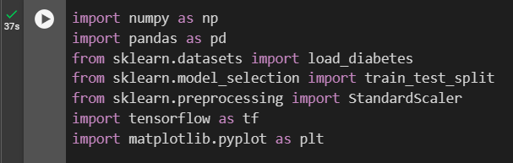

Figure 1: Import library

NumPy, abbreviated as np, is a library in Python that supports linear algebra operations, Fourier transformations, and other mathematical functions. Pandas, abbreviated as pd, is a library in Python that supports data analysis and processing.

Importing the Scikit-learn library: The load_diabetes function from the datasets module will download the diabetes dataset. The train_test_split function from the model_selection module is used to split the data into two sets: the training set and the test set. The StandardScaler class from the preprocessing module is used to normalize the data.

TensorFlow, abbreviated as tf, is an open-source library used for machine learning and deep learning. The pyplot module from the Matplotlib library, abbreviated as plt, provides an interactive graph drawing interface, similar to MATLAB.



Figure 2: Load data

This code loads the Diabetes dataset from the sklearn library and saves it into the variable data.



Figure 3: data properties

This code prints out the keys of the data object. These keys include: ‘data’, ‘target’, ‘frame’, ‘DESCR’, ‘feature_names’, ‘data_filename’, ‘target_filename’, ‘data_module’.

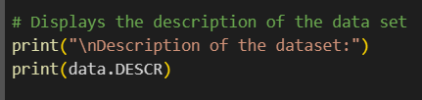

Figure 4: Description the dataset 1

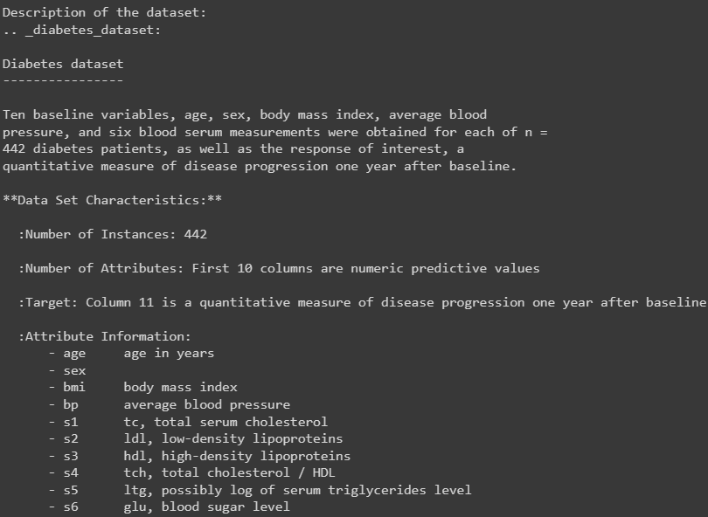

Figure 5:Description the dataset 2

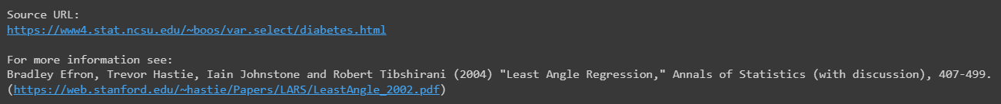

Figure 6: Source of Diabetes dataset

This line prints out a detailed description of the dataset, including the number of samples, the number of features, the origin of the dataset and so on.

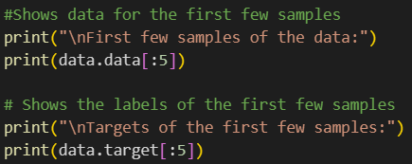

Figure 7: Show first 5 Target and samples 1

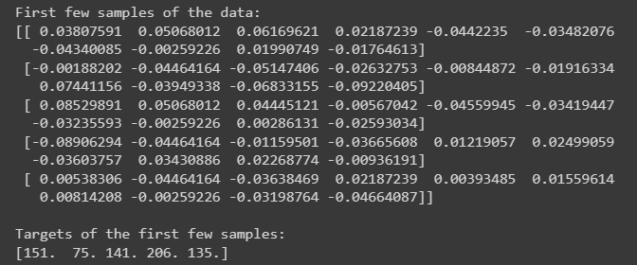

Figure 8: Show first 5 Target and samples 2

The above code prints out the input data of the first 5 samples in the dataset and prints out the Target of the first 5 samples in the dataset.

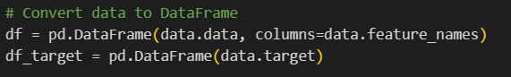

Figure 9: Convert data to DataFrame

The code segment converts the input data and labels from the dataset into pandas DataFrames for easier manipulation and analysis. df contains the data and df_target contains the Target.

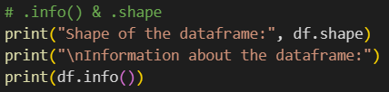

Figure 10: info and shape

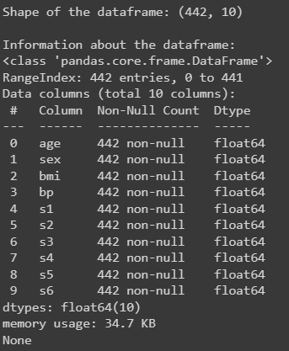

Figure 11: info and shape

This line prints out the size of the DataFrame (number of samples and number of features) and detailed information about the DataFrame such as the data type of the columns, the number of non-null values, etc.

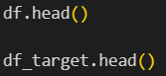

Figure 12: Print first 5 Target and samples (DataFrame) 1

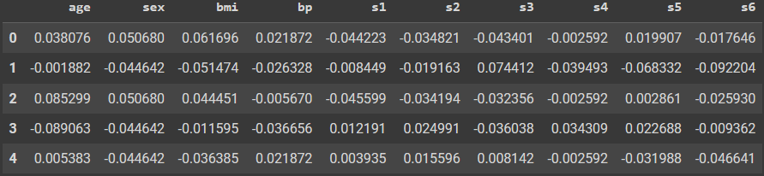

Figure 13: Print first 5 Target and samples (DataFrame) 2



Figure 14: Print first 5 Target and samples (DataFrame) 3

This line prints out the first 5 samples of the Data and Targets.

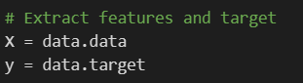

Figure 15: Extract features and target

This line extracts the Data and Targets from the dataset and saves them into X and y.



Figure 16: Split data into train and test sets

This line splits the data into two sets: the training set (80% of the data) and the test set (20% of the data). random_state=42 ensures that the split is performed in the same way each time the code is run, which helps to reproduce the results.

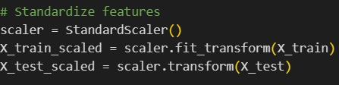

Figure 17: Standardize features

This code normalizes the data using StandardScaler from sklearn. This ensures that all features have a mean value of 0 and a standard deviation of 1, which helps many machine learning algorithms perform better.

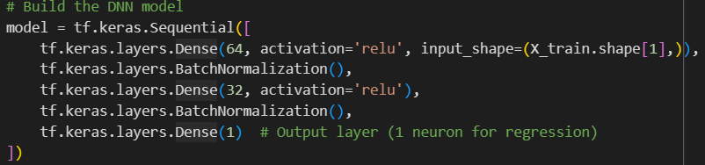

Figure 18: DNN model with Batch Normalization

The Sequential Deep Neural Network (DNN) model is initialized using the Keras library in TensorFlow. A Dense layer is added to the model with 64 neurons and the ReLU activation function. The size of the input data, in this case, the number of features in the training dataset, is determined by input_shape=(X_train.shape[1],).

Next, a Batch Normalization layer is added to the model. This layer normalizes the output of the previous layer to have a mean value of 0 and a standard deviation of 1, which helps to speed up learning and improve the performance of the model.

Then, another Dense layer with 32 neurons and the ReLU activation function is added to the model, followed by another Batch Normalization layer.

Finally, a Dense layer with 1 neuron is added, serving as the output layer of the model. In this case, the model is used for a regression problem so only 1 neuron is needed in the output layer.

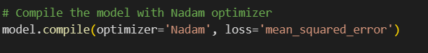

Figure 19: Nadam

the model using the Nadam optimizer and the loss function is mean squared error. The Nadam optimizer is a variant of Adam, it combines the benefits of Adam and Nesterov accelerated gradient. Mean squared error is a common loss function for regression problems.



Figure 20: Early stopping 1

A callback for early stopping. If the model does not improve after 10 epochs (defined by patience=10), the training process will stop. restore_best_weights=True ensures that the model will restore the best weights from the training process.

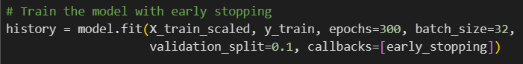

Figure 21: Early stopping 2

This code trains the model with the normalized data. The model will be trained for a maximum of 300 epochs, with a batch size of 32. validation_split=0.1 means that 10% of the training data will be used as the validation set. The early_stopping callback is used during training to stop early if the model does not improve.

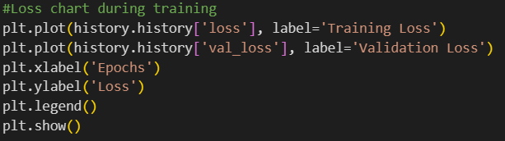

Figure 22: Chart

First, a graph is drawn to represent the loss value on the training set after each epoch. The list of loss values after each epoch is stored in history.history['loss'].

Next, another graph is drawn to represent the loss value on the validation set after each epoch. The list of validation loss values after each epoch is stored in history.history['val_loss'].

The x-axis of the graph is labeled ‘Epochs’ and the y-axis is ‘Loss’. A legend for the graph is displayed, helping to distinguish between ‘Training Loss’ and ‘Validation Loss’.

Finally, the drawn graph is displayed. This is a way to visualize the learning process of the model, making it easy to monitor and evaluate the performance of the model over each epoch.

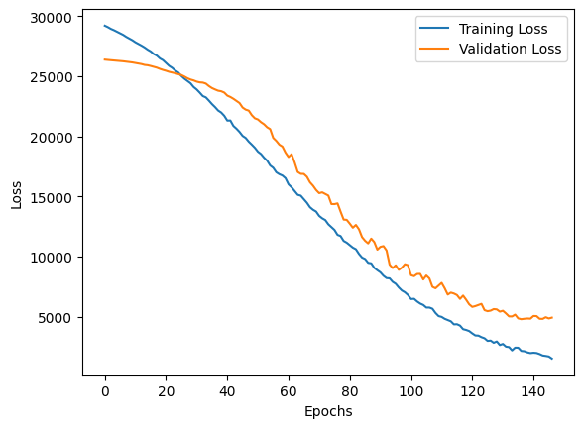

Figure 23: Result of DNN and Batch Normalization

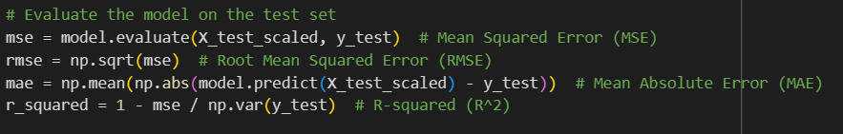

Figure 24: test set

The model is evaluated on the test set using Mean Squared Error (MSE), which is the average of the squared differences between the predicted and actual values. Root Mean Squared Error (RMSE) is calculated by taking the square root of MSE, providing a measure of prediction error that can be directly compared with the target values.

Next, Mean Absolute Error (MAE), MAE is the average of the absolute differences between the predicted and actual values. Finally, the coefficient of determination R-squared (R^2), R^2 is the ratio between the total variance explained by the model and the total variance in the data. These are important parameters for evaluating the performance of a machine learning model.

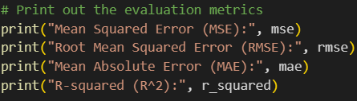

Figure 25: Print MSE, RMSE, MAE, R^2

Print out the model evaluation metrics: MSE, RMSE, MAE, and R^2.



Figure 26: Save model

Save the trained model to an HDF5 file named “diabetes_model.h5”. HDF5 is a popular file format for storing machine learning models.



Figure 27: Load model

Load the saved model from the file “diabetes_model.h5” and assign it to the variable loaded_model.

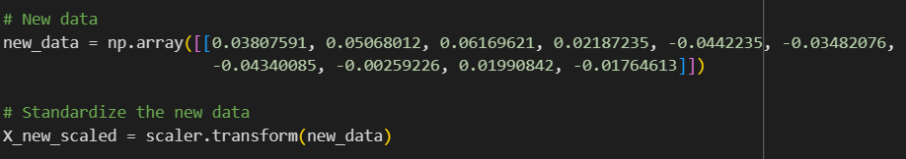

Figure 28: New data

Create a new numpy array containing data to test the results.

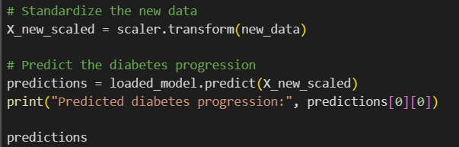

Figure 29: Format new data

Normalize the new data using the scaler that was previously fit with the training data. Use the loaded model to predict the progression of diabetes from the newly normalized data. The prediction results are printed out with Predictions.

**Evaluate the chart:**

The chart (Figure 22) depicts the change in training loss (blue) and validation loss (orange) over epochs. Both lines decrease as the number of epochs increases, indicating that the model is learning effectively. However, it’s important to note that if the validation loss begins to increase while the training loss continues to decrease, this could be a sign of overfitting.

**Evaluate the Reasult:**

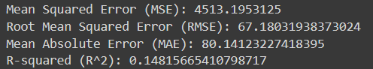

Figure 30: MSE, RMSE, MAE, R^2 of DNN and Batch Normalization

* Mean Squared Error (MSE): The MSE, which stands at 4513.1953125, is a statistical metric that calculates the average of the squared discrepancies between the predicted and actual values. The substantial magnitude of this value signifies a considerable error in the model’s predictions.
* Root Mean Squared Error (RMSE): The RMSE, valued at 67.18031938373024, is the square root of the MSE and serves as a measure of the average error magnitude. Its utility stems from its unit being identical to the initial values, rendering it more interpretable than the MSE. The elevated RMSE value implies that the model might lack the requisite power for accurate predictions.
* Mean Absolute Error (MAE): The MAE, with a value of 80.14123227413895, is the mean of the absolute differences between the predicted and actual values. It quantifies the average magnitude of the errors in a set of predictions, irrespective of their direction. The high MAE value suggests that the model might not possess sufficient power for accurate predictions.
* R-squared (R^2): 0.14815665410798717: The R-squared value, also known as the coefficient of determination, is a statistical measure that represents the proportion of the variance for a dependent variable that's explained by an independent variable or variables in a regression model. The low R-squared value ranges from 0 to 1, so it can be seen that applying this model to train the Diabetes dataset is not appropriate.

# M1 Critically analyze the foundation of Artificial Intelligence and the key impact factors of AI in complexity environments

## 1 Advantages and Potential

**AI can indeed help increase productivity and efficiency in labor** by automating repetitive tasks, solving complex problems, optimizing processes and resources, improving product and service quality, analyzing data, predicting and advising, and supporting time management. This enhances the productivity and efficiency of business and production operations.

**Healthcare Sector:**

* Artificial Intelligence (AI) holds great potential in improving healthcare and enhancing the efficiency of healthcare systems. AI applications in this field include disease prediction and diagnosis, patient record management, treatment process optimization, and pharmaceutical research.
* With the ability to quickly and accurately analyze large amounts of medical data, AI helps healthcare professionals make more effective diagnosis and treatment decisions, improving the efficiency of doctors and healthcare staff.
* One of the most notable healthcare technologies is IBM Watson. It can understand natural languages and respond to requested questions. The system leverages patient data and other available data sources to generate hypotheses. It then presents a reliable briefing schema.
* Chatbots, online computer programs to answer questions and support customers, schedule appointments, or assist patients through payment processes, and virtual medical assistants provide basic healthcare feedback.

**Business and Manufacturing Sector**

* Automation processes using robots are applied to tasks that are repetitive in nature. Machine Learning algorithms are integrated into analytics and CRM platforms (Analytics Platform: This is a system or software environment designed to collect, store, process, and analyze data from various sources through tools and features to visualize data, perform qualitative and quantitative analyses, and generate reports and charts to support business decision-making. CRM (Customer Relationship Management): CRM is software or a system used to manage customer relationships, organizations collect, manage, and analyze information about customers, from personal information to purchase history and interactions with the business by managing customer lists, relationship management, automating business processes, and analyzing data to better understand customer behavior and predict trends) to uncover insights into how to better serve customers. Chatbots are integrated into websites to provide instant service to customers. This helps save businesses money while optimizing customer experiences.
* AI's predictive feature helps forecast production demand, optimize production schedules, and minimize waste.
* Enhanced automation in the manufacturing process, from controlling machinery systems to minimizing errors in product creation, predicting and managing maintenance, repair, intelligent supply chain management, thereby optimizing the production process.

**Marketing Sector**

* Media companies can utilize AI to analyze user data, then generate customized content based on the preferences and behaviors of each individual, from advertisements to social media content.
* AI is also integrated to produce diverse content, from writing articles to producing videos, helping save time and costs for media organizations.
* AI is also used in data analysis and trend prediction, helping media professionals gain a better understanding of their target audience and develop more effective marketing strategies.

**Banking and Finance Sector**

* AI systems have the ability to process large volumes of data from various sources, from market information to transaction history, enabling accurate predictions and rapid risk assessment.
* Banks are heavily adopting AI in electronic identification (eKYC) to verify identities.
* In the field of credit scoring and risk management, AI provides powerful tools to classify and assess customers, enabling financial organizations to make decisions with high accuracy and enhancing predictive capabilities.
* Automated customer support through chatbots, fraud detection, and complaint management.

**AI brings many benefits and potential in generating new creativity**. There are numerous applications in art, design, entertainment, and many other fields. AI in art has brought many benefits, opening the door to a new genre of art - AI art:

* AI can act as a creative support tool, providing information, ideas, and suggestions to humans to develop new ideas and explore their creative potential.
* AI can generate creative content such as music, images, text, and videos, creating diverse and rich content, from movies to comics and video games based on machine learning models and deep neural networks.
* Creating art becomes easier: AI has made the process of creating art easier for everyone, not just professional artists. By providing tools and platforms, AI allows ideas to be transformed into images or artworks. Like DALL-E, or the AI-generated artwork by Jason Allen that won the digital art competition at the Colorado State Fair.

**Artificial Intelligence (AI) technology has the potential to bring many benefits and opportunities in optimizing processes.** It can minimize costs, time, and resources for management and operations activities. It enhances efficiency, quality, and safety of products and services.

* AI can integrate with automation systems to create continuous and automated operational processes, minimizing human intervention and enhancing consistency.
* Detection and troubleshooting: AI can analyze data from processes and detect errors or potential issues, thereby improving the quality and accuracy of the process.
* Traffic monitoring support systems: With the assistance of Deep Learning algorithms and useful functions such as voice recognition and control, natural language processing, image recognition and processing, regulatory agencies can build a vast database of vehicle activities. At the same time, they greatly enhance their ability to monitor and manage their traffic systems.
* Unmanned Vehicles: Applying artificial intelligence to long-haul transportation can reduce costs and minimize fatal accidents. This has been clearly demonstrated in many car and motorcycle products from major companies worldwide. In 2019, Tesla introduced the Tesla Model S line with the ability to semi-autonomously control the vehicle, thanks to AI that can make predictions and decisions while in traffic.
* Building virtual assistants: Artificial intelligence helps virtual assistants become more flexible in handling requests by learning the habits of users and predicting emotions.

**Few virtual assistants in reality**

* Google's virtual assistant, Google Assistant, can understand multiple languages and support various smart features such as searching for information, performing tasks like opening contacts, making calls, reading messages, playing music, and even telling jokes.
* Virtual Assistant: VinFast's electric car is integrated with Vivi, a virtual assistant capable of understanding Vietnamese, assisting drivers in performing various hands-free tasks while driving.
* Search Tool: Coc Coc introduced 2 AI tools, Coc Coc AI Chat (similar to ChatGPT language assistant) and Coc Coc AI Search (quick summary of user queries' results by AI), with the advantage of understanding Vietnamese and reflecting Vietnamese cultural characteristics.
* A digital workspace or virtual assistant helps government officials handle large amounts of data requiring compliance with various regulations. Virtual assistants support government officials, detect legal document inconsistencies, provide legal assistance to citizens, and assist judges.

**The potential for AI development is huge with current trends in**:

* Generative AI technology, which can create unlimited new content in various forms such as images, text, music, or video automatically and has applications in various fields such as digital art, creativity, and product development.
* A significant impact of generative AI is its ability to change job structures and enhance individual labor capabilities through automating some tasks. Current generative AI can automate tasks that occupy 60-70% of each employee's working time.
* In terms of annual Gross Domestic Product (GDP) by country, the total value of generative AI is projected to be equivalent to the GDP of the third-largest country in 2022, following only the United States and China. It's important to note that this forecast by McKinsey & Company is only for business applications, meaning the value would be even larger if consumer applications were included.
* Large language models (like GPT) can be considered a specific form of Generative AI. With the explosion of ChatGPT and the latest generations of GPT, experts believe that Generative AI will continue to develop to provide more comprehensive responses to user questions and requests.
* Computer Vision: Computer vision technology utilizes artificial intelligence to recognize and analyze image information by converting it into digital signals and processing those signals. When installed, computer vision can be programmed to see through walls to recognize signatures and analyze images in healthcare.
* Control - Automation: Artificial intelligence is integrated into manufacturing technology in the industrial sector, where machines in production lines will be fully automated and AI will help handle large volumes of extremely accurate tasks.
* Robotics: This technology applies artificial intelligence AI to perform many high-difficulty tasks requiring meticulous and precise work, such as automobile manufacturing, assembly, or moving large objects in space.
* Auto Machine Learning (AutoML) is a field of artificial intelligence (AI) focused on automating the training and deployment process of machine learning models efficiently. The development of Auto Machine Learning, with two prominent areas being the automation of neural network structure editing and data labeling, will make AI technology applications cheaper and less time-consuming to bring to market.
* Predictive Analysis is an AI field aimed at making predictions about the future based on past data, statistical algorithms, and machine learning techniques.
* Integration of AI technology in Cybersecurity: In addition to protecting and storing data as it is today, with advanced analysis capabilities, in the future, AI technology can also help detect cyber attacks or suspicious trends.
* Expanding Natural Language Processing (NLP) capabilities: NLP technology helps computers understand, evaluate, and generate natural language significantly, opening up many opportunities for practical applications (customer consultation and support, automatic translation, information synthesis and summarization, etc.)

Computer vision involves the recognition and analysis of image information through artificial intelligence technology to convert it into digital signals and process those signals. When implemented, computer vision can be programmed to see through walls to recognize signatures and analyze images in healthcare.

## 2 Challenges and Risks

### 2.1 Ethics and Responsibility

**In terms of ethics:**

* AI can collect and analyze large amounts of personal data without the user's consent, creating systems that can manipulate user behavior, and AI replacing human jobs, leading to unemployment issues.
* AI can be exploited for malicious purposes, posing dangers to society and humanity, causing serious consequences for security, safety, rights, and human values if not well controlled and managed. For example, automated weapons systems, AI-integrated weapons such as unmanned aerial vehicles, autonomous missiles, etc., or devaluing traditional artworks when AI can create similar or better works.

**In terms of responsibility:**

* Some AI systems have complex and opaque operations, posing challenges in transparency and explaining their workings, especially in decisions with significant impacts.
* Difficulty in controlling, monitoring, and assessing the effectiveness of processes carried out by AI.
* AI often struggles to manage and accurately assess risks, leading to unintended consequences and ethical dilemmas.

**The challenges presented here are:**

* Ensuring Responsible AI (RAI) development by designing and deploying transparent, fair, accountable AI systems that adhere to ethical principles. This includes traceability (data, preprocessing steps, and accessible models), Context (purpose requiring accountability explanation), Scope (responsible entity), Open Communication (related to AI system limitations), Standards (criteria for accountability explanation), Process (method of explanation), Implications (consequences of accountability).
* Governance involves a set of rules, policies, and monitoring procedures for the development and deployment of AI systems.
* As AI systems become more prevalent, regulations are needed to consider ethical and societal values.

### 2.2 Privacy and Security.

Regarding privacy and security challenges associated with AI:

* Privacy infringement: AI systems often require large amounts of data for training and effective operation. AI can infringe on users' privacy by collecting, storing, analyzing, and sharing personal data without users' consent or control. Personal data used to create AI models can be breached by untrusted parties, leading to information abuse and privacy threats. For example, Clearview AI, a company producing facial recognition models for law enforcement agencies and universities, was fined £7.5 million by the UK's data watchdog for collecting images of UK residents from social media without consent to create a database of 20 billion images.
* Risk of copyright infringement, intellectual property ownership, and privacy when AI uses existing data and processes to generate new processes.
* Data security risks: Personal and sensitive data used to train and operate AI systems can become targets of cyberattacks, posing risks of loss or exposure of crucial information.
* Impersonation attacks and security risks: AI systems can be easily attacked through impersonation or fraud, especially in identification or authentication applications. An example of a security threat to AI is adversarial attacks, which deceive machine learning (ML) and artificial intelligence (AI) models into making incorrect decisions.
* AI increases the risk of identity theft: According to Symantec's report, identity theft cases surged by 60% in 2020, reaching 1.1 million incidents. AI is believed to be a major factor driving this type of crime increase by helping generate highly realistic fake messages, emails, or calls, bypassing users, or by recognizing faces and tracking individuals' movements without consent.
* AI poses challenges to online anonymity: AI can analyze user behavior to identify their real identity, even when they use anonymous accounts. With minimal contextual information, AI can link a person's online activities and detect their true identity. According to statistics on the Anonymity website, with just 3-4 pieces of information such as age, gender, location..., AI has a high probability of revealing the identity of anonymous users.

The challenges of AI in terms of privacy and security are: how to ensure that AI complies with regulations and standards for personal data protection, such as GDPR or Vietnam's Personal Data Protection Law. Preventing AI from being hacked, stolen, exploited, or manipulated by malicious actors, which can lead to cyberattacks, data breaches, fraud, or military attacks. Identifying and addressing privacy, copyright, intellectual property ownership issues when AI uses data and generates content.

### 2.3 Artificial Intelligence bias.

The risks of AI bias include:

* AI systems can make biased or discriminatory decisions based on characteristics such as gender, race, or geography, leading to issues of fairness and ethics. For example, AI may be used to create recruitment systems that exhibit bias against women or minorities. Human biases related to age, gender, nationality, and race can influence data collection, potentially leading to biased AI models.
* Reinforcing and perpetuating prejudices: AI can automate or reinforce inaccurate prejudices and perceptions, especially if the training data contains these biases.
* Eroding user trust: If users or communities feel that AI systems are biased, they may lose trust and refuse to use them.

The challenge of AI bias is how to detect, measure, and mitigate bias and discrimination issues in data, algorithms, and AI decisions. Ensuring that AI complies with regulations and standards regarding fairness, transparency, and responsibility.

# M2 Replace Batch Normalization with SELU and try regularizing the model with alpha dropout

## Building a DNN model

Base on building a DNN model and optimizing that DNN model using Nadam optimization, early stopping, and batch normalization.

I will also build the DNN model and optimize the DNN model but I will Replace Batch Normalization with SELU and try regularizing the model with alpha dropout.

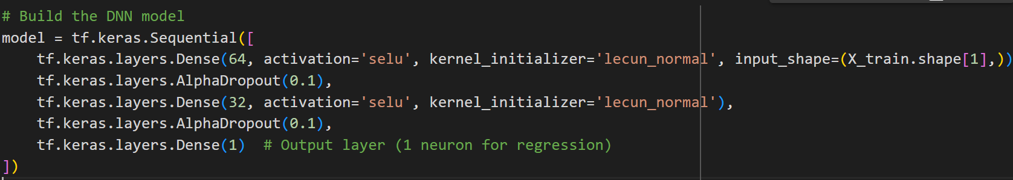

Figure 31: DNN model with Alpha dropout 1

Certainly! Let's break down each line of code and provide detailed comments:

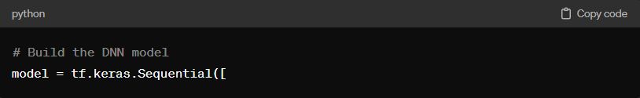

Figure 32: DNN model with Alpha dropout 2

Here, we start by defining a Sequential model. The Sequential model is a linear stack of layers, where each layer has exactly one input tensor and one output tensor. We are going to define our layers sequentially.

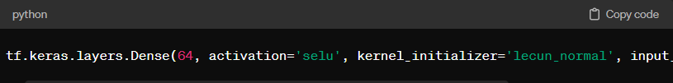

Figure 33: DNN model with Alpha dropout 3

This line adds a fully connected (Dense) layer to the model with 64 units. The activation function used here is SELU (Scaled Exponential Linear Unit), which helps combat the vanishing/exploding gradient problem. The kernel_initializer parameter is set to 'lecun_normal', which initializes the layer's weights using the LeCun normal initializer. Since this is the first layer in the model, we also specify the input_shape, which corresponds to the number of features in the input data.



Figure 34: DNN model with Alpha dropout 4

After the first Dense layer, we apply Alpha Dropout regularization with a rate of 0.1. Alpha Dropout is a type of dropout regularization specifically designed for SELU activations. It helps in preventing overfitting by randomly setting a fraction of input units to zero during training, thus forcing the network to learn more robust features.

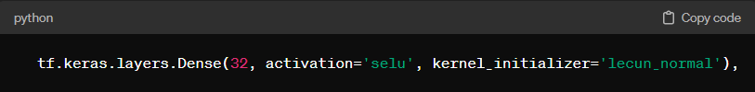

Figure 35: DNN model with Alpha dropout 5

Next, we add another Dense layer with 32 units, using the SELU activation function and LeCun normal weight initialization.



Figure 36: DNN model with Alpha dropout 6

Similar To before, we apply Alpha Dropout with a rate of 0.1 after this Dense layer for regularization purposes.

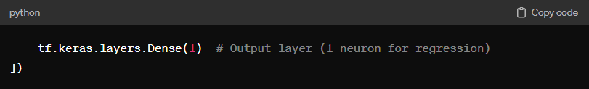

Figure 37: DNN model with Alpha dropout 7

Finally, we add the output layer, which consists of a single neuron since this is a regression problem (predicting a continuous value). No activation function is specified for the output layer, which means it will use a linear activation function by default. This layer will output the predicted target value.

After I built the DNN Model of P2 and M2. I was able to comment that the main difference between the two code snippets is the way the model is built and the activation function is used. Here are some comparison points:

* **SELU activation function:** In the second code snippet, I use the SELU (Scaled Exponential Linear Unit) activation function instead of ReLU in the hidden layers of the model. SELU has automation capabilities, which can lead to faster and more efficient condenser geometry work in some cases with ReLU.
* **Alpha Dropout**: In the second code snippet, I use the Alpha Dropout class instead of the regular Dropout. AlphaDropout is designed to work well with SELU triggers and can improve model performance.
* **Lecun Normal initializer**: At the same time, I also use the Lecun Normal initializer to select the number of layers in the second configuration. This initializer is designed to work well with the SELU trigger function.

These changes can lead to better improvements in faster convergence and creating a better model. However, the final result will depend on many different factors such as the structure of the data, the size of the model, and even the lack of the initial key initialization.

## Evaluate the chart and model results

**Evaluate the chart:**

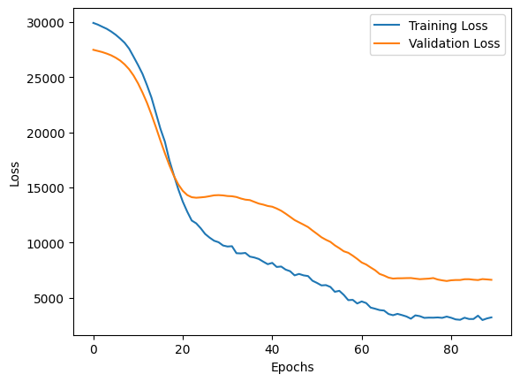

Figure 38: Result of DNN and Alpha dropout

The chart displaying the variation of loss function (loss) on both the training and validation sets across epochs is a useful tool to evaluate the model's performance. Here are some points to consider when interpreting this chart:

1. **Model learning:** If the loss on both the training and validation sets decreases steadily over time (epochs), it indicates that the model is learning effectively from the data.
2. **Overfitting:** If the training loss decreases but the validation loss increases after a certain number of epochs, the model might be starting to overfit. This suggests that the model has learned "too much" from the training data and cannot generalize well to new data.
3. **Underfitting**: If both the training and validation losses are high and do not decrease over time, it may indicate that the model is too simple and cannot capture the complex structure in the data.
4. **Loss fluctuations:** If the loss fluctuates significantly and is unstable across epochs, it suggests that the model may have trouble learning from the data.

In your case, if both the training and validation losses are decreasing and there are no signs of overfitting (validation loss does not increase), it indicates that your model is learning effectively and generalizing well to new data.

**Result evaluation**

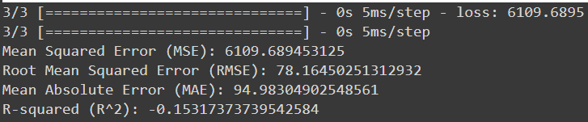

Figure 39: MSE, RMSE, MAE, R^2 of DNN and Alpha dropout

Based on the evaluation results, the current model does not perform well in predicting the progression of diabetes. This is reflected through the error metrics such as Mean Squared Error (MSE), Root Mean Squared Error (RMSE), and Mean Absolute Error (MAE), along with the R-squared (R^2) value.

1. **Mean Squared Error (MSE):** MSE measures the average squared difference between the predicted and actual values. In this case, the MSE value is 6109.69, indicating a significant difference between the predictions and the actual values.
2. **Root Mean Squared Error (RMSE):** RMSE is the square root of MSE and represents the magnitude of the error. The RMSE is 78.16, suggesting a considerable difference between the predicted and actual values.
3. **Mean Absolute Error (MAE):** MAE measures the average absolute difference between the predicted and actual values. The MAE is 94.98, indicating a substantial deviation between the predictions and the actual values.
4. **R-squared (R^2):** R^2 measures the proportion of the variance in the target variable that is predictable from the independent variables. In this case, the R^2 value is -0.15, which is negative, indicating that the model cannot explain much of the variance in the target variable and even performs worse than simply using the mean value.

Based on these results, it's essential to reconsider the modeling strategy and data preprocessing. It may be necessary to experiment with different preprocessing methods, select more suitable feature variables, or try different neural network architectures to improve the model's performance.

# D1 Consider the theory of AI; develop a DNN model and the direction to improve accuracy.

There are many ways to have a DNN model develop and improve accuracy, but before I build such a DNN model, I'll go over certain techniques for optimization:

**Architecture Changes:**

* Change the number and size of layers: Experiment with different neural network architectures by adding or removing layers and adjusting their sizes.
* Reusable Neural Network Architecture: Use reusable neural network architectures such as ResNet or Inception to enhance model learning.

**Training Techniques:**

* Early Stopping: Use early stopping to stop the training process when there is no significant improvement in performance on the validation set.
* Learning Rate Schedules: Use learning rate schedules to adjust learning rate over time.
* Data Augmentation: Expands data by applying transformations such as rotation, zoom in, zoom out, or cropping.

**Normalization:**

* Batch Normalization: Add a batch normalization layer to the model to balance the output of each layer and increase learning speed.
* Layer Normalization: Experiment with layer normalization to normalize the output of each individual layer.

**Regularization:**

* L1 and L2 Regularization: Apply L1 and L2 regularization to minimize overgeneralization and increase generalization.
* Dropout: Use the dropout class to drop some random neuron units during training.

There are many ways to have a highly developed and highly accurate DNN model. But remember that improving accuracy is an iterative process that requires experimentation, expertise, and understanding of the problem you are trying to solve. Track your experiments, learn from both successes and failures, and continuously strive to improve.

## Building a DNN model

After introducing some techniques, I will apply them to the DNN model of M2 to develop and improve its accuracy. Here's how to build the DNN model that I improved:

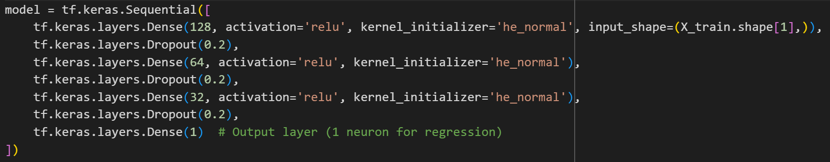

Figure 40: DNN model with Dropout 1

Below I will provide a more detailed analysis of each line:

**Initialize Sequential Model**

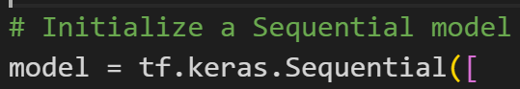

Figure 41: DNN model with Dropout 2

This line initializes a sequential model using TensorFlow's Keras API. The sequential model allows you to build models layer-by-layer in a linear stack.

**Add First Dense Layer**



Figure 42: DNN model with Dropout 2

This line adds a dense (fully connected) layer to the model with 128 neurons. The activation='relu' argument sets the Rectified Linear Unit (ReLU) activation function for this layer, which introduces non-linearity into the model. The kernel_initializer='he_normal' argument specifies the He normal initializer for initializing the weights of this layer. The input_shape=(X_train.shape[1],) argument sets the input shape of the data to match the number of features in the training data.

**Add First Dropout Layer**



Figure 43: DNN model with Dropout 3

This line adds a dropout layer to the model with a dropout rate of 0.2. Dropout is a regularization technique that randomly sets a fraction of input units to 0 during training to prevent overfitting.

* + - **Add Second Dense Layer:**



Figure 44: DNN model with Dropout 4

This line adds another dense layer to the model with 64 neurons. Similar to the first dense layer, it uses the ReLU activation function and He normal initializer.

**Add Second Dropout Layer:**

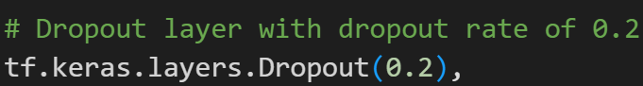

Figure 45: DNN model with Dropout 5

This line adds another dropout layer with the same dropout rate of 0.2 after the second dense layer.

**Add Third Dense Layer**



Figure 46: DNN model with Dropout 6

This line adds a third dense layer to the model with 32 neurons, again using ReLU activation and He normal initializer.

**Add Third Dropout Layer**

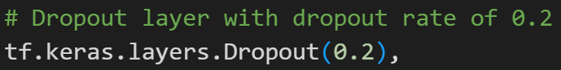

Figure 47: DNN model with Dropout 7

This line adds another dropout layer after the third dense layer.

**Add Final Dense Layer**



Figure 48: DNN model with Dropout 8

This line adds the output layer to the model with a single neuron, which is typical for regression tasks where the model predicts a continuous value. Since no activation function is specified, it defaults to a linear activation (identity function).

## Techniques and skills used to develop DNN models and directions for improving accuracy

1. **Sequential Model Architecture:** Using Sequential model architecture allows building DNN models in a linear fashion, each layer is added in order from start to finish.
2. **Dense Layers:** Use Dense layers to create fully connected layers in the model. These layers help learn complex relationships between input features and desired output.
3. **Activation Functions (ReLU):** Use the ReLU (Rectified Linear Unit) activation function in hidden layers to help the model learn non-linear features and avoid the vanishing gradient problem.
4. **Weight Initialization (He Normal):** Using the He normal weight initialization method helps initialize the network's weights to be uniform and minimize the problem of gradient vanishing or exploding.
5. **Dropout Regularization:** Using dropout layers with a dropout rate of 0.2 helps prevent model overfitting by randomly removing some units during training.
6. **Optimizer (Nadam):** Use Nadam optimizer (combination of Adam optimizer and Nesterov Accelerated Gradient) to optimize the loss function. Nadam often works well in training deep neural networks.
7. **Mean Squared Error Loss Function:** Use the mean squared error (MSE) loss function for the regression problem. MSE is a popular and suitable choice to evaluate the deviation between predicted and actual values.
8. **Early Stopping:** Use the EarlyStopping callback to track model improvement on the validation set and stop the training process when there is no improvement within a certain number of tests (patience). This helps avoid overfitting and minimizes training time.
9. **Batch Size and Epochs:** Set the batch size to 32 and the number of epochs to 700. Batch size determines the number of samples used in each weight update, while the number of epochs determines the number of times the entire dataset is used to train the model.

In summary, this code snippet constructs a deep neural network model with three hidden dense layers, each followed by a dropout layer for regularization, and an output layer for regression tasks. The ReLU activation function introduces non-linearity, and the He normal initializer is utilized to initialize the weights effectively. Dropout layers are added to prevent overfitting by randomly dropping a fraction of input units during training. These techniques collectively create an effective DNN model with improved architecture and overfitting control during the training process.

## Evaluate the chart and model results

**Evaluate the chart:**

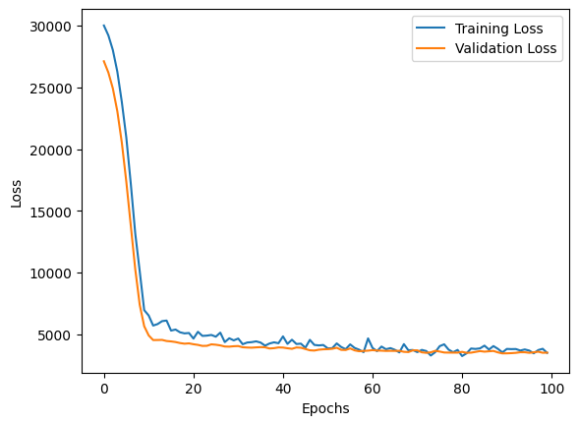

Figure 49: Result of DNN and Dropout

Based on this chart, it can be seen that the chart is showing a common pattern when training a learning machine

1. **Significant decrease in both training and validation loss in the early stages:** This typically occurs as the model learns from the data and improves its accuracy.
2. **Validation loss starts to stabilize after about 20 epochs:** This often happens when the model transitions from learning general information (generalization) from the data to learning specific information (features) from the data. When the validation loss stabilizes, it may indicate that the model is no longer improving its performance significantly on the validation set.
3. **Training loss continues to decrease gradually but no longer decreases significantly:** This can occur when the model has reached an optimal level of complexity or has learned all the generalization capabilities from the training data.

Based on chart, it seems like your model has reached a point of convergence and is no longer improving significantly in performance on the validation set. However, the final assessment of your model's accuracy depends on the specific conditions of your problem and its requirements.

**Result evaluation**

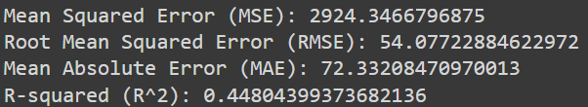

Figure 50: MSE, RMSE, MAE, R^2 of DNN and Dropout

Based on the evaluation results of the model:

* **Mean Squared Error (MSE):** The MSE is approximately 2924.35. This indicates that the average squared difference between predictions and actual values is relatively low, suggesting the model's predictions are reasonably accurate.
* **Root Mean Squared Error (RMSE):** The RMSE is around 54.08. A low RMSE indicates a high level of accuracy in predicting the actual values.
* **Mean Absolute Error (MAE):** The MAE is approximately 72.33. This implies that the average absolute difference between predictions and actual values is relatively small, indicating the model's predictions are quite accurate.
* **R-squared (R^2):** The R^2 value is about 0.45, suggesting that the model explains approximately 45% of the variance in the target variable. This is considered acceptable for a regression model.

Overall, the model demonstrates relatively good performance in predicting the target variable and explaining a portion of the data variance.

## Compare new result and previous result

To see the improvement and development of this DNN model, I will compare this result with the results of M1's model and draw the best conclusion

**Mean Squared Error (MSE):**

* Previous result: Around 6109.69
* New result: Around 2924.35
* Comparison: MSE doubled from the previous result, indicating a significant increase in the discrepancy between predictions and actual values.

**Root Mean Squared Error (RMSE):**

* Previous result: Around 78.16
* New result: Around 54.08
* Comparison: RMSE increased significantly, indicating a higher level of inaccuracy in the model's predictions of actual values.

**Mean Absolute Error (MAE):**

* Previous result: Around 94.98
* New result: Around 72.33
* Comparison: MAE increased, suggesting a larger discrepancy between predictions and actual values.

**R-squared (R^2):**

* Previous result: Around -0.15
* New result: Around 0.45
* Comparison: R^2 decreased to negative, indicating that the model fails to explain a significant portion of the variance in the target variable.

In summary, compared with the previous M1 results, the D1 results show that the prediction performance of M1 is significantly worse and the explanatory power of the model is weaker. At the same time, comparing the two charts, we can see more clearly their bias and stability. From there, we can conclude that this new chart is truly the development of the DNN model and the best direction to improve accuracy.

# Conclusion

This paper has discussed the fundamentals of artificial intelligence (AI) and intelligent systems, using the Python programming language and the TensorFlow library. The report has covered the following aspects: the theoretical background of AI, including its definition, evolution, benefits, applications, and primary technologies. The DNN model building and optimization process, using different techniques such as Nadam optimization, early stopping, batch normalization, SELU activation, and alpha dropout. The critical analysis of the foundation and impact of AI in complex environments, including the advantages and potential, as well as the challenges and risks, of AI in various fields and sectors. The paper has shown that AI is a rapidly evolving and influential field, with many opportunities and challenges for society and industry. The report has also demonstrated the use of Python and TensorFlow to create and improve a DNN model for a regression problem, using the diabetes dataset. The report has evaluated the performance of the model using various metrics and graphs, and suggested some possible ways to further enhance the model’s accuracy. The report has concluded that AI is a fascinating and important topic, and that Python and TensorFlow are powerful and useful tools for developing AI.

# Critical Evaluation

Through this paper, it has helped my team gain more useful knowledge and gain a deeper understanding of the importance of data analysis. Furthermore, it also helps my team improve their teamwork skills and see the group's strengths and weaknesses. The team's strengths in this essay are its excellent teamwork and effective organization. Each team member contributes ideas and works together to achieve common goals. Task assignment is done fairly and wisely, helping everyone complete work as planned and on time. However, the team's weakness may be its lack of creativity in coming up with new solutions to problems. Too often, teams can fall into repeating old ideas without offering new perspectives. This can limit the ability to create creative and groundbreaking solutions, making it impossible for the essay to stand out among other works. To overcome this, the team may need to encourage each member to foster creativity and explore new ideas as they work. This paper still has some limitations regarding the R^2 index, which only ranges from 0.148 to 0.448, causing a significant discrepancy in the output results. During the implementation of this paper, our team always sought other methods to help the model achieve a higher and more stable R^2 index. The training process was limited in using the DNN model, so we could not introduce other models to produce results. In the following papers, our team will explore more models combined with more algorithms to improve the reliability of the model. Finally, with the content that has been implemented, our team has met the conditions to achieve a D grade.

# References

Adsplus.vn, 2023. *Đạo đức của AI: Những thách thức và giải pháp.* [Online]   
Available at: https://adsplus.vn/blog/dao-duc-cua-ai  
[Accessed 28 2 2024].

AZnet, 2023. *Vấn đề bảo mật và quyền riêng tư trong thời đại AI.* [Online]   
Available at: https://tritue.ai.vn/van-de-bao-mat-va-quyen-rieng-tu-trong-thoi-dai-ai.html  
[Accessed 28 2 2024].

GS Trần Thọ Đạt, Nguyễn Thị Thùy Dương (Trường Đại học Kinh tế Quốc dân), 2024. *AI sáng tạo ở Việt Nam và tiềm năng kinh tế.* [Online]   
Available at: https://cafef.vn/ai-sang-tao-o-viet-nam-va-tiem-nang-kinh-te-188240123130439532.chn  
[Accessed 28 2 2024].

họa, B. m. T. k. đ., 2023. *Cuộc cách mạng AI trong sáng tạo nghệ thuật mang đến nhiều tiềm năng và những cuộc tranh cãi.* [Online]   
Available at: https://caodang.fpt.edu.vn/tin-tuc-poly/tp-ho-chi-minh-tin-sinh-vien/cuoc-cach-mang-ai-trong-sang-tao-nghe-thuat-mang-den-nhieu-tiem-nang-va-nhung-cuoc-tranh-cai.html  
[Accessed 2024 2 28].

IDC, V., 2021. *Trí tuệ nhân tạo AI và tiềm năng ứng dụng đa lĩnh vực năm 2021.* [Online]   
Available at: https://viettelidc.com.vn/tin-tuc/tri-tue-nhan-tao-ai-va-tiem-nang-ung-dung-da-linh-vuc-nam-2021  
[Accessed 2024 2 28].

Khanh, L., 2023. *Ứng dụng công nghệ AI: Cơ hội và rủi ro nào cho doanh nghiệp?.* [Online]   
Available at: https://itviec.com/blog/ung-dung-cong-nghe-ai-co-hoi-va-rui-ro-nao-cho-doanh-nghiep/  
[Accessed 28 2 2024].

Laskowski, N., 2023. *artificial intelligence (AI).* [Online]   
Available at: https://www.techtarget.com/searchenterpriseai/definition/AI-Artificial-Intelligence  
[Accessed 1 3 2024].

MONA.Media, 2023. *AI là gì? Tiềm năng của trí tuệ nhân tạo ở tương lai.* [Online]   
Available at: https://mona.media/ai-la-gi/  
[Accessed 28 2 2024].

Sajid, H., 2023. *AI có trách nhiệm là gì? Nguyên tắc, thách thức và lợi ích.* [Online]   
Available at: https://www.unite.ai/vi/nguy%C3%AAn-t%E1%BA%AFc-ai-c%C3%B3-tr%C3%A1ch-nhi%E1%BB%87m-th%C3%A1ch-th%E1%BB%A9c-l%E1%BB%A3i-%C3%ADch/  
[Accessed 28 2 2024].

Tâm, N., 2024. *AI là gì? Từ A đến Z thông tin về công nghệ AI (2024).* [Online]   
Available at: https://bepos.io/blogs/tri-tue-nhan-tao-ai-la-gi/  
[Accessed 2024 2 28].