

Requirement & Design Specification

**Quan Ly Nhan Su**

**Version: 1.0**

– Hanoi, November 2024 –

# 

Contents

Record of Changes 2

I. Overview 4

1. User Requirements 4

1.1 Actors 4

1.2 Use Cases 4

2. Overall Functionalities 5

2.1 Screens Flow 5

2.2 Screen Descriptions 5

2.3 Screen Authorization 5

2.4 Non-UI Functions 6

3. System High Level Design 6

3.1 Database Design 6

3.2 Code Packages 7

II. Requirement Specifications 8

1. <<Feature Name>> 8

1.1 <<UseCaseCode_UC Name>> 8

2. Common Functions 11

2.1 UC-2_Login System 11

3. Patron Feature 12

3.1 UC-5_Order a Meal 12

3.2 UC-6_Register for Payroll Deduction 13

III. Design Specifications 14

1. <<Feature Name>> 14

1.1 <<SubFeature Name>> 14

1.2 System Access 15

IV. Appendix 19

1. Assumptions & Dependencies 19

2. Limitations & Exclusions 19

3. Business Rules 19

4. .. 19

# I. Overview

## 1. User Requirements

### 1.1 Actors

| **#** | **Actor** | **Description** |
| --- | --- | --- |
| 1 | Employee | Company’s Employees |
| 2 | Manager | They are the users who manage the employees in their department. |
| 3 | Admin | They are the users who manage all employees and departments. |

### 1.2 Use Cases

#### a. Use-case diagram

#### 

#### b. Descriptions

*This part describes the use cases, you can follow the table form as below]*

| **ID** | **Feature** | **Use Case** | **Use Case Description** |
| --- | --- | --- | --- |
| 01 | Common | Login | Allow user login to system |
| 02 | Forgot Password | Allow user to reset password when they forgot them |
| 03 | View profile | User can see their profile |
| 04 | UpdateProfile | User can change their profile |
| 05 | Log out | Allow user to log out of their account |
| 06 | Manager function | View list of employees in department | Display a list of all employees within the manager's assigned department. |
| 07 | View employee details | Allow the manager to see detailed information about an individual employee. |
| 08 | Add rewards and punish for employees | Enable the manager to reward or penalize employees based on performance or behavior. |
| 09 | Update rewards and punish for employees | Allow the manager to edit or adjust previously assigned rewards or penalties. |
| 10 | Delete rewards and punish for employees | Permit the manager to remove specific rewards or penalties from an employee's record. |
| 11 | view employee attendance record | Provide the manager access to attendance logs and records for employees. |
| 12 | Admin function | View holiday list | Display a list of holidays relevant to the manager’s department or organization. |
| 13 | Add holidays | Allow the manager to create new holiday entries for employees. |
| 14 | Update holidays | Enable the manager to modify existing holiday details. |
| 15 | Delete holidays | Permit the manager to remove holiday entries from the system. |
| 16 | View list department | Display a list of all departments within the organization. |
| 17 | Add department | Allow the admin to create new departments in the system. |
| 18 | Update department information | Enable the admin to edit details of existing departments. |
| 19 | Delete department | Permit the admin to remove departments from the system. |
| 20 | View list employees | Display a comprehensive list of all employees in the organization. |
| 21 | Create employee account | Allow the admin to create new user accounts for employees. |
| 22 | Update employee information | Enable the admin to modify details of existing employee records. |
| 23 | Ban employee account | Permit the admin to deactivate or block an employee's account from accessing the system. |

## 2. Overall Functionalities

### 2.1 Screens Flow

a, total screen

#### 

b .Employee screen flow

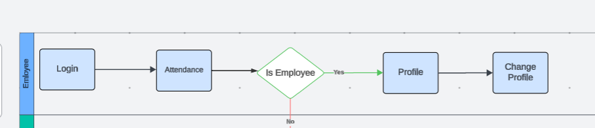

c, Manager screen flow

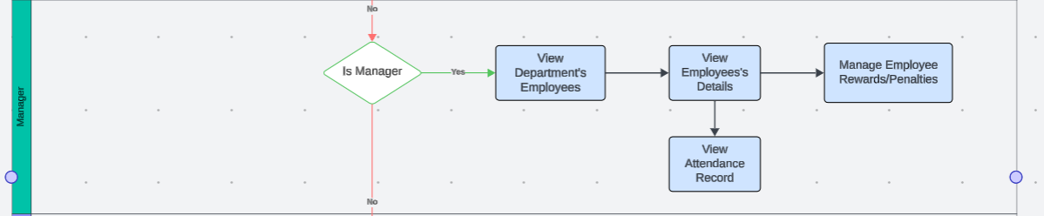

d,Admin screen flow

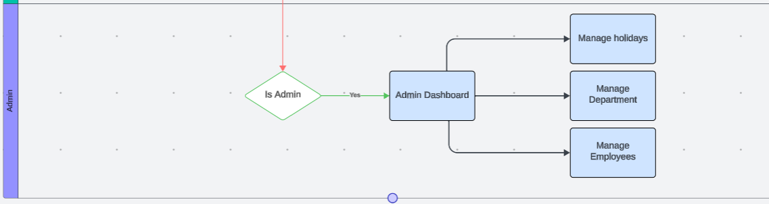

## 3. Sequence Diagram

### 3.1 Employee Sequence

*[Provide the tables relationship like example below]*

#### a. Sequence Design

#### b. Sequence Descriptions

### 

### 3.2 Manager Sequence

#### a. Sequence Design

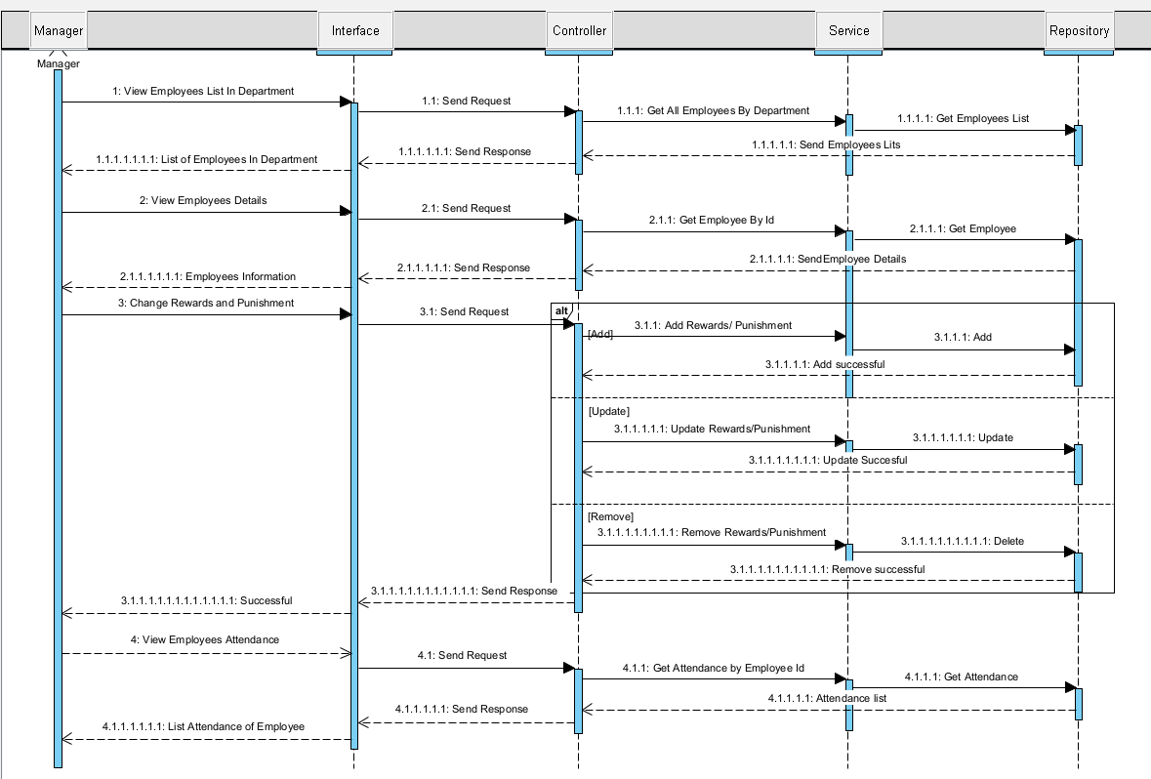

#### b. Sequence Descriptions

### 3.3 Admin Sequence

#### a. Sequence Design

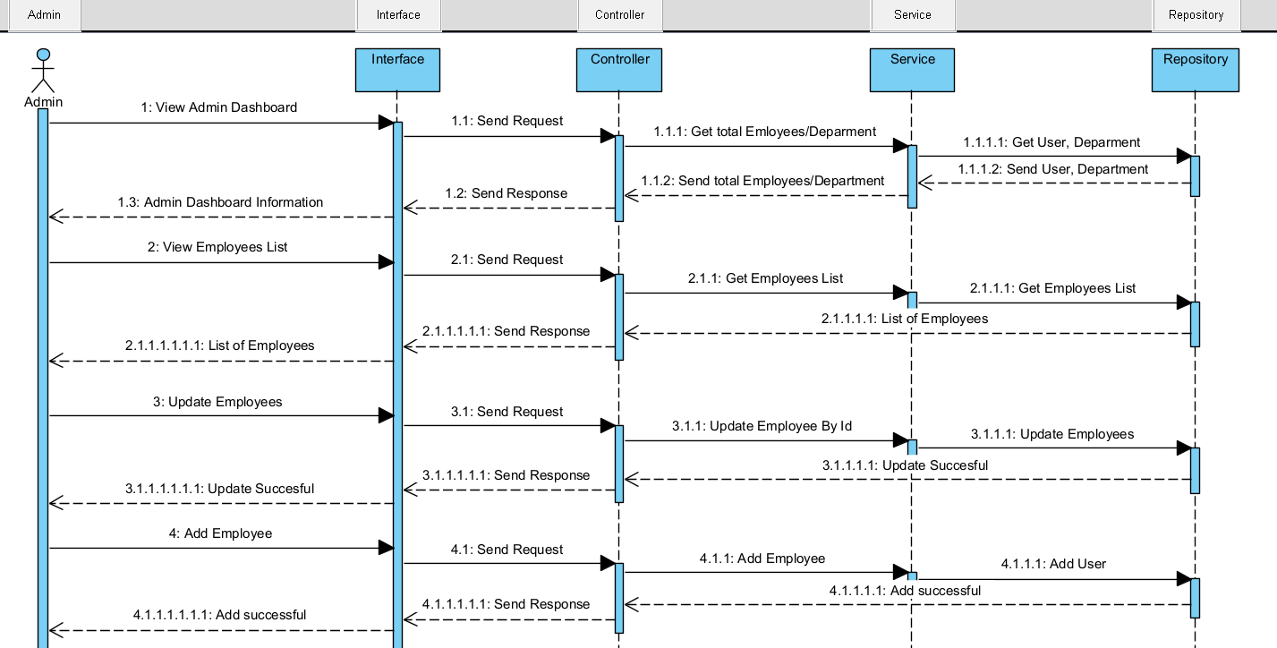

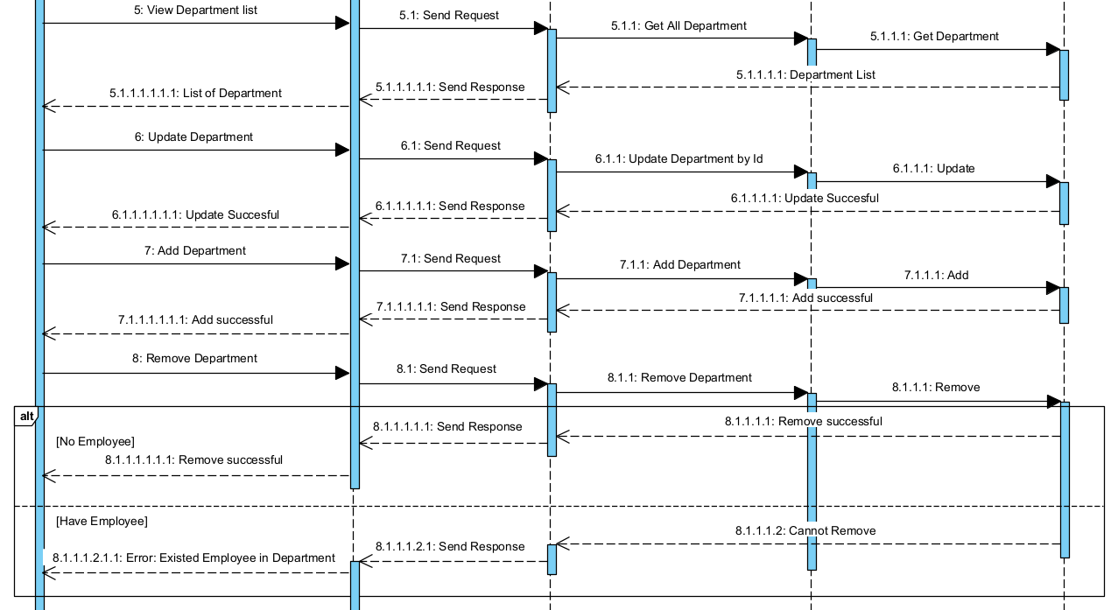

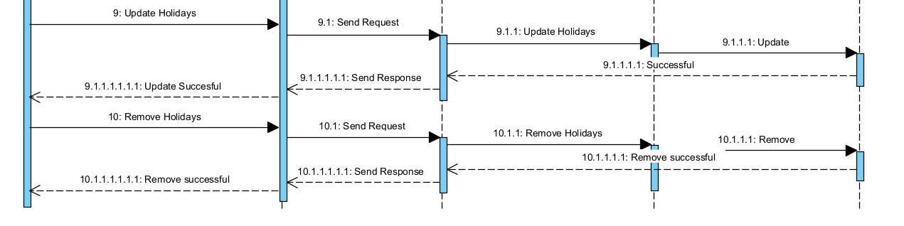

#### b. Sequence Descriptions

## 4. Database

### 4.1 Database Design

