LAB 01

1. Iris
2. KNN

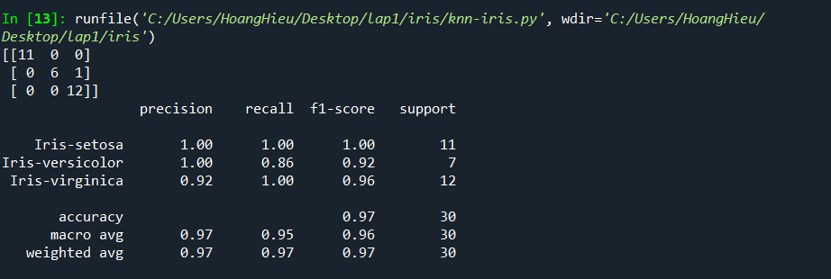

1. Decision Tree

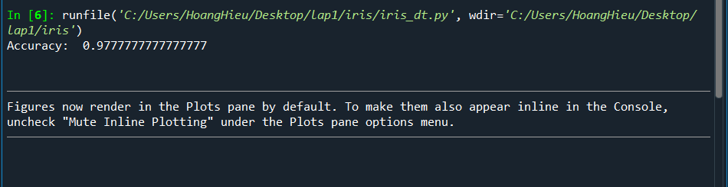

1. Random Forest

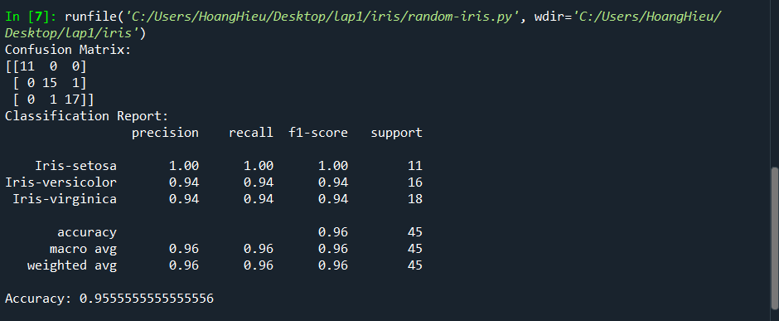

1. SVM :

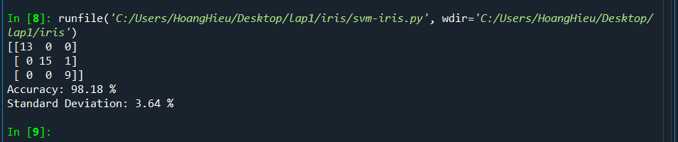

1. Lung cancer
2. KNN
3. Decision Tree

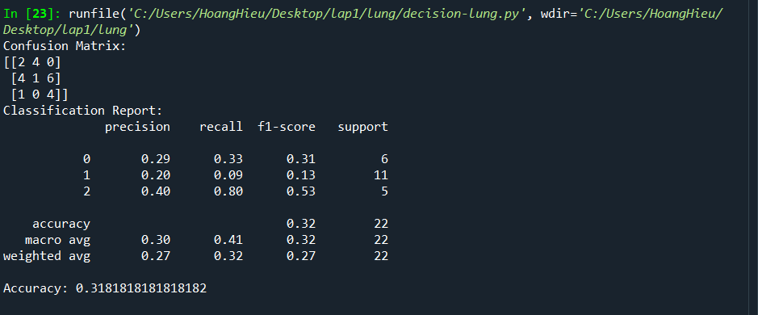

1. Random Forest

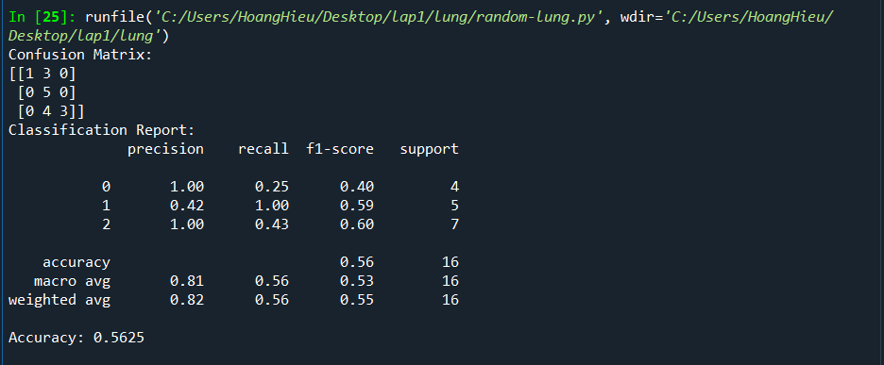

1. SVM

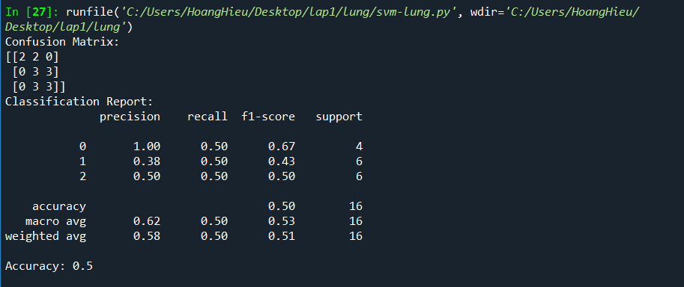

1. Face Images
2. Breast Cancer:
3. KNN

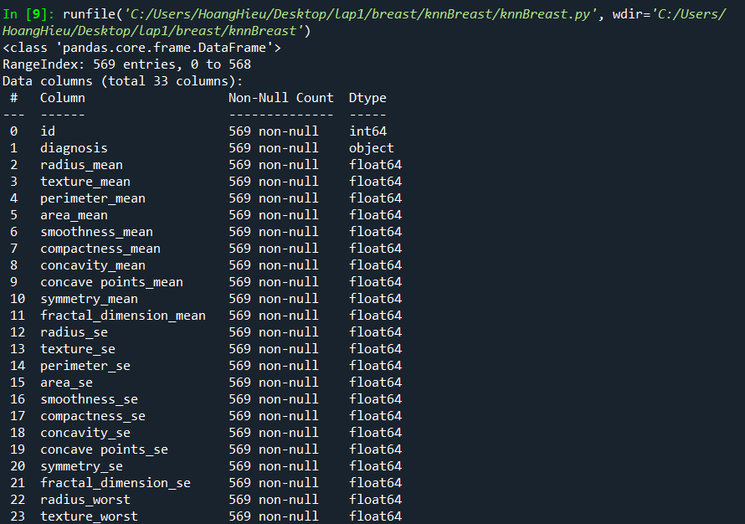

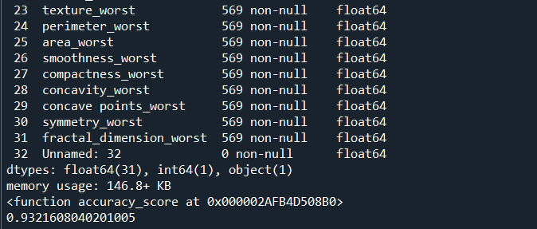

1. Decision Tree

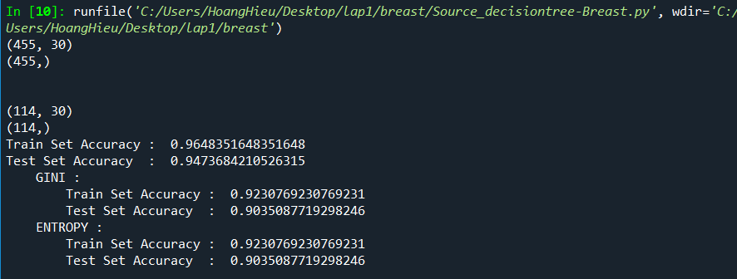

1. Random Forest
2. SVM

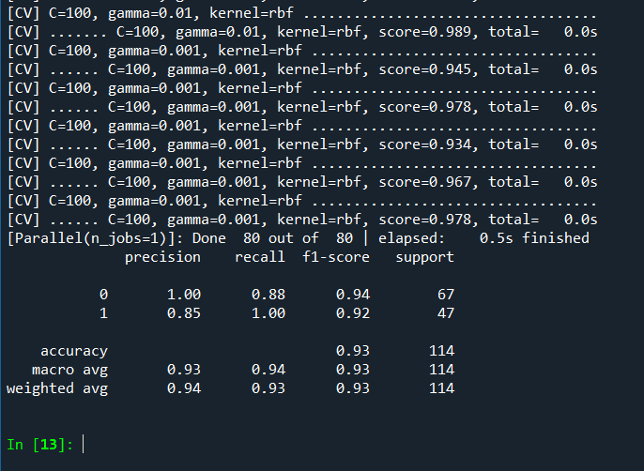

Source Code: <https://github.com/Hoanghieu003/ML_Lab1>