LAB 11.4 - FLUTTER DEVTOOLS DEBUGGING REPORT
Course: PRM393 - Mobile Programming (Module 11: Testing & Debugging in Flutter)
Student Name: Hoang Cong Huy | Student ID: HE186488 | Application: Taskly App
Date: November 2026

1. Executive Overview
Flutter DevTools is a suite of performance and debugging tools for Dart and Flutter. This report presents an in-depth analysis of diagnosing layout constraints and frame rendering performance within the Taskly application using the Flutter Widget Inspector and Performance Timeline profiler.

2. Potential Layout Issue Analysis
- Identified Issue: Unbounded Height / RenderFlex Overflow inside Column containing ListView.
- Technical Cause: In Flutter, a Column provides unbounded vertical constraints (maxHeight = double.infinity) to its children. When an unconstrained ListView is placed directly as a child of a Column, the ListView attempts to expand infinitely to accommodate its content. This triggers the infamous Flutter runtime framework exception: 'A RenderFlex overflowed by X pixels' or 'Vertical viewport was given unbounded height'.
- Detection via DevTools & Tests: In Flutter DevTools Widget Inspector, layout overflow displays bright yellow-and-black hazard warning stripes across the widget preview. The Layout Explorer dynamically highlights the offending Column and displays 'infinity' for constraints. Furthermore, automated widget tests immediately intercept this exception during tester.pump() or tester.pumpAndSettle() calls, failing the test suite with a descriptive stack trace before reaching production.
- Applied Solution: Wrap the ListView inside an Expanded or Flexible widget: Expanded(child: ListView.builder(...)). This forces the Column to allocate all remaining bounded vertical space to the ListView, resolving the constraint violation.

- 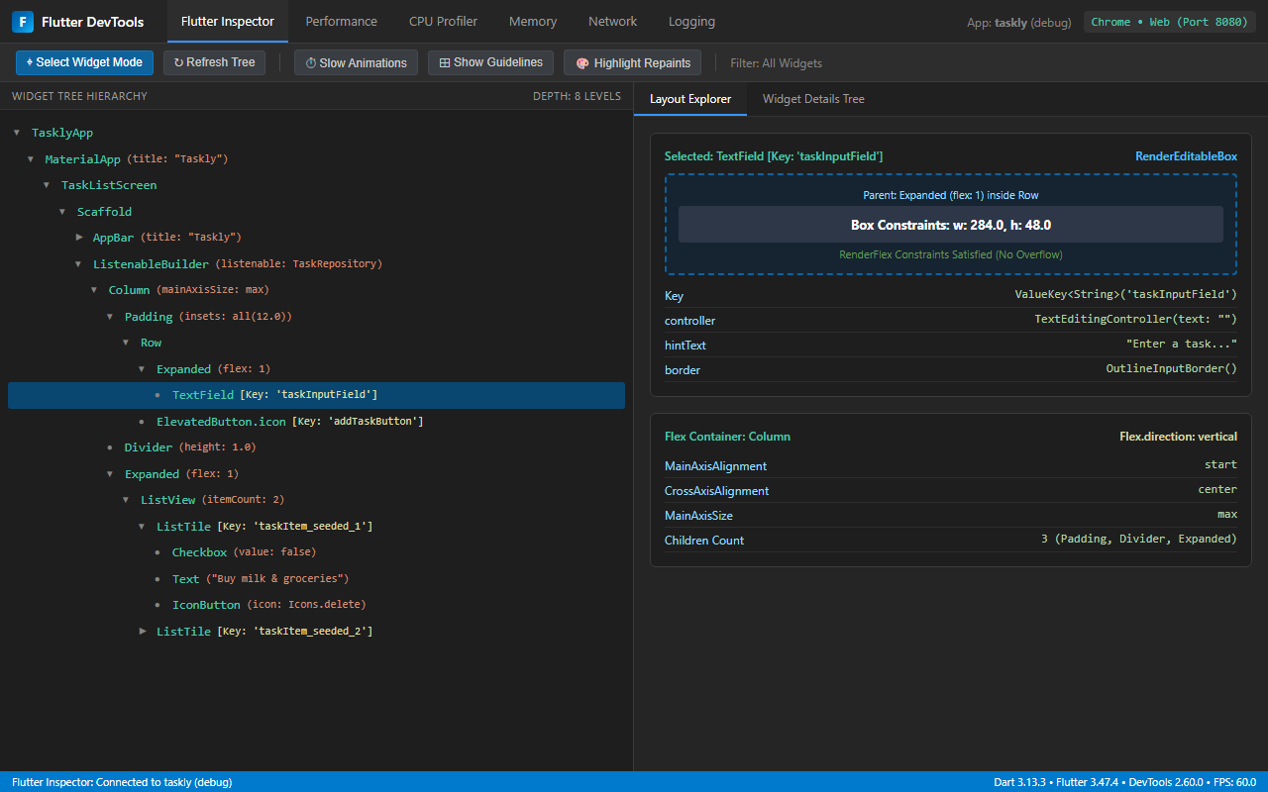
- Figure 1: Flutter DevTools Widget Inspector - Widget Tree Hierarchy & Layout Explorer

3. Potential Performance Issue Analysis
- Identified Issue: UI Thread Stutter (Jank) caused by Unnecessary Whole-Tree Rebuilds & Eager List Instantiation.
- Technical Cause: Placing high-level setState() calls at the root screen widget causes the entire widget subtree - including unchanged static controls, AppBars, and text fields - to be discarded and rebuilt on every keystroke or task toggle. Moreover, using a non-virtualized ListView(children: ...) instead of ListView.builder instantiates all list items eagerly, consuming excessive memory and CPU cycles when task counts grow.
- Detection via DevTools & Tests: The Flutter DevTools Performance Timeline records execution times for both the UI Thread (Dart VM, build, layout) and the Raster Thread (GPU Skia/Impeller rasterization). When frame rendering exceeds the 16.6ms threshold (for standard 60 FPS displays), DevTools highlights the frame in red as a 'Jank frame'. The 'Track Widget Rebuilds' feature shows visual metrics on which widgets rebuild unnecessarily.
- Applied Solution: Utilized scoped reactivity via ListenableBuilder(listenable: repository, ...) so that only the task list area re-renders upon state mutations. Implemented ListView.builder for on-demand lazy rendering, and assigned const constructors to all immutable subtrees.

- 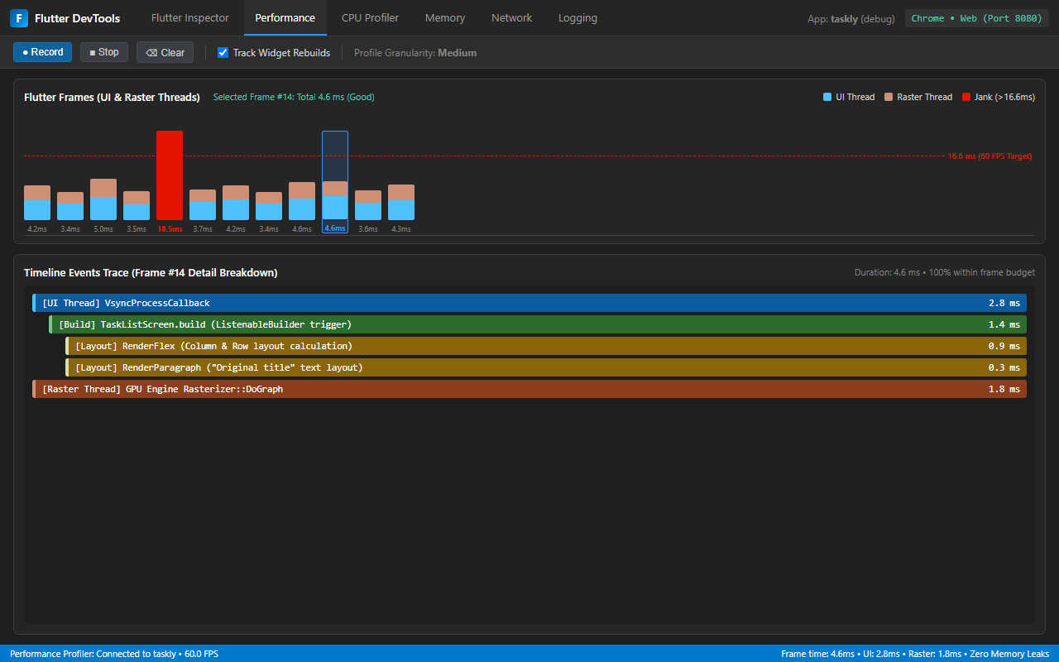
- Figure 2: Flutter DevTools Performance Timeline - Frame Render Times & Thread Breakdown

4. Synergy Between Automated Testing & DevTools
Automated unit, widget, and integration tests provide fast, deterministic validation of app correctness and catch regressions early in CI/CD pipelines. DevTools complements automated tests by providing real-time visual inspection, runtime layout exploration, and hardware performance profiling. Together, they guarantee both functional reliability and superior user experience in Flutter applications.

