Abstract— The main reason of this lab is to use logic work to compare and verify logical theorem from a true table

CmpE 124 Lab <#2>: <Verifying Theorems with Logic Circuits>
<Name: Hoang Le>, <SID:012679771>, CmpE 124 Spring 2019, Lab Section <#3>

INTRODUCTION

This Lab is designed for student to practice and prove Boolean Algebra equation. Student have a chance to get familiar with OR/AND equation in order to create a circuit. It is important to see the result of a circuit before building it in physical board.

Design methodology

This lab require student to have a basic Knowledge about OR gate, NOR gate, AND gate, NAND gate, Karnaugh maps, and derived equations.

Parts List in LogicWorks

- SN74S163
- OR gate
- AND gate
- Binary switch
- NOT gate

Truth Tables
Table 1: g1= x+x’ and g2 = 1

X | X’ | g1=x+x’ | G2 =1
0 | 1 | 1 | 1
1 | 0 | 1 | 1

Table 2: g1= x*x’ and g2= 0

X | X’ | G1 | G2=0
0 | 1 | 0 | 0
1 | 0 | 0 | 0

Table 3: g1 = x+1 and g2=1

X | 1 | G1 | G2=1
0 | 1 | 1 | 1
1 | 1 | 1 | 1

Table 4: g1 = x +0 and g2=x

X | 0 | g1 | G2 =x
0 | 0 | 0 | 0
1 | 0 | 1 | 1

Table 5: g1 = x +x’y, g2 = x+y

X | y | G1 = x+x’y | G2 = x+y
0 | 0 | 0 | 0
0 | 1 | 1 | 1
1 | 0 | 1 | 1
1 | 1 | 1 | 1

Table 6: g1 = x +ab, g2 = (x+a)(x+b)

X | a | b | G1=(x+ab) | G2=(x+a)(x+b)
0 | 0 | 0 | 0 | 0
0 | 0 | 1 | 0 | 0
0 | 1 | 0 | 0 | 0
0 | 1 | 1 | 1 | 1
1 | 0 | 0 | 1 | 1
1 | 0 | 1 | 1 | 1
1 | 1 | 0 | 1 | 1

Table 7: g1 = (xy)’, g2 = x’+y’

X | y | G1 = (xy)’ | G2 = x’+y’
0 | 0 | 1 | 1
0 | 1 | 1 | 1
1 | 0 | 1 | 1
1 | 1 | 0 | 0

Table 8: g1 = (x +y)’, g2 = x’y’
X | y | G1 = (x+y)’ | G2 = x’y’
0 | 0 | 1 | 1
0 | 1 | 0 | 0
1 | 0 | 0 | 0
1 | 1 | 0 | 0

Karnaugh Maps

Not applicable

Original and Derived Equations

Not applicable

Schematics
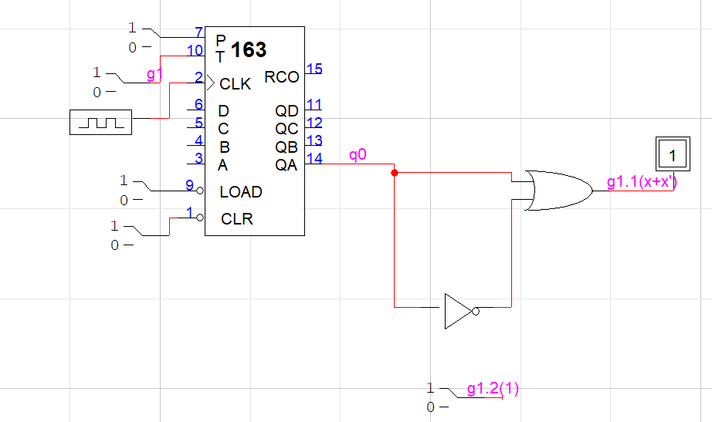
Figure 1: The circuit #1

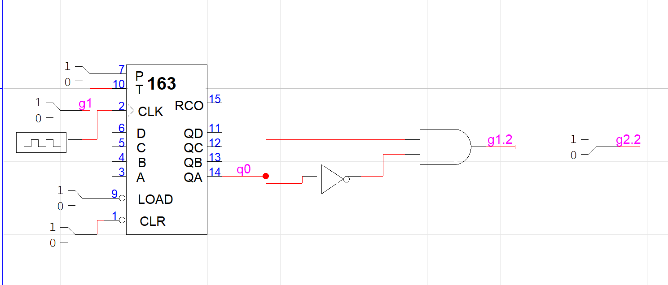
Figure2: The circuit #2

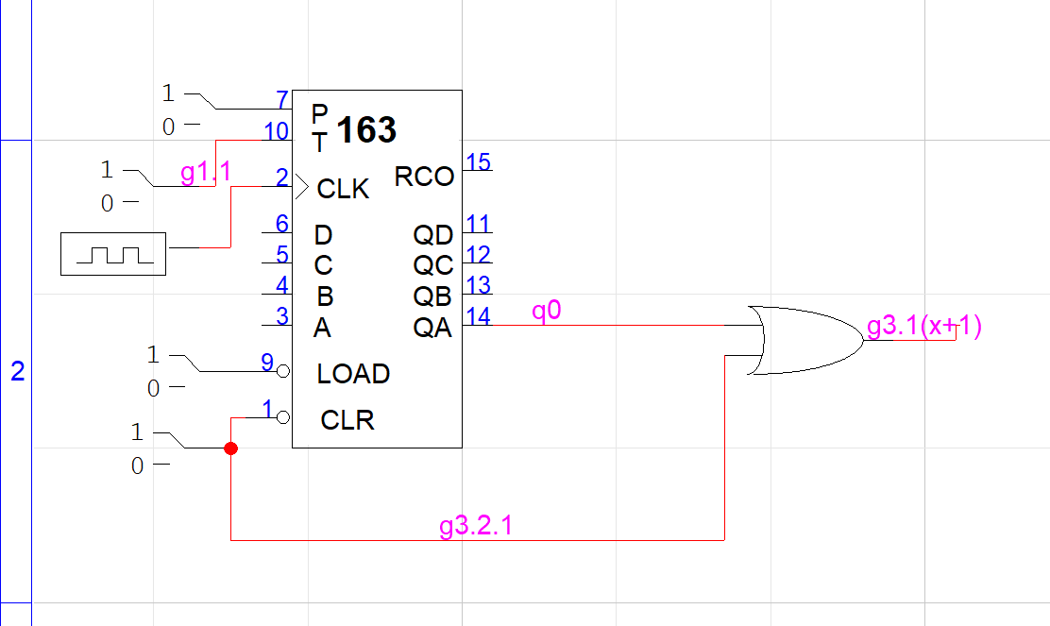
Figure 3: The circuit #3

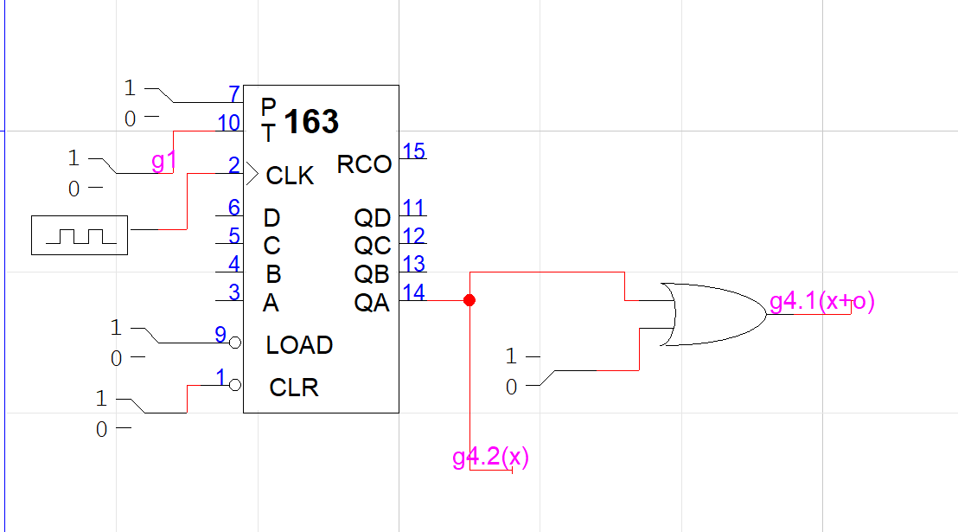
Figure 4: The circuit #4

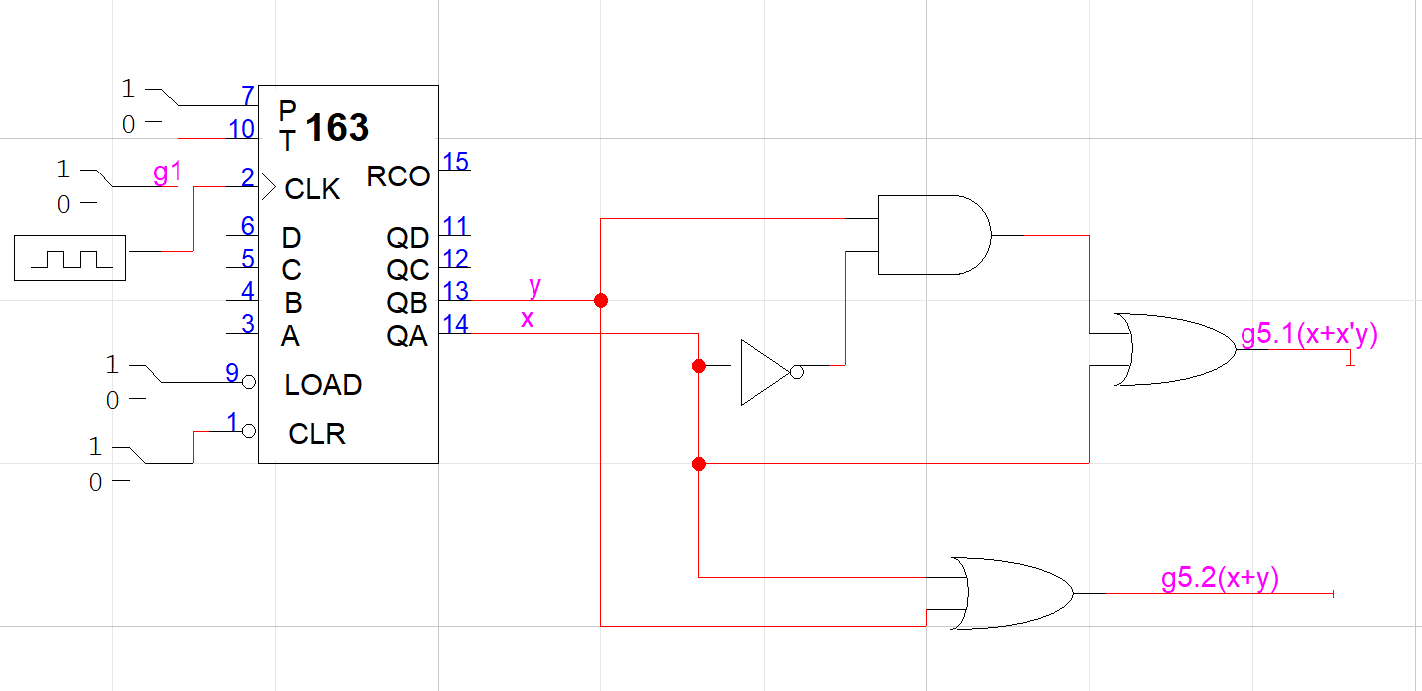
Figure 5: The circuit #5

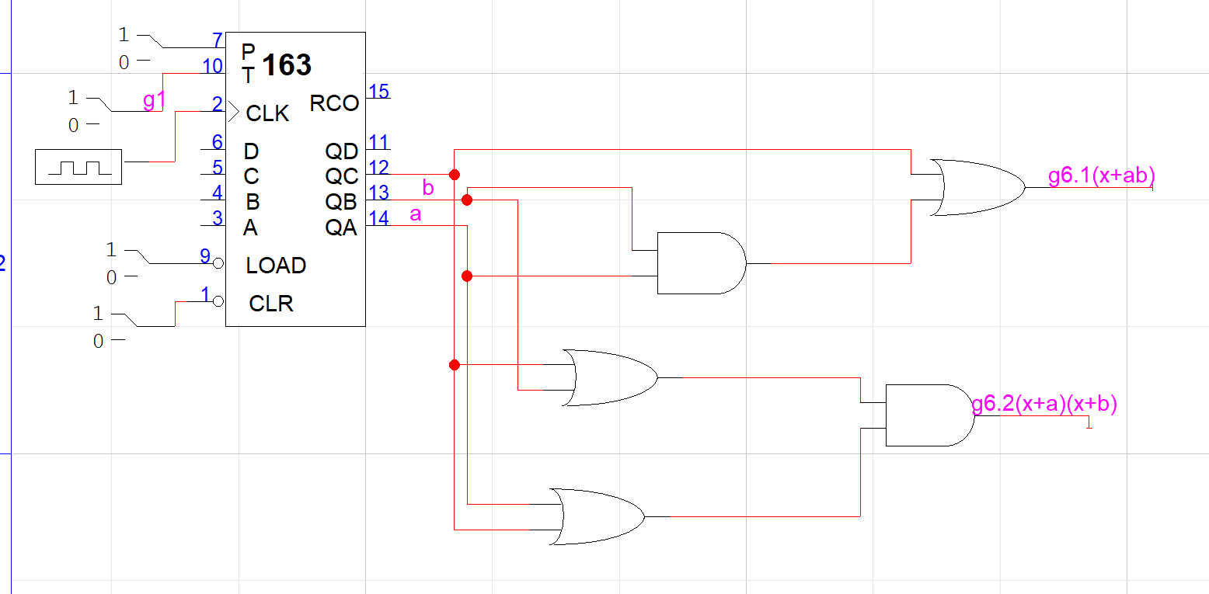
Figure6: The circuit #6

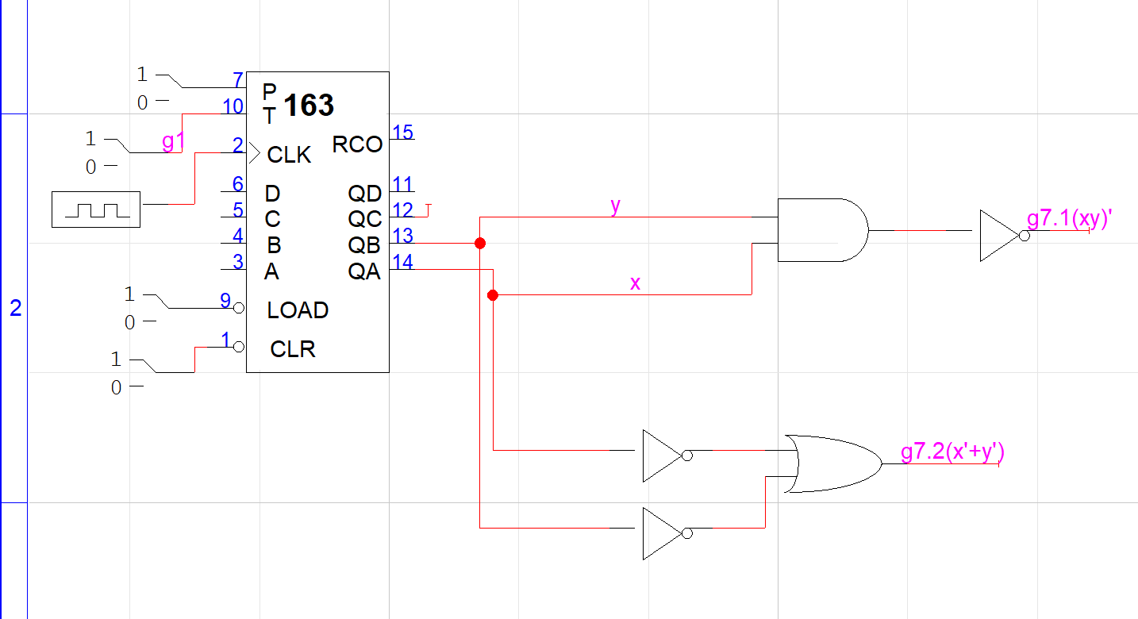
Figure 7: The circuit #7

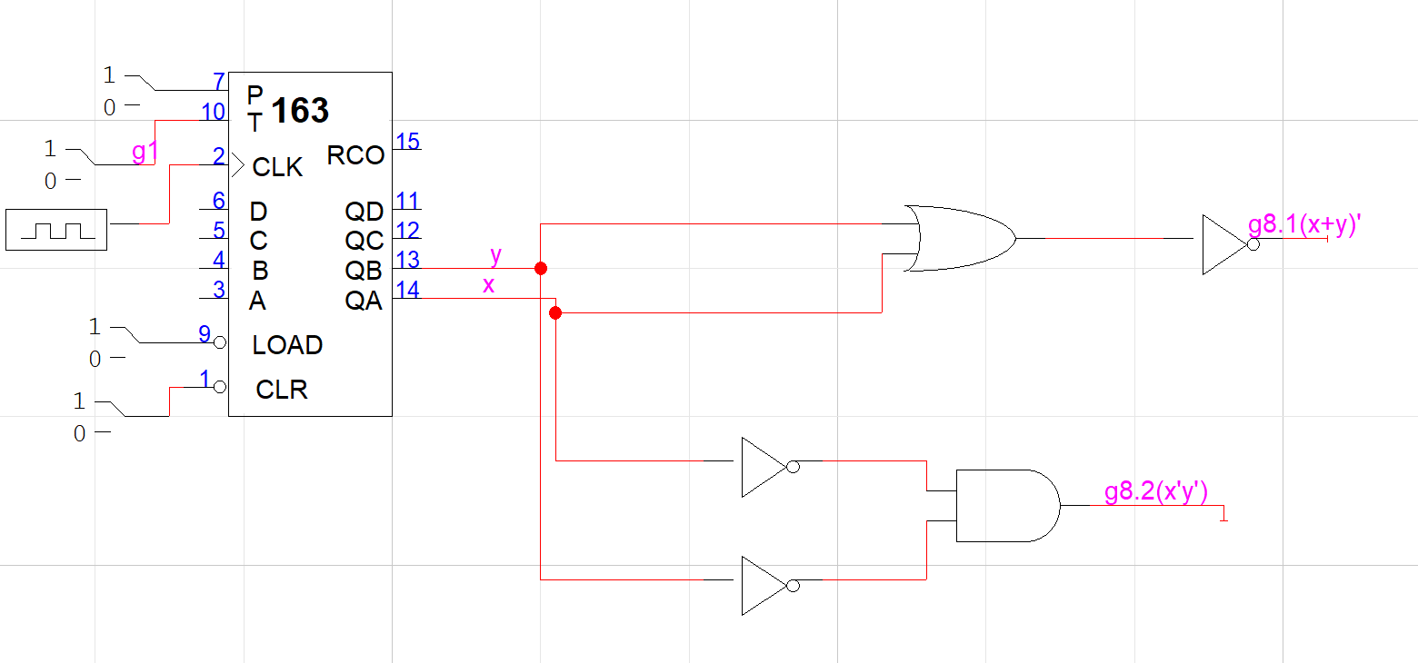

Figure 8: The circuit #8

testing procedures

- Step 1: Decide function OR/AND from equation
- Step 2: Build the circuit on logic work based on equation and test it
- Step 3: Observe the 2 output and check wave form if it is correct.
- Step 4: Observe and compare the output of g1 and g2

testing results

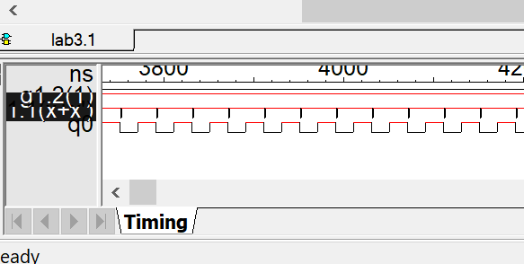
Figure 9 : The circuit #1

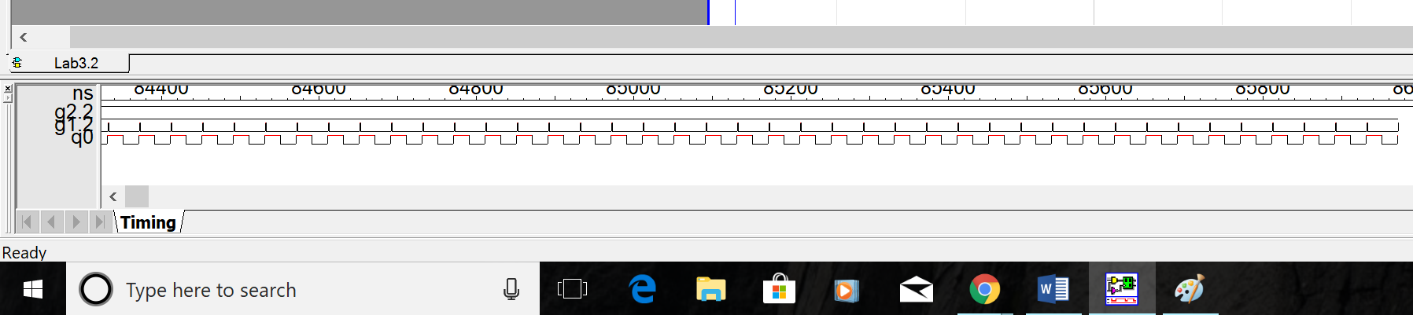
Figure 10: The circuit #2
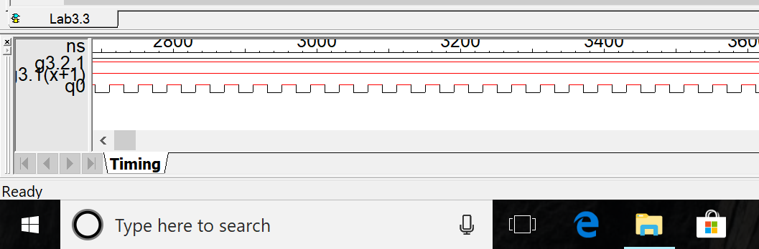
Figure 11: The circuit #3

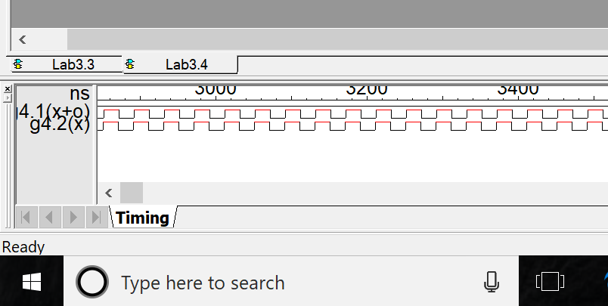
Figure12: The circuit #4

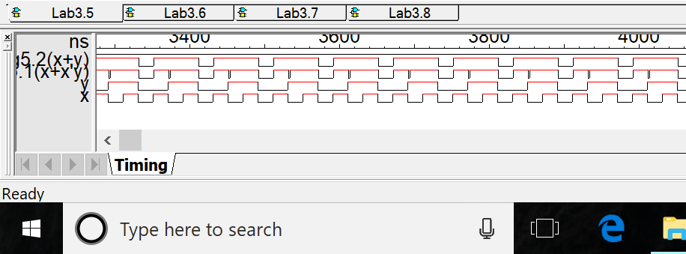
Figure13 : The circuit #5

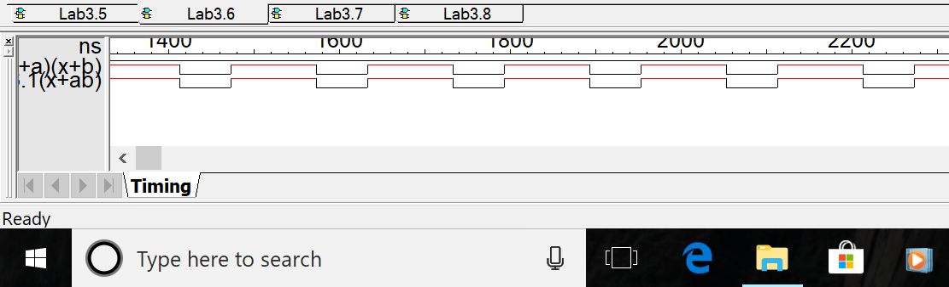
Figure 14: The circuit #6
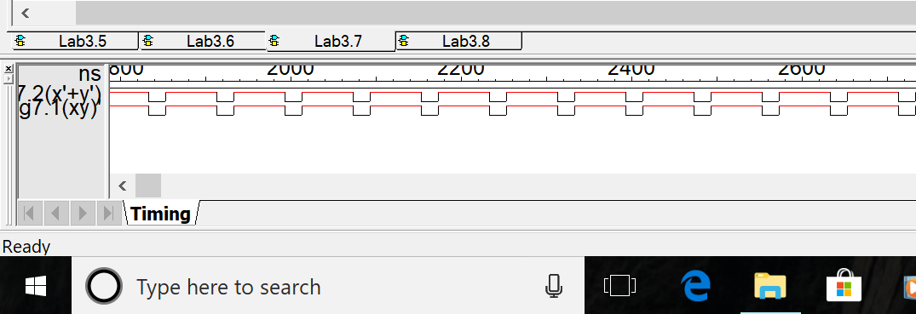
Figure 15: The circuit #7

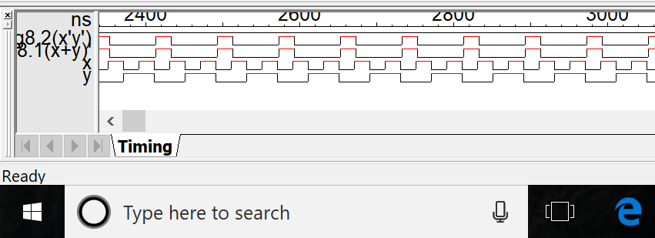

Figure 16 : The circuit #8

Conclusion

After doing this lab, Student learned to transfer from an equation into a circuit problem. Observe the output of waveform give student idea what the hazard is and what make hazard happen. Hazard make the line circuit’s signal change a little bit which cause the signal delay in small amount of time. Especially, Student learned to know that the inverter also cause the hazard because the signal takes time to convert from low to high and make the signal delay.

appendices and references

 

