

**<<BRAINSTORMERA>>**

**Online course and certificate management system**

**Software Requirement Specification**

– Cantho, September 2024 –

**Table of Contents**

I. Overview 3

1. Introduction 3

2. System Functions 4

3. Common Requirements 7

II. Functional Requirements 13

1. Home Page 13

a View Notifications. 13

b.Search for courses 14

2. Login 15

a.Log in to the system using credentials. 15

3. Register 16

a. Register a new account as an admin, instructor, or student.. 16

4. Logout 18

a. Log out of the system. 18

5. Profile Management 19

a. View and update profile details, change passwords, and manage personal settings19

6. Courses Management 21

a.Create, edit, and delete courses manage content, search, and view courses 22

7. Courses details 23

a.View course details 23

8. Enrolled Course 25

a.View and Manage Enrolled Courses 26

9. Certificate Management 27

a.Issue, view, and download certificates after course completion 27

10. Feedback Management 29

a. Submit and manage feedback for courses, including review responses 29

11.Achivement Management 31

a. View and track achievements related to courses and certifications. 31

12.Interact With Chatbot 33

a.Use the chatbot for support, queries, and assistance 33

13..Notification Management 35

a. Manage notification settings and view updates for courses and actions 35

# I. Overview

## 1. Introduction

The product is an online learning platform that enables students to sign up, browse, and enroll in various courses. The product will provide users access to a range of educational content, including videos, reading materials, quizzes, and interactive content. The primary goal is to offer a user-friendly platform that encourages students’ self-paced learning and promotes an engaging educational experience.

The platform will be accessible via web browsers on multiple platforms including Windows, and Linux,... To ensure the development of the product in the future, the product also provided a responsive interface to develop compatibility across various devices, including desktops, computers, tablets, and smartphones. This ensures that learners can engage with the platform at any time and from anywhere, as long as access to the internet is provided.

The primary users of this product will be:

1. Students: Individuals who look to learn new courses at their own pace. They will have access to course materials, assignments, and quizzes.
2. Instructors: Educators responsible for creating course content, managing materials, and evaluating their courses, and students' progress.
3. Administrator: System administrators who oversee the platform’s functionality, manage user access, and ensure the system works efficiently.
4. Guests: Guests can browse the website, and check course details.

Products’ Constraints:

1. Data Privacy and Security: Cooperate with educational data protection regulations including securing personal data and academic records
2. Scalability: The system must handle several users and course content with an efficacious system.

Assumption:

1. All users must have access to an internet connection through devices.
2. Learners are familiar with basic digital learning interfaces and basic operations on websites such as login, log out, and sign up,...
3. Course instructors must have the necessary knowledge to upload and manage their content through the platform.

Dependencies:

1. Browser Compatibility: The product depends on the proper functioning of modern browsers to deliver the user interface and learning content.

**Content part 2:** Context diagram of product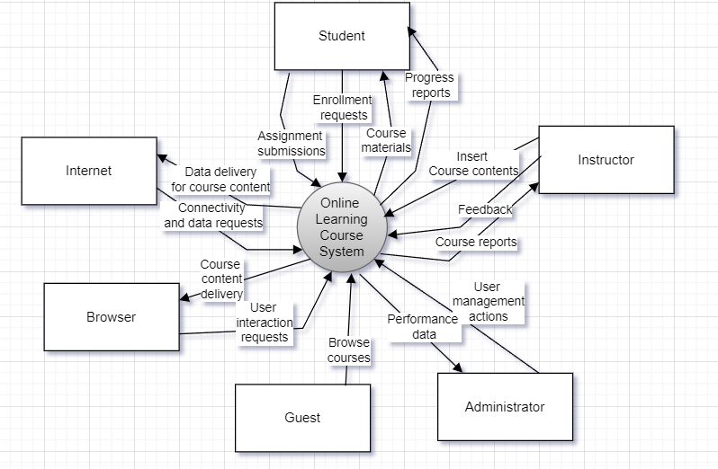

## To describe the key Entities and Interactions:

## Student:

## Enrollment Requests: Students can request enrollment in available courses.

## Course Materials: Students access the course materials once enrolled.

## Assignment Submissions: Students can submit assignments for evaluation.

## Progress Reports: Students receive reports detailing their progress in various courses.

## Instructor:

## Insert Course Contents: Instructors add new content to courses, ensuring it's available to students.

## Feedback: Instructors provide feedback to students based on their submissions.

## Course Reports: Instructors access course reports for progress and performance analysis.

## Administrator:

## User Management Actions: Administrators manage user accounts and oversee platform operations. They are also involved in managing Payments.

## Performance Data: Administrators also manage performance-related metrics for the courses and users.

## Guest:

## Browse Courses: Guests are limited to browsing the available courses but cannot enroll.

## Browser:

## User Interaction Requests: Interactions made by users (e.g., course enrollment, browsing).

## Course Content Delivery: Delivery of course materials and contents via the browser.

## Internet:

## Data Delivery for Course Content: Enables delivery of content to students, instructors, and other users.

## Connectivity and Data Requests: Allows the system to communicate and function properly through online connectivity.

### System Boundaries:

## The central system, "Online Learning Course System," is the core platform that facilitates the interactions between users (students, instructors, administrators, guests), browsers, and external resources like the Internet. Each external entity has defined interactions, such as sending or receiving data and managing courses, user data, or progress reports.

## 

## 

## 2. System Function

1. Screen flow

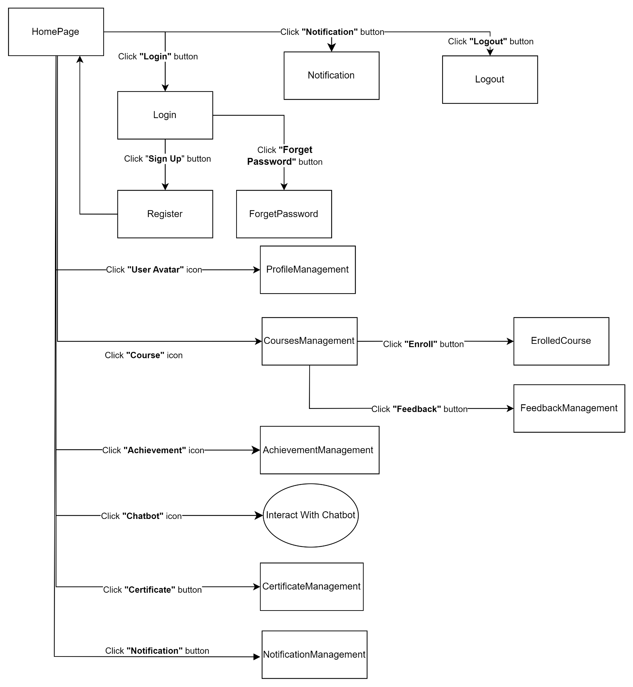

#### b. Screen Details

| **#** | **Feature** | **Screen** | **Description** |
| --- | --- | --- | --- |
| 1 | HomePage | HomePage | Main landing page after login, providing navigation options to courses, profiles, and other system features. |
| 2 | Login | Login | Page where users can enter their credentials to log in to their accounts. |
| 3 | Register | Register | Enables new users to sign up by entering their details such as email, password, and other relevant info. |
| 4 | Forget Password | Forget Password | Allows users to reset their password by submitting their email address to receive a reset link. |
| 5 | Profile Management | Profile Management | Users can view and update their personal information, profile pictures, and account settings. |
| 6 | Courses Management | Courses Management | Lists all available courses for the user to browse, with options to view details or enroll. |
| 7 | Enrolled Course | Enrolled Course | Shows the list of courses the user is currently enrolled in, with access to course materials and progress. |
| 8 | Feedback Management | Feedback Management | Allows users to submit feedback on courses they have taken and manage/view their submitted feedback. |
| 9 | Achievement Management | Achievement Management | Displays achievements and milestones the user has unlocked during their learning journey. |
| 10 | Interact With Chatbot | Chatbot | Provides an interface for the user to interact with the system chatbot for support and guidance. |
| 11 | Certificate Management | Certificate Management | Enables users to view, download, and manage their certificates after completing courses. |
| 12 | Notification Management | Notification Management | Users can manage notification settings, including preferences for receiving course updates and reminders. |
| 13 | Notification | Notification | Displays system notifications to the user, including enrollment updates, system messages, and reminders. |
| 14 | Logout | Logout | Logs the user out of the system and redirects them to the homepage or login screen. |

#### c. User Authorization

| **Screen** | **Role1** | **Role2** | **Role3** | **Role4** |
| --- | --- | --- | --- | --- |
| HomePage | X | X | X | X |
| View notifications, and search for courses. |  |  |  |  |
| Login | X | X | X |  |
| Log in to the system using credentials. |  |  |  |  |
| Register | X | X | X | X |
| Register a new account as an admin, instructor, or student. |  |  |  |  |
| Logout | X | X | X |  |
| Log out of the system. |  |  |  |  |
| Profile Management | X | X | X |  |
| View and update profile details, change passwords, and manage personal settings. |  |  |  |  |
| Courses Management | X | X | X | X |
| Create, edit, and delete courses manage content, search, and view courses. | Manage courses content | Create, edit, and delete courses | View and enroll in Courses only | View Course only |
| Course Detail | X | X | X |  |
| View course details. | Report and analyse courses |  |  |  |
| Enrolled Course |  |  | X |  |
| View and manage enrolled courses. |  |  |  |  |
| Certificate Management | X | X | X |  |
| Issue, view, and download certificates after course completion. |  |  |  |  |
| Feedback Management | X | X | X |  |
| Submit and manage feedback for courses, including review responses. |  |  |  |  |
| Achievement Management | X | X | X |  |
| View and track achievements related to courses and certifications. |  |  |  |  |
| Interact With Chatbot |  | X | X |  |
| Use the chatbot for support, queries, and assistance. |  |  |  |  |
| Notification Management | X | X | X |  |
| Manage notification settings and view updates for courses and actions. |  |  |  |  |

In which:

* Role1 (Admin): The administrator has full access to the system. They can manage users, courses, transactions, and certificates, as well as perform system-wide updates and maintenance tasks.
* Role2 (Instructor): The instructor is responsible for creating and managing course content. They can track student progress, provide feedback, and issue certificates upon course completion. They have authority over course-related activities but limited system control.
* Role3 (Student): Students can search for and enroll in courses, submit assignments, track their learning progress, and receive certificates upon completing courses. Their access is limited to user-specific actions, such as personal progress tracking and course interaction.
* Role4 (Guest): Guests can browse available courses but are restricted from enrolling in courses or performing any other actions. They have view-only access to course listings and public resources

#### d. Non-Screen Functions

| **#** | **Feature** | **System Function** | **Description** |
| --- | --- | --- | --- |
| 1 | Enrollment Management | Batch Job for Enrollment Check | Periodically checks for enrollment requests, verifies student eligibility, and updates course participation status. |
| 2 | Notification System | Email Notification Service | Automatically sends email notifications to users for course deadlines, new content, feedback, and certificates. |
| 3 | Certificate Issuance | Certificate Generator API | Generates digital certificates for students upon course completion, stores them in the system, and emails them. |
| 4 | Analytics | Performance Analytics Job | Regularly collects and processes user interaction data to provide performance insights for both students and admins. |
| 5 | Security Monitoring | Security Audits and Alerts | Monitors system activity for unusual behaviour or security breaches and triggers alerts for the system administrator. |

## 3. Common Requirements

This section outlines general system-wide requirements that must be met, regardless of specific features or modules.

**3.1. Usability**

* The system must provide a user-friendly interface for all users (students, instructors, admins).
* All functionalities should be easily accessible from the main navigation menus.
* Error messages and alerts should be informative and guide users on how to resolve the issue.

**3.2. Performance Requirements**

* The platform must support at least *X* simultaneous users without significant performance degradation.
* Response time for all user actions (e.g., page navigation, course enrollment) should not exceed *5* seconds under typical load.
* Data retrieval operations (e.g., accessing course materials, and viewing profiles) must be completed within *2* seconds.

**3.3. Security**

* All user data must be encrypted in transit and at rest.
* The system must comply with the educational data protection regulations, ensuring that personal and academic information is securely stored.
* User roles (Admin, Instructor, Student, Guest) must be appropriately managed, with permissions set to restrict access to authorized content.

**3.4. Scalability**

* The system should be designed to handle future growth, including an increased user base, additional courses, and expanded features without major redesign or performance issues.
* The database and server infrastructure must be able to scale with minimal downtime.

**3.5. Accessibility**

* The platform must comply with web accessibility standards such as WCAG 2.1 to ensure all users, including those with disabilities, can use the system.
* Support for screen readers, keyboard navigation, and customizable text sizes is required.

**3.6. Compatibility**

* The system must be accessible on multiple browsers (Chrome, Firefox, Edge) and operating systems (Windows, Linux, MacOS).
* It should also be optimized for mobile devices such as smartphones and tablets.

**3.7. Maintainability**

* The system codebase should follow coding standards and be well-documented to allow easy maintenance and future enhancements.
* Regular updates and patches should be implemented to fix bugs and improve functionality.

## II. Functional Requirements

## 1. Home Page

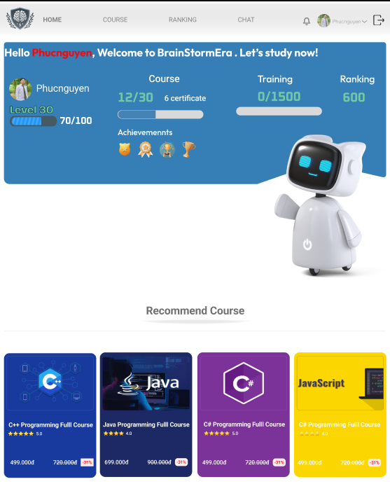

## **a. View notifications**

**Function trigger:**

* This function is triggered when the user has logged in to the system homepage.

**Function description:**

* Actors/Roles: All users who have access to the homepage.
* Purpose: Allow users to view the latest notifications related to the system and search for courses.
* Interface: Displays a list of notifications with an option to search for courses.
* Data processing: Fetches notification data from the system for display.

**Function details:**

* Validation: Ensure that there are no empty notifications displayed.
* Business Logic: Users can click on individual notifications to view more details.

## b. Search for courses

**Function trigger:**

* This function is triggered when the user enters keywords in the search bar and clicks the "Search" button on the homepage or in the course management section.

**Function description:**

* Actors/Roles: Any user with access to the system’s course catalog.
* Purpose: Allow users to search for available courses by keywords such as course name, category, or instructor.
* Interface: The user enters search criteria in the search bar and clicks the "Search" button to initiate the search.
* Data processing: The system retrieves relevant courses from the database based on the entered search criteria and displays the results in a list format.

**Function details:**

**Validation:**

* The search input must not be empty. A validation message should prompt the user to enter at least one keyword if the search bar is empty.

**Business Logic:**

* After the user clicks "Search," the system will query the database and return a list of courses that match the keywords.
* The search results can be filtered further by category, instructor, or other attributes (if applicable).
* If no results match the search, the system will display a "No courses found" message.

## 2. Login



## a. Log in to the system using credentials.

**Function trigger**

* This function is triggered when the system is required to authenticate itself to an external service, API, or platform by providing a set of predefined credentials (e.g., API key, client ID, client secret).

**Function description:**

* Actors/Roles: The system itself (without user intervention), acting as a client requesting access to another service or database.
* Purpose: Allow the system to authenticate itself using stored credentials (such as API keys, tokens, or certificates) to communicate securely with other systems or services.
* Data processing: The system retrieves the necessary credentials from secure storage, submits them to the external service, and receives an authentication token or confirmation of successful login.

**Function details:**

* Validation:

The system checks the format and validity of the stored credentials before making an authentication request (e.g., ensuring that API keys are not expired).

If credentials are missing or malformed, the system will return an error and log the issue.

* Business Logic:
  + The system initiates the authentication process by sending the stored credentials to the external service’s authentication endpoint.
  + If the credentials are valid, the system receives an authentication token or access confirmation, which is then stored securely for future communication.
  + If the authentication fails (e.g., due to invalid credentials or expired tokens), the system retries or logs the error for administrative review.
  + The system should handle token expiration by automatically refreshing the token when necessary or initiating a re-authentication process.
  + This process must be fully automated without requiring manual user input.
  + The system should support secure storage and encryption of all credentials to prevent unauthorized access.

## 3. Register



## a. Register a new account as an admin, instructor, or student.

**Function trigger:**

* This function is triggered when a new user attempts to register for an account through the registration form.

**Function description:**

* Actors/Roles:
  + Role 1: Admin
  + Role 2: Instructor
  + Role 3: Student
  + Role 4: Guest (optional or additional user type, if applicable)
* Purpose:
  + Allow users to register for a new account by selecting their role and providing the necessary details (e.g., username, password, email). Depending on the role selected (admin, instructor, or student), the system will grant specific permissions and access rights after registration.
* Data processing:
  + The system validates the user’s input, stores the data in the user database, and assigns the user their appropriate role based on the registration selection.

**Function details:**

* Validation:
  + Required fields for registration include:
    - Username: Must be unique across the system.
    - Password: Must meet security requirements (minimum length, complexity, etc.).
    - Email: Must be a valid email address and unique.
    - Role selection: Admin, Instructor, or Student (Role 1, 2, or 3).
  + Password and email must be confirmed through re-entry fields to ensure accuracy.
  + The system checks that the selected username and email are not already registered in the database.

**Business Logic:**

* Admin (Role 1):
  + Admins have full access to system management, including user management, content management, and overall system settings.
  + Registration for Admin users may require additional approval (e.g., system administrator approval or specific invitation codes).
* Instructor (Role 2):
  + Instructors have permissions to manage course content, create new courses, and review student progress.
  + Instructors may also need verification (such as validation from an existing admin) before they are granted full access.
* Student (Role 3):
  + Students are granted access to view and enroll in courses, participate in learning activities, and track their progress.
  + Student registration is typically open and doesn’t require special approval unless system policies specify otherwise.
* Guest (Role 4) (if applicable):
  + Guests might have limited access to view public content or sample courses, but cannot enroll or manage content.
* Upon successful registration, the system sends a confirmation email with a verification link to validate the user’s email address.
* Once the email is confirmed, the user can log in to the system with the appropriate role-based access rights.
* Failed registrations (e.g., username already exists, invalid email) will prompt error messages guiding users to correct their inputs.

## 4. Logout

## a. Log out of the system.

**Function trigger:**

* This function is triggered when a user clicks the "Log Out" button or link from any screen within the system.

**Function description:**

* Actors/Roles:
  + Role 1: Admin
  + Role 2: Instructor
  + Role 3: Student
* Purpose: End the user’s session and securely log the user out of the system, ensuring that no further actions can be performed until they log in again.
* Data processing: The system clears the active session, removes any session-specific tokens, and redirects the user to the login page or the public home page.

**Function details:**

* Validation:
  + The system must verify that the user’s session is active before allowing them to log out.
  + If the user’s session is already expired or inactive, the system will notify the user and redirect them to the login page automatically.
* Business Logic:
  + Admin (Role 1):
    - Admins are logged out from all administrative tools and management features, ensuring that no sensitive operations can be performed without re-authentication.
      * + Instructor (Role 2):
    - Instructors are logged out from their course management tools and content creation features.
      * + Student (Role 3):

Students are logged out from course participation, progress tracking, and any enrolled course activities.

After the user clicks "Log Out," the system clears their session data from the server, invalidates any session cookies or tokens, and redirects them to the login screen or home page.

If the system detects inactivity for a pre-defined time (e.g., 30 minutes), an automatic log-out will occur to protect security. The user will be notified of this via a pop-up or upon their next action attempt.

The system should display a confirmation message (e.g., "You have been successfully logged out.") after a successful log-out.

Any attempt to access protected pages after log-out will result in a redirect to the login page.

## 5. Profile Management

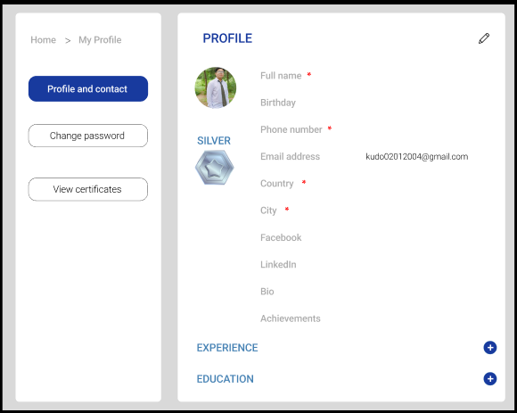

## a. View and update profile details, change passwords, and manage personal settings

**Function trigger:**

* This function is triggered when a user navigates to the "Profile" or "Settings" page and selects options to view or update their personal information, change passwords, or manage settings.

**Function description:**

* Actors/Roles:
  + Role 1: Admin
  + Role 2: Instructor
  + Role 3: Student
* Purpose: Allow users to view and update their personal information (such as name, email, contact details), change their password, and modify personal settings (such as notification preferences, language options, etc.).
* Data processing: The system retrieves the user’s existing profile details from the database, allows them to make updates, and then saves the modified information. It also handles password changes by securely updating the stored credentials.

**Function details:**

* View Profile:
  + Users can view their current profile information, such as username, full name, email address, and contact details.
* Update Profile:
  + Users can update editable fields, including name, email, phone number, and other personal data.
* Validation:
  + The email must be in a valid format and unique.
  + The phone number (if applicable) must follow the standard format.
  + If changes are made to critical fields (e.g., email), the system sends a confirmation email to the new address to verify the change.
* Change Password:
  + Users can change their password by entering their current password and providing a new password that meets the system’s security requirements (e.g., minimum length, special characters).
  + Validation:
    - The new password must be confirmed by re-entering it in a second field to avoid errors.
    - The system checks that the new password does not match the old one.
    - If the current password entered is incorrect, the system will display an error message and deny the password change.
* Manage Personal Settings:
  + Notification Preferences: Users can enable or disable notifications (e.g., email notifications, in-app notifications).
* Role-Specific Access:
  + Admin (Role 1):
    - Admins can update additional information, such as administrative roles or system permissions, and manage notifications related to system updates and critical tasks.
      * + Instructor (Role 2):

Instructors can modify preferences related to course notifications and manage instructor-specific settings (e.g., preferred grading methods, communication settings with students).

Student (Role 3):

Students can update preferences for course notifications, exam alerts, and personal progress tracking.

**Business Logic:**

* After making updates, the system saves changes to the database and displays a confirmation message.
* Any password changes will prompt the user to re-login using the new password.
* The system should handle secure data encryption for sensitive information, such as passwords.
* A detailed log of profile changes should be maintained for security auditing purposes.

## 6. Courses Management

## a. Create, edit, and delete courses manage content, search, and view courses

**Function trigger:**

* This function is triggered when a user accesses the course management interface to create, edit, delete, search, or view courses.

**Function description:**

* Actors/Roles:
  + Role 1: Admin (Manage course content)
  + Role 2: Instructor (Create, edit, and delete courses)
  + Role 3: Student (View and enroll in courses)
  + Role 4: Guest (View courses only)
* Purpose: Allow users to manage courses according to their assigned roles, including creating new courses, editing existing courses, deleting courses, searching for courses, and viewing course details.
* Data processing: The system interacts with the course database to retrieve, create, update, or delete course data based on user actions.

**Function details:**

* Manage Courses Content (Role 1 - Admin):
  + Admins have full access to manage all courses, including:
    - Creating new courses.
    - Editing course details (e.g., title, description, schedule, prerequisites).
    - Deleting courses that are no longer relevant or necessary.
    - Reviewing and approving course content created by instructors.
      * + Validation: Ensure that all required fields are filled in when creating or editing a course.
        + Business Logic: Admins can access a dashboard to see all courses and their statuses, approve or reject changes, and ensure quality control of the course catalog.
* Create, Edit, and Delete Courses (Role 2 - Instructor):
  + Instructors can:
    - Create new courses and provide course details (e.g., objectives, syllabus, assessment criteria).
    - Edit their existing courses to update content or schedules.
    - Delete courses they are responsible for, subject to admin approval.
      * + Validation: Similar to Admin validation, with checks for required fields and unique course codes.
* Business Logic: Instructors will have access to their dashboard to manage courses they created and review enrolled students’ progress.
* View and Enroll in Courses (Role 3 - Student):
  + Students can:
    - Search for available courses using various criteria (e.g., course name, category).
    - View detailed information about courses, including course objectives, syllabus, instructor details, and prerequisites.
    - Enroll in courses that match their interests and meet prerequisites.
      * + Validation: Ensure that students can only enroll in courses for which they meet the requirements.
        + Business Logic: The system will allow students to keep track of their enrolled courses and progress within them.
* View Courses Only (Role 4 - Guest):
  + Guests can:
    - Search for and view a limited set of courses, typically those marked as public or sample courses.
    - Access course descriptions and basic details but cannot enroll or interact further with course content.
      * + Business Logic: Guests may be prompted to create an account or log in to gain additional access to enroll in courses.
* Search Courses:
  + All roles can search for courses based on various criteria (e.g., keywords, categories).
  + Validation: Search inputs must not be empty.
  + Business Logic: The system returns a list of matching courses, filtered based on user roles and access permissions.

## 7. Courses details

## **a.** View course details.



**Function trigger:**

* This function is triggered when a user selects a specific course to view its details.

**Function description:**

* Actors/Roles:
  + Role 1: Admin (Report and analyze courses)
  + Role 2: Instructor (No additional functionalities)
  + Role 3: Student (No additional functionalities)
  + Role 4: Guest (No additional functionalities)
* Purpose: Allow users to view detailed information about specific courses, including course content, structure, enrollment numbers, and performance metrics.
* Data processing: The system retrieves the requested course data from the database and displays it to the Admin.

**Function details:**

* View Course Details:
  + Admin (Role 1):
    - * Admins can view comprehensive course details such as:
        + Course title and description
        + Objectives and learning outcomes
        + Syllabus or course outline
        + Instructor information
        + Schedule (e.g., start date, end date, meeting times)
        + Current enrollment numbers
        + Student feedback and ratings (if applicable)
      * Reporting and Analysis:
        + Admins can generate detailed reports on each course, which include:

Enrollment statistics (e.g., number of students enrolled, demographics)

Course completion rates and student performance metrics

Historical data comparing course offerings (e.g., trends in enrollments over time)

Feedback summaries from students and instructors.

* + - * Admins can filter reports based on specific criteria (e.g., time period, course category) and export the data for further analysis.

## 8. Enrolled course



## a. View and Manage Enrolled Courses

**Function trigger:**

* This function is triggered when a student accesses their enrolled courses section from their profile or dashboard.

**Function description:**

* Actors/Roles:
  + Role 3: Student
* Purpose: Allow students to view and manage the courses they are enrolled in, including tracking their progress and accessing course materials.
* Data processing: The system retrieves the list of courses a student is enrolled in from the database and displays relevant information.

**Function details:**

* + - * View Enrolled Courses:
        + Students can see a list of courses they are currently enrolled in, along with:

Course title and description

Instructor information

Course schedule and important dates (e.g., assignment due dates, exam dates)

Current progress in the course (e.g., percentage completed, grades received on assignments)

Links to access course materials (e.g., syllabus, readings, lectures)

Manage Enrolled Courses:

Students can manage their enrolled courses with the following options:

Access Course Content: Students can click on a course to access all related materials, assignments, and discussions.

Withdraw from Course:

Students have the option to withdraw from a course before a specified deadline.

The system will prompt for confirmation before finalizing the withdrawal.

Upon withdrawal, students will no longer have access to the course materials and their progress will be removed.

Track Progress:

Students can view their grades for completed assignments and assessments.

A progress bar or percentage completion metric may be displayed for each course to help students gauge their advancement.

* + - * + Business Logic:
    - Students will only see courses they are enrolled in and will not have access to courses they are not enrolled in.
    - If a student attempts to withdraw from a course, the system checks if the withdrawal is within allowed timeframes and displays appropriate messages if not.

## 9. Certificate Management

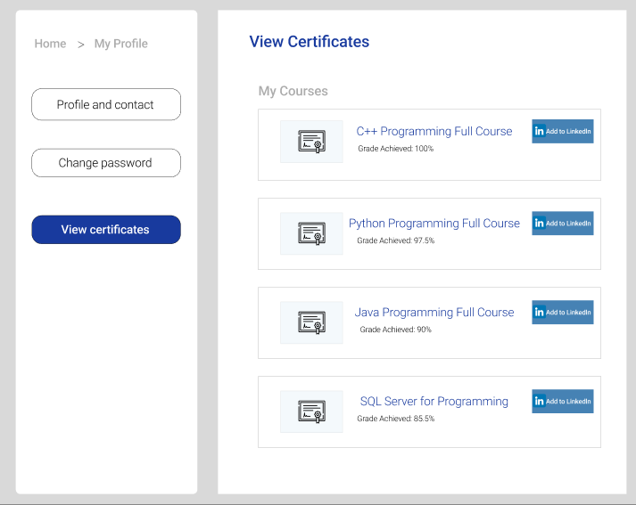

## a. Issue, view, and download certificates after course completion.

**Function trigger:**

* This function is triggered upon the successful completion of a course by a student.

**Function description:**

* Actors/Roles:
  + Role 1: Admin (Manage certificates)
  + Role 2: Instructor (Issue certificates)
  + Role 3: Student (View and download certificates)
* Purpose: Allow users to issue, view, and download course completion certificates, ensuring recognition of achievements for students.
* Data processing: The system retrieves course completion data from the database and generates certificates based on user roles.

**Function details:**

* Issue Certificates (Role 2 - Instructor):
  + Instructors can issue certificates to students who have successfully completed their courses.
  + After verifying that all course requirements have been met, instructors can initiate the certificate issuance process.
  + The certificate will include the student’s name, course title, completion date, and the instructor’s signature.
  + Validation: The system checks if the student has completed all necessary components of the course before allowing the issuance of a certificate.
* View Certificates (Role 1 - Admin and Role 2 - Instructor):
  + Admins and instructors can view a list of issued certificates for their respective courses.
  + They can access details such as student names, course titles, issue dates, and status (e.g., pending, issued).
  + Admins can also view statistics regarding certificate issuance across all courses.
* Download Certificates (Role 3 - Student):
  + Students can view and download their course completion certificates once issued.
  + After successful completion, students will receive a notification indicating that their certificate is available for download.
  + Students can access their certificates from their profile or course completion page and download them in a PDF format.
* Business Logic:
  + Certificates will be automatically generated based on a predefined template once the course is completed.
  + Students will be notified via email or in-app notification when their certificates are ready for download.
  + The system should maintain a secure record of issued certificates to prevent forgery and maintain data integrity.

## 10. Feedback Management

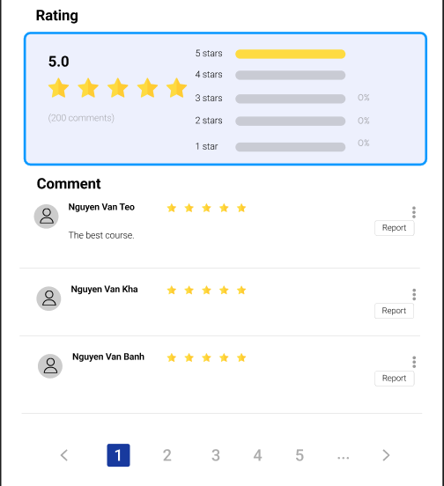

## a. Submit and manage feedback for courses, including review responses

**Function trigger**:

* This function is triggered when a user submits feedback for a course or responds to reviews.

**Function description**:

* Actors/Roles:
  + Role 1: Admin
  + Role 2: Instructor
  + Role 3: Student
* Purpose: Allow users to submit, view, and manage feedback for courses, facilitating continuous improvement and responsiveness to student needs.
* Data processing: The system collects feedback data from users and allows for the management of responses based on user roles.

**Function details**:

* Submit Feedback (Role 3 - Student):
  + Students can submit feedback on courses they have completed, providing insights on their learning experience.
  + Feedback may include ratings (e.g., 1 to 5 stars), comments, and suggestions for improvement.
  + Students can submit feedback anonymously or with their name displayed, depending on system settings.
  + Validation: Ensure that all required fields (e.g., rating, comments) are completed before submission.
* View Feedback (Role 1 - Admin and Role 2 - Instructor):
  + Admin (Role 1):
    - * Admins can view all feedback submitted for any course, including ratings, comments, and submission dates.
      * They can generate reports to analyze overall course performance and student satisfaction.
        + Instructor (Role 2):
      * Instructors can view feedback specifically related to their courses, enabling them to assess student satisfaction and areas for improvement.
      * Instructors may also see aggregate ratings and trends over time.
* Manage Feedback (Role 1 - Admin and Role 2 - Instructor):
  + Admin (Role 1):
    - * Admins can manage all feedback, including the ability to edit or delete inappropriate comments.
      * They can also respond to feedback as necessary to address student concerns.
        + Instructor (Role 2):
      * Instructors can respond to feedback submitted by students, thanking them for positive comments or addressing concerns raised.
      * Responses may be visible to other students, fostering a sense of engagement and transparency.
* Business Logic:
  + - * + The system will notify students when their feedback has been responded to, encouraging continued engagement.
        + Feedback will be stored securely and made available for review in a way that respects student privacy.
        + Admins and instructors can analyze feedback trends over time to inform course improvements and instructional strategies.

## 11.Achievement Management

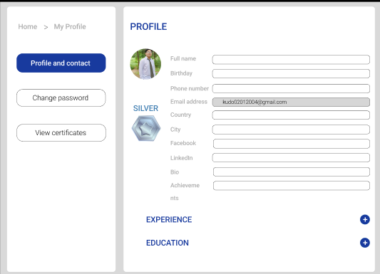

## a. View and track achievements related to courses and certifications.

**Function trigger:**

* This function is triggered when a user accesses their achievements section from their profile or dashboard.

**Function description:**

* Actors/Roles:
  + Role 1: Admin
  + Role 2: Instructor
  + Role 3: Student
* Purpose: Allow users to view and track their achievements related to completed courses and certifications, providing insights into their learning progress and accomplishments.
* Data processing: The system retrieves achievement data from the database and displays it to users based on their roles.

**Function details:**

* View Achievements (All Roles):
  + Users can view a summary of their achievements, which may include:
    - Completed courses with completion dates
    - Earned certifications with issue dates
    - Badges or recognitions received for course participation or excellence
  + Business Logic: The system should categorize achievements by type (e.g., courses completed, certifications earned) and provide an overall summary.
* Track Achievements (Role 3 - Student):
  + Students can track their progress over time, seeing how many courses they have completed and the certifications they have earned.
  + They may also view progress toward specific goals, such as completing a series of courses for a specialized certification.
  + Students can receive notifications or alerts for milestones (e.g., completing a certain number of courses).
* Manage Achievements (Role 1 - Admin and Role 2 - Instructor):
  + Admin (Role 1):
    - Admins can view achievements for all users, generating reports on course completions and certification issuances.
    - They can analyze trends in student achievements to assess program effectiveness and areas for improvement.
  + Instructor (Role 2):
    - Instructors can view achievements of students enrolled in their courses, tracking performance and engagement levels.
    - They can see a list of students who have completed their courses and earned certifications, allowing them to offer additional support or recognition.

## 12. Interact With Chatbot

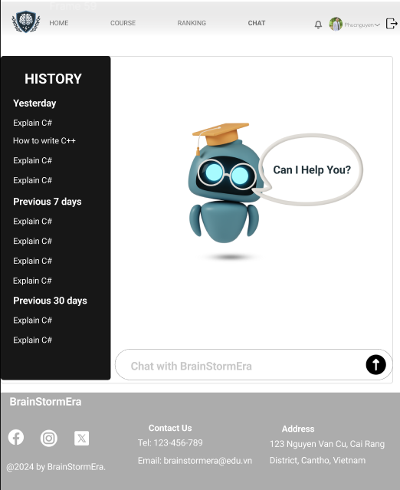

## a. Use the chatbot for support, queries, and assistance.

**Function trigger:**

* This function is triggered when a user initiates a chat session with the chatbot for support or assistance.

**Function description:**

* Actors/Roles:
  + Role 2: Instructor
  + Role 3: Student
* Purpose: Provide a chatbot interface that allows users to ask questions, seek assistance, and receive support regarding courses and related queries.
* Data processing: The chatbot processes user inquiries and provides relevant responses based on pre-defined FAQs and AI-driven responses.

**Function details:**

* Chatbot for Queries (Role 3 - Student):
  + Students can interact with the chatbot to ask questions related to course content, enrollment processes, assignment submissions, and other student-specific inquiries.
  + The chatbot can provide instant responses to frequently asked questions, directing students to relevant resources or support personnel if necessary.
  + If the chatbot cannot answer a question, it should provide an option for students to escalate the inquiry to a human support representative.
* Chatbot for Support (Role 2 - Instructor):
  + Instructors can use the chatbot to seek assistance with course management tasks, including troubleshooting issues related to course materials, student submissions, and grading.
  + The chatbot can also provide updates on student engagement, performance metrics, and course-related announcements.
  + Similar to students, instructors can escalate complex queries that require human intervention.
* Business Logic:
  + The chatbot should be available 24/7 to assist users, ensuring that support is accessible at all times.
  + The system will log interactions with the chatbot to help improve responses and identify common issues faced by users.
  + User feedback on chatbot interactions should be collected to enhance its capabilities and responsiveness over time.

## 

## 13. Notification Management

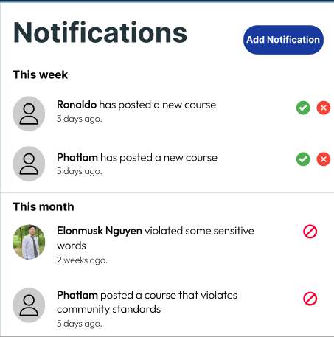

## a. Manage notification settings and view updates for courses and actions.

**Function trigger:**

* This function is triggered when a user accesses their notification settings or views updates related to their courses and actions.

**Function description:**

* Actors/Roles:
  + Role 1: Admin
  + Role 2: Instructor
  + Role 3: Student
* Purpose: Allow users to manage their notification preferences and view important updates regarding courses, assignments, and other actions related to their roles.
* Data processing: The system retrieves user preferences and displays relevant updates based on their roles and settings.

**Function details:**

* Manage Notification Settings (All Roles):
  + Users can access a notification settings page to customize how they receive notifications related to their courses and actions.
  + Notification preferences may include options for:
    - Email notifications
    - In-app notifications
    - SMS notifications
    - Frequency of notifications (immediate, daily, weekly)
  + Users can toggle notifications on or off for specific actions, such as:
    - New course announcements
    - Assignment deadlines
    - Grades posted
    - Course updates from instructors
  + Business Logic: Changes to notification settings will be saved to the user’s profile and reflected in their future communications.
* View Course Updates (All Roles):
  + Users can view a list of recent updates related to their courses, including:
    - Announcements made by instructors
    - Changes to course schedules or content
    - New assignments or assessments posted
    - Responses to submitted queries or feedback
  + Updates will be displayed in chronological order, allowing users to easily track important information.
  + Users will receive notifications for critical updates, ensuring they stay informed about significant changes.