|  |  |
| --- | --- |
| Logo_FPT_University_doc | **MINISTRY OF EDUCATION AND TRAINING** |

**FPT UNIVERSITY**

**CAPSTONE PROJECT DOCUMENT**

**AGC**

**Report #1 – Project Introduction**

|  |  |
| --- | --- |
| **Tra Da** | |
| **Group Member** | SE03193- Nguyen Hoang |
| SE03271- Hoang Van Canh |
| SE03334- Nguyen Huu Thao |
| SE03030- Vu Hoang Hieu |
| SE03451- Soulivong Phimmathong |
| **Supervisor** | Nguyen Van Sang |
| **Project Code** | AGC |

- Hanoi, 04/2016 -

Table of Contents

[1 INTRODUCTION 3](#_Toc452318826)

[1.1 Purpose 3](#_Toc452318827)

[1.2 Acronyms and Definitions 3](#_Toc452318828)

[2 ABSTRACT 3](#_Toc452318829)

[3 LITERATURE REVIEW 3](#_Toc452318830)

[4 PROPOSAL 7](#_Toc452318831)

[4.1 The idea 7](#_Toc452318832)

[4.2 Objectives 8](#_Toc452318833)

[4.3 Brief description about system 8](#_Toc452318834)

[4.4 System features 10](#_Toc452318835)

[5 BENEFIT FROM PROJECT 11](#_Toc452318836)

[5.1 For our group 11](#_Toc452318837)

[5.2 For Community 11](#_Toc452318838)

[6 CRITICAL ASSUMPTION AND CONSTRAINTS 11](#_Toc452318839)

[7 POTENTIAL RISKS 12](#_Toc452318840)

[8 REFERENCES 12](#_Toc452318841)

# INTRODUCTION

## Purpose

This report provides an overview of AGC project – our Capstone Project in FPT University. It includes background information, literature review of existing systems, the initial idea of this project, a brief description about our expected system and some potential risks, critical assumptions, constraints, also some benefits for our group and website users.

## Acronyms and Definitions

|  |  |  |
| --- | --- | --- |
| Acronym & Abbreviation | Definition | Note |
| AGC | Angi.com |  |
| PHP | Hypertext Preprocessor |  |
|  |  |  |
|  |  |  |
|  |  |  |
|  |  |  |
|  |  |  |

Table 1-1: Definitions and Acronyms

# ABSTRACT

The development of technology and the increasing use of the Internet as a primary source of information lead to the introduction website explosively. This increasing on demand for better restaurant services; these changes in the habits of current and potential customers directly result with the need for significant changes in the development of Online marketing plan.

Almost restaurants currently do not have their own websites to be a channel for advertising, introducing and supporting their business. For the rest, the current system cannot afford the demand of customer like searching, comparing, communicating and reviewing the quality of services efficiently and optimally.

So, we have to connect all customers and restaurant owners, create mutual zone to share the market and bring the benefit for all of them. Furthermore, new expected website has to ensure that provides all functions for customers (seek information, compare, review, book table, order food and manage their booking); for restaurant owners (manage their site content, manage food order, customer booking on their restaurant); has friendly interface and easy to use.

# LITERATURE REVIEW

There are many restaurant & food websites, mobile applications, Facebook pages, blogs that introduce about restaurants, suggest users about places to eat, book a table, order food and manage their booking too such as: Lozi.vn, Foody.vn, etc.

**Facebook Page**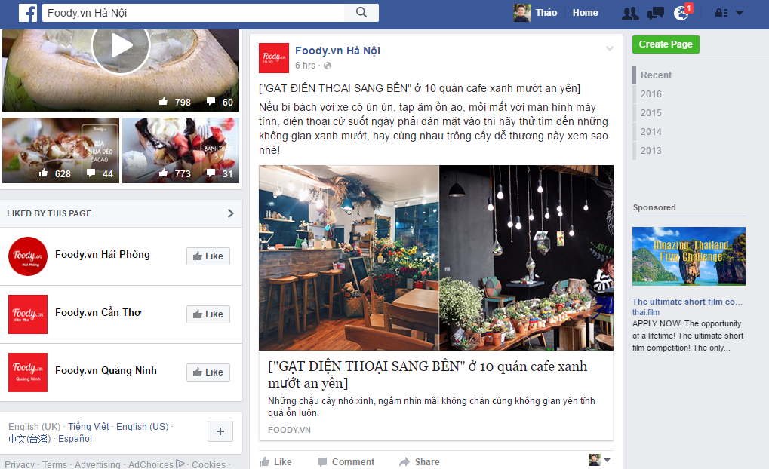

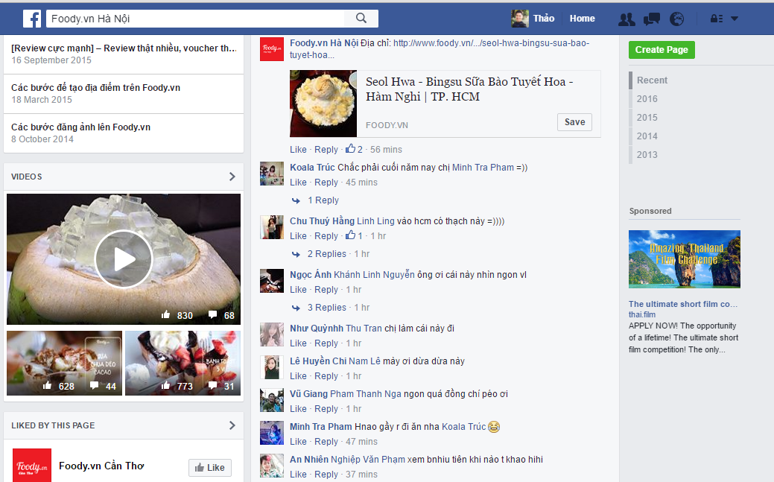

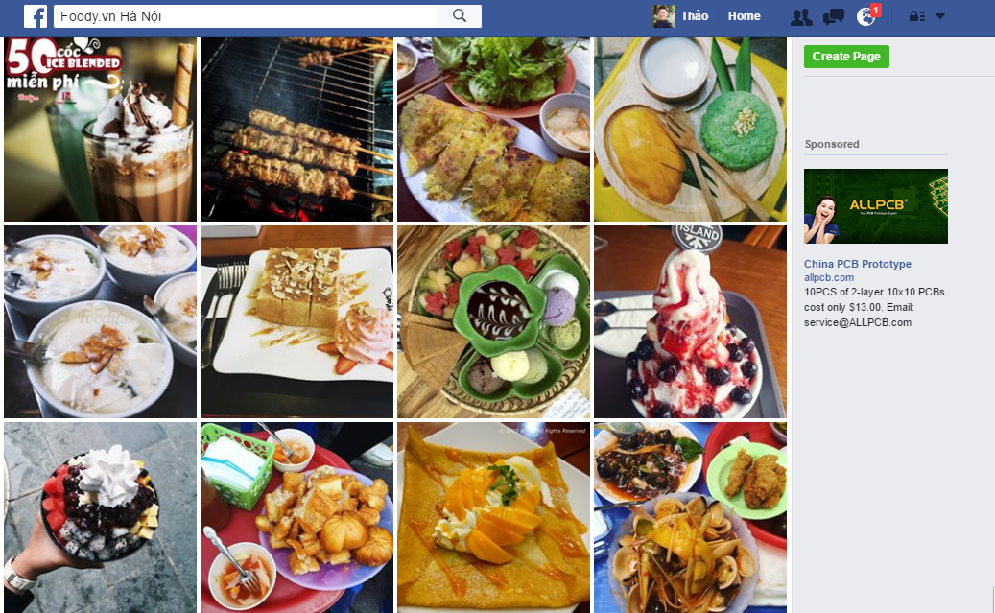

Figure 1‑1 Foody.vn Facebook Page

Facebook Page is one of most online social network which user to share information and interact in a large community. User can add others, view topic and get news from notifications.

Best selling point of Facebook Page is shop owners have a free space to communicate with others and the frequently of using.

However, with the functions provided in Facebook fan page, it only helps user to get news and review subjectively following the direction of admin. To afford demand of customer like: searching, comparing, reviewing & making reservation online efficiently – what social network likes Facebook, Tweeter cannot do, we need a website which supports more tools for these requirements.

**Restaurant & food website such as: Foody.vn & Lozi.vn**

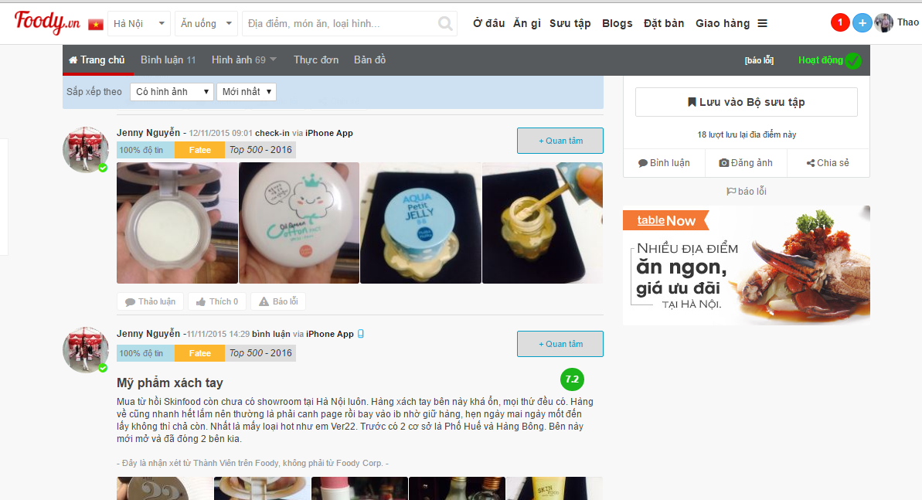

Figure 1‑2 a. Foody.vn

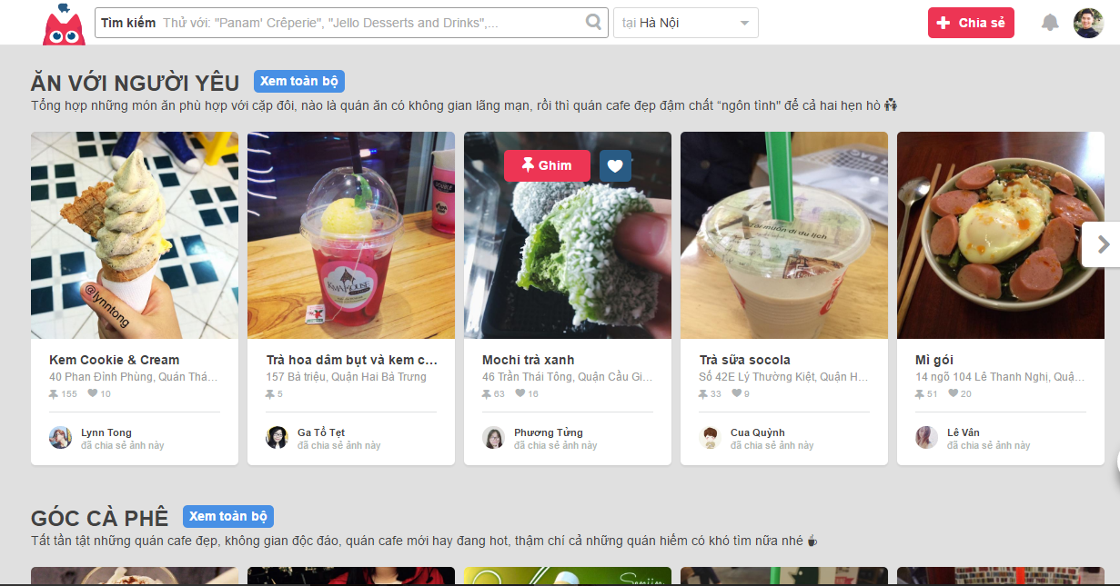

Figure 1‑2b. Lozi.vn

Foody.vn & Lozi.vn are two examples of most successful restaurant & food websites in Viet Nam. They provide all information about foods & places for users. User also can create post by upload picture and write review for a place. Easy to use and friendly imagine are the advantages to attract users.

However, those website still have some weakness affect choice of customer, such as: too many advertises; Website interface is hard for user to catch up direct information; the duplicate of information; clone accounts and quality of reviews also.

# PROPOSAL

## The idea

The ideas of creating a web application for introducing about restaurant & booking table online is not new; there are many existing websites now. However, our expected AGC web application is included main functions of current websites, have friendly user interface and easy to use.



## Objectives

This project is the Capstone Project for all team members. Firstly, we do this project to fulfill  
the requirements from FPT University studying program. During the time do this, we can  
learn how to develop a project, how to communicate with other team members, how to  
control time, how to do teamwork effectively. We also can work with some new technology – PHP, new frameworks: Codesigniter, MySQL Workbench, etc. Therefore, after finishing this project, we can practice what we have learnt in university and learn so many new things. It is very necessary for our future work after graduated from FPT University.

Secondly, we want to create a web application that helps user find information about restaurants, dining address; the promotions. It provides the users a more effective, easier and simpler way to book table. They can view, edit, and manage their booking too. Specially, this web application allows user to review the restaurant that they used services. So other user can refer to and make thier decision. The other special features of AGC is to enable users to order food on menu before coming so that they can enjoy the best services.

The difference between our system from the current restaurant and food website is that our website content is manage by restaurant owner users. They have to pay fee for administrator to have restaurant account. And they can manage (view, update, delete) their site content, manage (view, statistic) customer order/ booking on their restaurant. So, they can develop their business effectively.

## Brief description about system

This web application will includes most restaurants in Hanoi. It will be public for all Internet users to look for information about restaurant and food. However, they need to sign up to use full functions from the system. With friendly and simple interface, customer can easily find information, review restaurants, book table, order food, and manage their reservation; restaurant owner can manage their site content, manage (view, statistic) customer order/ booking on their restaurant. If they have any problem, they can get help from User Instruction and Feedback functions. This web application uses PHP technology platforms and browsers.

The picture below is the application feature flow:

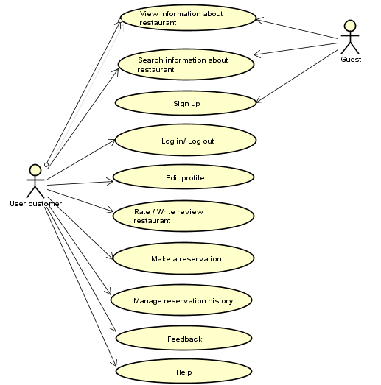

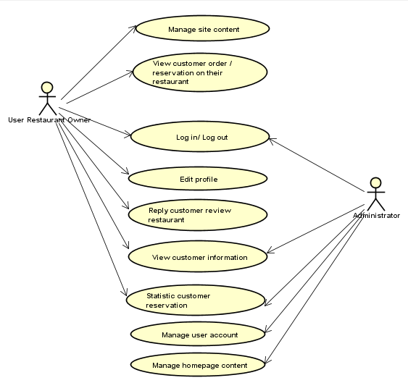

## System features

About the feature of AGC web application, it has main features of current rival products such as: For customers: they can view/ search information about restaurant & food, rate and write review for restaurant services, make reservation and manage their reservation, order food before coming, etc.

For restaurant owners: They can manage their site content, manage order/ booking on their restaurants, view and reply customer comments, view customer information, etc.

For administrators: They can manage account (customer and restaurant owner), manage home page content and view statistical number.

**There are the detailed functions of this application:**

General users (Guest & Customer):

* View Restaurant and food information.
* Search Restaurant and food information: By keyword, by category, by address,etc.

Guests:

* Sign up to become registed user.

Registed users (Customer & Restaurant owner):

* Login and Logout system.
* Manage their profile (Create, view, update, edit personal informations).
* Feedback with administrator.

Customers:

* Make reservation and order food.
* Write comment and review for the restaurant.
* Manage historical reservations (View, edit, delete reservations).

Restaurant owner users:

* View and reply comments of customers.
* Manage site content (View, edit, update, delete site content).
* View customer informations.
* View detail table booking and order.
* View detail statistical number of views, rating, table booking and order in their restaurants.

Administrators:

* Login/ Logout system.
* Manage user accounts (enable and disable account).
* View general statistical number of views, rating, table booking and order of restaurants.
* Manage homepage site content.

# BENEFIT FROM PROJECT

When this web application is developed and implemented successfully, our group and all  
users will gain the following benefits:

## For our group

After developing and implementing this project, our group will:  
• Have experiences in managing software project: How to make a plan, manage time  
and risk, etc. These experiences will help us a lot in our future work.  
• Know how to communicate with other team members and how to do teamwork  
efficiently.  
• Have chance to study new technology: PHP technology and frameworks: Codesigniter, Bootstrap, HTML5, JQuery, etc.   
• Complete Capstone Project successfully. And we can continue to develop it to be a start-up project and bring money for all team members.

## For Community

Our website will provide channel to help restaurant owners connect with customers effectively. On the other hand, customer can save their time, money and choose the restaurants those meet their need. They also can review and give feedback for restaurant to improve the quality of services.

For restaurant owners, they can have the best marketing engine to develop their business, save a lot of money. They can manage the food orders, manage bookings service easily; avoid overloading and have best preparation for special demand from customer. Finally, statistic function of system will give references for them to create the right marketing strategies.

# CRITICAL ASSUMPTION AND CONSTRAINTS

There are some critical assumptions that we realize after analyzing this project. The first  
assumption is about team members. We assume that all the developers can study new web  
technology - PHP in a short time. We do not know anything about it before this project, but we have to study hard for not missing any deadline of project plan. Besides, we also assume all our  
members do not have any health problems, so they are not absent and can do their works. The  
second one is about devices – laptop. We assume they are always at good condition.  
There are also some constraints of our project. Firstly, we are international group so the misunderstanding between team members always happened and need more time to solve. Secondly, about the time and deadline, we have to finish project on time. It has no extra time for us to complete developing and deliver application to teachers. Besides, the reports need to be submitted before the deadline. Thirdly, about the quality, the application must be well enough for users to do main functions. Fourly, about the business requirements assumption, we assume that restaurants operate well and our system provides almost their needs. Finally, about the technique, out knowledge in web developing is not the high level. Therefore, with all the expected features that we gave before, we do not know if we can solve all of those or not. However, we will try our best to make our project successfully.

# POTENTIAL RISKS

After analyzing this project, we may be facing some risks:  
• Developing a web application by PHP technology is new with us, so it will take time for us to study and may be later we will have some technical problems.  
• With the short duration - about 3 months – we will not have enough time to do all  
things and miss the delivery deadline.  
• We do not have any experiences in software project management such as time  
management, risk management etc. Therefore, our project plan will be not good and  
completed. So maybe we will miss the deadline or have some unknown risks.  
• It is the first time we manage big project like this, we do not have much experiences  
in communicating between the team. So maybe in the future, we will have conflict  
and argument and we will not finish all the works in time.  
• About the device, all team members have different laptop with different configuration so we will have some difficulties in installing and testing application.  
• Maybe we will lose source code or device during the developed time.

# REFERENCES

[1] Foody.vn Hà Nội, viewed 23/5/2016

https://www.facebook.com/FoodyHaNoi/?fref=nf

[2] Foody.vn website, viewed 23/5/2016

<http://www.foody.vn/ha-noi>

[3] Lozi.vn website, viewed 23/5/2016

http://lozi.vn/a/ha-noi