|  |  |
| --- | --- |
|  | **MINISTRY OF EDUCATION AND TRAINING** |

**FPT UNIVERSITY**

**CAPSTONE PROJECT DOCUMENT**

**AGC**

**Report #2 – Software Project Management Plan**

|  |  |
| --- | --- |
| **Tra Da** | |
| **Group Member** | SE03451 – Soulivong Phimmathong |
| SE03271 – Hoang Van Canh |
| SE03030 – Vu Hoang Hieu |
| SE03193 – Nguyen Hoang |
| SE03334 – Nguyen Huu Thao |
| **Supervisor** | Nguyen Van Sang |
| **Project Code** | AGC101 |

- Hanoi, 05/2016 – 8/2016

Table of Contents

1 INTRODUCTION 3

1.1 Purpose 3

1.2 Definition and Acronyms 3

1.3 References 3

2 PROJECT OVERVIEW 4

2.1 Project Description 4

2.2 Scope 4

2.3 Standard Objectives 4

2.4 Milestone and Deliverables 4

3 PROJECT ORGANIZATION 6

3.1 Software Process Model 6

3.2 Project lifecycle 6

3.3 Organizational Chart 7

3.4 Roles and Responsibilities 8

4 TOOLS AND INFRASTRUCTURES 9

4.1 Development tool 9

4.2 User system requirements 10

5 SCHEDULE 10

5.1 Detailed Schedule 10

5.2 Meeting Schedule 10

5.3 Effort Estimation 11

6 RISK MANAGEMENT 11

6.1 Risk Register 11

6.2 Risk probability and impact matrix 11

7 QUALITY MANAGEMENT 12

7.1 Quality Checklist 12

7.2 Quality Assurance 14

7.3 Quality Control 14

8 CODING CONVENTION 15

8.1 Php naming convention 15

8.2 File naming convention 15

# INTRODUCTION

## Purpose

The purpose of this document is to be used as a guide for AGC software development process, it briefly describes steps of what to be doing first and later. This document will be used by project manager and ensure to complete the project successfully.

## Definition and Acronyms

|  |  |  |
| --- | --- | --- |
| Acronym & Abbreviation | Full form | Definition |
| AGC | Angi.com | Project name |
| AGC | AGC | Project code |
| SRS | Software Requirements Specification | A document |
| SPMP | Software Project Management plan | A document |
| SDD | Software Design Description | A document |
| STD | Software Test Documentation | A document |
| SUM | Software User’s Manual | A document |
| IDE | Integrated Environment Development | Software development tool |
| QA | Quality Assurance |  |
| QC | Quality Control |  |

Table 1 Definitions and Acronyms

## References

*Information Technology Project Management | 7e Kathy Schwalbe textbook.*

<http://www.projectmanagementdocs.com/project-documents/quality-checklist.html#axzz49LxmQ8h0>

<https://en.wikipedia.org/wiki/Rational_Unified_Process>

*AGC_WorkSchedule.mpp*

*AGC_Risk_Register.xlsx*

# PROJECT OVERVIEW

## Project Description

We plan to create a responsive website that assembles restaurants around Hanoi. The restaurant owners will be able to post their menus, services and detailed description about their restaurants on this website. On the other hand, the people who are looking for food or/and drink will be able to browse these information through ACG website.

## Scope

The website will gather restaurant information in Hanoi only and will contain the following functions:

**In Scope**

* Display a list of restaurants.
* Display restaurants information posted by restaurants owners.
* Book tables.
* Rate and review.

**Out scope:**

* Will not collect restaurant information outside Hanoi.
* Will not develop mobile web application.
* Will not create functions for users to choose menus from the website.
* Will not provide online payment through the website.

## Standard Objectives

1. Must deploy the project before August 27, 2016.
2. Fulfil all requirements specified in SRS.
3. Submit all reports to FPT university capstone stone project committees and academic department.

## Milestone and Deliverables

* ***Milestones***

|  |  |  |
| --- | --- | --- |
| **No** | **Milestones** | **Date** |
| 1 | Held kick – off meeting | 9-Apr-16 |
| 2 | Establish team advisor | 12-Apr-16 |
| 3 | Define project and system scope | 23-Apr-16 |
| 4 | Complete draft screen prototypes | 13-May-16 |
| 5 | Create work breakdown structure | 19-May-16 |
| 6 | Create project schedule | 20-May-16 |
| 7 | Complete draft requirements | 25-May-16 |
| 8 | Complete main functions and processes | 1-Jun-16 |
| 9 | Complete ERD | 6-Jun-16 |
| 10 | Complete detail database design | 10-Jun-16 |
| 11 | Develop report no.4 software design description | 24-Jun-16 |
| 12 | Complete coding | 10-Jul-16 |
| 13 | Submit report no.5 final version | 21-Jul-16 |
| 14 | Deliver tested codes (Code demo 1) | 25-Jul-16 |
| 15 | Submit report no.6 final version | 1-Aug-16 |
| 16 | Submit all documents and CD source code last version | 4-Aug-16 |
| 17 | Represent capstone project and close the project | 27-Aug-16 |

Table 2 Milestones

* ***Deliverables***

|  |  |  |  |  |
| --- | --- | --- | --- | --- |
| **No** | **Deliverables** | **Format** | **Delivery Date** | **Delivery Method** |
| **1** | Report No.1 Introduction | .pdf | May 16, 2016 | Email |
| **2** | Report No. 2 SPMP | .pdf | May 23, 2016 | Email |
| **3** | AGC_WorkSchedule | .mpp | May 23, 2016 | Email |
| **4** | AGC_Risk_Register | .xlsx | May 23, 2016 | Email |
| **5** | Report No. 3 SRS | .pdf | June 7, 2016 | Email |
| **6** | Report No. 4 SDD | .pdf | June 24, 2016 | Email |
| **7** | Report No.5 STD | .pdf | July 21, 2016 | Email |
| **8** | Report No.6 SUM | .pdf | August 1, 2016 | Email |
| **9** | The CD - Source Code Executable Program Package | .rar | August 4, 2016 | Hand directly by hand |
| **10** | Final documentation | .pdf | August 4, 2016 | Email |

Table 3 Deliverables

# PROJECT ORGANIZATION

## Software Process Model

We use Rational Unified Process model to develop AGC website.

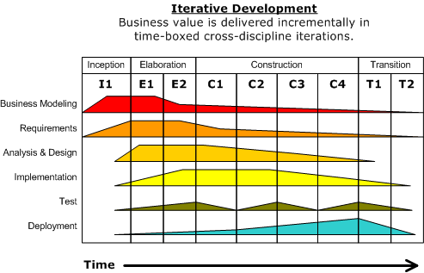

## Project lifecycle

There are 4 phases in this development:

1. **Inception phase**

This is a first phase of project development. We plan to develop business case, software project management plan and prototype. Define scope, cost and schedule.

1. **Elaboration phase**

During this phase, we further analyze and complete the work in the Inception phase. After this stage we should have been able to decide whether the project is worth develop or not.

1. **Construction phase**

During this phase, all remaining components and application features are developed and integrated into the product. The main activities will be coding and testing.

1. **Transition phase**

Is the last phase in this software development life cycle, where the final product is created and deploy.

## Organizational Chart

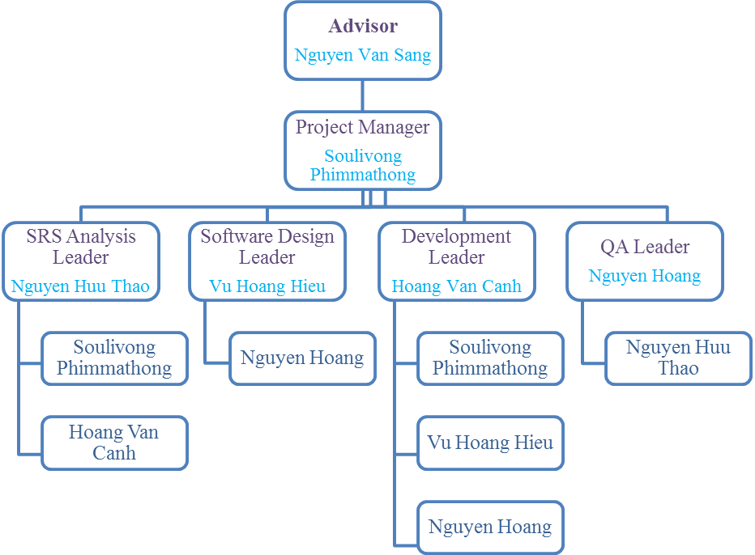

Figure 1 AGC101 Organizational Chart

## Roles and Responsibilities

|  |  |  |
| --- | --- | --- |
| **Full Name** | **Roles** | **Responsibilities** |
| **Nguyen Van Sang** | Team Advisor | * Provide team direction. * Give team consultation. * Approve all deliverables. * Approve project success or fail. |
| **Soulivong Phimmathong** | Project Manager | * Encourage and motivate members. * Divide and assign tasks. * Oversee of overall project. * Create SPMP. * Control work quality. |
| **SRS Analysis** | | |
| **Nguyen Huu Thao** | SRS Analysis Leader | * Lead collecting and analyzing software requirements. * Complete SRS documentation. |
| **Soulivong Phimmathong** | SRS Analysis member | * Work closely with the SRS analysis leader. |
| **Software Design** | | |
| **Vu Hoang Hieu** | Software design Leader | * Lead and design the look and feel of the end software. * Complete SDD documentation. |
| **Nguyen Hoang** | Software design member | * Work closely with the Software design leader. |
| **Development** | | |
| **Hoang Van Canh** | Development Leader | * Lead coding team. * Demonstrate the completed software. |
| **Soulivong Phimmathong** | Development member | * Work closely with the Development leader. |
| **Vu Hoang Hieu** | Development member | * Work closely with the Development leader. |
| **Nguyen Hoang** | Development member | * Work closely with the Development leader. |
| **Testing** | | |
| **Nguyen Hoang** | QA Leader | * Lead Testing team. * Complete STD. |
| **Nguyen Huu Thao** | QA member | * Work closely with the testing leader. |

Table 4 Roles and Responsibilities

# TOOLS AND INFRASTRUCTURES

## Development tool

|  |  |
| --- | --- |
| **Hardware** | **Detail** |
| **5 Laptop computers** | With minimum: 4GB RAM, 500GB Hard disk and Intel core i5, 1.80 GHz |
| **Smart phone** | Android and IOS |

Table 5 Hardware tool

|  |  |  |
| --- | --- | --- |
| **Category** | **Software** | **Version** |
| **IDE** | Netbeans IDE | 8.1 |
| MySQL Workbench | 6.3 CE |
| **Operating system** | Windows 7, 10 | Home, Professional, Education |
| **Communication** | Facebook |  |
| Email |  |
| Skype |  |
| **Documentation** | Microsoft Word | 2013 |
| Microsoft Excel | 2013 |
| Microsoft PowerPoint | 2013 |
| **Database** | MySQL |  |
| **Data Repository** | Google Drive |  |
| Git Hub |  |
| Facebook |  |
| **Design** | https://www.draw.io/ |  |
| https://pidoco.com/ |  |
| **Server** | Apache Tomcat | 8.0.27.0 |

Table 6 Software tools

## User system requirements

Users must have internet access and browsers installed.

# SCHEDULE

## Detailed Schedule

*See AGC_WorkSchedule.mpp for details.*

## Meeting Schedule

The meeting will be held once in a week, In order to plan, in order to accomplish the goals we have the 2 following kind of meeting

1. **Team with the Advisor**:

The advisor will call for the meeting once in a week on the weekday between 12:20 to 1:00 PM based on the day available. The meeting agenda includes guiding, reviewing, and giving recommendations from the advisor. Finally, questions from members are asked and answered instantly. The meeting result will be recorded in a note, then this note will be posted on Google Drive group folder.

1. **Team meeting**

The meeting will be held officially once a week, The PM will create meeting agenda, specifically include reviewing the previous work, plan for incoming tasks and assign members to carry out the tasks. All team meeting result will be posted in Google drive and all assigned tasks will be posted on Tra Da Facebook group.

Furthermore, we also have many minor meeting via instant messages on Facebook chat group.

## Effort Estimation

|  |  |  |  |
| --- | --- | --- | --- |
| **Task name** | **Worst case(days)** | **Best case(days)** | **Expected case(days)** |
| **Initiation** | **52** | **38** | **45** |
| **Solution** | **39** | **25** | **32** |
| **Construction** | **59** | **45** | **52** |
| **Transition** | **31** | **17** | **24** |
| **Total** | **181** | **125** | **153** |

Table 7 Effort estimation

# RISK MANAGEMENT

## Risk Register

*See AGC_Risk_Register.xlsx file for detail.*

## Risk probability and impact matrix

|  |  |  |  |  |
| --- | --- | --- | --- | --- |
| **Probability** | **High**  **Medium**  **Low** | **R10** | **R4** | **R1** |
|  | R2, R5, R6 |  |
| R9 | R3, R7, R8 |  |
| **Low** **Medium** **High** | | | |
| **Impact** | | | | |

Table 8 Probabilities and impact matrix

# QUALITY MANAGEMENT

## Quality Checklist

|  |  |  |  |  |  |  |
| --- | --- | --- | --- | --- | --- | --- |
| **Quality Checklist** | | | | | | |
| **Project: AGC101** | | | | | **Date: 22 May 2016** | |
|  | **Verification** | | | | | |
| **Quality Item** | **Yes** | **No** | **N/A** | **Date** | | **Comments** |
| **Does the project have an approved quality management plan?** |  |  |  |  | |  |
| **Has the quality management plan been reviewed by all stakeholders?** |  |  |  |  | |  |
| **Do all stakeholders have access to the quality management plan?** |  |  |  |  | |  |
| **Is the quality management plan consistent with the rest of the overall project plan?** |  |  |  |  | |  |
| **Have product quality metrics been established, reviewed, and agreed upon?** |  |  |  |  | |  |
| **Have process quality metrics been established, reviewed, and agreed upon?** |  |  |  |  | |  |
| **Is the project team familiar with the project's quality review process?** |  |  |  |  | |  |
| **Does the project have an appropriate number of resources assigned for quality assurance and control?** |  |  |  |  | |  |
| **Has the project team established a repository for all quality documentation?** |  |  |  |  | |  |
| **Do all team members have access to the quality documentation repository?** |  |  |  |  | |  |
| **Have all appropriate team members been notified of their required participation in quality reviews?** |  |  |  |  | |  |
| **Have quality responsibilities been assigned and documented and the applicable personnel notified?** |  |  |  |  | |  |
| **Have product and process quality standards been established, documented, and communicated?** |  |  |  |  | |  |
| **Have quality thresholds and limits been established, documented, and communicated?** |  |  |  |  | |  |
| **Does the change control process accommodate project changes based on quality improvements?** |  |  |  |  | |  |
| **Has a project quality manager been assigned?** |  |  |  |  | |  |
| **Is the project sponsor aware of his/her responsibilities relating to quality acceptance?** |  |  |  |  | |  |
| **Is the customer aware of his/her responsibilities relating to quality acceptance?** |  |  |  |  | |  |

Table 9 Quality checklist

## Quality Assurance

* ***Perform software testing level: Unit testing, Integration testing, System testing, and User acceptance testing.***
* ***Benchmarking by compare with the current website such as*** [***http://pasgo.vn/***](http://pasgo.vn/)

## Quality Control

* ***Use Check sheet to control defects as the template below:***

|  |  |  |  |  |  |  |  |  |
| --- | --- | --- | --- | --- | --- | --- | --- | --- |
| **Defect** | **Mon** | **Tue** | **Wed** | **Thu** | **Fri** | **Sat** | **Sun** | **Total** |
| **Defect #1** |  |  |  |  |  |  |  |  |
| **Defect #2** |  |  |  |  |  |  |  |  |
| **Defect #3** |  |  |  |  |  |  |  |  |
| **Defect #4** |  |  |  |  |  |  |  |  |
| **Defect #5** |  |  |  |  |  |  |  |  |

Table 10 Defect check sheet

* ***Use scatter diagram for user satisfaction and age of respondent as the template below:***

|  |  |  |  |  |  |  |
| --- | --- | --- | --- | --- | --- | --- |
| **Age of Respondent** | **70** |  |  |  |  |  |
| **60** |  |  |  |  |  |
| **50** |  |  |  |  |  |
| **40** |  |  |  |  |  |
| **30** |  |  |  |  |  |
| **20** |  |  |  |  |  |
| **10** |  |  |  |  |  |
| **0** | **2** | **2.5** | **3** | **3.5** | **4** |
| **User Satisfaction rating** | | | | | |

Figure 5 QC scatter diagram

# CODING CONVENTION

## Php naming convention

* ***ClassName – PascalCase***
* ***methodName – camelCase***
* ***propertyName – camelCase***
* ***functionName – camelCase***
* ***$variableName – camelCase***

## File naming convention

Specified a meaningful name and use underscores to separate space

Ex: Capstone_Project_Report2_SPMP.docx