

|  |
| --- |
| **FPT UNIVERSITY** |
| **Capstone Project Document** |
| **Angi.com web application** |
|  |
| |  |  | | --- | --- | | **Tra Da Team** | | | **Group Member** | Nguyễn Hoàng SE03193  Hoàng Văn Canh SE03271  Nguyen Huu Thao SE03334  Vu Hoang Hieu SE03030  Soulivong Phimmathong SE03451 | | **Supervisor** | Nguyễn Văn Sang | | **Capstone Project code** | AGC |   Hanoi, 05/2016 |

# Definitions and Acronyms

|  |  |  |
| --- | --- | --- |
| **Acronym** | **Definition** | **Note** |
| API | Application Programming Interface |  |
| AWS | Azure Web Service |  |
| CSRF | Cross-site request forgery |  |
| CSS | Cascading Style Sheets |  |
| DB | Database |  |
| DBMS | Database Management System |  |
| GUI | Graphical User Interface |  |
| HTML | Hypertext Markup Language |  |
| HTTP | Hypertext Transfer Protocol |  |
| IDE | Integrated Development Environment |  |
| JSON | JavaScript Object Notation |  |
| N/A | Not Available |  |
| ORM | Object Relational Mapping |  |
| PHP | Hypertext Preprocessor |  |
| PM | Project Manager |  |
| RAM | Random Access Memory |  |
| REST | Representational State Transfer |  |
| SRS | Software Requirement Specification |  |
| SSE | Server-sent Event |  |
| UC | Use Case |  |
| UI | User Interface |  |

Contents

Definitions and Acronyms 2

CHAPTER 1. INTRODUCTION 4

1.1 Purpose 4

1.2 Project Information 4

1.3 The People 4

1.3.1 Supervisor 4

1.3.2 Team Members 4

1.4 Problem 4

1.5 Literature Review 5

1.6 Ideas 6

1.7 Proposal of System 7

1.7.1 Our proposal system 7

1.7.2 Introduction about our proposal system 8

# INTRODUCTION

## Purpose

This report provides an overview of project include background information, literature review of existing system and raising a proposal for ideas of improvement.

## Project Information

* Project name: **Angi.com**
* Project code: **AGC**
* Project group name: **Tra Da**
* Product type: **Website application**
* Timeline: **From 4th May to 30th August 2016**

## The People

### Supervisor

|  |  |  |  |  |
| --- | --- | --- | --- | --- |
|  | **Full name** | **Phone** | **Email** | **Title** |
| Supervisor | Nguyễn Văn Sang | 0912210727 | [SangNV@fpt.edu.vn](mailto:SangNV@fpt.edu.vn) | Lecturer |

Table 1‑1 Supervisor’s information

### Team Members

|  |  |  |  |  |  |
| --- | --- | --- | --- | --- | --- |
| **No** | **Full name** | **Student ID** | **Phone Number** | **Email** | **Role in Group** |
| 1 | Soulivong Phimmathong | SE03451 | 01686476949 | [SoulivongSE03451@fpt.edu.vn](mailto:SoulivongSE03451@fpt.edu.vn) | Leader |
| 2 | Vũ Hoàng Hiếu | SE03030 | 01646223394 | [HieuVHSE03030@fpt.edu.vn](mailto:HieuVHSE03030@fpt.edu.vn) | Member |
| 3 | Nguyễn Hữu Thảo | SE03334 | 01687821254 | [ThaoNHSE03334@fpt.edu.vn](mailto:ThaoNHSE03334@fpt.edu.vn) | Member |
| 4 | Hoàng Văn Cảnh | SE03271 | 01665076026 | [CanhHVSE03271@fpt.edu.vn](mailto:CanhHVSE03271@fpt.edu.vn) | Member |
| 5 | Nguyễn Hoàng | SE03193 | 01698880299 | [HoangNSE03193@fpt.edu.vn](mailto:HoangNSE03193@fpt.edu.vn) | Member |

Table 1‑2 Team members’ information

## Problem

There are problems affect the development of the catering services industry today such as:

- Firstly, the demand for catering services of consumers increases explosively. However, each user has hobbies, habits and the need to use services differently. So, connecting all of them, create mutual zone to share the market is a big problem that we have to solve.

- Secondly, there are so many restaurants, places also caused headaches for users when considering or choosing to use the catering services from which provider. Customers are having difficulty on searching or choosing the address provided catering services suitable for their needs.

- Thirdly, It’s time to take advantage of new opportunities to promote catering servises. We are witnessing the rapid development of technology and the increasingly frequent use of the Internet as a primary source of information.These changes in the habits of current and potential customers directly result with the need for significant changes in the development of Online marketing plan.

- Fourly, most catering services vendor currently do not have own website pages aimed at advertising, introducing and supporting their business. The rest, almost website, forum about the catering services can not afford demand of customer like searching, comparing, communicating and reviewing the quality of services efficiently and optimally.

- Finally, all kind of electrical page nowadays include: online social networking service (Facebook, Google+), Forum do not have methods to ensure the objectivity and truthfulness of the post or the review from users due to the easy on account creation that lead to the wrong selection of user.

## Literature Review

**Facebook**

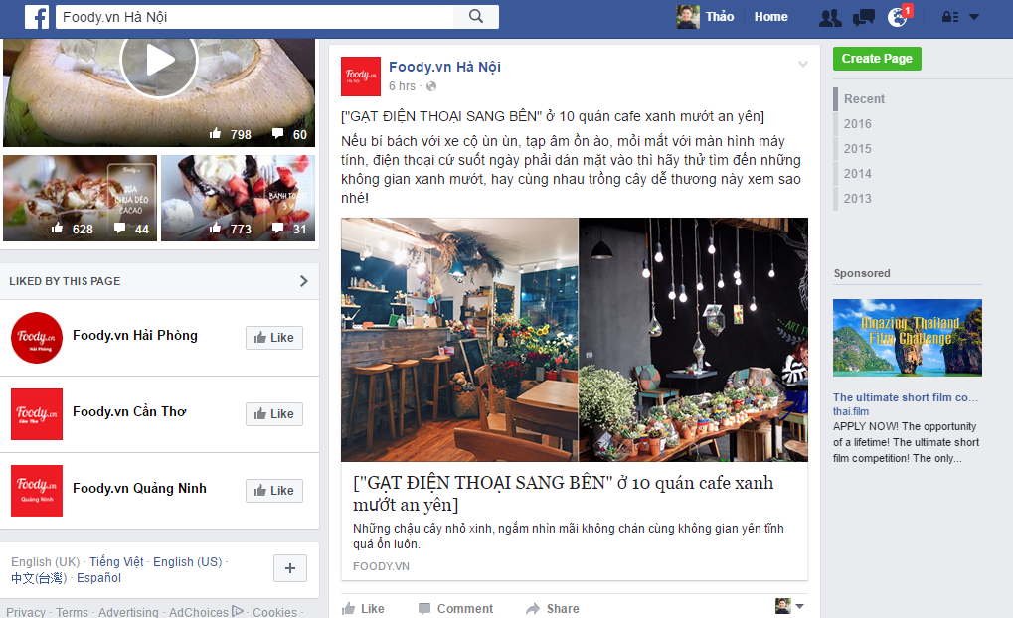

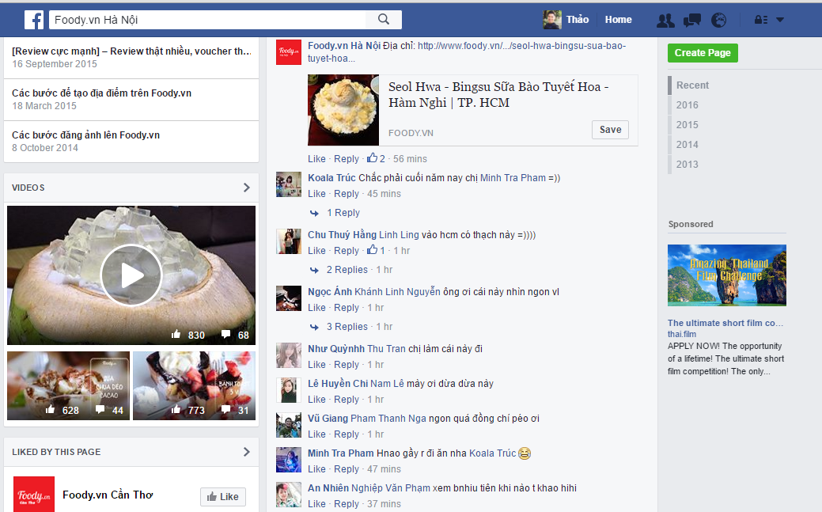

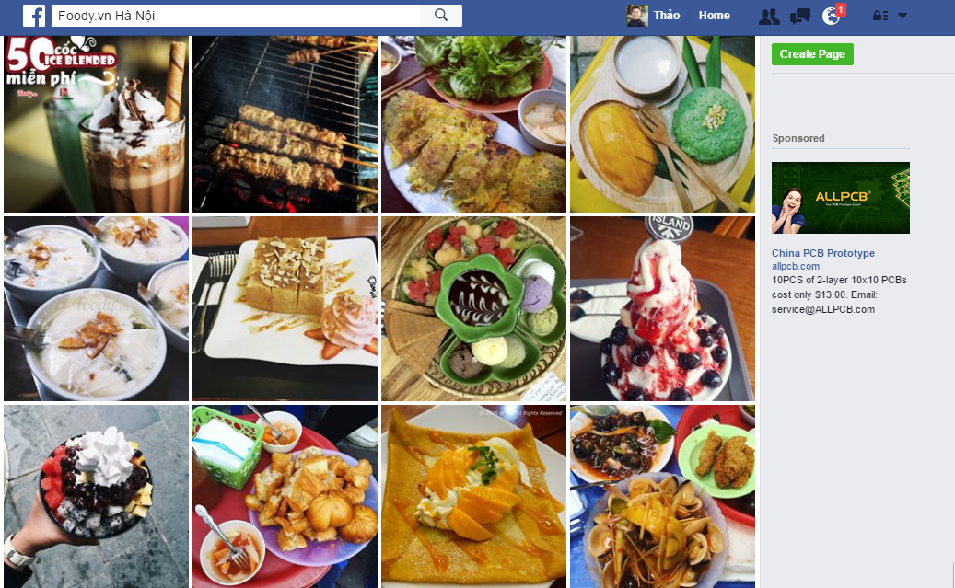

Figure 1‑1 Foody.vn Facebook

Facebook is one of most online social network which help customer to share information and interact in a large community. User can add others, view topic and get news from notifications.

Best selling point of Facebook is user have a free space to communicate with others and the frequently of using.

However, with the UI of Facebook, it just helps user get news and review subjectively following the direction of admin. To afford demand of customer like searching, comparing, reviewing & making reservation online efficiently – what social network likes Facebook, Tweeter can not do, and we need a website which supports more tools for these requirements.

**Foody.vn & Lozi.vn**

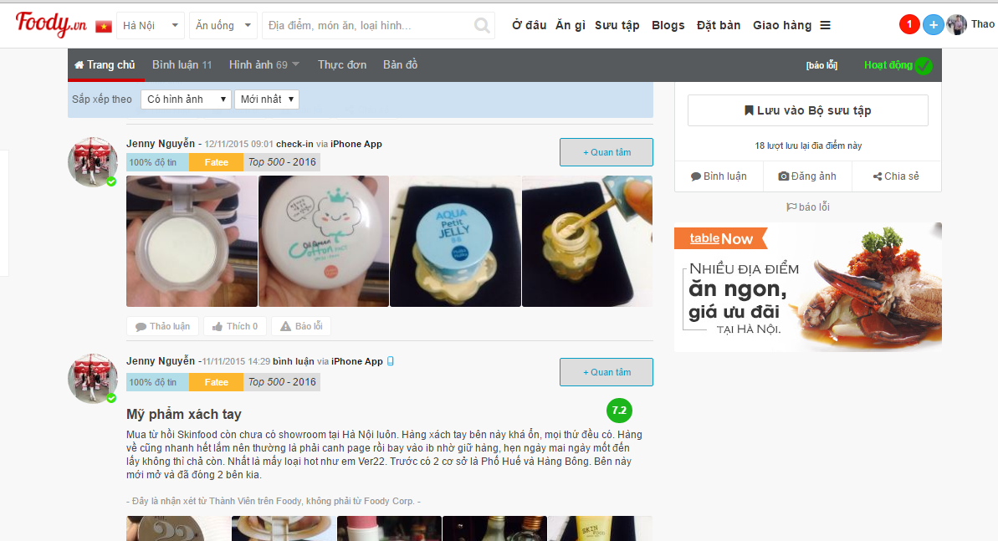

Figure 1‑2 a. Foody.vn

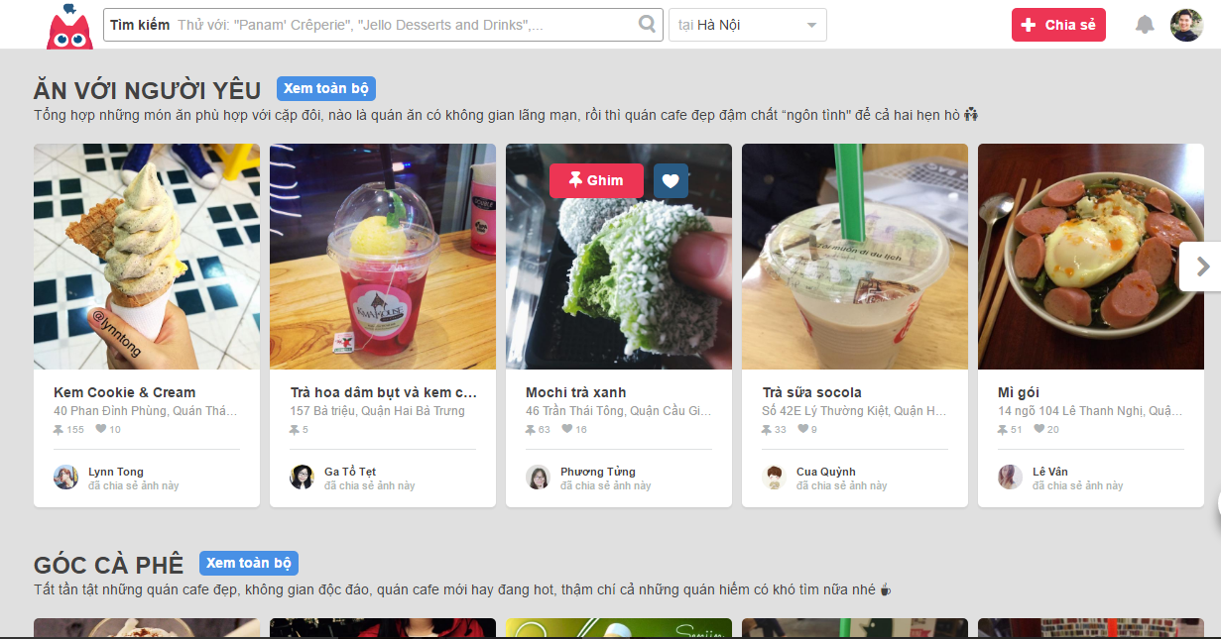

Figure 1‑2b. Lozi.vn

Foody.vn & Lozi.vn are two of most successful catering service websites in Viet Nam. They provide all informations about foods & places for user. User also can create post by upload picture and write review for a place. Easy to use and friendly imagine are the advantages to attach customer choose those websites.

However, those website still have some weakness affect choice of customer, such as: too many advertises Website interdface hard for user to catch up direct informations, duplicate informations, clone account and quality of reviews also.

## Ideas

As the engineering student that studies on e-commerce, we think our products to solve real problems of society. From this purpose, we started researching and found that the cateringservices industry is a potential market that has not fully exploited the value.

The object of this service sector is all of us who have, are and will be accessible to the internet for the purpose of search, reference and use the catering services. With huge numbers and difficult to control quality, users need a tool to get the necessary information, refer to the objective assessment and support in order to book a table online to save time and ensure best service.

Besides offering information, search for places to eat and support the table booking, customers using the website also enjoyed special privileges from product suppliers in terms of price than the usual way.

Before us, there were a number of social networking sites and similar sites. But it is very difficult for customers to use. So we decided to make our own website to better support users and promote the development of e-commerce industry in the area of ​​catering service.

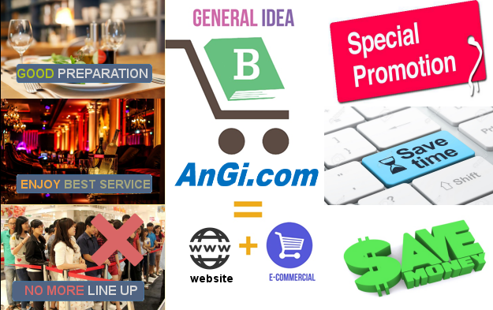

Figure 1‑3 Our Ideas

## Proposal of System

### Our proposal system

After research the user habits and analyze competitor websites available on the market, we decided that our website would focus on the basic, friendly and most useful functions in order to meet the needs of users. This website will provide official information about catering service and related functions like: search, compare, review and reservations. Simultaneously, we will limit the existing weaknesses in the current rival products, to maximize the advantages of our products in order to create competitions.

BASIC FUNCTIONS:

* For all people: can search foods, restaurants or categories with many search option, see content of posts and reviews from registed user.
* For registed user:
  + Allow user to create/update/edit their profile to provide the general information about their interests, contact, payment...etc that will be useful when they using functions of website: search, take reservations and contact with website administrator:
    - Allow user to write description and fill information about their hobbies, interests.
    - Allow user to add image
    - Allow user to edit information.
    - Allow user to change image by adding news if it’s uncorrected.
    - Allow user to update security for their account by update password.
  + Allow user to create their own profile page to:
    - Comment on post and feedback for the services they used in restaurant
    - Create reservation.
    - Review booking history.
  + Activities statistic
    - Top rated
    - Top promotion
    - List of new restaurant
  + Allow user sign in through another social network account ( Facebook)
* For Restaurant admin role, they can:
  + Create/ edit/ delete/ update posts about their services and menu.
  + They can create special promotions for users.
  + Restaurant admin can see all information about user reservations.
  + They can see their customer’s information.
* For Administrator role, they can:
  + Contact with user following their information.
  + Manage the content of banners
  + Manage accounts of Restaurant admin and user.
  + View user informations.
  + View & statistic about reservations.

OUT OF SCOPE FUNCTIONS:

* Switchboard
* Real time
* Mail contact

SPECIAL FUNCTIONS:

### Introduction about our proposal system

Based on the actual situation, users had difficulty on finding information and booking services in the restaurant dining. Users need to have a professional website which provides information, has effective and convenience functionality to support their needs, simultaneously promote the development of e-commerce in order to bring benefits to both customer and supplier of catering services. We decided to invest resources to solve this problem.

The system will have six types of pages: Home page, the Restaurant page, Menu/ Reservation page, Admin Page, User Profile Page, and Login / Registration page.

* In “Home page”, user will have an overview about restaurants (Name, Logo, Address, Promotion, and Rating). System will focus on some statistic and recommendation such as:
  + Top high rated restaurant.
  + Top promoted restaurant.
  + Top newest restaurant.
  + Top seller.
* In “Restaurant page”, user can find all detail about restaurant: Name, Address, Introduction, Contact, Review, Rating, Comment and Map also.
* In “Menu/ Reservation page”, user will see the menu, detail item menu and they can book table, order also.
* In “Login / Registration page”, user will see some fields that need to fill their information to complete Login/ Registration.
* In “Administrator Page”, user will manage user account; manage the number of booking (general statistic).
* In “User Profile Page”, user will see the registed detail informations about their account, they can edit, update their info also.
  + For Restaurant User Profile, they can see more information to manage their post, manage their restaurant booking/ order also.