**Folder Map**

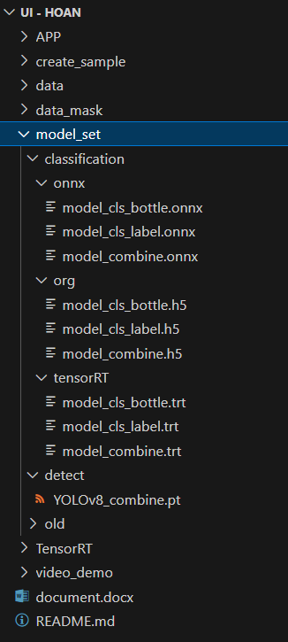

Link download model_set folder an video_demo folder:

<https://drive.google.com/drive/folders/1FriBIvQ1KnfTovB32yGta3KUmEnOen1B?usp=sharing>