**1 Singleton**

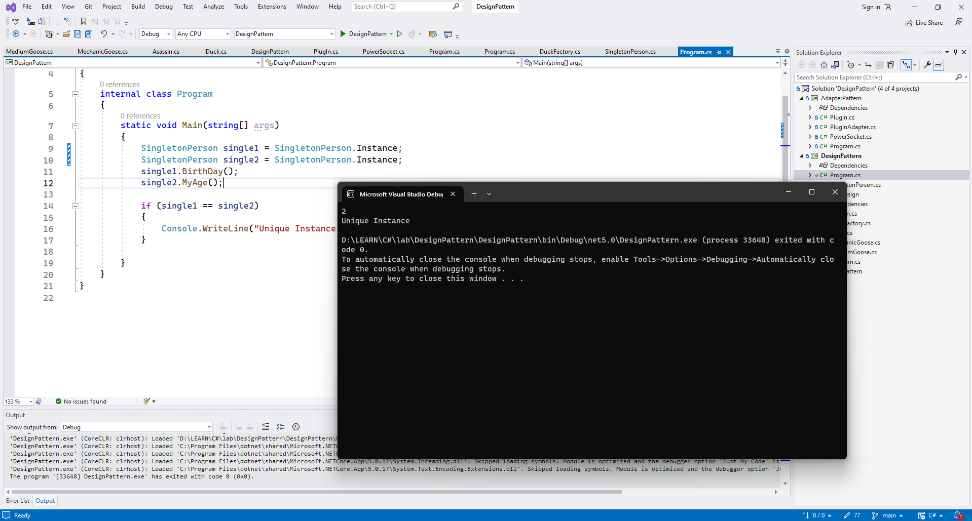

|  |
| --- |
| class Program  {  static void Main(string[] args)  {  SingletonPerson single1 = SingletonPerson.Instance;  SingletonPerson single2 = SingletonPerson.Instance;  single1.BirthDay();  single2.MyAge();  if (single1 == single2)  {  Console.WriteLine("Unique Instance");  }  }  } |

|  |
| --- |
| class SingletonPerson  {  private int Age { get; set; }  private SingletonPerson()  {  Age = 1;  }  public void BirthDay()  {  Age += 1;  }  public void MyAge()  {  Console.WriteLine($"{Age}");  }  public static SingletonPerson instance;  public static SingletonPerson Instance  {  get  {  if (instance == null)  {  instance = new SingletonPerson();  }  return instance;  }  }  } |

**2 Adapter**

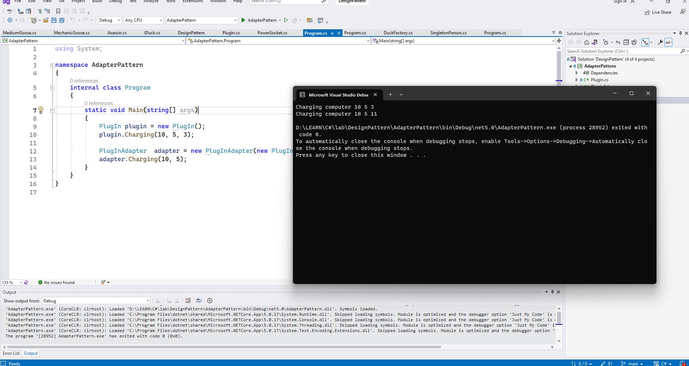

|  |
| --- |
| interface PowerSocket  {  void Charging(int x,int y,int z);  } |

|  |
| --- |
| class PlugIn : PowerSocket  {  public void Charging(int x,int y,int z)  {  Console.WriteLine($"Charging computer {x} {y} {z}");  }  } |

|  |
| --- |
| class PlugInAdapter  {  private PowerSocket powerSocket ;  public PlugInAdapter(PowerSocket powerSocket)  {  this.powerSocket = powerSocket;  }  public void Charging(int x,int y)  {  int z = (int) Math.Sqrt(x*x + y*y);  powerSocket.Charging(x, y, z);  }  } |

|  |
| --- |
| class Program  {  static void Main(string[] args)  {  PlugIn plugin = new PlugIn();  plugin.Charging(10, 5, 3);  PlugInAdapter adapter = new PlugInAdapter(new PlugIn());  adapter.Charging(10, 5);  }  } |

**3 Strategy**

|  |
| --- |
| interface Strategy  {  float DoDiscount(float price);  } |

|  |
| --- |
| class NoDiscount:Strategy  {  public float DoDiscount(float price)  {  return price;  }  } |

|  |
| --- |
| class HalfDiscount : Strategy  {  float Strategy.DoDiscount(float price)  {  return (float)(price * 0.5);  }  } |

|  |
| --- |
| class Context  {  private Strategy strategy;  public Context(){}  public Context(Strategy strategy)  {  this.strategy = strategy;  }  public void SetContext(Strategy strategy)  {  this.strategy = strategy;  }  public float GetPrice(float price)  {  return strategy.DoDiscount(price);  }  } |

|  |
| --- |
| class Program  {  static void Main(string[] args)  {  Context context = new Context();  context.SetContext(new HalfDiscount());  Console.WriteLine($"Price = {context.GetPrice(50000)}");  context.SetContext(new NoDiscount());  Console.WriteLine($"Price = {context.GetPrice(50000)}");  }  } |