dataDocumentation
Catherine dell’Olio
2025-10-20
#associate trees NMDS builder
#note: columns 76 through 103 are the trees presence/absence data
#MAKE CHANGES HERE
ordTrtData <- data_CPVTliveadults
trt_var <- "retention_strategy"
trt_0 <- "healthy"
trt_1 <- "unhealthy"
#END OF CHANGES
ordTrtData <- ordSetup(ordTrtData, trt_var, trt_0, trt_1)
trt <- ordTrtData %>% select("numID", "trt")
orddata <- ordTrtData[c(1, 76:103)]
ord <- invisible(ord_er(orddata))
plot_ano
plainNMDS(ord)
NMDS_centroids(ord)
NMDS_ellipses(ord)
#CHANGES HERE
ordTrtData <- data_ILMliveadults
trt_var <- "retention_strategy"
trt_0 <- "healthy"
trt_1 <- "unhealthy"
#END OF CHANGES
ordTrtData <- ordSetup(ordTrtData, trt_var, trt_0, trt_1)
trt <- ordTrtData %>% select("numID", "trt")
orddata <- ordTrtData[c(1, 76:103)]
ord <- invisible(ord_er(orddata))
plot_ano
plainNMDS(ord)
NMDS_centroids(ord)
NMDS_ellipses(ord)
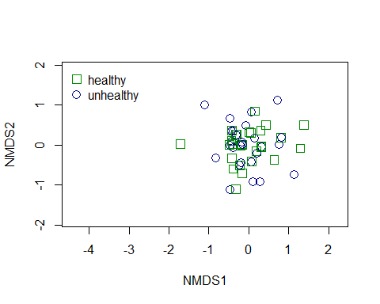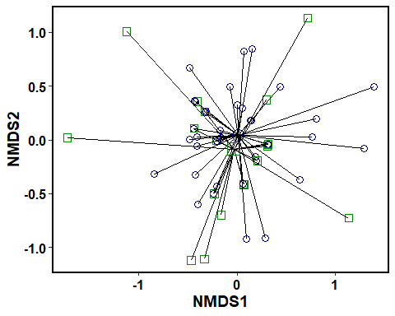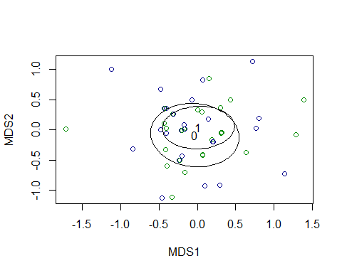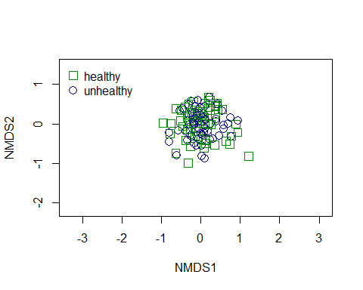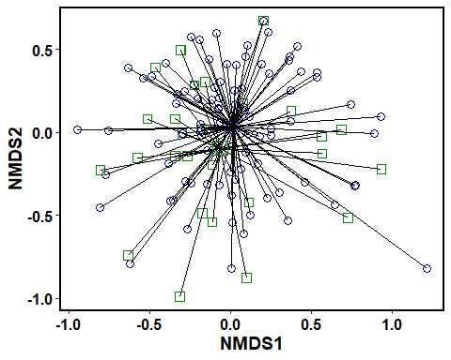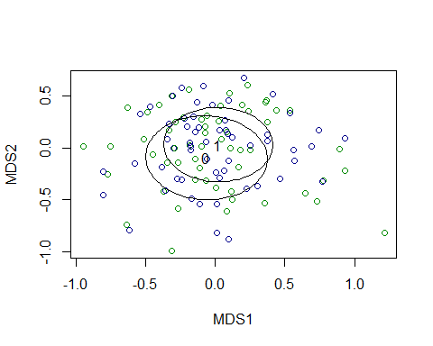
#CHANGES HERE
ordTrtData <- data_CPVT
trt_var <- "seedling_or_adult"
trt_0 <- "Seedling"
trt_1 <- "Adult"
#END OF CHANGES
ordTrtData <- ordSetup(ordTrtData, trt_var, trt_0, trt_1)
trt <- ordTrtData %>% select("numID", "trt")
orddata <- ordTrtData[c(1, 76:103)]
ord <- invisible(ord_er(orddata))
plot_ano
plainNMDS(ord)
NMDS_centroids(ord)
NMDS_ellipses(ord)
#CHANGES HERE
ordTrtData <- data_ILM
trt_var <- "seedling_or_adult"
trt_0 <- "Seedling"
trt_1 <- "Adult"
#END OF CHANGES
ordTrtData <- ordSetup(ordTrtData, trt_var, trt_0, trt_1)
trt <- ordTrtData %>% select("numID", "trt")
orddata <- ordTrtData[c(1, 76:103)]
ord <- invisible(ord_er(orddata))
plot_ano
plainNMDS(ord)
NMDS_centroids(ord)
NMDS_ellipses(ord)
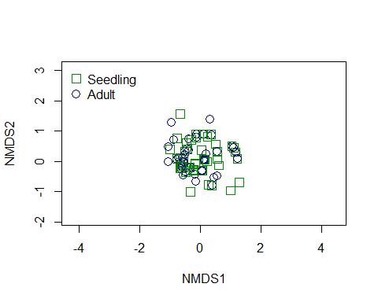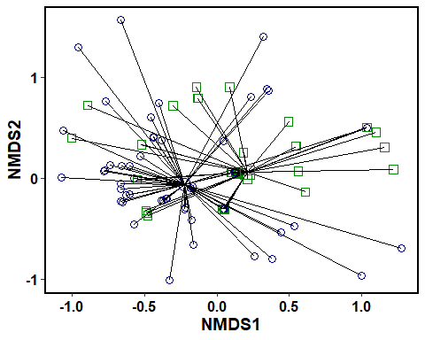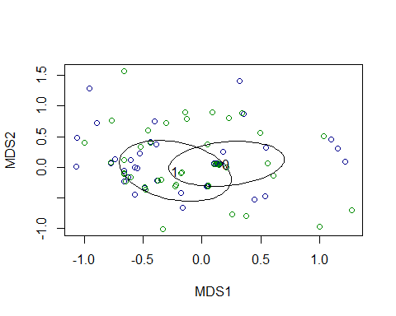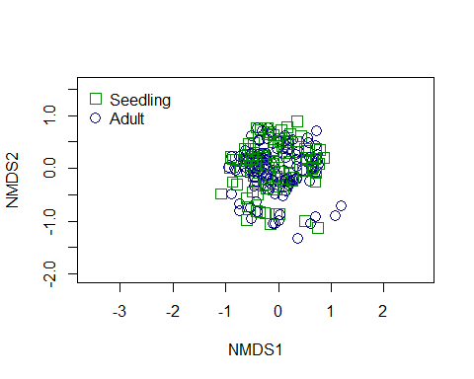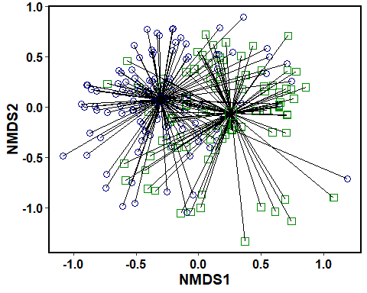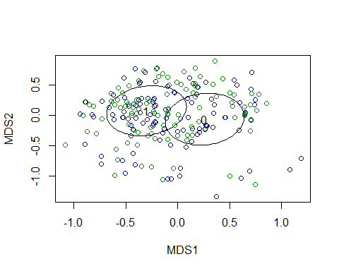
#CHANGES HERE
ordTrtData <- data
trt_var <- "riparian_or_upland"
trt_0 <- "Riparian"
trt_1 <- "Upland"
#END OF CHANGES
ordTrtData <- ordSetup(ordTrtData, trt_var, trt_0, trt_1)
trt <- ordTrtData %>% select("numID", "trt")
orddata <- ordTrtData[c(1, 76:103)]
ord <- invisible(ord_er(orddata))
plot_ano
plainNMDS(ord)
NMDS_centroids(ord)
NMDS_ellipses(ord)
