This document explains how to integrate Angular CLI project into .Net Framework MVC project. I have used Visual Studio 2017 for this.
- Install NodeJS
- To Check npm version, Open command prompt
npm -v
I have 3.10.10 installed

- Install Angular CLI
npm install -g @angular/cli
- To check Angular CLI version
npm install -g @angular/cli
I have 1.3.2 installed. More info: https://cli.angular.io/

- Now Create an Angular CLI project
ng new Neo-CLI-app

This will install the project “Neo-CLI-app” with following structure with all “node_modules”
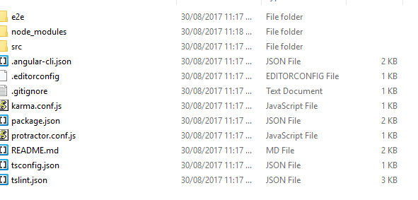

cd Neo-CLI-app

ng serve Neo-CLI-app

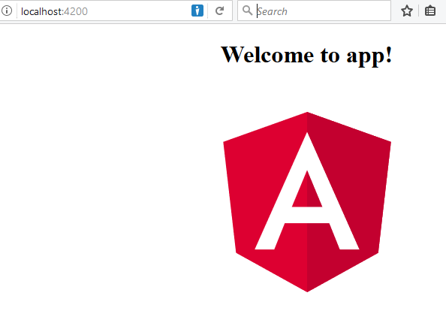
The site is now ready. Observe the root does not have the “dist” folder. Now type the below command.
ng build

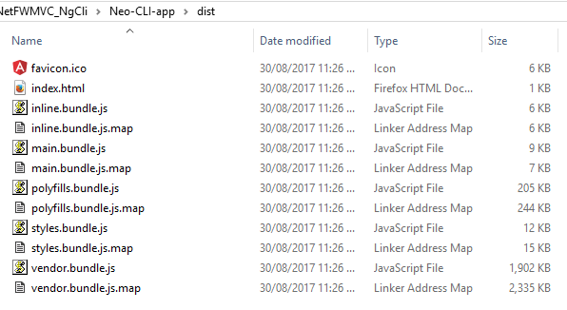
See the “dist” folder contents created now. Notice the js files created.
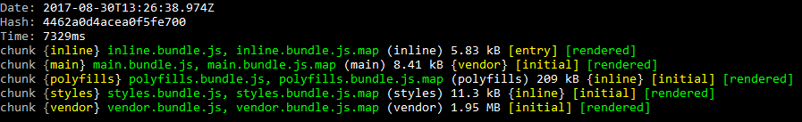
Now we are ready to integrate on an MVC project. In VS 2017 select File->New Project
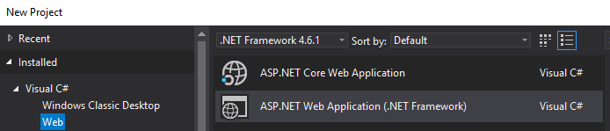
Select ASP.Net Web Application (.Net)
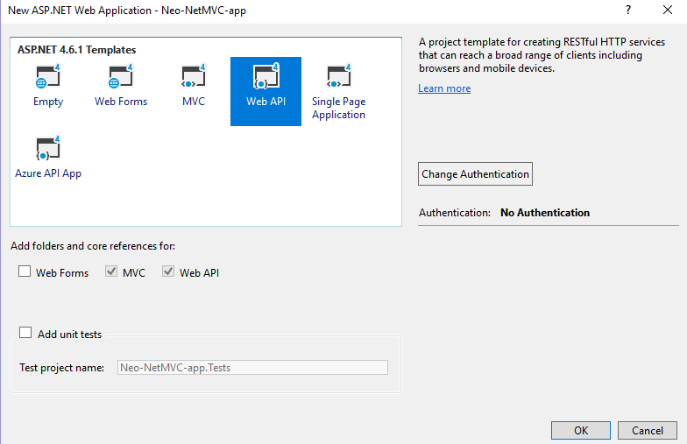
Select “Web API” with No Authentication (Individual User Accounts is also fine).
Run the project and make sure it shows default page. Notice the localhost and port number
http://localhost:52168/
Copy the necessary NG Cli files into this project root folder of VS 2017 (except dist folder).
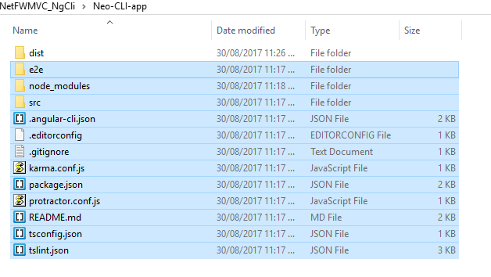
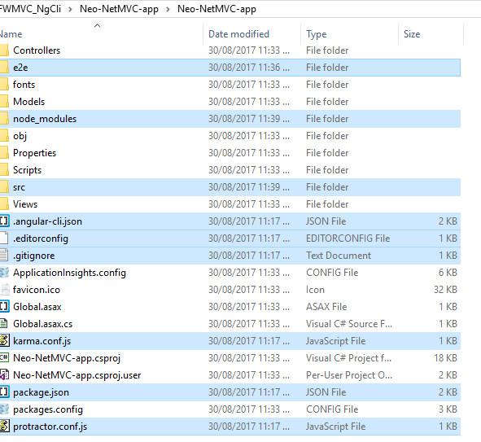

Click “Show All Files” in Vis Studio
Add all files into the project except “node_modules” folder
Now modify _layout.cshtml
<base href="/">
<meta name="viewport" content="width=device-width, initial-scale=1">
<link rel="icon" type="image/x-icon" href="favicon.ico">

<body>

@RenderBody()
<script type="text/javascript" src="~/dist/inline.bundle.js"></script>
<script type="text/javascript" src="~/dist/polyfills.bundle.js"></script>
<script type="text/javascript" src="~/dist/styles.bundle.js"></script>
<script type="text/javascript" src="~/dist/vendor.bundle.js"></script>
<script type="text/javascript" src="~/dist/main.bundle.js"></script>

@Scripts.Render("~/bundles/jquery")
@Scripts.Render("~/bundles/bootstrap")
@RenderSection("scripts", required: false)
</body>

You can copy this from index.html in the “dist” folder of “Neo-CLI-app” created earlier and add update with “~/dist/” path location
Modify index.cshtml and Replace all content with <app-root>
<app-root></app-root>

Close Solution. Modify “AfterBuild” settings in .csproj file after opening it in Notepad
<Target Name="AfterBuild">
<Exec Command="ng build --deploy-url http://localhost:52168/dist/" WorkingDirectory="$(ProjectDir)" Condition=" '$(Configuration)|$(Platform)' == 'Debug|AnyCPU' " />
</Target>
More info: https://www.codeproject.com/Articles/1193423/Integrating-the-Angular-CLI-With-Visual-Studio
Make sure only modify “Afterbuild” section
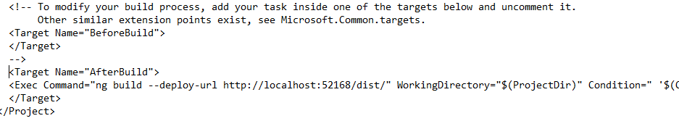
Save and re-open Solution. Run the solution
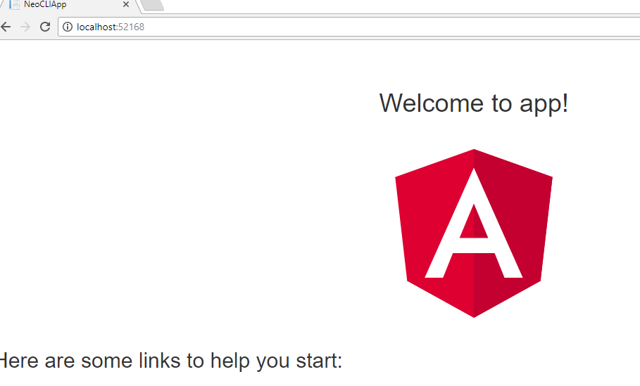
Now you have Angual CLI app in .net Framework with Bootstrap theme

