**MATLAB FS11 – Research Plan**

**Document Version:** 1

**Group Name:** foodtrail

**Group participants names:** Michael Aebli, Matthias Roggo, Moritz Vifian

**General Introduction**

It has been noted by many people that the architectural design of the Polymensa is sub-par. The queue formation seems chaotic in nature and not predetermined. For example, people are forced to cross each others paths. The question arises if there is room for improvement or if the current system is already optimal as it is. More broadly speaking, this is a problem concerning pedestrian/crowd dynamics. How do pedestrians chose their paths and how do they interact. Pedestrian dynamics has many fields of application (such as evacuation) and is becoming more important as cities and buildings are more densely populated. There have been many proposed models for pedestrian dynamics. A well known example is the Social Force Model of 1995 (Helbing Dirk et. al).

**Fundamental Questions**

(1) How do pedestrian groups with different destinations interact with one another?

* + How does one group of pedestrians with one destination behave?
  + How do two groups of pedestrians with separate destinations interact? (Fig 1, top)
  + How do two groups of pedestrians with separate destinations interact on a there are obstacles?
  + How do two groups of pedestrians with separate destinations interact closely in a room 2D room resembling a birds-eye-view of the Polymensa?
  + What happens when there are three groups or more? (Fig 1, middle)
  + Is queue formation accurately modeled? (Fig 1, bottom) What changes/additions need to be made if this is not the case?

(2) How do pedestrian groups with different destinations interact when all pedestrians return to the same checkout point (cash register) once they have reached their respective destination?

(3) How accurately are pedestrian-dynamics models able to depict the empirically collected crowd behavior of the Mensa queue area?

* + Are queues formed at the same locations?
  + Are similar distributions observed?
    - * Are densely occupied areas in the same location?
      * Are certain areas never occupied?

- What geometrical changes could be made to the Mensa to increase the flow of pedestrians per unit time?

Variables of Interest:

* + The time it takes for all pedestrians to reach their destinations
    - measured by logging simulation
  + The number of times pedestrians cannot move because their path is blocked by another pedestrian
    - measured by logging simulation
  + the location of the queues (are they realistic?)
    - measured by analyzing simulation snapshots

**Expected Results**

Results which resemble the crowd behavior observed at the Polymensa are expected. This means queue formation at similar localities and similar flow of pedestrians per unit of time. We expect that the flow of pedestrians per unit of time can be influenced by the number of different destinations. The more destinations the slower the whole process.

**References**

* Social Force Model for Pedestrian dynamics (1995) – Dirk Helbing et al.
  + Describes model we are considering to build on (Social Force Model)
* Self-organized Pedestrian Crowd Dynamics (2005) - Helbing et al.
  + Uses model we are considering to build on (Social Force Model)
* [Pedestrian Dynamics Airplane Evacuation Simulation - Author(s): P. Heer, L. Bühler](http://www.soms.ethz.ch/teaching/MatlabFall11/projects/Airplane_Evacuation-Buehler_Heer.pdf#_blank)
  + Model we are considering to build on (Social Force Model)
* Response to intrusion into waiting lines. (2010) By Milgram,Stanley et al.

<http://psycnet.apa.org/index.cfm?fa=buy.optionToBuy&id=1987-04011-001>

* + A possible extension to queue modeling. This extension would include intruders which are more aggressive and attempt to intrude into waiting lines.
* Approach to Collective Phenomena in Pedestrian Dynamics (2002) Andreas Schadschneider et al.
  + In case we attempt to use Cellular Automata this paper would be useful.

**Research Methods**

An Agent-Based Model will most likely be implemented for the simulation. We are also considering Cellular Automata although we are of the opinion this approach would require too many adjustments and tweaks.

**Other**

In order to set model parameters realistically and see if the model accurately depicts the behavior of people waiting for their meals we will collect empirical data ourselves.

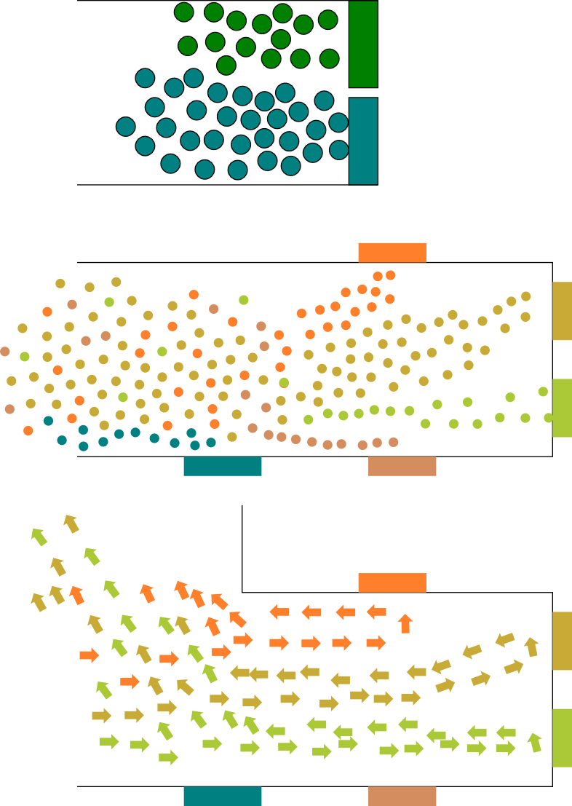Fig 1 – images depicting the nature of the desired results