o PART I (introduction):

1. This project is mainly to use java swing to implement graphical sorting and create ­­­­­­­control loading and sort by area.
2. The main challenge is ordering of shape positions. In this project, the bubble sort method will be used to realize the instantiation shape.
3. Open-Close Principle (OCP), open, refers to open to extension, that is, to support convenient extension. Closed refers to the closing of modification, that is, the modification of existing content must be strictly restricted. The open-close principle is the most abstract and important OOD principle.

o Part II (design):

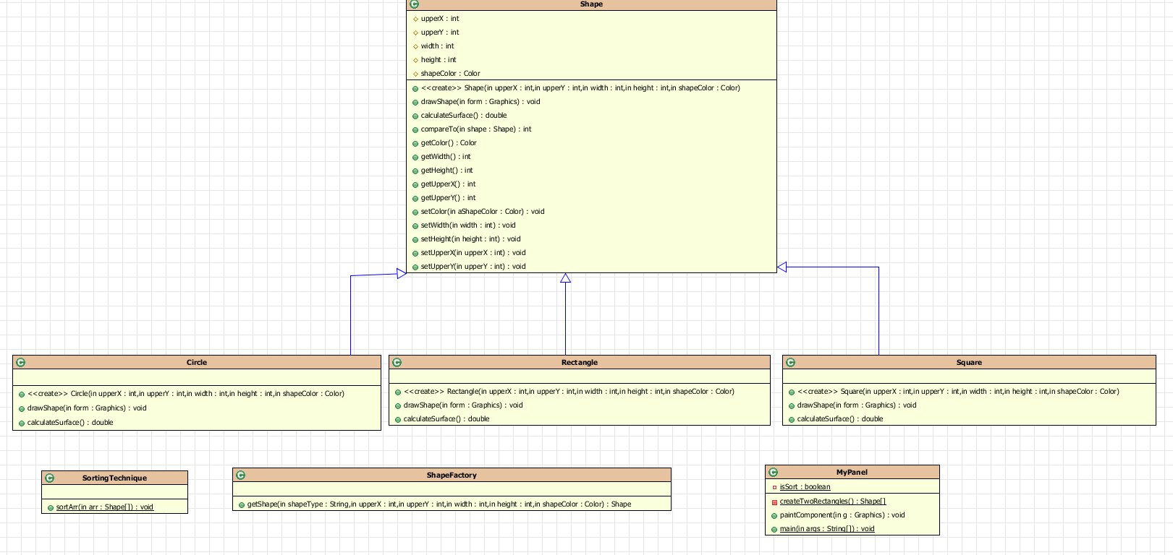

o The Circle class: it represents a circle

o The Rectangle class: it represents a Rectangle

o The Square class: it represents a rectangle whose height and width are equal

o The Shape class: class that embodies the generic concept of Shape

o The SortingTechnique class: it allows sorting shapes based on their surfaces

o The ShapeFactory: it supports the instantiation of different Shapes

o The classes allowing to display the shapes on an interface

o The myPanel instantiate graphical interface

o Part III (implementation):

This project sorting mainly adopts the bubble sorting method.

Basic idea: Bubbling sorting is similar to bubbling in water. The larger numbers sink and the smaller ones rise slowly. Assuming that from small to large, the larger numbers will slowly go backwards, and the smaller ones Slowly move forward.

Intuitively, each time running the function will move a largest number to the end of the sequence.

Algorithm description: Compare adjacent elements, if the previous one is larger than the next, swap them. The first pass sorts the first and second pairs, compares and swaps, and then compares and swaps the second and third pairs, so as to move the largest number to the last one until the second and last one. Bit. In the second pass, the second largest number is moved to the penultimate place, until all the exchanges are completed at the end.

The code is implemented as follows:

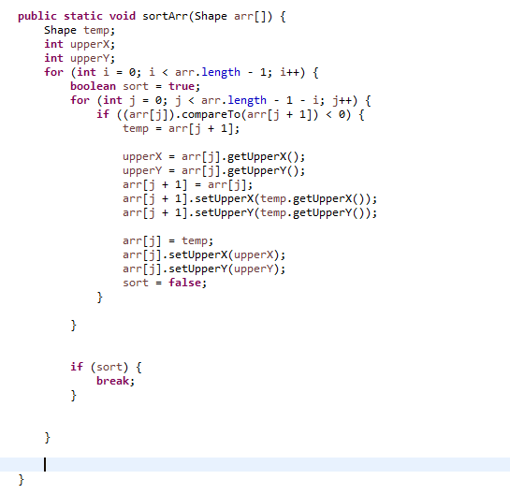

This project tool uses Eclipse IDE 2021-06, and JDK uses JDK15 version.

First define the basic shape class, and use the simple factory pattern to create the object. There are mainly Shape, Rectangle, Square, ShapeFactory, Circle, and ShapeFactory classes.

Then implement the interface, which contains two buttons and 6 instantiated shapes. There are mainly MyPanel classes.

Finally, the bubble sort is implemented, mainly in the SortingTechnique class.

The results of the operation are as follows:

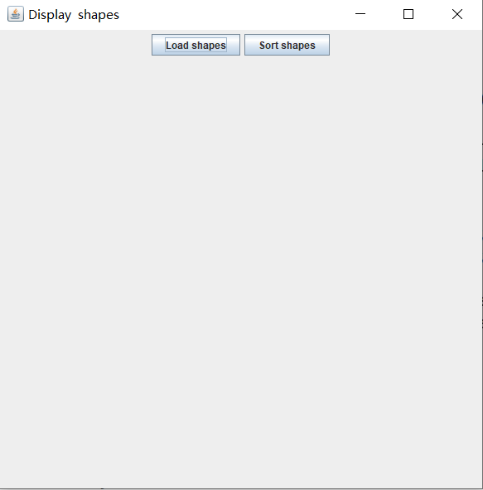

Click the Load shapes button, and the results are as follows:

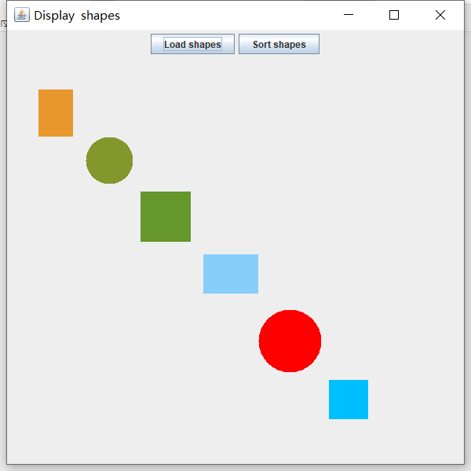

Click the Sort shapes button to achieve sorting:

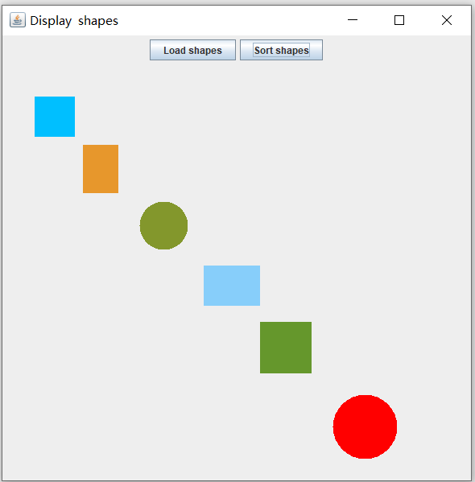

o Part IV (conclusion):

I made a java C/S mode program this week, which allowed me to learn C/S development. Although it is only a small program, it won’t be unfamiliar if I do it next time. There are still a lot to do this time. Insufficiency, with in-depth understanding in the future, I believe I will do better.

In the entire program development, it is easier to define basic shape classes and implement sorting. There is a small obstacle in the use of buttons to control the display and sorting of graphics. The function is basically completed