1.1.

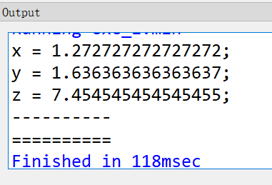

1.2.

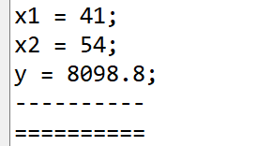

1.3. [1, 1, 0, 0, 0, 0,

0, 0, 0, 0, 0, 0,

0, 0, 1, 0, 1, 1,

0, 0, 0, 1, 0, 0,

0, 0, 0, 0, 0, 0,

0, 0, 0, 0, 0, 0]

最大值为6

2.

3.

4. [false, false, false, true, false,

false, false, false, false, true,

false, false, true, false, false,

false, true, false, false, false,

true, false, false, false, false]