Byron Kweh Tze Min

+60178778996

Age :21 (25th October 1997)

binexkweh@gmail.com

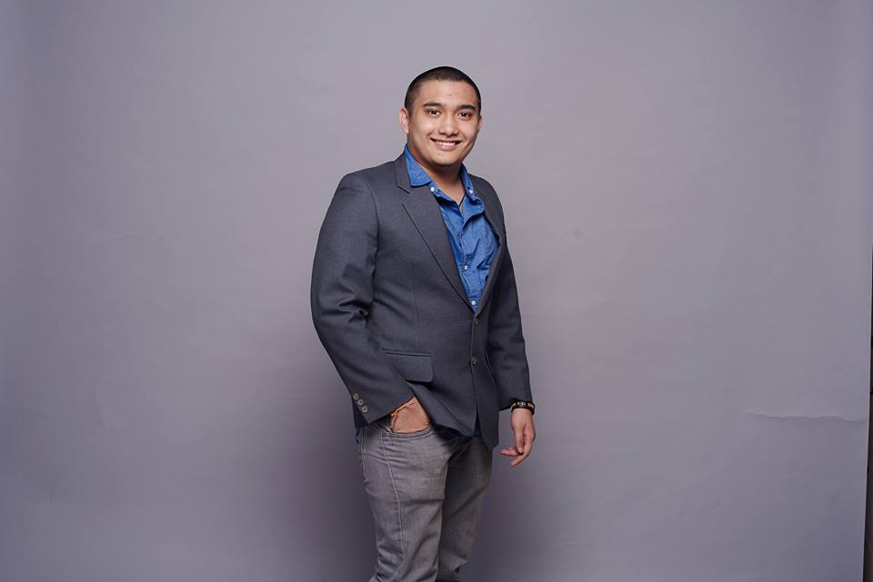

Education

Beaconhouse Sri Inai International School

***Completed in 2014***| SPM

* 5As, 3Bs, 1C. (A in English, Chemistry, and Sejarah; A+ in Add Math and Math)

Tunku Abdul Rahman University College

***Completed in 2016***| A-Level AS Examinations

* 2B, 1D (B in Math and General Paper, D in Physics)

HELP University

***Completed in 2017***| Foundation in Science

* Completed with a 3.3 CGPA.

INTI International University

***Completing in 2020***| Degree in Computer Science

* Currently holding 3.8 CGPA.

Experience

Volunteer Teacher ***September 2016***

PT Foundation | 7C-1, Jalan Ipoh Kecil off Jalan Raja Laut, Kuala Lumpur, Chow Kit, Kuala Lumpur, 50350 Kuala Lumpur, Malaysia

Assistant Tournament Director ***April/May 2016***

Spiderworks Sdn Bhd |

Finance Assistant ***November/December 2014***

Zaluvida Corporate Sdn Bhd | E-16 Plaza Mont Kiara, 2, Jalan Kiara, Mont Kiara, 50480 Kuala Lumpur, Wilayah Persekutuan Kuala Lumpur, Malaysia

Freelance Emcee  ***August 2015***

Achievements

Monash CSR Challenge 5th (Monash Entrepreneurship Week) ***2017***

uSim Programming Challenge ***2018***

IMU Science Discovery Challenge (Semifinalist) ***2017***

Freelance Emcee  ***August 2015***