Chinook Music User Manual
Mateusz Hobot B00412541
Table of contents:
1. Index Page
- Search
- Filter
- Pages
4. Create Album
5. Details Page
6. Update Page
7. Delete Page
Index
On the Index page, the user can find the table with each album title, artist name, and Edit, Details and Delete buttons.
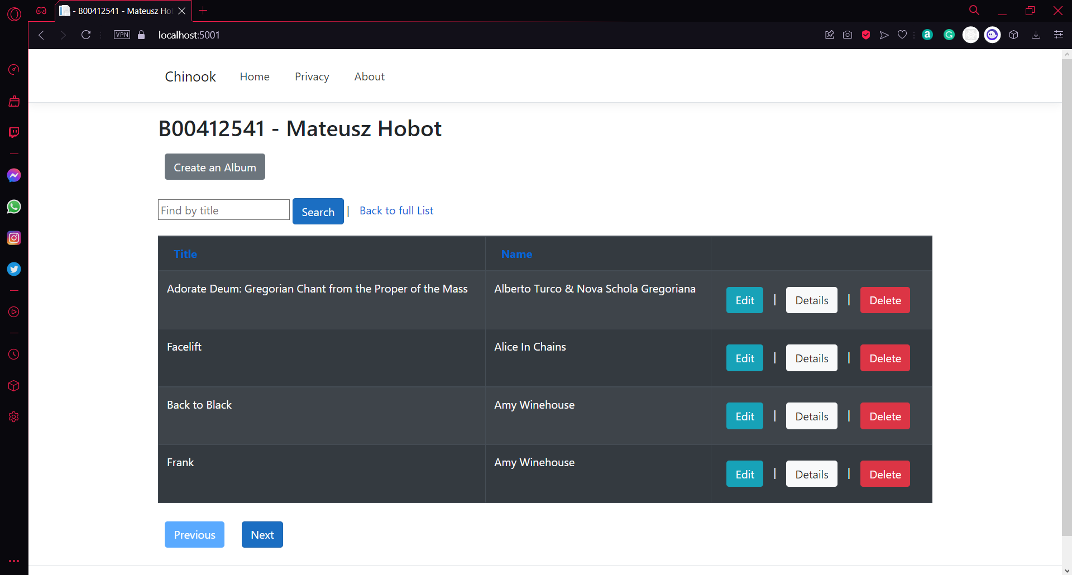

Search
There is a Search text box on the Index page that allows users to find the specific album title by typing in the first few letters of the album title.
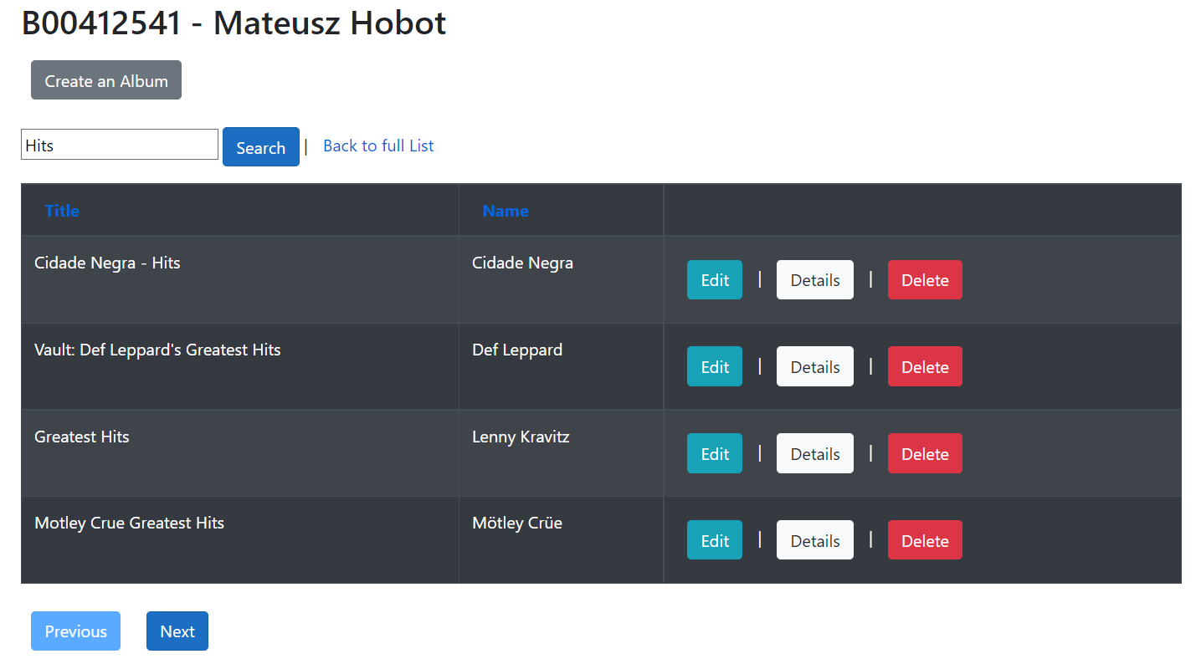
Filter
Users can change the content's order by simply clicking on Title or Name. This action changes the alphabetical display order for descending or ascending by default.
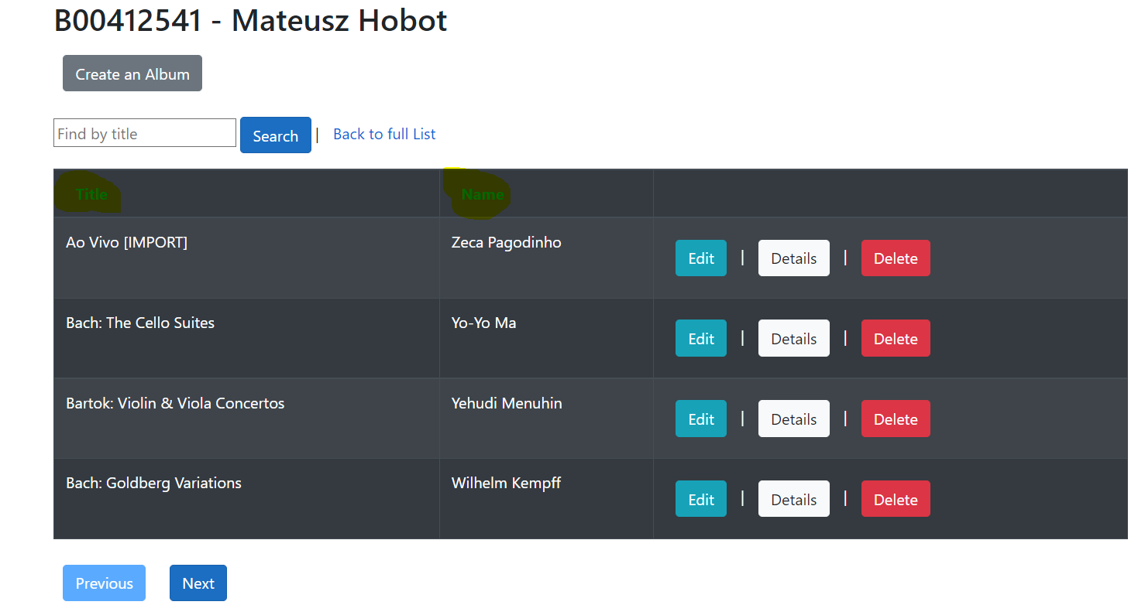

Pages
Users can change the page number using the Previous or Next buttons below the table with album data.
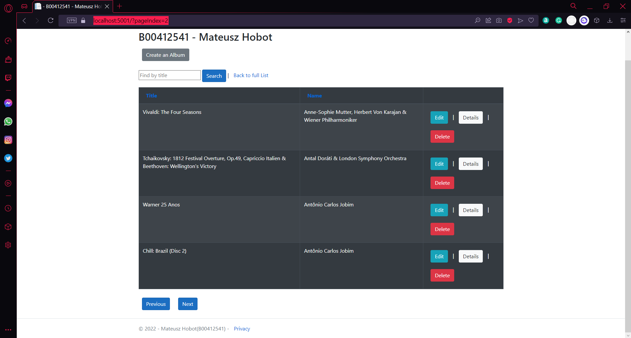

Create Album
Creating the album is very easy. Type in the album title, a select artist from the artist data list and add song titles using appropriate buttons.

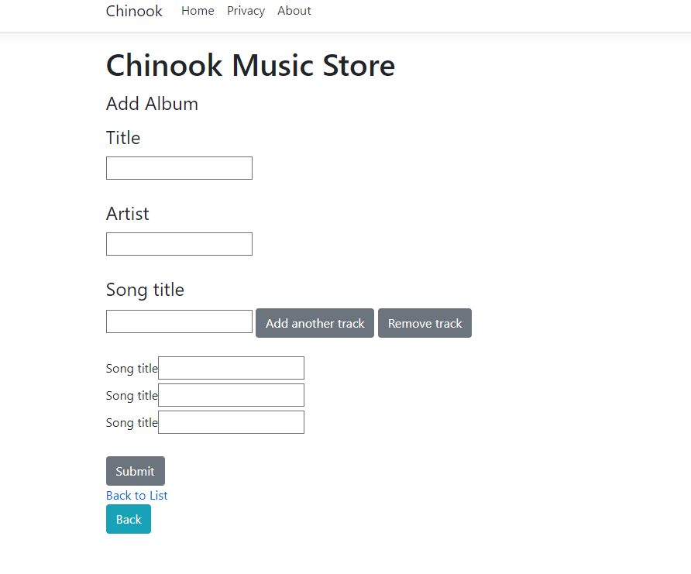
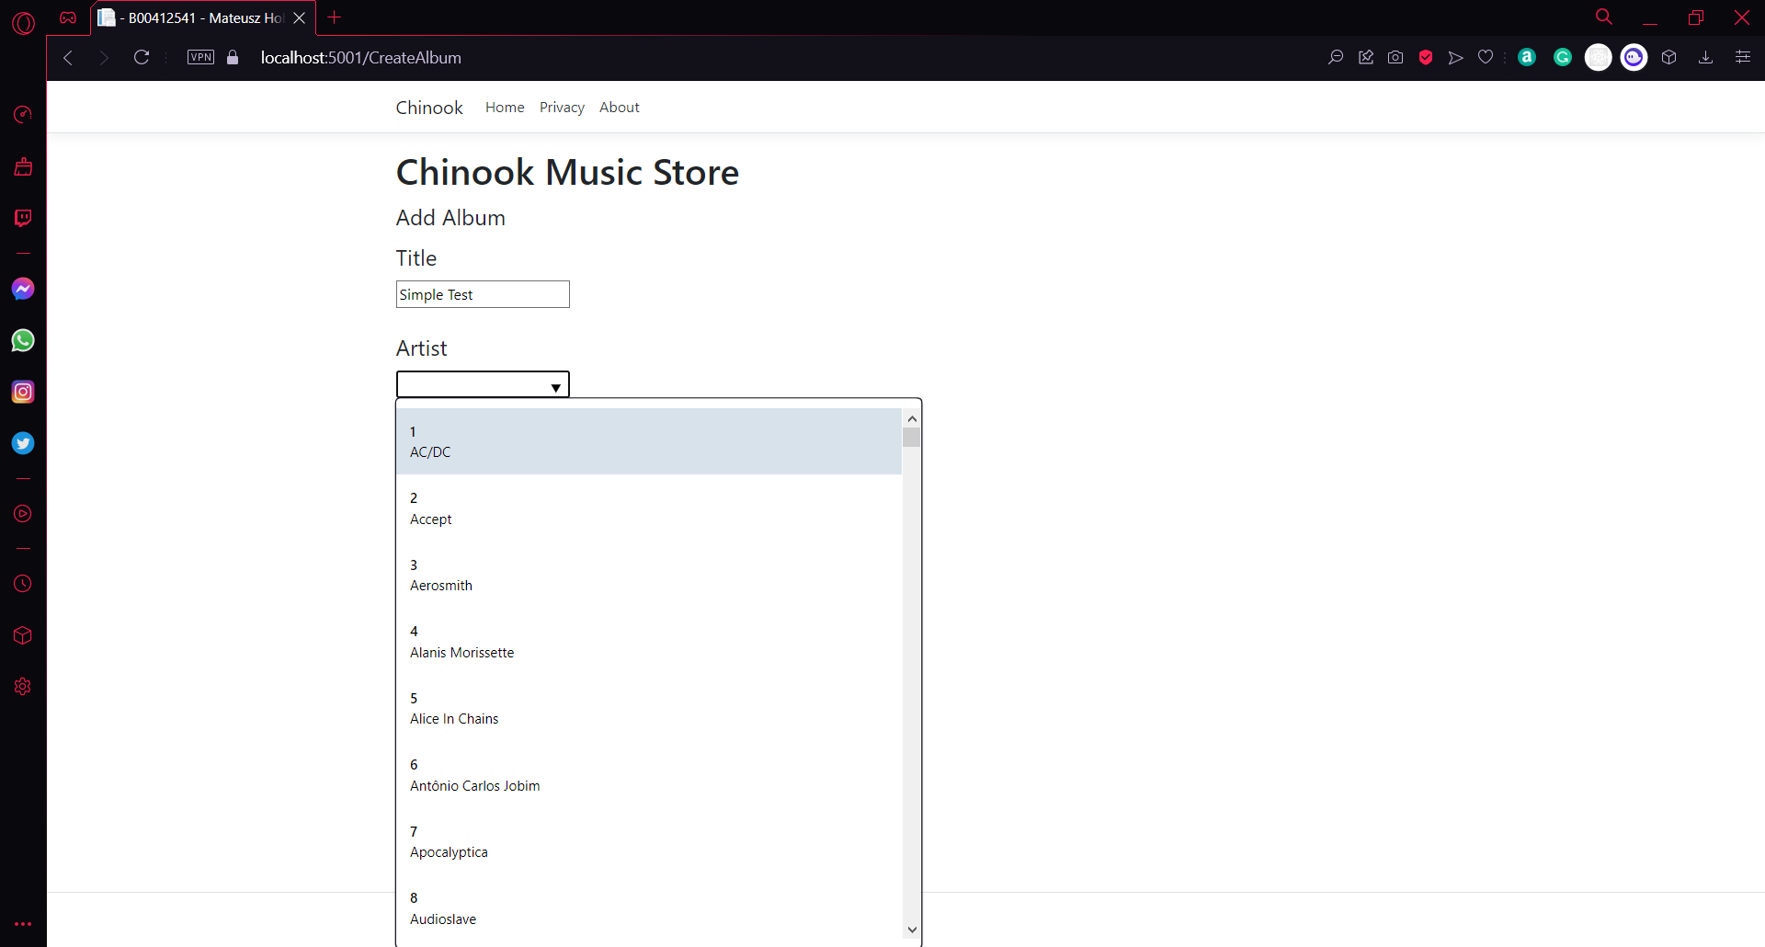
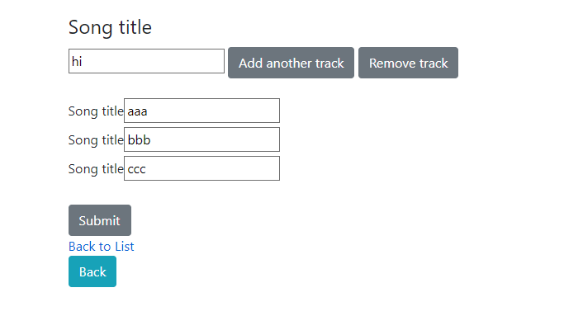

Details
The detail page represents all tracks, album titles, and artist name associated with the particular album.

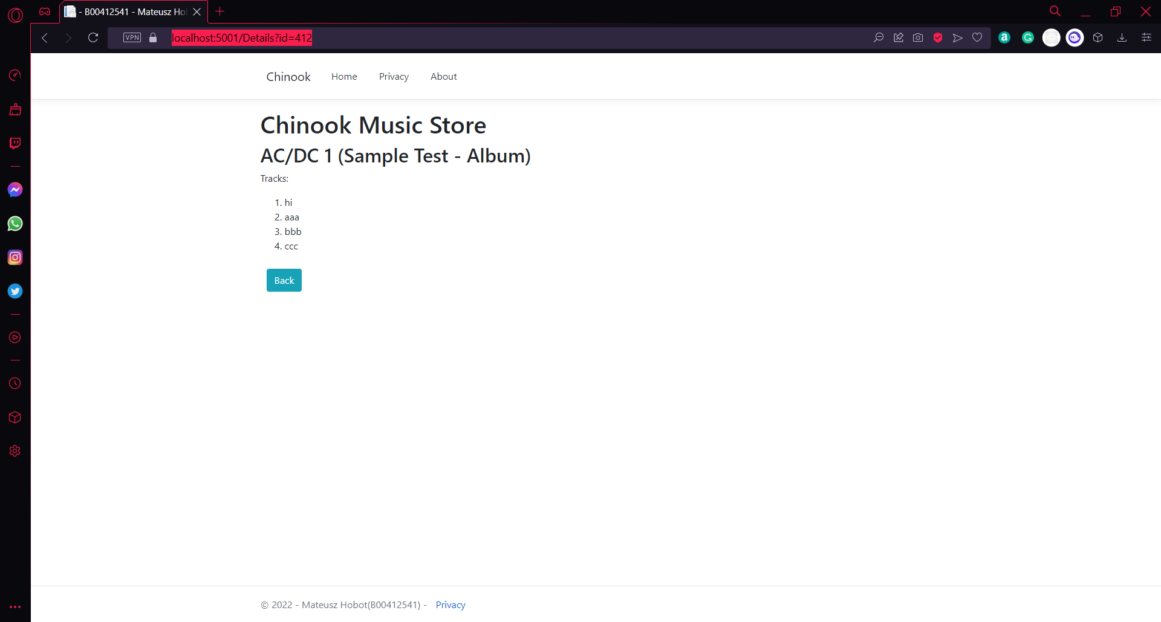

Update
To update the album, click the update button on the index page to the album it needs updating. Users will be redirected to the update page, and the album Information can be edited in the appropriate text box or data list.
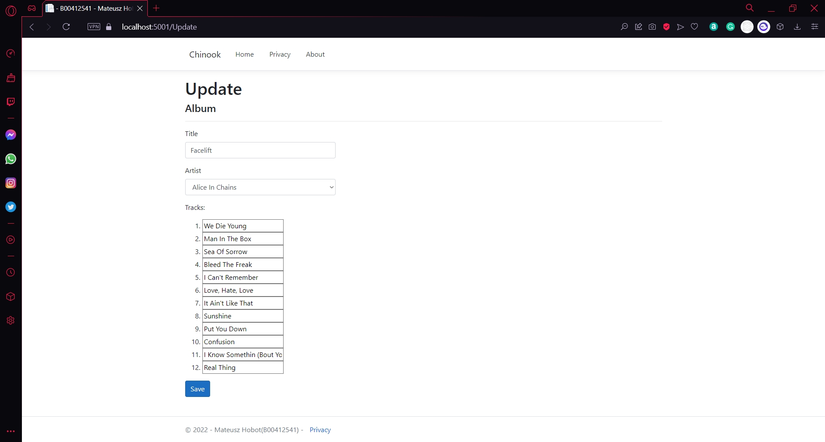

Delete
Users can delete an album and all the tracks with this album. Use the Delete button from the index page next to the album that the user wants to remove from the list and database.
