**Eval01 **

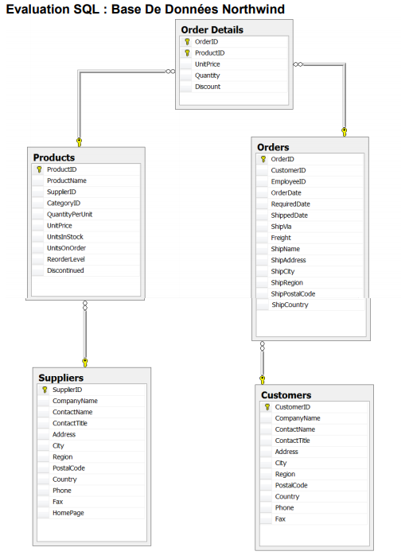

Écrivez les requêtes permettant d'obtenir les résultats suivants :

**Eval01 **

**1 - Liste des contacts français :**

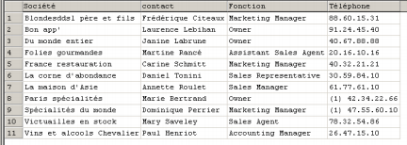

SELECT CompanyName AS Société, companyName AS contact,

contacttitle AS Fonction, phone As Téléphone

FROM customers

WHERE country = 'France’;

**2 - Produits vendus par le fournisseur « Exotic Liquids » :**

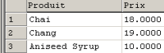

SELECT productname AS Prodtuit, unitprice as Prix

FROM products, suppliers

WHERE products.SupplierID = suppliers.SupplierID

AND companyname = 'Exotic Liquids';

**Eval01 **

**3 - Nombre de produits vendus par les fournisseurs Français dans l’ordre décroissant:**



SELECT DISTINCT companyname AS Fournisseur,count(productID) AS 'Nbre_produits'

FROM suppliers, products

WHERE suppliers.SupplierID = products.SupplierID

AND country = 'France'

GROUP BY CompanyName

ORDER BY Nbre_produits DESC;

**4 - Liste des clients Français ayant plus de 10 commandes :**



SELECT CompanyName AS Client, count(orderdate) AS Nbre_commandes

from customers, orders

WHERE orders.CustomerID = customers.CustomerID

AND customers.Country = 'France'

GROUP BY CompanyName

HAVING Nbre_commandes> 10;

**Eval01 **

**5 - Liste des clients ayant un chiffre d’affaires > 30.000 :**

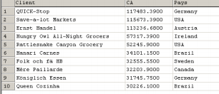

SELECT Companyname AS client, sum(quantity*unitprice) AS ca, Country AS pays

FROM orders, customers, orderdetails

WHERE orders.CustomerID = customers.CustomerID

AND orders.OrderID = Orderdetails.orderId

GROUP BY Companyname, country

HAVING ca >30000

ORDER BY ca desc;

**6 – Liste des pays dont les clients ont passé commande de produits fournis par « Exotic Liquids » :**

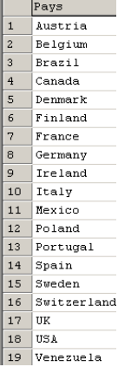

SELECT customers.Country AS pays

FROM customers, orders, orderdetails, products, suppliers

WHERE customers.CustomerID = orders.CustomerID

AND orders.OrderID = orderdetails.OrderID

AND orderdetails.ProductID = products.ProductID

AND products.SupplierID = suppliers.SupplierID

AND Suppliers.companyname = 'Exotic Liquids'

GROUP BY pays;

**Eval01** 

**7 – Montant des ventes de 1997 :**



SELECT SUM(quantity*unitprice) as 'Montant des ventes 97'

FROM orderdetails, orders

WHERE orderdetails.OrderID = orders.OrderID

AND YEAR(Orderdate) = 1997;

**8 – Montant des ventes de 1997 mois par mois :**

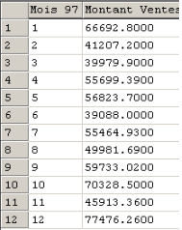

SELECT MONTH(orderdate) as Mois_97, SUM(quantity*unitprice) as 'Montant des ventes 97'

FROM orderdetails, orders

WHERE orderdetails.OrderID = orders.OrderID

AND YEAR(Orderdate) = 1997

group by Mois_97;

**9 – Depuis quelle date le client « Du monde entier » n’a plus commandé ?**



SELECT MAX(orderdate) as 'Date dernière commande'

from orders, customers

WHERE orders.CustomerID = customers.CustomerID

AND companyName = 'Du monde entier';

**10 – Quel est le délai moyen de livraison en jours ?**



SELECT ROUND(avg(datediff (shippeddate, orderdate))) AS 'Délai moyen de livraison en jours'

FROM orders;