SUBSTACK — hockeyROI.substack.com
Title: How to Beat Lukas Dostal: A Shot-by-Shot Scouting Report for Round 1
The Oilers open their first-round series against Anaheim on Monday at Rogers Place. Lukas Dostal will be in net for the Ducks, and he’s coming off a season where he carried a massive workload on a young roster - 54 starts, the most of his career.
The headline number: Dostal posted a .899 ES SV% this season against a league benchmark of .908. Below average. But that number doesn’t tell you much on its own. The real value is in the splits, where specifically is he leaking, and how should the Oilers exploit it?
I pulled every shot Dostal faced in 2025-26 from the NHL API and compared each split against the full league pool of qualifying starters. Backhands are excluded throughout, they’re a function of the shot situation, not goalie skill.
Here’s what the data says.

The Slot Is Where You Beat Him
The single most important finding in Dostal’s 2025-26 profile is the collapse of his medium-danger save percentage.
Medium-danger shots are the slot and circle area — not the crease, not the perimeter. Think shots from between the hash marks and the tops of the circles. This zone is where goalie positioning, read-and-react speed, and lateral movement matter the most.
In 2023-24, Dostal was elite in this zone: .936 SV%, a full 2.6 percentage points above the league average. In 2024-25, he was still above average at .923 (+1.8pp). This season? He cratered to .884, flipping to 1.1pp below the league’s .896.

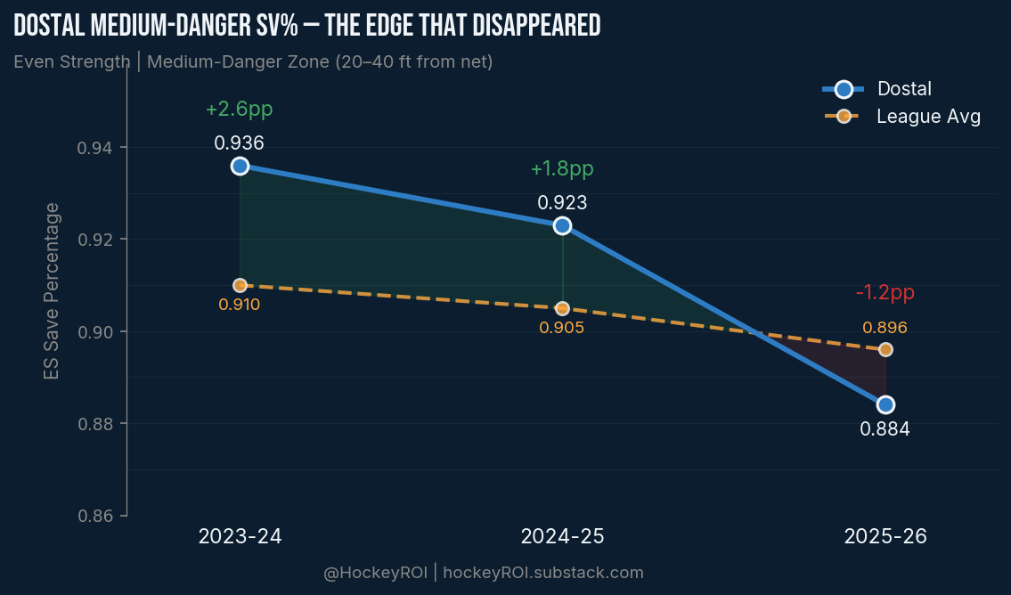

That’s a 5 percentage point swing on what was his best zone. It’s the single biggest driver of his overall regression this year.
Whether this is fatigue from carrying a rebuilding roster through 54 starts or something more structural, the result is the same: the slot is open against Dostal right now in a way it wasn’t in previous seasons.
Snap Shots From the Circles
If the medium-danger zone is where Dostal is weakest, snap shots are the specific weapon that exploits it.
Dostal on medium-danger snap shots this season: .849 vs league .879. That’s −3.0 percentage points on 192 shots — his highest-volume weak split.
The snap shot is interesting because it’s also his most volatile shot type across seasons. In 2023-24 he was below league on snaps (.868 vs .886). In 2024-25 he surged above league (.915 vs .894). This year he’s back below (.885 vs .896). The pooled 3-season number looks perfectly average, but the year-to-year swings suggest this is a consistency problem, not a talent problem. And right now, the consistency isn’t there.
For the Oilers, this means: McDavid pulling up from the left circle for a snap shot is the highest-value shot in this series. Nugent-Hopkins from the right side. Any forward with a quick release working the slot area. The snap shot from the circles is where Dostal gives up the most relative value.
Interestingly, Dostal is actually strong on high-danger snaps (.851 vs league .788, +6.3pp). When you get in really tight with a snap shot, he handles it. It’s the medium-distance snap, the pull-up shot from the circles, where he struggles.

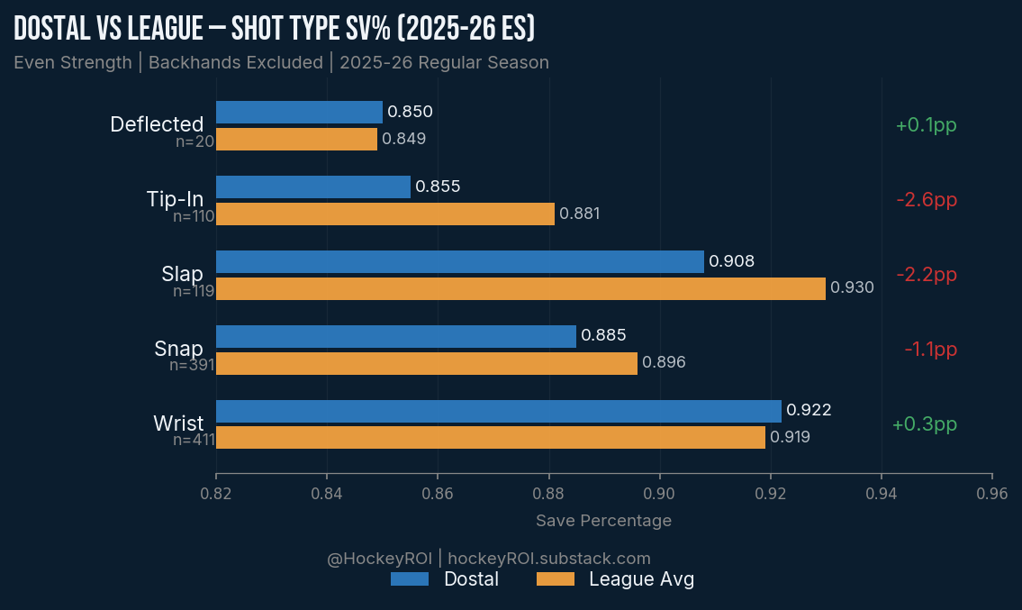

Net-Front Tips Are the Persistent Weak Spot
Tip-ins and deflections are inherently high-danger shots. They’re redirections that change the angle and speed of the puck at the last moment, and they’re the hardest shot type for any goalie to track.
But Dostal is below his peers on them. High-danger tip-ins this season: .830 vs league .865, a gap of −3.5 percentage points on 94 shots. This isn’t a one-year blip either — his tip-in SV% has been below league in all three seasons of data I have (.853, .859, .855 against rising league benchmarks).
This is the net-front vulnerability profile. Redirected shots from in tight are where Dostal consistently gives up the most relative to other starters. For the Oilers, the implication is simple: Hyman needs to live at the net front. Bouchard and Ekholm need to be shooting from the point with traffic. The combination of point shots and net-front presence plays into Dostal’s two weakest areas simultaneously, slap shots (where he’s −2.3pp below league this season) and tip-ins.
Don’t Try to Walk It In
Here’s the counterintuitive part: Dostal is actually above league average in the high-danger zone this season. His .836 SV% on high-danger shots is a full percentage point above the league’s .826.
This means the Oilers should not be trying to force plays to the inner crease expecting Dostal to collapse. He doesn’t. When shooters get in tight on him, he’s solid. The vulnerability is one layer out — in the slot, not at the doorstep.
Rush chances are also a dead end. Dostal posted a .966 on rush shots this season against a league average of .892. That’s an absurd gap and the sample is small (29 shots), but the message is clear: you’re not beating this goalie on the rush.
Wrist shots are similarly unproductive. Dostal is at .922 on wristers vs league .919, slightly above average, and he’s been above league on wrist shots in all three seasons. If an Oiler has time and space for a clean wrist shot, Dostal is probably saving it. The value is in the quicker, less predictable shots, snaps from the circles, tips at the net.
The PK Is Cratering
Dostal’s penalty kill numbers this season are rough across the board. His .820 PK SV% is 4.0 percentage points below the league’s .860.
The medium-danger PK is where it gets ugly: .790 vs league .865. PK slap shots: .737 vs .876, a tiny sample of 19 shots, but the direction is severe.
For the Oilers’ power play, this means the same principle applies: work through the middle. The half-wall cycle that generates perimeter wrist shots is the lowest-value approach against Dostal. The PP should be looking for the snap shot from the top of the circles and the seam pass to the slot. That’s where his PK breaks down.
The Scouting Report
Attack the medium-danger zone. Snap shots from the circles. Bodies at the net for tip-ins. Point shots from Bouchard and Ekholm with traffic in front. Power play through the middle, not the perimeter.
Don’t try to dangle through him. Don’t rely on the rush game. Don’t settle for clean wristers from the outside.
Dostal carried a heavy workload this year and his game eroded in the areas that require the most precision, lateral movement in the slot, tracking deflections, PK positioning. Whether that’s fatigue or the league adjusting to him, the Oilers have specific, identifiable areas to exploit.

Data: NHL API play-by-play, 2025-26 season. Backhands excluded. League benchmark: all qualifying starters. Even strength unless noted.
@HockeyROI on X · u/HockeyROI on Reddit · github.com/HockeyROI/nhl-analytics

