The Geometry of Winning: What 921,000 NHL Shots Taught Me About the Most Underrated Play in Hockey
ASH GARG L HOCKEYROI
APR 17, 2026
There’s a play in hockey that happens dozens of times every game. Nobody talks about it. It doesn’t make SportsCenter. The player who does it best doesn’t get as much of a look in free agency.
A forward skates hard to the front of the net before a shot goes off. He gets there early. He stands in traffic, takes a stick to the shin, absorbs a cross-check from a defenceman twice his size. The shot goes off. The goalie makes the save. The puck bounces directly to him. He buries it.
The goal gets credited. Nobody asks why he was standing there.
I spent the last several months trying to answer that question with data. What I found surprised me, and I think it has real implications for how NHL teams should be built.

The Basketball Problem
Modern basketball solved offense with drive and kick. Force the defense to collapse, kick to the open three, repeat. It works partly because the analytics supported it. The three pointer is genuinely more valuable than the mid-range two. But it also works because the incentive structure aligns. Steph Curry pulling up from 30 feet is a highlight. Players want to do it. Coaches can sell it.
Hockey may have an equivalent. But the incentive structure works against it.
A tip-in off your shin pad doesn’t make the highlight reel. Parking in front of the net getting hacked by a defence-man doesn’t show up in a box score. A wrist shot from the circle is prettier, cleaner, easier to sell to a player making eight million dollars a year.
The question I wanted to answer: is the data-supported play in hockey the same as the unsexy one? And if so, why aren’t more teams doing it deliberately?

What I Built
I pulled six seasons of NHL shot event data directly from the NHL API — 921,141 even strength shots from 2020-21 through 2025-26. Every shot-on-goal, missed shot, blocked shot, and goal. Every event has x/y coordinates, shot type, shooter, goalie, team, and timestamp.
From that I built a rebound sequence model - identifying every instance where a shot was followed by another attempt from the same team within two seconds. Then I mapped where those rebound attempts came from and how dangerous they were.
The finding is simple and it’s the foundation of everything that follows.

The Corridor

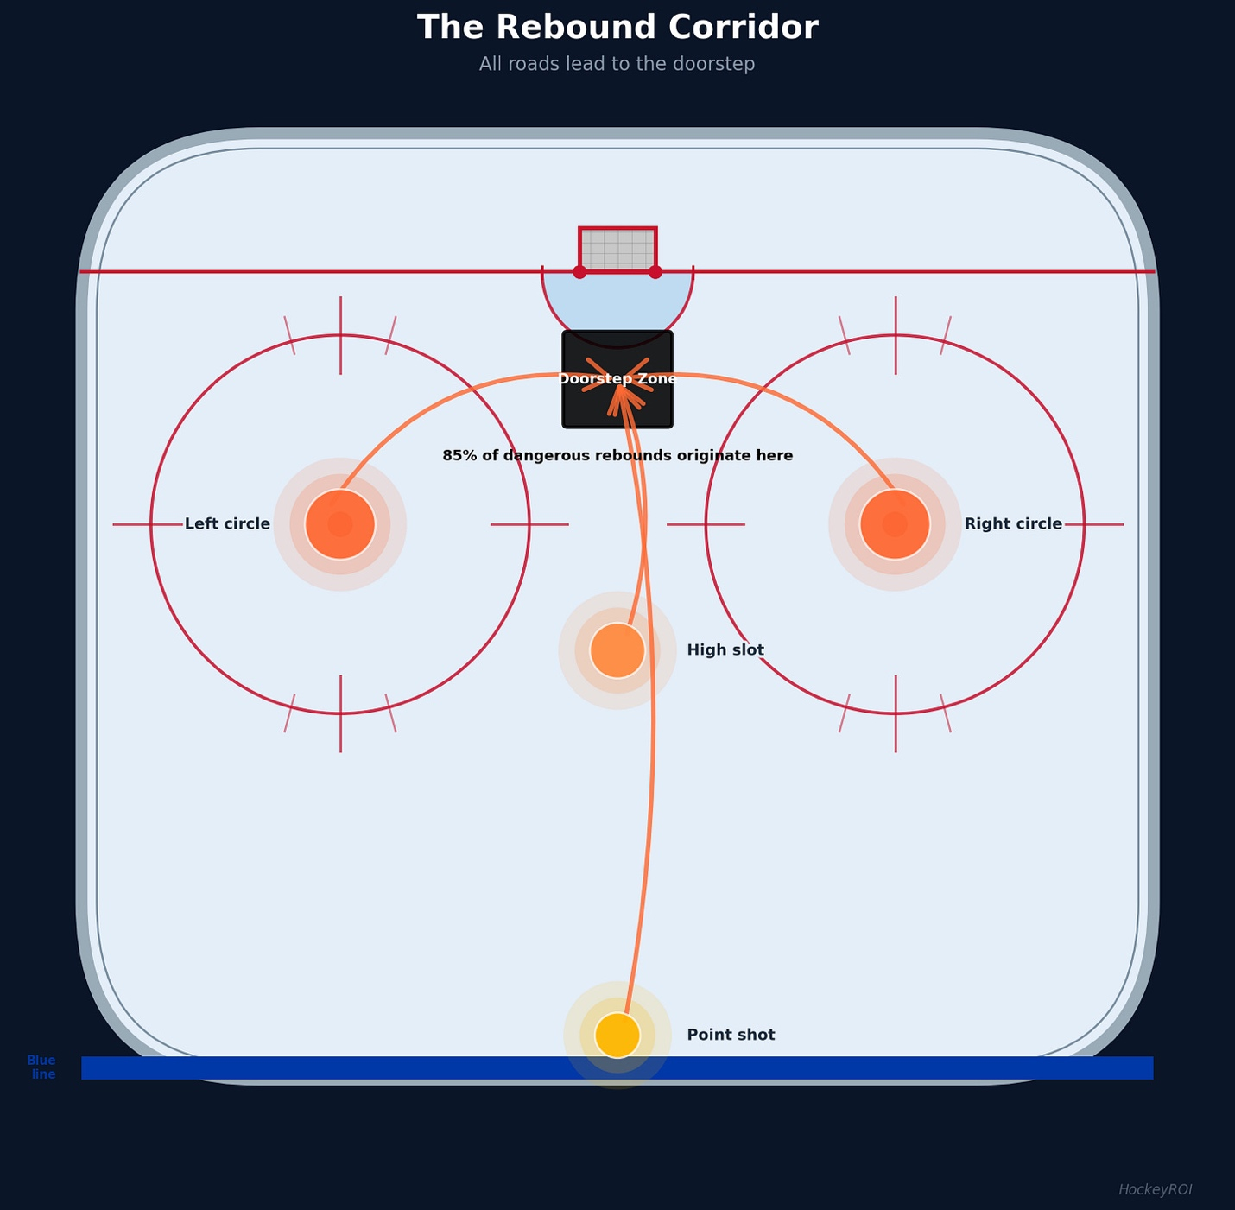

Here’s what the data shows. Take any shot from anywhere in the offensive zone: the point, the right circle, the left circle, the high slot. If that shot generates a rebound attempt, that attempt almost always originates from the same place, an area barely larger than the crease itself, centred directly on the goal mouth.
I call this the doorstep zone.
87% of dangerous rebounds land in a 7-foot by 8-foot rectangle centered on the crease. The median rebound goal lands at the crease dot — dead centre, right on top of the goalie’s skates. It doesn’t matter where the original shot came from. The rebound funnels to the same place every time.
This isn’t a new idea. Coaches have been telling players to crash the net for 100 years. What’s new is the data confirming exactly where the corridor is and quantifying what it’s worth.

What It’s Worth
Across 921,000 even strength shots over six seasons, net-front attempts (tip-ins, deflections, and rebound sequences) convert at 1.59 times the rate of all other even strength shots. Nearly double.
Break it down by component:
Rebound shots convert at exactly 2.00x baseline. Deflections at 1.75x. Tip-ins at 1.59x.
That’s the difference between a 7.6% goal rate on perimeter wrist shots and a 13.6% goal rate on rebound attempts. Run those numbers over a full season and it’s the difference between a team that scores 2.4 goals per game and one that scores 2.7.
In a league decided by margins, that’s a playoff spot.

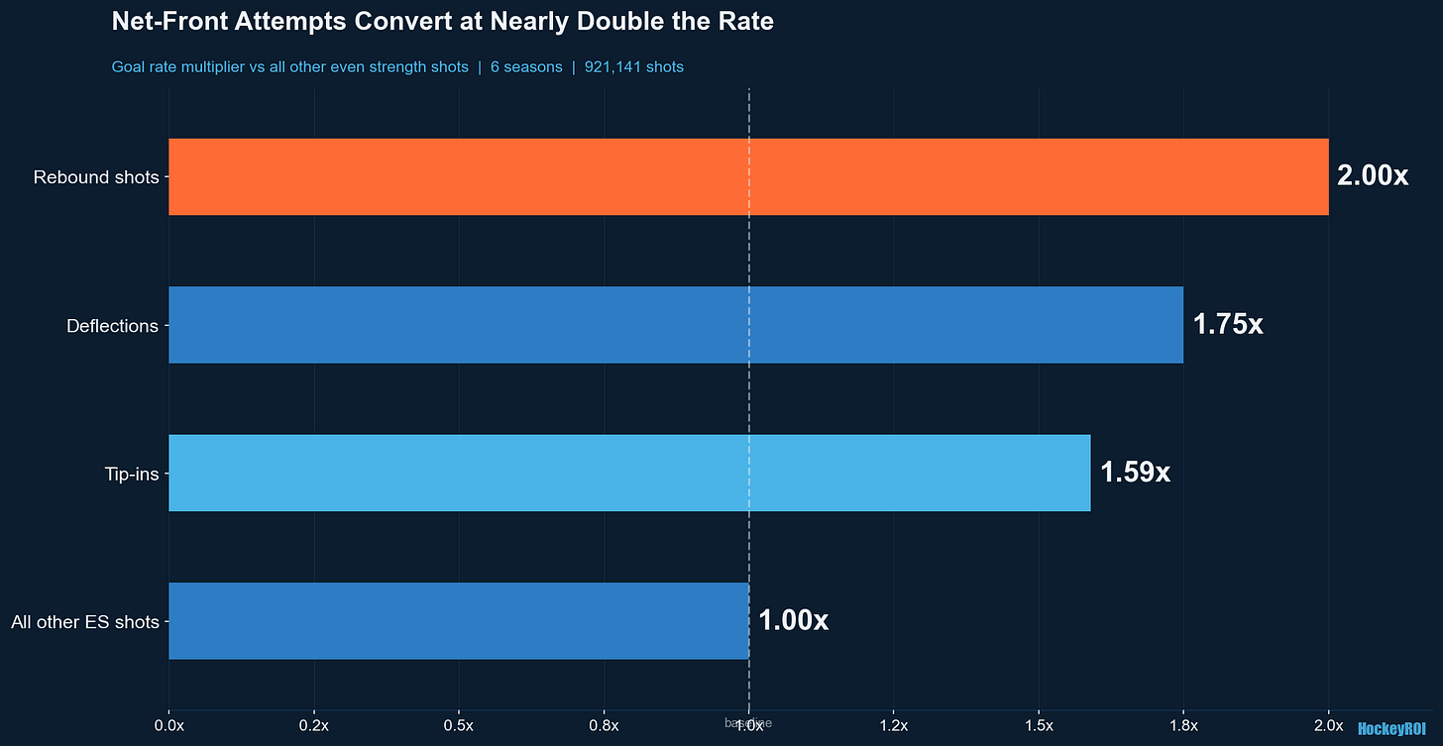

The Timing Problem
The data revealed something I didn’t expect. The best net-front players in the league share one specific characteristic beyond positioning. Their average time gap between the original shot and their rebound attempt is between 1.3 and 1.6 seconds.
That’s not a coincidence. It means they’re moving before the shot, not after the save. They read the play, anticipate where the puck is going, and arrive at the doorstep zone at roughly the same time as the rebound.
The basketball analogy holds here too. Dennis Rodman famously counted the rotations on a basketball so he could predict when misses would land before anyone else. He wasn’t reacting to the rebound. He was already timing his movement to the rebound.
The players who do this in hockey aren’t lucky. They’re not physical freaks who muscle defenders aside. They’re spatially aware players who understand the geometry of their own sport better than the guys guarding them.
Zach Hyman is one of the best examples in the league.

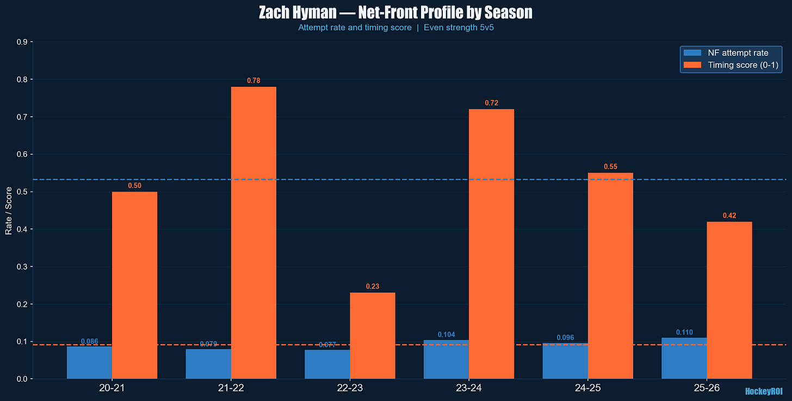

His attempt rate has climbed to a career-high 11% in 2025-26. More importantly his timing in his best seasons — 2021-22 and 2023-24 — shows he’s arriving at rebounds in under 1.5 seconds consistently. That’s not crashing the net. That’s reading the play before the shot goes off.
That is a coachable, acquirable, deployable skill.

Does It Actually Win Games?
This is where I expected to find confirmation and instead found something more interesting.
Across 159 team-seasons, net-front attempt rate correlates with regular season winning — and that relationship is strong enough that there’s less than a 1 in 1,000 chance it’s a statistical coincidence. Teams that generate more net-front attempts win more games. Consistently. Even after accounting for goaltending quality, defensive suppression, and shot quality metrics. It’s not a proxy for good teams generally. It’s an independent signal.
But winning consistently requires more than one edge. What predicts playoff contention, with 86% accuracy on holdout data, is a combination of three factors:
Net-front attempt rate. Goals against per game — which captures both defensive structure and goaltending quality in a single number. Special teams score — the average of power play and penalty kill percentage.
I call this the three-pillar model.

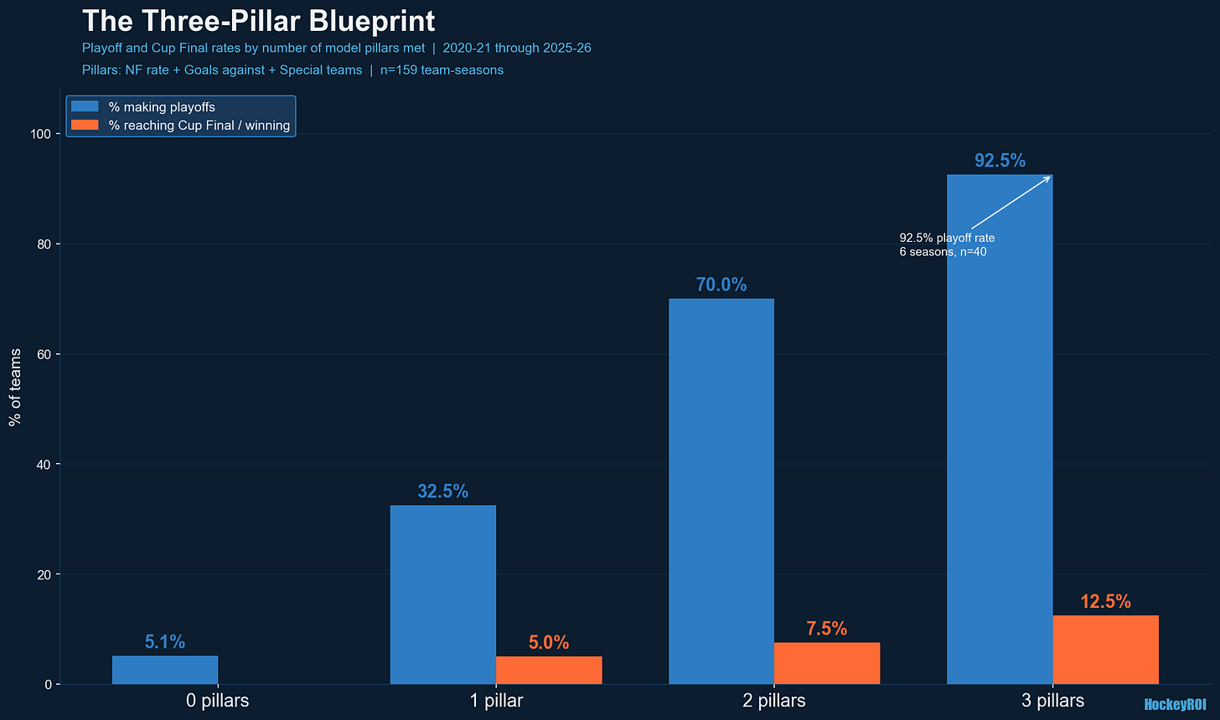

37 of 40 three-pillar team-seasons made the playoffs — 92.5%. The three exceptions all occurred in the disrupted 2020-21 and 2021-22 seasons, where the COVID bubble format and arena transitions created structural noise the model couldn’t anticipate. In normal competitive conditions, meeting all three pillars is as close to a playoff guarantee as the data produces.
Teams that met all three pillars reached the Cup Final or won the championship at 2.5 times the rate of zero-pillar teams.
That’s not a correlation. That’s a blueprint.
As a side note, I will be doing a deeper dive in follow up posts on the other two pillars. The first pillar of net front attempt rate was in part a deep dive into the popular high danger chances, and I will be apply a similar methodology to the other pillars.

Why Most Teams Don’t Do It
The data supports net-front play. The incentive structure works against it.
A skilled forward making eight million dollars a year didn’t get there by parking in front of goalies. He got there by being creative, by generating offense with the puck on his stick, by doing the things that show up on highlight reels and in contract negotiations.
Asking him to become Zach Hyman in the playoffs is asking him to abandon the identity that made him valuable in the first place. The coaches who can solve that culture problem, the coaches who can get elite players to embrace unglamorous work as part of a system, are the ones whose teams show up in the three-pillar column year after year.
Florida did it. Carolina is doing it. Colorado has quietly assembled five of the top net-front forwards in the league on the same roster.
The teams that figure out the cultural piece on top of the analytical foundation are the ones cutting down nets in June.

What’s Coming
This is the foundation. Over the next several weeks:
Which players do this best and which ones are available this summer at prices that don’t reflect their actual value.
Why one of the NHL’s biggest stars (you will be VERY surprised who it is) is a below-average net-front finisher by this model, and what the data says about whether that’s changed this season.
Why one playoff team is historically bad at this specific metric despite having some of the most skilled forwards in the league.
And the complete roster construction formula, net-front forwards plus defensive suppression plus goaltending (which as noted will have a deeper dive than the surface numbers I am using for this analysis). Do teams that excel at all three win championships at rates that exceed what luck would predict?
The short answer is yes. The longer answer is coming.

Model limitations: This analysis uses even strength data plus power play and penalty kill percentages. We’re measuring outcomes, not causes. 86% accuracy on holdout data means roughly one in seven predictions will be wrong. System vs player effects not fully separable without tracking data. Full methodology and data at github.com/HockeyROI/nhl-analytics to be posted soon.
@HockeyROI on X | hockeyROI.substack.com

