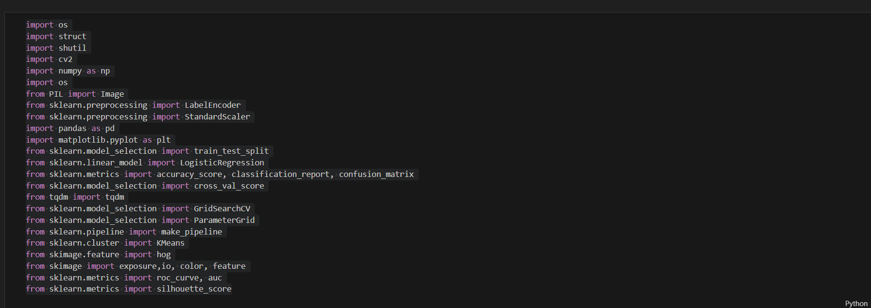

Import libraries

-------------------------------------------------------------------------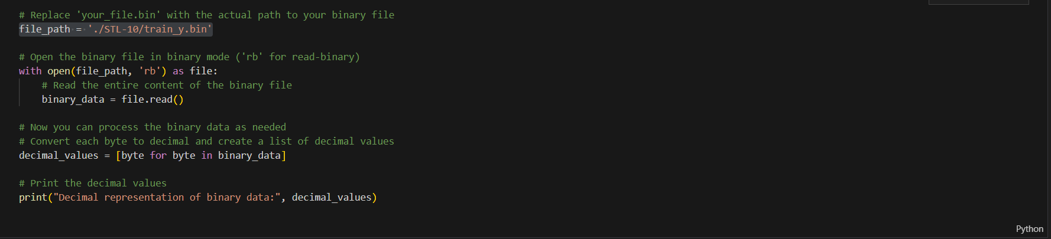

This code replace path file.bin to binary file with (file_path=’./STL-10/train_y.bin’) ,open the binary file with (open(file_path, ‘rb’)),read this binary file with (file.read),then we can make process on binary file as need and make convert from binary to list of dicimal values ,and print

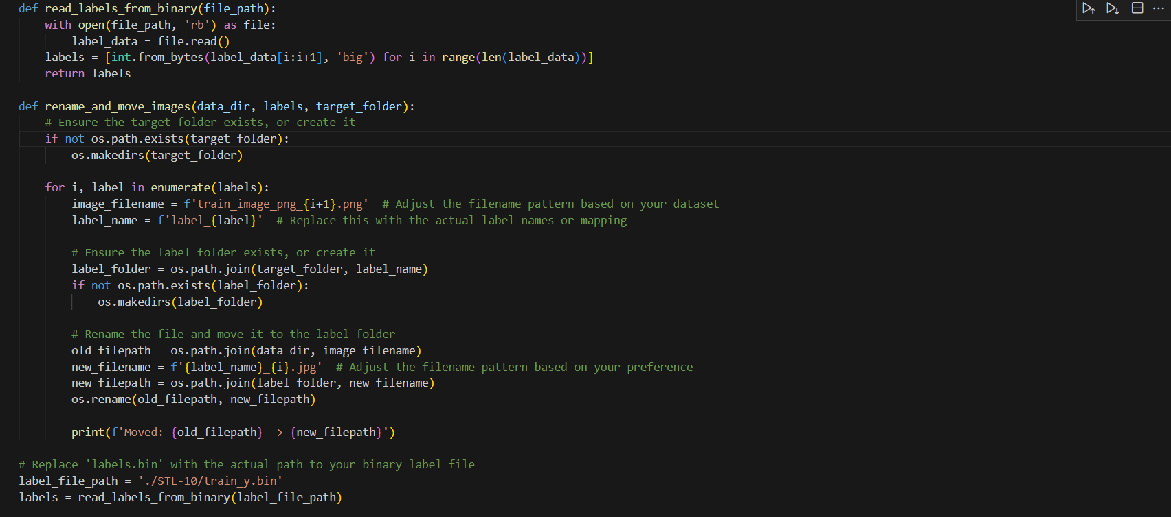

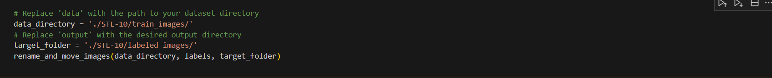

The function (read_labels_from_binary) takes file path as input ,opend the binary file read _binary mode,read the label data, convert each byte to an integer using (‘in.from.bytes’) the resulting list of integer represent the label , renaming and moving images based on labels by (rename_and_move_images) this func. Take parameters

1-(‘data_dir’) path to file containing the images

2-(‘labels’) list of labels corresponding each image

3-(‘target_folder’)path to file where the renamed and organized image will save

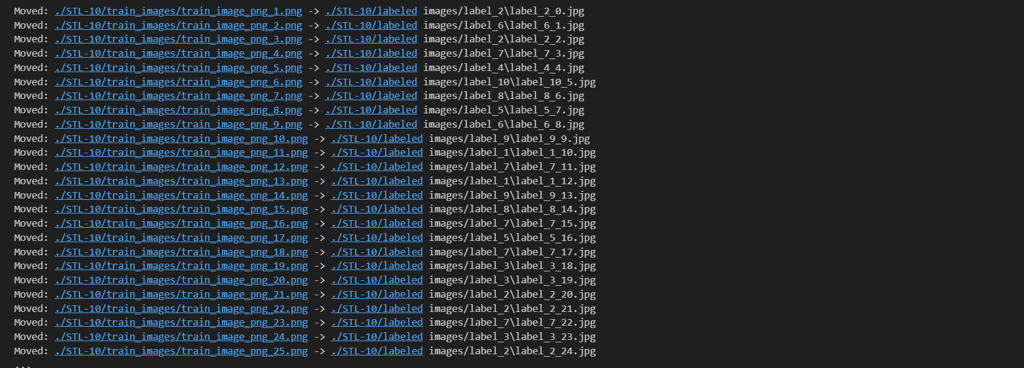

This is the output for incoding and the image there organized and take a binary number as label

------------------------------------------------------------------------------------

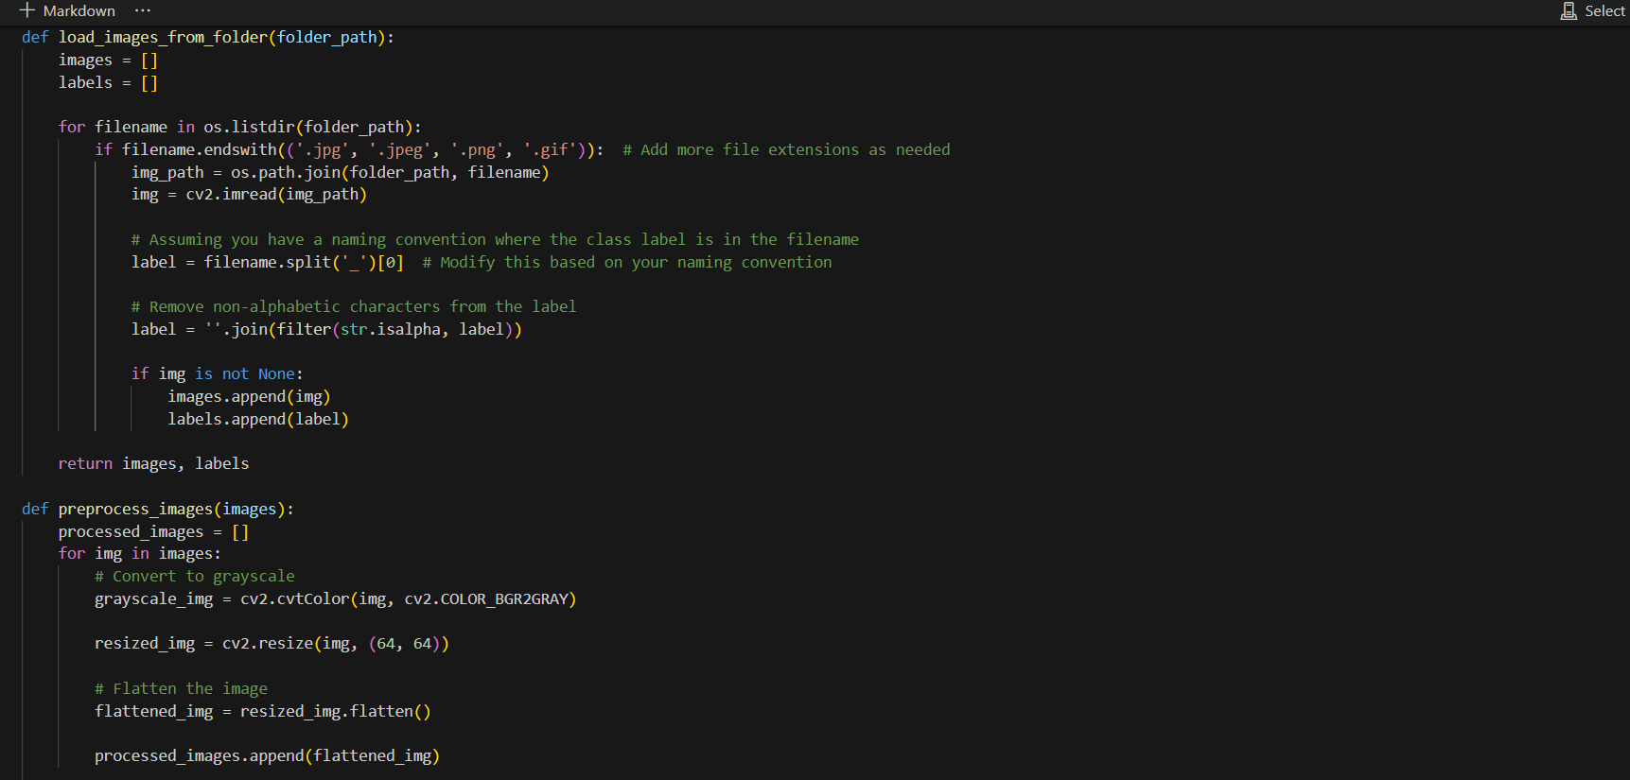

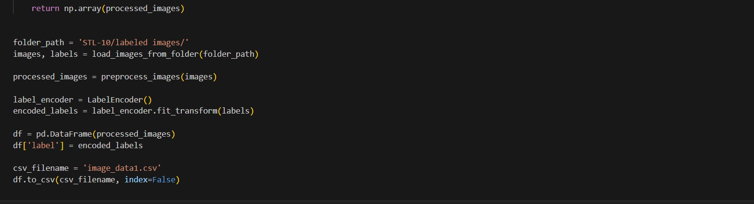

Function (‘load_image_from_folder’) take a folder path as a input and iterate over the file in the folder,(‘cv2.imread’) is used to read the image _for each file with a supported image extension(‘.jpg’,’.jpeg’,’.png’,’.gif’)_using openCV, extract the lavbel from the filename which the image &label are collected in the ‘images’ & ‘labels’lists, the function (‘preprocess_image’) take a list of images as input and performs the following preprocessing steps each image:

1-convert the image to grayscale using (‘cv2.cvtcolor’)

2-resize the image to fixed size(64x64pixel) using (‘cv2.resize’)

3-flatten the image to a 1D array using (‘flatten’)

The processed images are stored in the (‘processed_images’) list , (‘labelEncoder’) from scikit-learn to encode the textual labels into numerical values , the processed image and encoded label are combined into a pandas dataframe , the dataframe is saved in CSV file named(‘image_data1.csv’) using ‘to_csv’ , (folder_path=’STL-10/labeled images/’) for specify the path to the folder ,

(‘images , label = load_images_from_folder(folder_ path)’) using in load images and labels from the specified folder , (‘preprocess_images’)to load images that are converted to grayscale,resized,and flattened into 1D array

---------------------------------------------------------

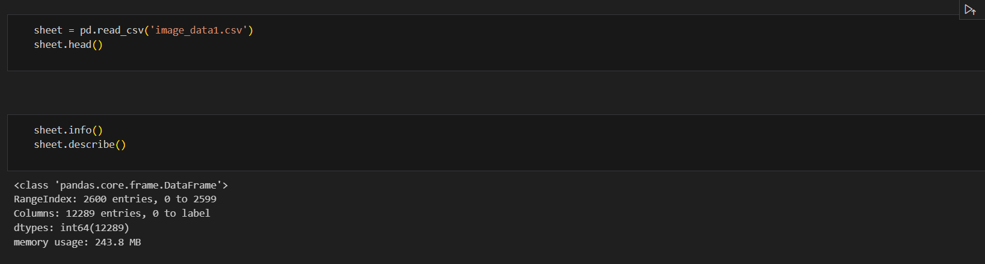

We put csv file in dataframe and named variable sheet and call function (‘sheet.head()’) to show first 5 row by default ,call function (‘sheet.info()’) to show information like non missing value for each column and data type for each column and memory usage of the data fram

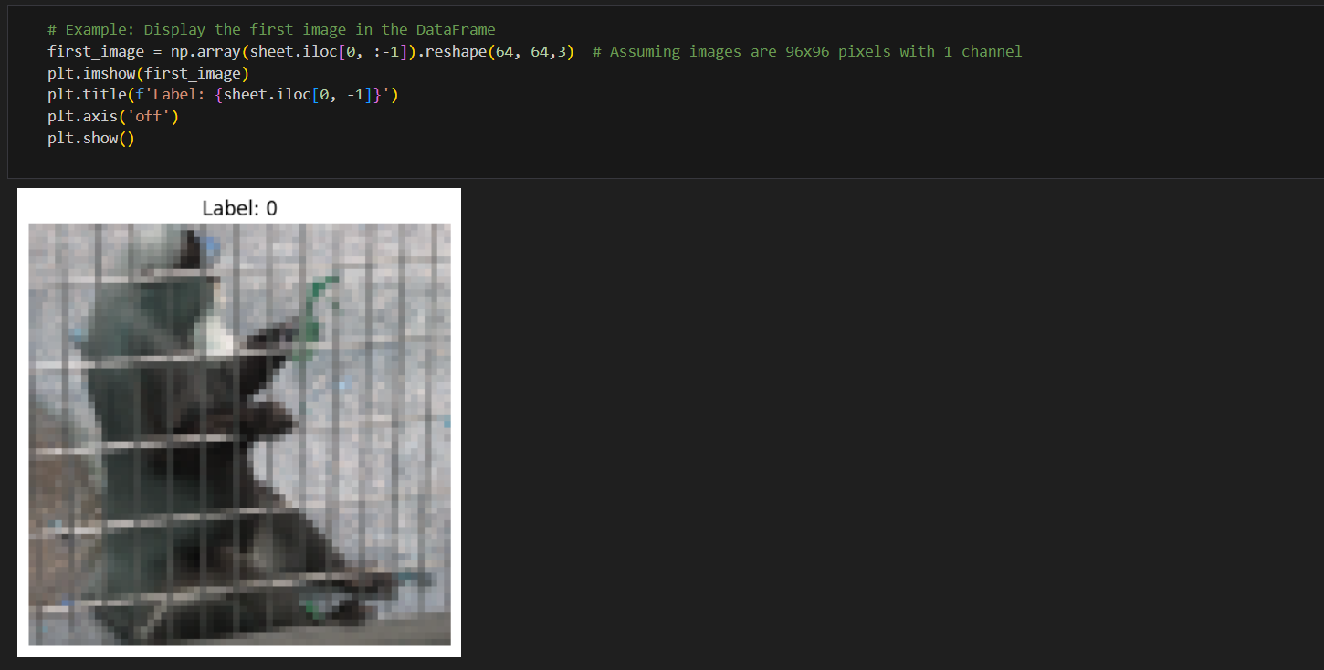

Display the first image in data frame and show output with (‘plt.show’)

----------------------------------------------------------------------------

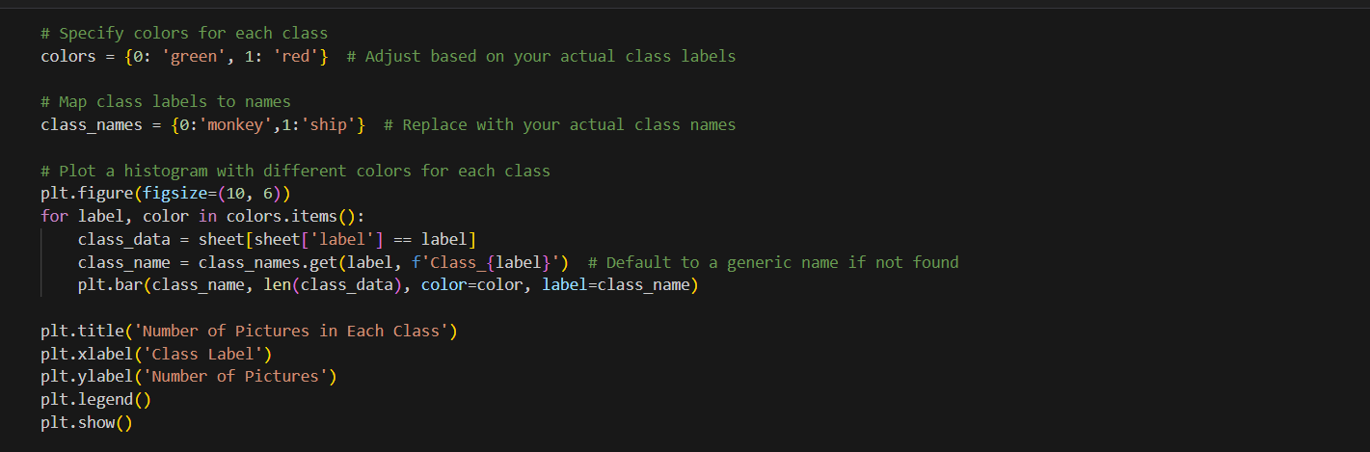

s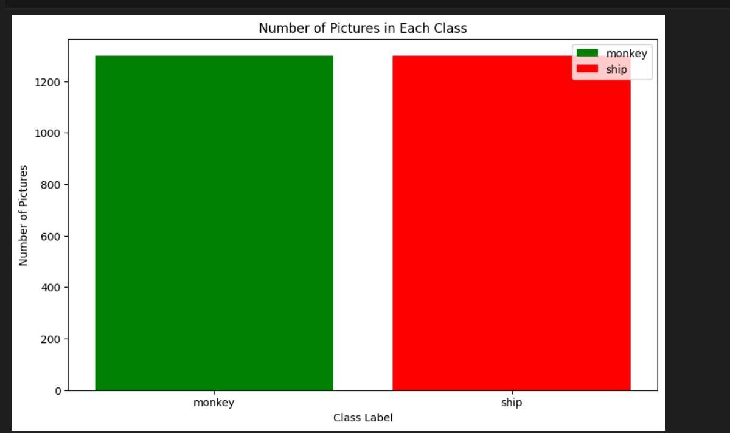

specify color for each class and give the class label named monkey and ship and show output in 2D with size 10&6 with function (figsize)

---------------------------------------------------------------------

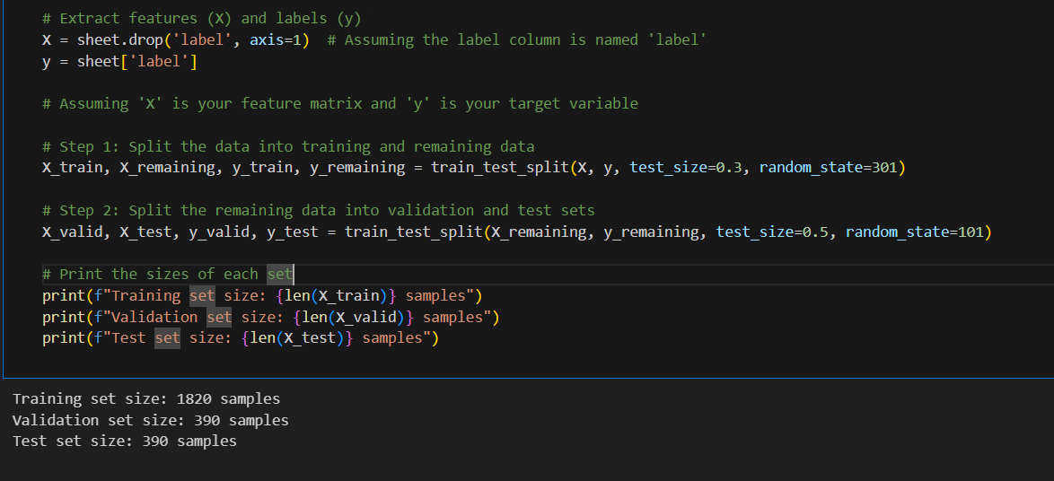

Will extract feature x by drop and y by select and make split the data into training and remaining data and split the remaining data into validation and test sets and print the output

------------------------------------------------------------------------------------

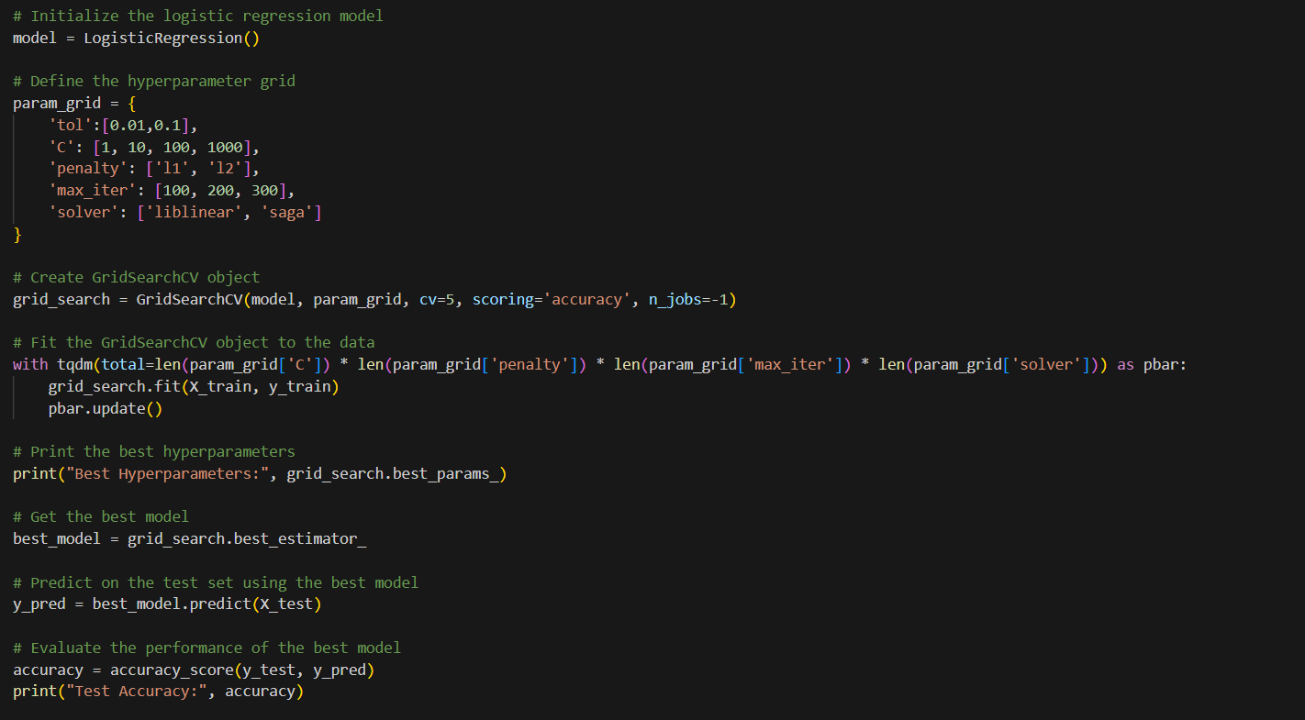



In this code will initiate logistic regression and define hyperparameter gird and fit the girdsearchcv object to data and print the best hyperparameter and get the best model and predict on test set with best model and evaluate the performance of the best model

-------------------------------------------------------------------------

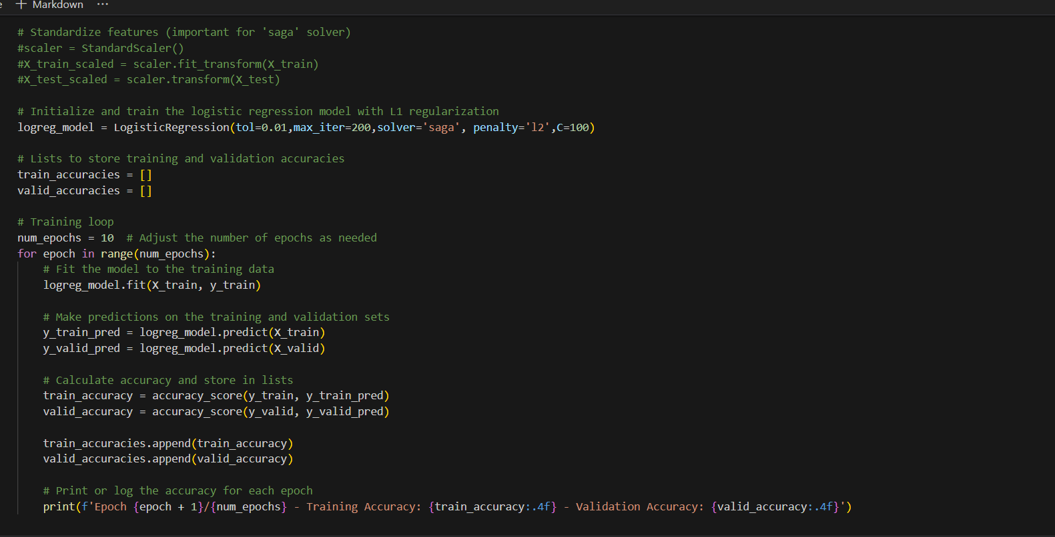

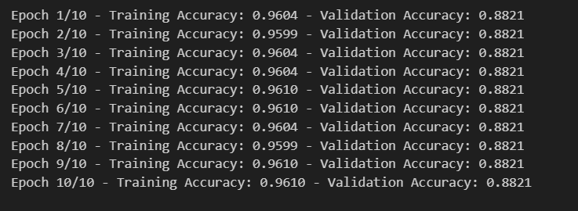

In this code make 10 epoch where training accuracy & validation accuracy fixed

-------------------------------------------------------------------------

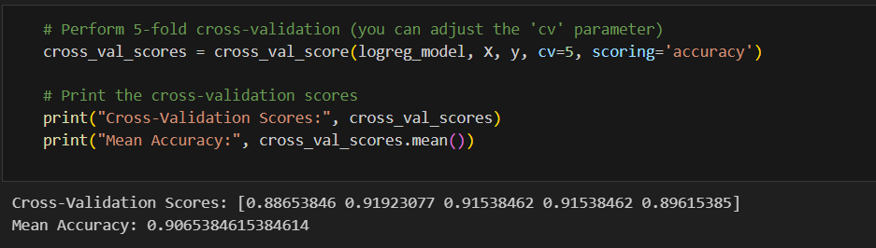

Perform 5 fold cross validation and print cross validation scores and mean accuracy

-------------------------------------------------------------------------

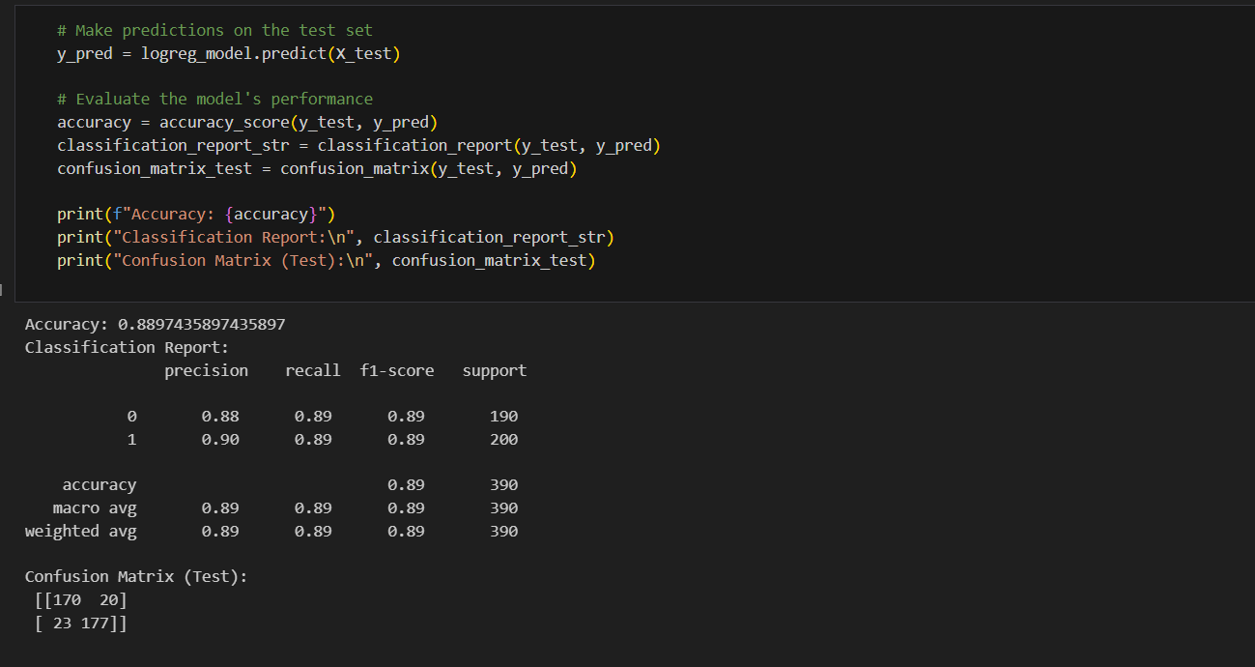

Show accuracies on model with test set and print confusion matrix where 1st number true negative and 4thtrue positive

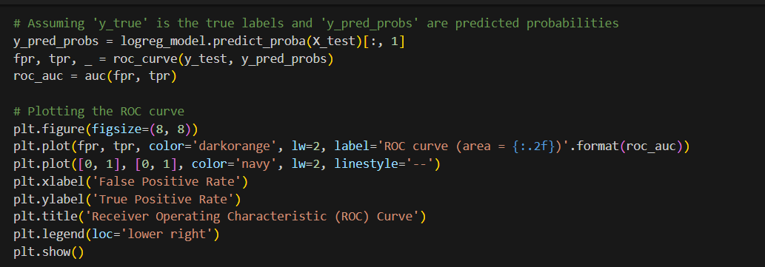

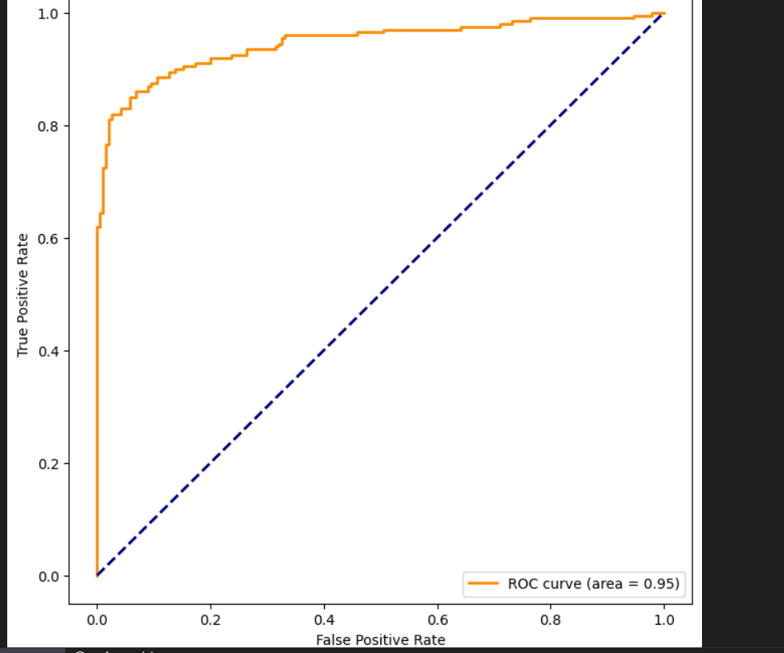

make compared y_test&y_predict and the more curv increase the more prediction be best

-------------------------------------------------------------------------

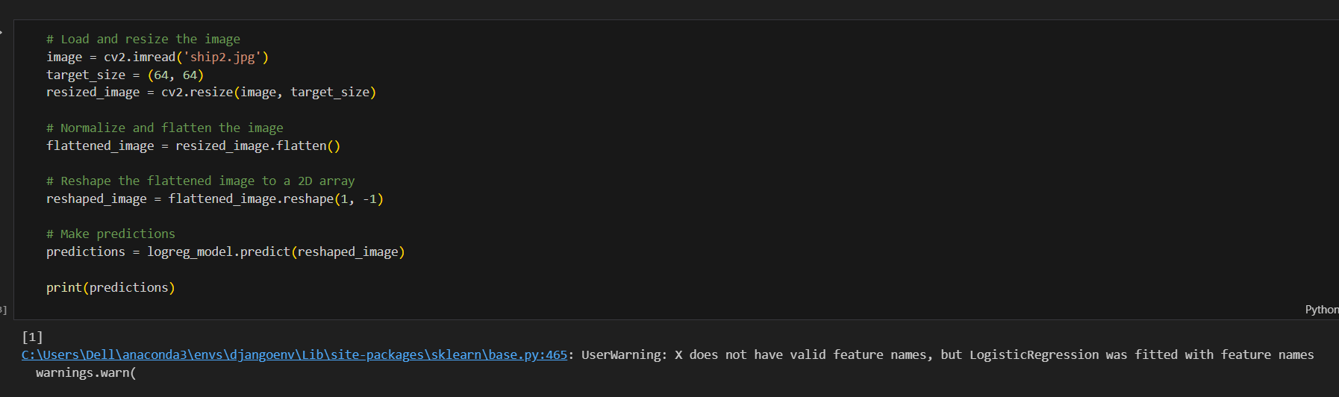

Take random image and make preprocessing _flatten&reship_ and make predict on image and print predict