**Library Management System**

**By: Hoda Salah**

1. **Customer Problem Statement:**

* How traditional Libraries be like?

Traditional Libraries gives priority on storage and keeping of physical items, particularly books and revisions those in which librarian were a responsible of the library. Information is assembled physically in one place; users must go to the library to know what is there and use, read, or buy it.

* Difficulties of traditional way of libraries management:
* It makes users struggle of finding the book which he/she wants. Thousands of books in same place take a lot of time to be arranged and a lot of time to be recorded.
* Very difficult and inaccurate to write the sales of the books or the books are borrowed.
* High probability of missing a book or being stored at wrong section.
* Low security of keeping rare books.
* Why should we use a software system for libraries?

Because of all the previous problems we had to level up the management system of libraries. Avoid the struggles which face the readers. Make searching book more organized and easier for customers.

* In technological revolution, there has been a corresponding growth of tools that make complex and time-consuming tasks more simpler and time efficient. One among the sectors that have benefited significantly from this advancement is that the library system. This is not only for libraries, but also for other firms which would require an online information management system such as hospitals, banks, car manufacturers, and other design-based entities.
* Those organizations use integrated library system (ILS) which allows them to manage their online resources electronically. An ILS is as an interface for users and administrative staff, a relational database, and the software which fit easily the operations of those individual components. The integrated operations enable the firms to [manage libraries](https://ciiva.com/smart-parts/benefits#automatically-manage-libraries-for-your-whole-organization) automatically so as to bring organizational efficiency and user experience enhancement. An ILS can be defined in the future as an online resource planning structure which allows to track and manage orders, and billings received, as the patrons.
* Benefits of Using the Integrated Library Management System:

Commonly used systems which separated into operating modules that allow to precise monitor of acquisitions, catalogs, serials, and how these materials circulate. The primary objective of using an ILS is to achieve convenience and flexibility in accessing information process.

For manufacturers who use computer-aided design, the use of an ILS cannot be avoided because it enhances total design process and increases its fluidity. Major advantages of using management libraries system is to include the following:

* **Encourages ease of use**

The graphical user interfaces used by staff and patrons. This is because any ILS is designed to make materials tracking and publications easier. This allows users to develop a customs workflow to reduces the time consumed for accessing information.

* **Highly secured cloud data management**

What is Cloud Computing and How will it Affect Libraries?

Those systems are being updated and maintained regularly to ensure that user databases are always kept secure and confidential. Since they subject maintenance on a regular basis, an ILS is also very credible with a low probability to crash. Regular updates to the system make sure that they are no errors and can resist a significant increment of users.  
Since an ILS is divided into many components with special functions, you can also increase your ability to multitask.

* **Allows mobile access or web interface**

Automated systems allow for flexible access to information. This is because a modern ILS can have a mobile application and website in the future as more development to boost its use and system engagement. This also makes users can access information both online and offline.

* **Enhances reporting and monitoring**

How Technology Is Changing Student Study Habits?

Self-updating records give increase to dynamic reporting and monitoring capabilities. These capabilities support material circulation, efficient bookings, and user tracking. It will allow materials management within system because you will know exactly what available, and what has been borrowed.

* The project titled Library Management System is Library management software for monitoring and controlling the transactions in a library. The project “Library Management System”is developed in C++, which mainly focuses on basic operations in a library like adding new member, new books, and updating new information, searching books and members and facility to borrow and return books.
* “Library Management System” is a windows operating systems application, designed to help users maintain and organize libraries. Our software is easy to use for both beginners and advanced users. It features a familiar and well thought-out, an attractive user interface, combined with strong searching Insertion and reporting capabilities. The report generation facility of the library system helps to get a good idea of which are the books borrowed by the members, making users possible to generate reports’ hard copy.
* The software Library Management System has four main modules for users:
* Insertion to Database Module – User friendly input screen
* Extracting from Database module – Attractive Output Screen
* Report Generation module – borrowed book list, Available
* list Search Facility system – search for books and members

1. **System Requirements:**
   1. Enumerated Functional Requirements:

|  |  |  |
| --- | --- | --- |
| 1 | Updating stock | This feature allows to enter details with respect to new book and magazines, etc. The stock subtleties are refreshed at every update of books. |
| 2 | Reservation | Library members use this advantage to reserve books which aren’t available presently at offline store. also allows you to enroll number if there is a large queue behind one book. |
| 3 | Data Integrity | After intervals (at least monthly), the system sends an email reminding for user to update their profile, also System will send reminders on certain data elements when the data has become out of date (SAM expiration date, Audit date, etc). |
| 4 | Reviews | Feature allows to user to make review about books and can read previous reviews about books. |
| 5 | System Security | Public has read only access via website.   Profile editing requires password-protected user account with manually assigned rights. Change log records details on data modification (date, username). |

* 1. Enumerated Nonfunctional Requirements:

|  |  |  |
| --- | --- | --- |
| 6 | Performance Requirement | the proposed program that will be designing will be used as an output framework, which interacts with staff and students so, it’s expected that the database would perform functionally at all.   * The system performance should be rapid and valid. * The system should be capable of handling a lot of data. * Our System is responsible for handling planned and unexpected errors in many possible ways that could be happened. * Prevents loss of information, and prolonged downtime. And that would have been a mistake Check for invalid username/password identifier. |
| 7 | Safety Requirement | Due to viruses or operating system failure, the database can get crashed at any time. It is also important to take a backup of the database so that the database is not lost. |
| 8 | Security Requirement | - The system will employ a secure database.  - Normal users can just read information but they cannot edit or modify anything except their personal and some other information.  -The system will have different types of users and each user will have access restrictions.  -Must provide proper user authentication.  -No one should be able to hack users’ password. |
| 9 | Requirement Attributes | - The project may be created by multiple admins, all of whom will have the right to make system changes. But the members or other users cannot make modifications the project should be open source.  -The user can download and install the program very easily. |
| 10 | User Requirement | Members of the system are university administrators and librarians who serve as supervisors to keep the network going. Representatives are believed to have basic computer and internet browsing skills. Backup and recuperation. Proper user interfaces, user manuals, online help, and system installation and maintenance guides need to be adequate to educate users about how to use the system without any problems. The Admin provides users with such services in the form of:  --Forgot Password.  -- Migration of data whenever the user first registers the data on the server.  -- Replication of data, if data is lost in one branch, it will still be stored with the server.  -- Auto recovery, the information is often auto-saving. |

1. **Functional Requirements Specifications:**
   1. Stakeholders:

|  |  |
| --- | --- |
| 1 | Librarians |
| 2 | Students |
| 3 | Professors |
| 4 | Manager |
| 5 | Publishers |
| 6 | Software Engineer |

* 1. Actors and goals:

Our system has two main actors:

* Librarian: Mainly responsible for adding and modifying books, book items, and users. The Librarian can also issue, reserve, and return book items.
* Member: All members can search the catalog, as well as check-out, reserve, renew, and return a book.
  1. Use cases:
     1. Use Case description:
* Add/Remove/Edit book: To add, remove or modify a book or book item.
* Search catalog: To search books by title, author, subject or publication date.
* Register new account/cancel
* Check-availability book: To borrow a book from the library.
* Return a book: To return a book to the library which was issued to a member.
  + 1. 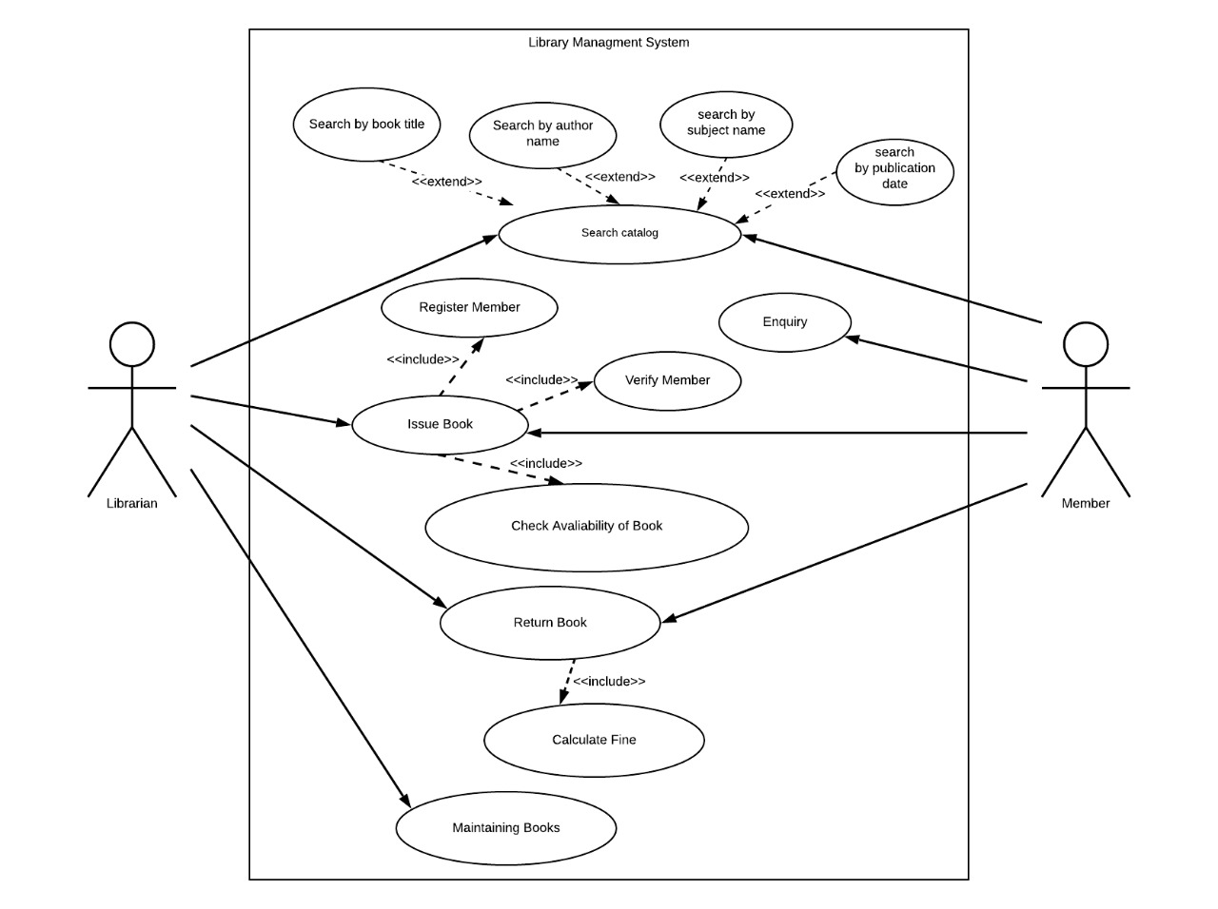Use Case diagram:
  1. 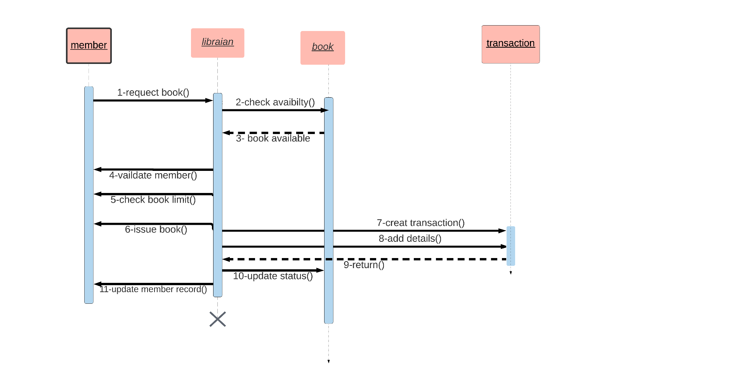System sequence diagram:
  2. 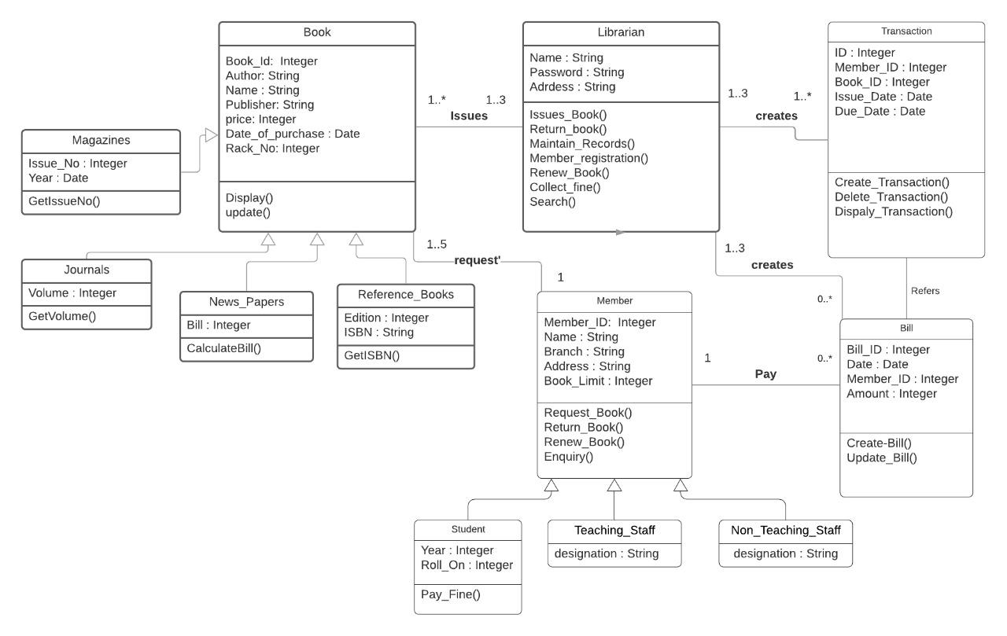Class diagram and Interface specification: