# DECLARATION

We, Better UMUTONI and Solange Uzarama declare that the project report entitled “CONSTRUCTION WORKS MANAGEMENT SYSTEM” submitted in fulfillment of the requirement for the award of the Diploma in ICT academic year 2017/2018, by IPRC South. We further declare that the work reported in this project has not been submitted, either in part or in full, for the award of any other degree or diploma in this institute or any other institute or university.

Better UZARAMA

Signature…………………….. Date……………………..

Solange UZARAMA

Signature…………………….. Date……………………..

# APPROVAL

This is to acknowledge that this research project has been submitted with our approval under our supervisor.

Mr. Simon AGABA

Signature……………………... Date….……………………….

# DEDICATION

We dedicate our work to the Almighty God,

To our beloved family,

To our supervisor,

To our classmates, colleagues that we shared ideas.

# ACKNOWLEGMENT

First and foremost, We are most grateful and also extend our lovely appreciation to the Mighty fortress is our God, a bulwark never failing for his mercies endures forever, and by whom this work has been made possible.

Sincere thanks goes to our supervisor Mr. Simon AGABA, for his support throughout our entire research. His continuous suggestions, critics, adherence and guidance made this project a success.

We also thank the administration and all lecturers of the IPRC South, especially in the department of ICT for their contribution through the course and we thank Head of department of ICT Mr. Egide NKURUNZIZA.

We are grateful to our families we are going to refer below. This work couldn't have been accomplished without their willing moral, financial and technical support.

We also highly indebted to our friends for their support and the sharing of everything developmental throughout our studies, may you achieve for anything you struggle for.

Finally I thank who ever, in one way or another contributed to the success of our project.

God Bless you all!

# ABSTRACT

# 

This study focused on the development of a construction works management system. It is Web enabled platform that helps construction engineers to manage from the simplest to the most complex management operations within construction company.

The existing construction software management have some challenges. Some of them are; not user-friendly, expensive, heavy to load, compatibilities issues for installations especially desktop version, access limit and sharing the documents, no real time report generating.

To achieve our objectives,Waterfall model was used as a software development process model to develop the software. The interviews, documentation and observation were used as the major data collection techniques in respect to the system analysis and requirements.

By conclusion, this platform will be working effectively, and save time. It is expected that effective implementation of this system would eliminate many problems discovered in existing construction management systems softwares. We recommend the researchers students and other interested to add some modules for keeping maintained and improved.

**TABLE OF CONTENTS**

# LIST OF TABLES

# LIST OF ABBREVIATION

AJAX: Asynchronous JavaScript and XML

CSS: Cascading Style Sheet

HTML: Hyper Text Markup Language

ICT: Information Communication and Technology

ERD: Entity Relationship Diagram

SDLC: Software Development Life Cycle

SQL**:** Structure Query Language

UML: Unified Modeling Language.

XML: Extensible Markup Language

# CHAPTER 1: INTRODUCTION

# 

Today, most of the systems of information management has been digitized. All these innovations have the aim to simplify life by making a lot of works easily and in a short time. This is to explain the concept construction works management system as our project. The existing construction software management have some challenges. Some of them are; not user-friendly, expensive, heavy to load, compatibilities issues for installations especially desktop version, access limit and sharing the documents, no real time report generating. The new system come to solve the pitfalls existed in the existing one. It helps construction engineers to manage from the simplest to the most complex management operations within construction company without wasting time and deliver automated reports with real-time data.

This software will help construction engineers to manage an estimation and planning, scheduling, cost control and budget management, resource allocation, collaboration software, communication, decision-making, quality management and documentation or administration systems.

## 1.1Background

Throughout the years the construction industry has gained a major place in everyday life. Construction Project Management (CM) is a professional service that uses specialized, project management techniques to oversee the planning, design, and construction of a project, from its beginning to its end. The purpose of CM is to control a project's time, cost and quality—sometimes referred to as a project's "triple constraint."[1] CM is compatible with all project delivery systems,[2] including design-bid-build, design-build, CM At-Risk and Public Private Partnerships. CM is expensive, and not user-friendly, it acquires more technicals and knowledge to use it. Even though, there are some existing construction softwares management systems likely to have some pitfalls still need to be improved.

The construction industry is exponentially revolutionized day to day, this raises project management complexity in different projects reflect on its revenue statement.

## 1.2 Problem statement

## 

Some software already exists to help manage a construction projects within construction company, the way each and every construction company manage daily projects are totally different due to financial level plus its Human resources capacity. To outsource and renting existing construction works management system are still a challenges for the most construction company with the following challenges, they are too expensive, not-user friendly with acquired high-level skills to use and deploy them, no support of real-time auto generate reports, no module of cloud-based shared information, time consumption for request paper based reports, and issues for back-up data.

## 1.3 Objectives

### 1.3.1 General objective

The general objective of this project is to implement a web-based, online construction works management system which will to manage from the simplest to the most complex management operations within construction company.

### 1.3.2 Specific objectives

The specific objectives are:

* Design a robust and scalable management system to manage construction daily projects
* Design user-friendly and interactive web based application which will reduce the paper work, faster and easy work and save the time.
* To develop a software will deliver automated reports with real-time data and facilitate team collaborate within the same construction company.

## 1.4 Hypothesis

To develop an construction works management system will help construction companies to save time and increase revenue by integrating real-time daily project management.

## 1.5 Scope of the project

This project is carried out in FAIR construction company for testing and evaluating it. The Scope of this application deals with the administrator of the software. The administrator here is the advocate who deals with the handling of addition, deletion and updating the detail This Daily Board software is limited to advocates only who is the administrator of the software, who manages all the working and allows the project's members to run their projects assigned and handle the data of the other workers on the same projects.

## 1.6 Significance of the study

Today, Rwanda has many construction companies that are operate in it, but the way of generating revenue and working daily project management are different depend on the scalability of the companies from small, medium and even large. As a final year student from department of Information Communication and Technology, we came up with a project idea of creating web-based platform that manage from simplest to the complex construction works project management. The benefits will be on construction engineers will be able to plan, monitor, projects items showcasing, other staff coordination without wasting time and working in paperless office.

Further, This software will help construction engineers to manage an estimation and planning, scheduling, cost control and budget management, resource allocation, collaboration software, communication, decision-making, quality management and documentation or administration systems.

As final year students, we got experience in what we have learnt. It improved our knowledge in designing and implementing an online system, develop professional attitude in our IT career, and it will help us to generate money after its implementation.

## 1.7 Project Profile

Project Title: Construction Work Management System

Technology Requirements:Front-End / UX& UI : Languages: - HTML5, CSS3, Javascript, Jquery

and Ajax.

Framework: - Twitter Bootstrap Package Management: Bower for Front-End & Composer for Back-end.

Back-end : Language : PHP

Framework: Slimv3 (Micro-framework for PHP )

Database: Mysql

Integrated Development Environment (IDE) : Jetbrains : PhpStorm 2017.1.3 & DataGrip 2017.1.0 and Mysql Workbench.

Distributed Version Control System:Github and Git for collaboration and keeps track coding periodically

# CHAPTER 2: LITERATURE REVIEW

Construction companies started to use the software projects management to raise revenues and reduce work loads for each and every project in the company, the SaaS (software-as-a-service) trend began in 2008, qualified by users as the most flexible type of project management software for their teams. In 2009, US News classified project management as one of the most demanded skills for obtaining a well-paid job.[3]

From 2010 on, the most popular project management solutions were cloud-based, designed for the needs of virtual teams looking to access information from any location or device.[4][5] As a result, 2012 brought the first mobile project management application users can apply on the go.[6**]**

# CHAPTER 3: METHODOLOGY

## 3.1 Introduction

This section will explain clearly the way that we intend to approach the research problem and the techniques and logic that we use to address it.

It also includes the procedures, the sample and the instruments we use in our research.

Methodology is the underlying principles and rules that govern a system method; on the other hand it is a systematic procedure for a set of activities. Thus, from these definitions a methodology encompasses the methods used within a study.

Iterative model under the software development life cycle is the methodology used to produce the design of the event storage and management system.

### 3.1.1 Data collection methods

Data-collection methods allow us to systematically collect information about our study and about the settings in which they occur.

There are two major approaches we have used to gather information about our study; those are primary data and secondary data that we gathered.

* **Secondary data**: Data that previously may have been collected for other purposes but can be used in the immediate study.

The secondary data were obtained by the researcher from magazine, journal, newspaper, library source and internet downloads. The data collected from this means have been covered in literature review in the chapter two.

* **Primary data**: Raw data that has been originally collected by the researcher specifically for the study at hand.
* **Oral interview**: The interview method of data collection can be defined as a systematic way of collecting data or information from a respondent through asking questions directly from the respondent and also collecting information with the aim of facilitating understanding.

The interview was done through people who works in the events management companies and other business men who are interested in event planning and management field. This helps the researcher in starting the work and also helped in the area of solution presentation of the new design.

### 3.1.2 Software development methodology

Software development methodologyalso known as asystem development methodology,software development life cycle,software development process,software process) is a splitting ofsoftware developmentwork into distinct phases or stages containing activities with the intent of better planning and management.

The development models are the various processes or methodologies that are being selected for the development of the project depending on the project’s aims and goals. There are many development life cycle models that have been developed in order to achieve different required objectives. The models specify the various stages of the process and the order in which they are carried out.

The selection of model has very high impact on the testing that is carried out. It will define the what, where and when of our planned testing, influence regression testing and largely determines which test techniques to use.

A systems development life cycle (SDLC) is the process by which an information system comes to life and maintains its usefulness to a business as it moves from inception to replacement. Some popular models of an SDLC include the

* waterfall model,
* iterative model,
* V model,
* the spiral model,
* agile model
* the incremental build model,
* the prototyping model, and
* The Rapid Application Development (RAD) model.

Choosing right model for developing of the software product or application is very important.

Based on the model the development and testing processes are carried out.

* The waterfall life cycle model it says the all the phases of SDLC will function one after another in linear manner. That is, when the first phase is finished then only the second phase will start and so on. This life cycle model assumes that requirements will remain stable after they are defined.
* Iterative model, this model leads the software development process in iterations. It projects the process of development in cyclic manner repeating every step after every cycle of SDLC process.Because a cycle includes small portion of whole software process, it is easier to manage the development process but it consumes more resources.
* V model provides means of testing of software at each stage in reverse manner.Very rigid and least flexible.
* Agile model is also a type of incremental model.Deliverables, especially the large ones, it is difficult to assess the effort required at the beginning of the software development life cycle.
* The incremental build model, in this model, the whole requirement is divided into various builds. Needs good planning and design
* The prototyping model is used for developing software prototypes to clarify user requirements for operational software.

Lead to implementing and then repairing way of building systems.

* RAD model uses an approach in which developers work with an evolving prototype.

Depends on strong and individual performances for identifying business requirement.

Here, we use iterative model for our project. We will see the advantages of using iterative model in full.

## 3.2 Waterfall

Waterfall model was being chosen because all requirements were known beforehand and the objective of our software development is the computerization/automation of an already existing manual working system. Reasons to choose

waterfall model are:

Waterfall model is simple to implement and also the amount of resources required for it are minimal.

When to use the waterfall model:

1. This model is used only when the requirements are very well known, clear and fixed.
2. Product definition is stable.
3. Technology is understood.
4. There are no ambiguous requirements
5. Ample resources with required expertise are available freely
6. The project is short.

Advantages of waterfall model:

1. Simple and easy to understand and use.
2. Easy to manage due to the rigidity of the model – each phase has specific deliverables and a review process.
3. Phases are processed and completed one at a time.
4. Phases do not overlap.
5. Works well for smaller projects where requirements are very well understood.

Disadvantages of waterfall model:

1. Once an application is in the testing stage, it is very difficult to go back and change something that was not
2. well-thought out in the concept stage.
3. No working software is produced until late during the life cycle.
4. High amounts of risk and uncertainty.
5. Not a good model for complex and object-oriented projects.
6. Poor model for long and ongoing projects.
7. Not suitable for the projects where requirements are at a moderate to high risk of changing.

The following figure illustrate the waterfall model:

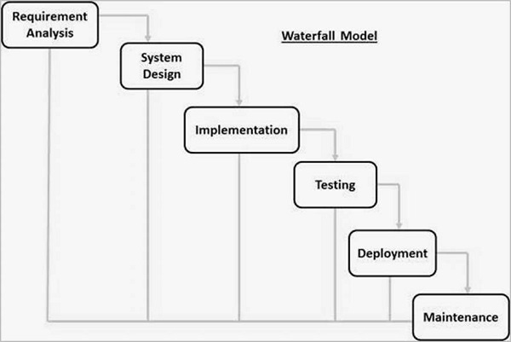

Figure 3. 1: waterfall model

### 3.2.1 Phase of waterfall model

**Requirement Gathering and analysis** − All possible requirements of the system to be developed are captured in this phase and documented in a requirement specification document.

**System Design** − The requirement specifications from first phase are studied in this phase and the system design is prepared. This system design helps in specifying hardware and system requirements and helps in defining the overall system architecture.

**Implementation** − With inputs from the system design, the system is first developed in small programs called units, which are integrated in the next phase. Each unit is developed and tested for its functionality, which is referred to as Unit Testing.

**Integration and Testing** − All the units developed in the implementation phase are integrated into a system after testing of each unit. Post integration the entire system is tested for any faults and failures.

**Deployment of system** − Once the functional and non-functional testing is done; the product is deployed in the customer environment or released into the market.

**Maintenance** − There are some issues which come up in the client environment. To fix those issues, patches are released. Also to enhance the product some better versions are released. Maintenance is done to deliver these changes in the customer environment.

## 3.3. The Software development technology tools and languages

Technology used:

**3.3.1 PHP** :

PHP is stand for hypertext preprocessor. PHP is a powerfulserver-side scripting language for creating dynamic and interactive websites.

1. PHP is the widely-used, free, and efficient alternative to competitors such as Microsoft's ASP.
2. PHP is perfectly suited for Web development and can be embedded directly into the HTML code.
3. The PHP syntax is very similar to C language.
4. PHP is often used together with Apache (web server) on various operating systems.
5. It also supports ISAPI (Internet Server Application Programming Interface.) and can be used with Microsoft's IIS on Windows.
6. In that all the concepts are from OOPS (Object Oriented Programming System), so if anyone knows about that concept then he/she can learn php easily.
7. PHP scripts are executed on the server side.
8. PHP supports many databases like (MySQL, Oracle, ODBC etc...).
9. PHP files have a file extension of ".php" or ".tpl" ".phtml"

**3.3.2 MySQL :**

1. MySQL is the most popular Open source Database System.
2. MySQL Database Management System.
3. The main goal of MySQL are speed and robustness.
4. MySQL, the most popular open source SQL (Structured Query Language) Database Management system, is developers,
5. distributed, and supported by MySQL AB.
6. MySQL AB is a commercial company, founded by the MySQL developers.

It is a second generation open Source company that unites open source values and Methodology with a successful business model.

# CHAPTER 4: **PRESENTATION AND ANALYSIS OF RESULTS**

## 4.1 REQUIREMENT OF SYSTEM

### This Web application is a very important feature used for construction work management.

The primary goal of this software is to store or keep all records of construction project.

In this project only admin will have to create new user, than they create the records, create purchase order, create vendors, etc. and super admin will provide the role like ccd, account and admin to users.

1. ADMINISTATOR

* Editing/Deleting/Creating the database.
* Super admin can give roles to users.

1. MEMBER

* Logging into the system.
* He/she can change or create the records when access is
* granted by super admin.
* Can update /edit its records.

4.1 FEASIBILITY STUDY

4.2.1 Operational Feasibility

In this we check the entire task by operation.

That means when we get task at the time first we search for what operation will going on during this task.

What will be input, output and what condition we have to put.

And from this kind of operation we get more clear idea,and thus we can understand more about client requirement and

functionality which client want.

So, operational feasibility is helpful to get more idea about task and client requirement.

4.2.2 Technical feasibility

Technically my project was feasible enough.

But the sources for guidance was not enough for my development.

4.2.3 Economic feasibility

For any system if the expected benefits equal or exceed the expected costs, the system can be economically feasible.

In economic feasibility, cost benefit analysis is done in which expected costs and benefits are evaluated.

We consider economic analysis for checking how much our project would cost.

4.3 USE CASE DIAGRAM

* **Member**

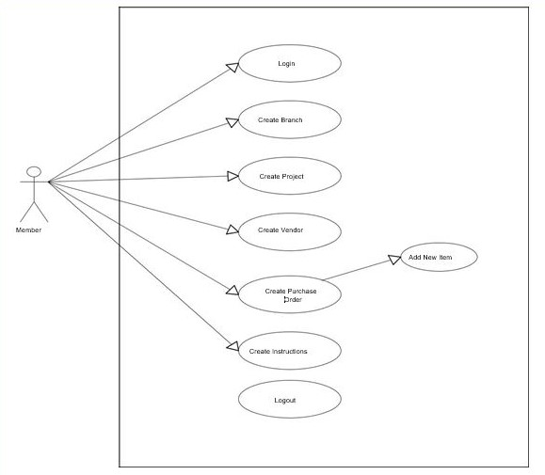

* Admin

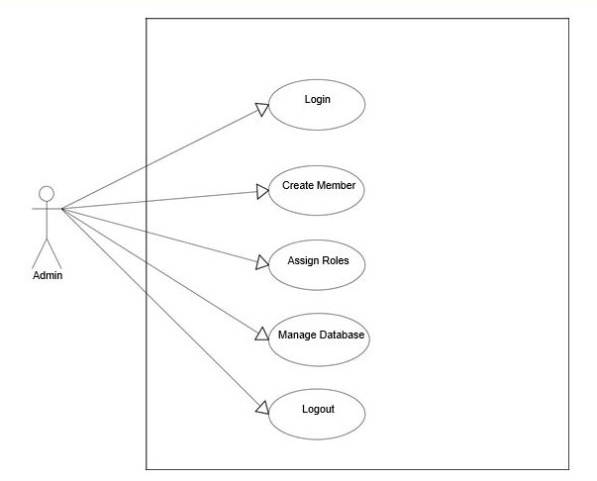

**4.42 DATA FLOW DIAGRAM (0 & 1 LEVEL)**

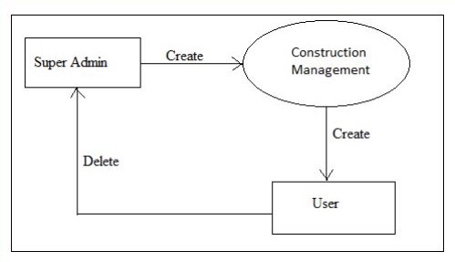

**Level – 0**

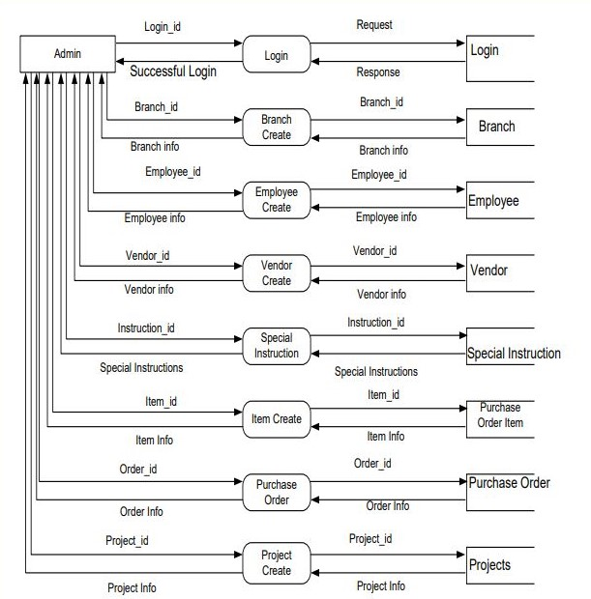

**Level – 1**

**4.5 E-R DIAGRAM**

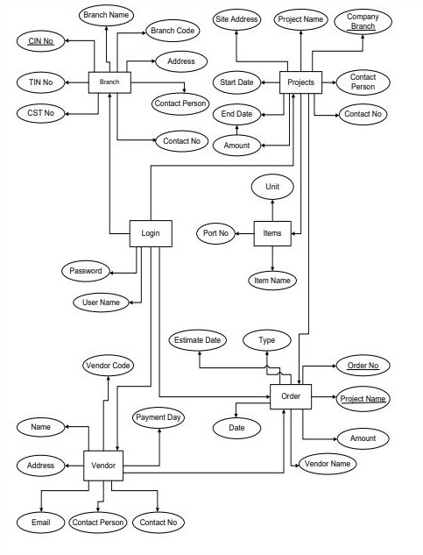

**4.6 Sequence Diagram**

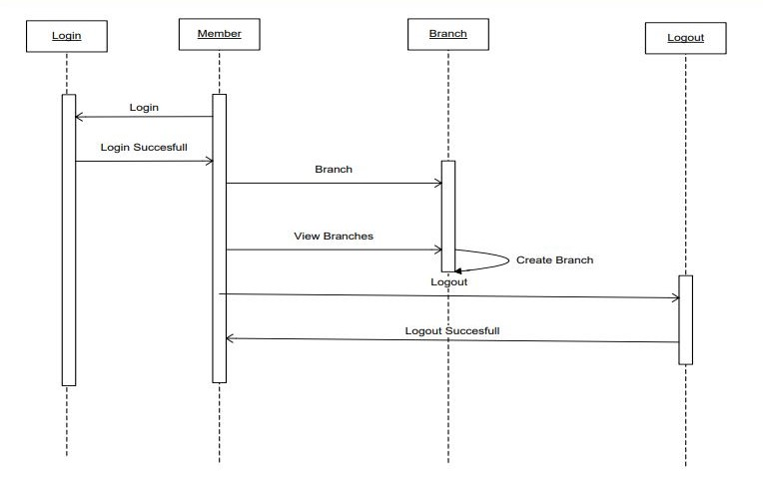

CHAPTER 5: CONCLUSION AND RECOMMENDATION

## 5.1 CONCLUSION

The core objective of the current project was to design and implement web based construction works management system . This objective has been achieved successfully with the best practices in designing it.

The choice of the topic was motivated by our desire to apply the knowledge acquired during our studies in developing a real -world application that satisfies not only its specifications, but also the industry standards as far as software engineering is concerned.

The requirements were drawn from a careful analysis of the existing system in use and its problems, and the analysis, design and implementation were guided by the provision of a system that effectively and efficiently solves the problems identified.The result of our project is a web based app, it is basically used for keep data on related construction. This web based app provides features that Admin can create Projects, Branches, Vendors, items,assign member to the projects etc. Members can change or create the records when access is granted by admin of construction. And also they can change the created records. This web based app is fast and easy retrieval and to reduce the work and time. Use of this project would make the web based app interactive. This software will help construction engineers to manage an estimation and planning, scheduling, cost control and budget management, resource allocation, collaboration software, communication, decision-making, quality management and documentation or administration systems by removing the existed pitfalls in construction project management.

To implement this project, we used PHP language and Mysql database. It is hoped that effective implementation of this system would eliminate many problems discovered in existing construction works management system.

## 5.2 RECOMMANDATIONS

This project has not been successfully achieved because of limited time and limited resources, it was not completed as we expected.

We recommend the IPRC South to help the final students by giving facilities on software hosting and continue to work on it by enhancing the following points in next release:

* Member can give orders online.
* Member can do online bidding.
* Data security can be enhanced.
* Reminder System can be enhanced.
* User Tracking.

# References

#### Books and publications

1. 3rd Forum "International Construction Project Management" 26th/27 June 2003 in Berlin
2. Antunes, Ricardo; Gonzalez, Vicente (2015-03-03). "A Production Model for Construction: A Theoretical Framework". Buildings. 5 (1): 209–228. doi:10.3390/buildings5010209. Archived from the original on 2015-04-02.
3. "11 Skills You'll Need for a Career", usnews.com,
4. Don Reisinger, "10 Cloud-Based Project Management Tools to Serve Every Company's Needs", eweek.com,
5. "4 Cloud-Based Project Management Tools to Manage Your Work Better", smallbiztrends.com,
6. Margi Murphy, "Six free, mobile-friendly project management tools for your business", techworld.com, August 13, 2015

**Electronic references**

1. **http://www.w3schools.com/php/**
2. **http://www.w3schools.com/css/**
3. **http://www.php.net**

**6 APPENDICES**

**6.1 Screen shots step by step**