**TP7**

**Calcul de la constante de PI en mono thread**

L'outil htop est conseillé car il permet de visualiser la consommation CPU sur chaque coeur de la machine. Pour installer cet outil , il faut lancer la commande suivante en étant root :

**apt-get install htop**

package TD7;

public class ex1 {

public static void main(String[] args) {

double a = 0;

for (long i = 0; i < 500000000; i++) {

a += Math.pow(-1, i)/(2*i+1);

}

System.out.println("PI : "+a);

}

}

**Calcul de la constante PI en multi thread**

package TD7;

public class ex2 extends Thread {

long start,end;

double nbrPi = 0;

public ex2(long start, long end) {

super();

this.start = start;

this.end = end;

}

public void run() {

for(long i = start; i <= end; i++) {

nbrPi += Math.pow(-1, i)/(2*i+1);

}

}

public static void main(String[] args) throws InterruptedException {

long time = System.currentTimeMillis();

int nbThread = 2;

long N = 500000000;

long end = N/nbThread;

long start = 0;

double PI = 0;

// conteneur de tout les threads

ex2[] threads = new ex2[nbThread];

//creation des différents thread

for (int i = 0; i< nbThread; i++) {

ex2 newThread = new ex2(start,end);

start = end+1;

end = start + N/nbThread;

threads[i] = newThread;

}

// activation des threads

for( int i = 0; i<nbThread; i++) {

threads[i].start();

}

// synchronisation

for (int i = 0;i <nbThread; i++) {

threads[i].join();

}

//recuperation des données

for (int i = 0; i<nbThread;i++) {

PI += threads[i].nbrPi;

}

System.out.println("Pi= "+PI);

System.out.println("time en ms= " + (System.currentTimeMillis()-time));

}

}

**Séquencement de threads (version simple)**

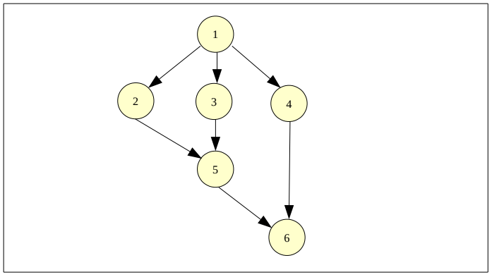

package TD7;

public class ex3 extends Thread{

int numThread;

public ex3(int numThread) {

super();

this.numThread = numThread;

}

public void run() {

System.out.println("debut du thread "+numThread);

try {

sleep(1000*numThread);

} catch (InterruptedException e) {

// TODO: handle exception

}

System.out.println("fin du thread "+numThread);

}

public static void main(String[] args) throws InterruptedException {

// conteneur de tout les threads

ex3[] threads = new ex3[6];

//creation des différents thread

for (int i = 0; i < 6; i++) {

ex3 newThread = new ex3(i+1);

threads[i] = newThread;

}

threads[0].start();

threads[0].join();

// rien n'est fait tant que le threads[1] n'est pas die

// cela est du a la fonction join()

threads[1].start();

threads[2].start();

threads[3].start();

threads[1].join();

threads[2].join();

threads[4].start();

threads[3].join();

threads[4].join();

threads[5].start();

}

}