# Application design

## Use Case Diagram

* Python: arlo honi dagokion aplikazioa menu baten bidez erabiltzen da; menuaren funtzionamendua, honako use case diagramekin azaldu dezakegu.
  + Menu nagusia + Use Case (hasierakoa):
    - 1. Reservations
    - 2. Products
    - 3. Users

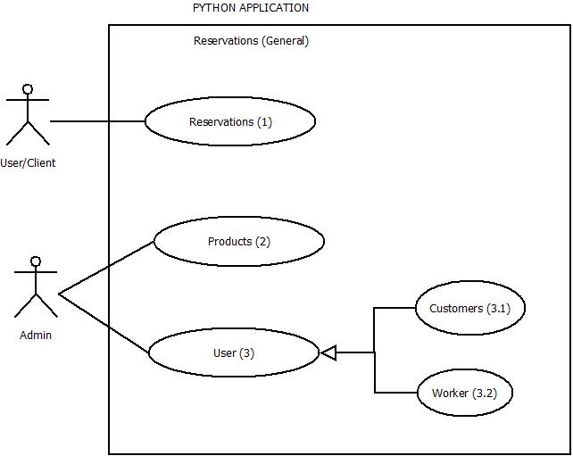

* + Menu nagusiko aukera bakoitzaren azpi menua + dagokien Use Case-ak:
    - **RESERVATIONS**:
      * View all the products
      * New Reservation (with Use Case)
        + Enter required data to create a new reservation: *idReservation (PK), date, cabin, service, products*.

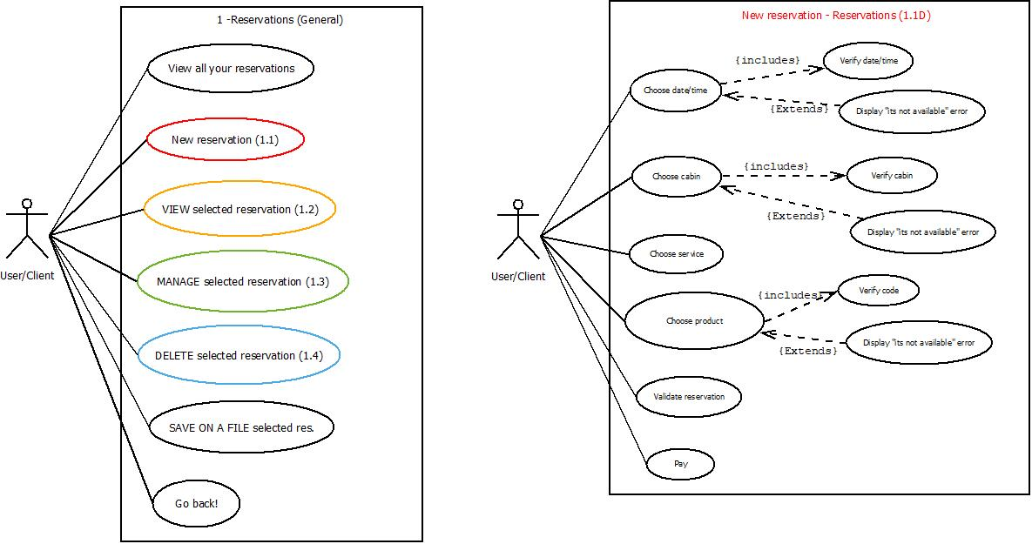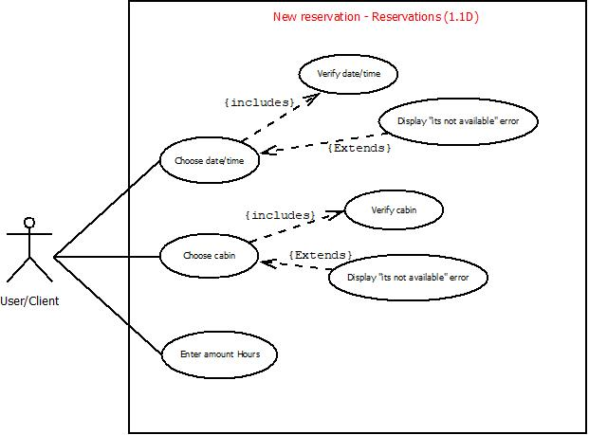

|  |  |
| --- | --- |
| **Reservation’s options** | **Reservations / New reservation procedure** |

* + - * Update/manage selected reservation

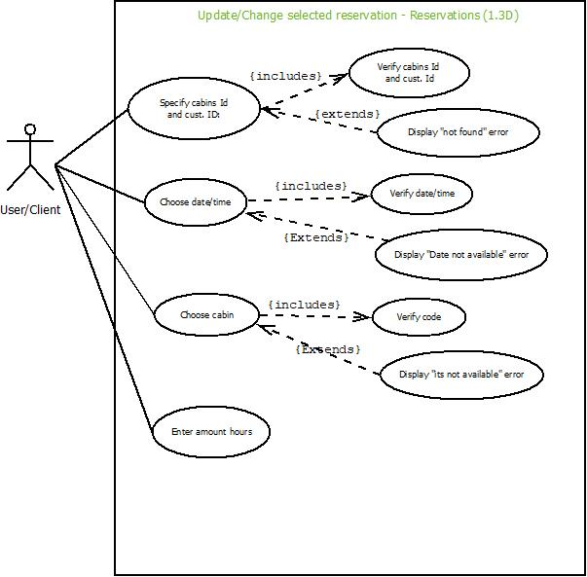

|  |  |
| --- | --- |
| **Reservation’s options** | **Reservations / Update res. procedure** |

* + - * View selected reservation **(r1)**
      * Delete selected reservation **(r1)**
      * Save on a new file the desired reservation (no Use Case)

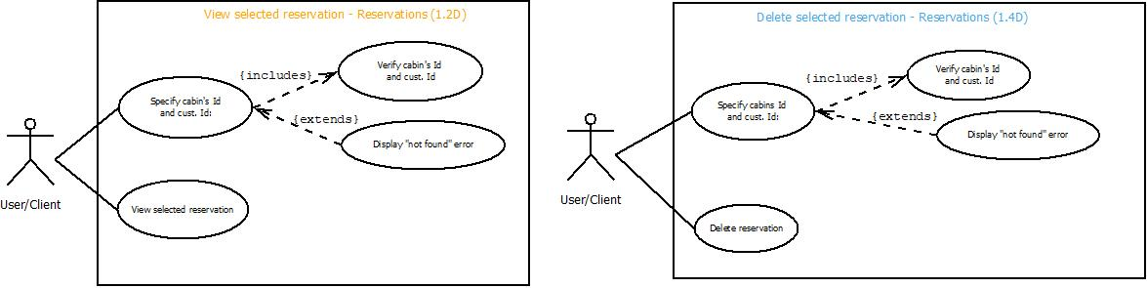

Image: r1 (View and Delete Reservation)

* + - **PRODUCTS**:
      * View all the products
      * New product (with Use Case)
        + Enter required data to create a product: *id* *(PK)*, *name*, *price*, *description*.

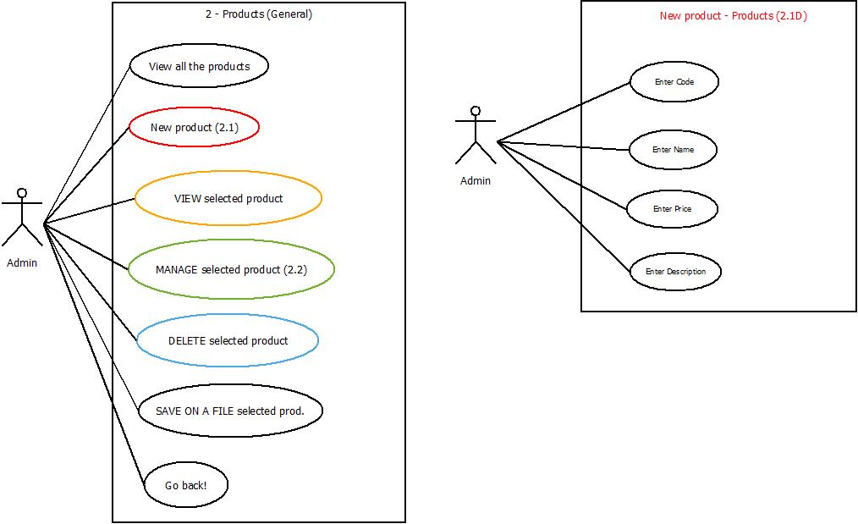

|  |  |
| --- | --- |
| **Products’ options** | **Products / New product’s procedure** |

* + - * View selected product **(p1)**
      * Update/manage selected product **(p1)**
      * Delete selected product **(p1)**
      * Save on a new file the desired product

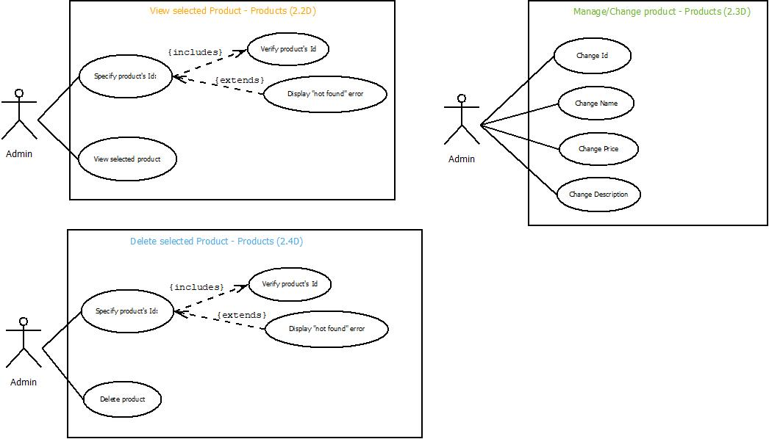

Image: p1 (View, Manage and Delete product)

* + - **USERS**:
      * ***Customers***:
        + View all customers
        + New customer (with Use Case)

Enter required data: *matriculation* (*PK*), *name*, *surname*, *password*, *age*, *mail*, *phone number*.

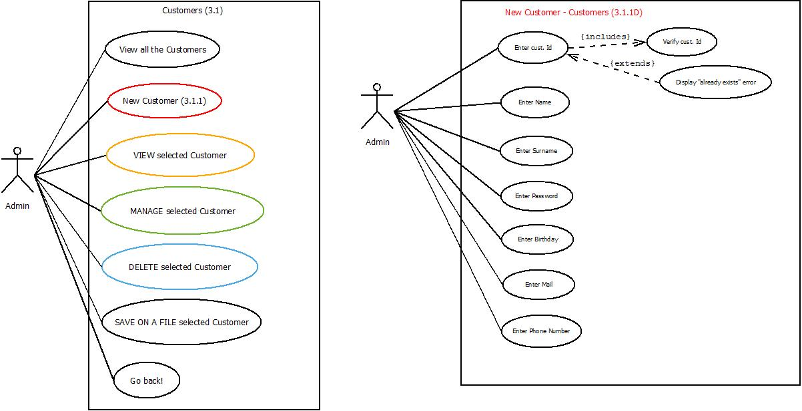

|  |  |
| --- | --- |
| **Customer’s options** | **Customers / New Customer’s procedure** |

* + - * + View selected customer

Enter desired customer’s matriculation and view all his data. **(c1)**

* + - * + Update/manage selected customer

Enter desired customer’s matriculation and mange it. **(c1)**

* + - * + Delete selected customer

Enter desired customer’s matriculation and delete it from the Customer’s history. **(c1)**

* + - * + Save on a new file the desired customer

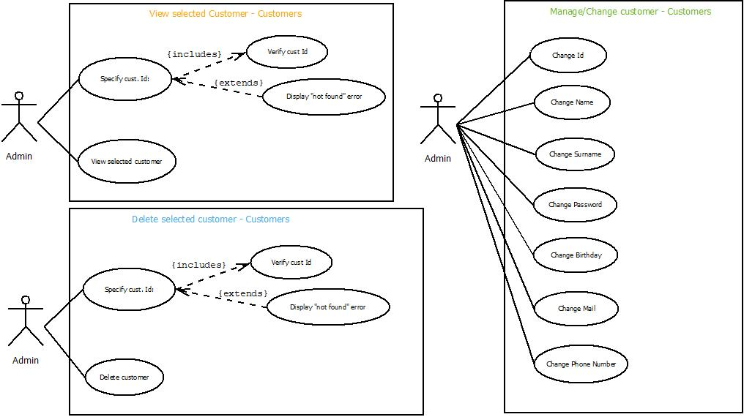

Image: c1 (View, Manage and Delete customer)

* + - * ***Workers***:
        + View all workers
        + New worker (with Use Case)

Enter required data: *idTrabajador* (*PK*), *name*, *surname*, *password*, *age*, *mail*, *phone number, occupation, salary*.

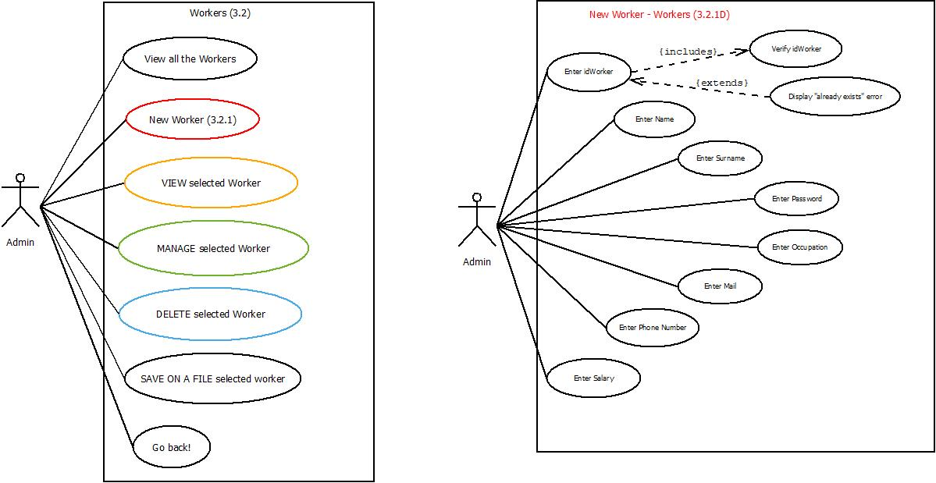

|  |  |
| --- | --- |
| **Worker’s options** | **Workers / New Worker’s procedure** |

* + - * + View selected worker:

Enter desired worker’s id to view his data. **(w1)**

* + - * + Update/manage selected worker

Enter desired worker’s id and manage it. **(w1)**

* + - * + Delete selected worker

Enter desired worker’s id and delete it. **(w1)**

* + - * + Save on a new file the desired worker

Enter desired worker’s id and save his data on a new file

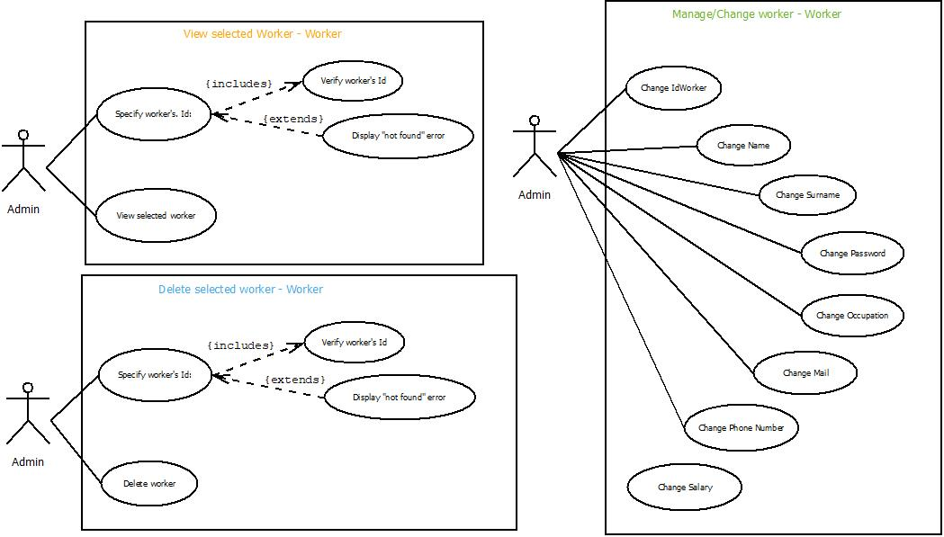

Image: w1 (View, Manage and Delete worker)