LISTA DE INFORMES:

1. **Today’s occupation**: this report will show the user, how the garage’s availability is. The report will also show who made each reservation, and which is his “”customer id. You can see an example of the report in the following picture:

|  |  |  |  |  |
| --- | --- | --- | --- | --- |
| 25/03/2022 | C1 | C2 | C3 | C4 |
| 9:00 – 10:00 | Adrian  Id: 1 |  |  |  |
| 10:00 – 11:00 |  | Pedro  Id: 4 |  |
| 11:00 – 12:00 |  | Jose  Id: 6 |  |
| 12:00 – 13:00 |  |  |  |  |
| LUNCH TIME | | | | |
| 15:00 – 16:00 |  |  |  | Lorena  Id: 9 |
| 16:00 – 17:00 |  |  |  |
| 17:00 – 18:00 | Juan  Id: 8 |  |  |
| 18:00 – 19:00 |  |  |  |  |

Actual reservations: 5 (morning = 3 / afternoon = 2)

1. **Search desired customer’s purchases**: this report allows the user to get the record of purchases that the desired customer’s has. We will also be able to save this report in a new file.

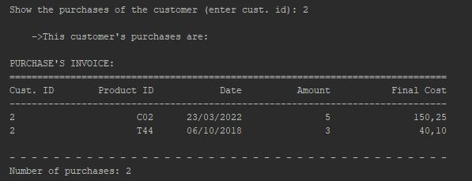

1. **Underage customers**: the program will show a report, which contains all underage customer’s data.

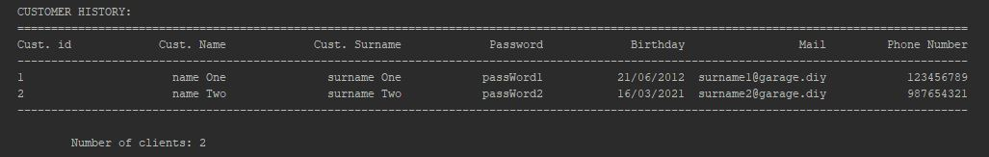

1. **Most reserved cabin**: the program will calculate/compare how many times customers reserved each cabin. This is how the report would look like:

|  |  |
| --- | --- |
| **Cabin’s id** | **Number of reservations** |
| C1 | 6 |
| C2 | 1 |
| C3 | 8 |
| C4 | 5 |
| Most reserved cabin: C3 | 8 |

1. **Most sold products:** We are going to print the most sold products and the total amount of money earned by them.

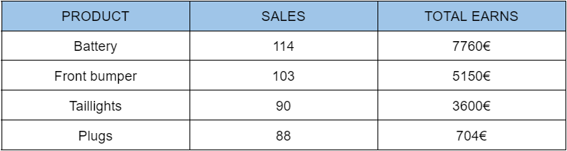

1. **Last 3 customers who have spent the longest time without reserving a cabin**.

|  |  |  |  |
| --- | --- | --- | --- |
| Customer_ID | Name | Last name | Days without booking |
| 56 | Xabier | Atza | 4560 days |
| 34 | Andrea | Garcia | 1350 days |
| 22 | Iker | Garrido | 2300 days |
| 8 | Lucia | Artaraz | 235 days |