TITLE

Authors: Hodei Olivas, Arkaitz Maiora,
Leire Renedo, Adrian Arceredillo
Date: 2022/03/22

INDEX

- PROJECT CONTEXT
- APPLICATION ANALYSIS
- APPLICATION DESIGN
  - USE CASE DIAGRAM
  - CLASS DIAGRAM
  - ACTIVITY DIAGRAM
  - DATABASE DESIGN
- TASK PLANNING AND REGISTER
  - TASK1: (name ,description): Goal and methodology:Describe the goal and methodology that is going to be used in this task. If this task is going to be divided in smaller tasks, described them.
    - Task1.1
    - Task1.2
Fill a table like this one with the information provided

 | Duration (hours) | Beginning date | Finishing date | Responsible
Task1- Taldekide denen artean Python menu bat adostu. | 4 | 2022/03/21 | 2022/03/22 | Adrian, Arkaitz eta Hodei
Task1.1-Taldekide bakoitza Python menuko 2 aukera programatu. | 4 | 2022/03/21 | 2022/03/25 | Adrian, Arkaitz eta Hodei
Task2 - Taldekide artean web gunea adostu | 6 | 2022/03/21 | 2022/03/24 | Denok
Task2.1- Taldekide bakoitzak menuko aukera bat programatu | 4 | 2022/03/21 | 2022/03/24 | Adrian, Arkaitz eta Hodei
Task3- Bakarkako DB diagrama | 8 | 2022/03/23 | 2022/03/25 | Adrian, Arkaitz eta Hodei
Task4- Javako Txosten testualaren zerrenda | 5 | 2022/03/23 | 2022/03/25 | Adrian, Arkaitz eta Hodei
Task5- Pythoneko Use Case diagramak | 6-7 | 2022/03/22 | 2022/03/25 | Adrian, Arkaitz eta Hodei
Task6- Web gunearen krokisak | 4 | 2022/03/23 | 2022/03/25 | Adrian, Arkaitz eta Hodei
Task7- Javaren aplikazioaren interfaze grafikoaren bozetoa | 7 | 2022/03/24 | 2022/03/28 | Adrian, Arkaitz eta Hodei
Task8- Datu Basearen kontrako SQL funtzioak planifikatu | 3 | 2022/03/25 | 2022/03/28 | Adrian eta Hodei
Task9- Laneko segurtasuneko oinarrizko kontseptuak | 5 | 2022/03/17 | 2022/03/28 | Leire, Arkaitz eta Hodei
Task10- DB diagrama bateratua | 4 | 2022/03/28 | 2022/03/29 | Leire, Arkaitz, Adrian eta Hodei
Task11- Use case guztien batuketa: Python, Java, Web orria | 3 | 2022/03/28 | 2022/03/29 | Adrian, Arkaitz eta Hodei
Task12- Web orriaren krokis batuketa | 3 | 2022/03/28 | 2022/03/29 | Adrian, Arkaitz eta Hodei
Task13- Aplikazioen clase diagrama | 3 | 2022/03/30 | 2022/03/31 | Adrian, Arkaitz eta Hodei
Task14 Sistemak proposamen teknikoa | 4 | 2022/03/29 | 2022/03/01 | Leire, Arkaitz eta Hodei

- SOFTWARE APPLICATION IMPLEMENTATION/INSTALLATION
- USERS GUIDE
- THOUGHTS
- BIBLIOGRAPHY

Project context:
First, we can say that the main goal of this project is to enable different customers to make repairs to their vehicles. To do this, we will facilitate them multiple amenities. These are the main ones:
- Rent garage’s cabins to the customers
- Offer variable bookings (checking date and time)
- An extended catalog of products to buy in there
In short, as we get there, we will get to work on the reason for your reservation. The garage will have 4 cabins, which will follow the rules of a timetable. In addition, it will be possible to view garage statistics and internal data through reports (staff only).

APPLICATION ANALYSis
Considering all the factors that can be involved, we have divided the general operation of the garage into three main areas.

- Website application: Through the garage’s website, both customers and staff will make sense of the garage. Needless to say, there will be different capacities between customers and employees.
  - Staff: garage’s details and data (daily earnings, all staff, all the bookings, etc.)
  - Customers: they will be able to make reservations. From the services offered by the garage, they will choose as many as they want. In addition, they will have the right to purchase the products contained in there.
  - Administration: this section of the garage will direct the operation of the garage; therefore, it will manage the most important items. These items include products, customers, staff, and cabins.

- Java application: we thought it was important to see or follow the evolution of the garage in some way; so we decided to save the data we get over time in different types of reports. Examples include some of these reports.

  - Today’s occupation: this report will show the user, how the garage’s availability is. The report will also show who made each reservation, and which his “customer id” is. You can see an example of the report in the following table/pic.

25/03/2022 | C1 | C2 | C3 | C4
9:00 – 10:00 | Adrian  Id: 1
10:00 – 11:00 | Adrian  Id: 1 |  | Pedro  Id: 4
11:00 – 12:00 |  | Jose  Id: 6 | Pedro  Id: 4
12:00 – 13:00
LUNCH TIME
15:00 – 16:00 |  |  |  | Lorena  Id: 9
16:00 – 17:00 |  |  |  | Lorena  Id: 9
17:00 – 18:00 | Juan  Id: 8 |  |  | Lorena  Id: 9
18:00 – 19:00

  - Underage customers: the program will show a report, which contains a list of all underage customers.

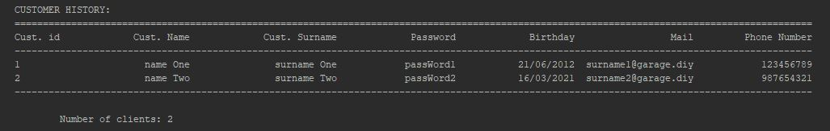

  - Search desired customer’s purchases: this report allows the user to get the record of purchases that the desired customer’s has. We will also be able to save this report in a new file.

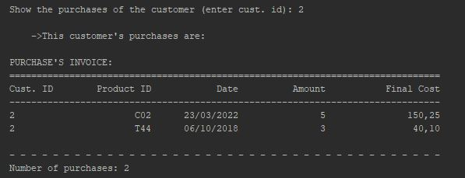

  - Most reserved cabin: the program will calculate/compare how many times customers reserved each cabin. This is how the report would look like:

Cabin’s id | Number of reservations
C1 | 6
C2 | 1
C3 | 8
C4 | 5
Most reserved cabin: C3 | 8

  - The product that gave the garage the most money: this report will print the three products that gave the most money to the garage.

PRODUCT | SALES | TOTAL EARNED
Battery | 114 | 7760
Front bumper | 25 | 5150
Plugs | 88 | 648

  - The three least frequent customers: this report will show the user the three customers who have spent the longest time without doing a reservation.

Username | Name | Last name | Days without booking
Xabi22 | Xabier | Atza | 4560 days
andreaND | Andrea | Garcia | 1350 days
soyIker | Iker | Garrido | 2300 days
Lucia197 | Lucia | Artaraz | 235 days

- Python aplikazioa: python-en egingo dugunaren laburpen orokorra, objektuak kudeatzea lortzen duen aplikazio/menu bat egitea dela esan dezakegu. Hauek izango dira “objektuak”:
  - Erreserbak
  - Produktuak
  - Bezeroak
  - Langileak
Elementu/objektu hauek kudeatzeko CRUD metodoa erabili dugu. Honen erabilera, hurrengo operazioak egitea ahalbidetzen du:
    - Erreserbak: new reservation (C), read reservation (R), update reservation (U), delete reservation (D). (preguntar en clase)
    - Produktuak: new product (C), read product (R), update product (U), delete product (D).
    - Bezeroak: new customer (C), read customer (R), update customer (U), delete customer (D).
    - Langileak: new worker (C), read worker (R), update worker (U), delete worker (D).

Application design

Use Case Diagram
- Python: arlo honi dagokion aplikazioa menu baten bidez erabiltzen da; menuaren funtzionamendua, honako use case diagramekin azaldu dezakegu.
  - Menu nagusia + Use Case (hasierakoa):
    - 1. Reservations
    - 2. Products
    - 3. Users

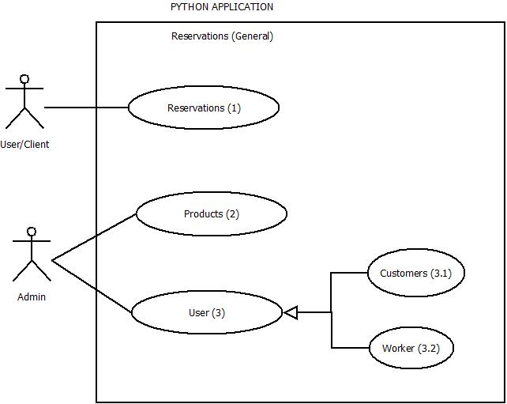

  - Menu nagusiko aukera bakoitzaren azpi menua + dagokien Use Case-ak:

    - RESERVATIONS:
      - View all the products
      - New Reservation (with Use Case)
        - Enter required data to create a new reservation: idReservation (PK), date, cabin, service, products.

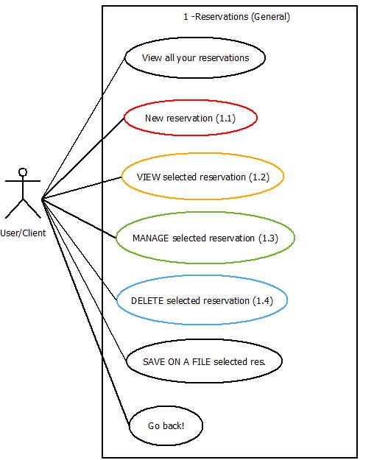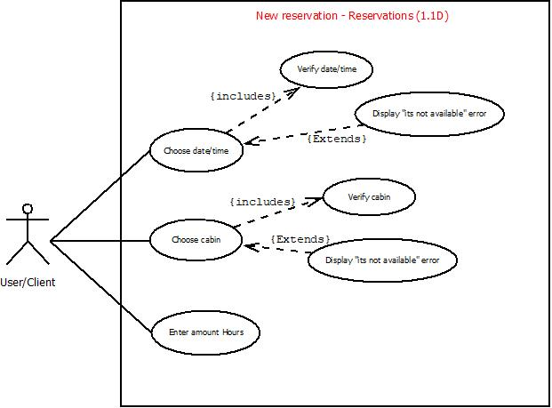

Reservation’s options | Reservations / New reservation procedure

      - Update/manage selected reservation
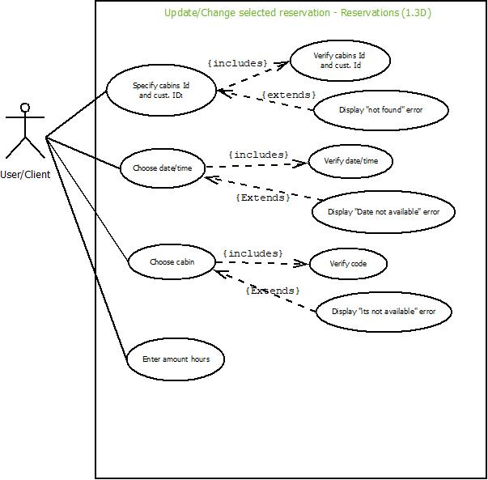

Reservation’s options | Reservations / Update res. procedure

      - View selected reservation (r1)
      - Delete selected reservation (r1)
      - Save on a new file the desired reservation (no Use Case)

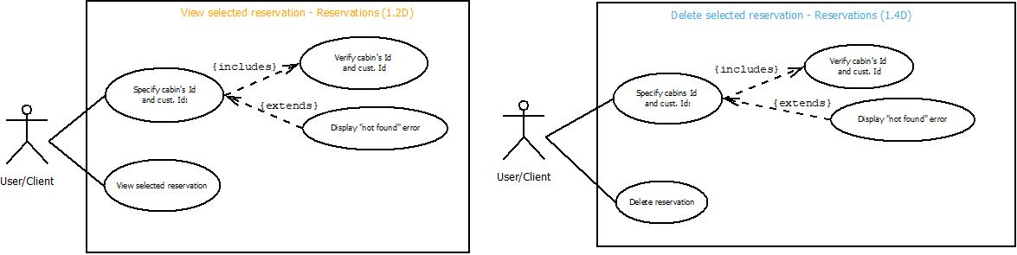
Image: r1 (View and Delete Reservation)

    - PRODUCTS:
      - View all the products
      - New product (with Use Case)
        - Enter required data to create a product: id (PK), name, price, description.

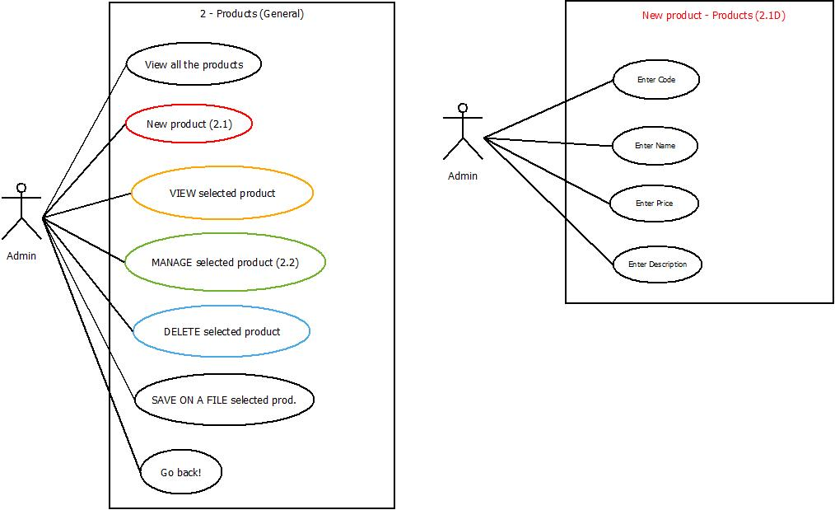

Products’ options | Products / New product’s procedure

      - View selected product (p1)
      - Update/manage selected product (p1)
      - Delete selected product (p1)
      - Save on a new file the desired product

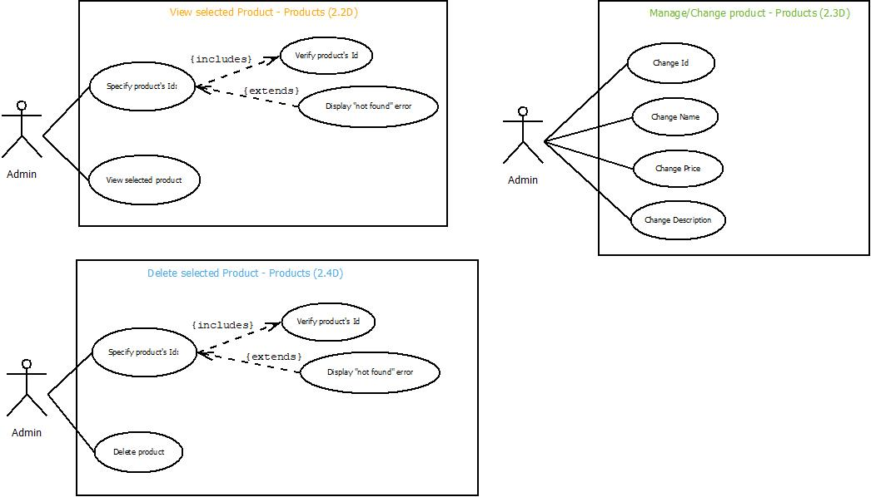

Image: p1 (View, Manage and Delete product)

    - USERS:
      - Customers:
        - View all customers
        - New customer (with Use Case)
          - Enter required data: matriculation (PK), name, surname, password, age, mail, phone number.

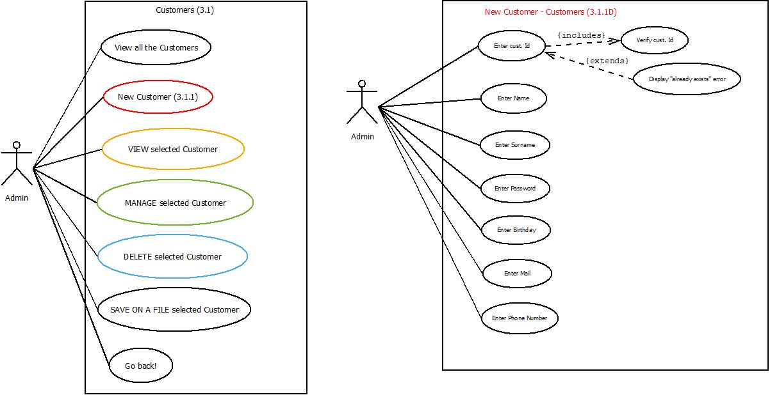

Customer’s options | Customers / New Customer’s procedure

        - View selected customer
          - Enter desired customer’s matriculation and view all his data. (c1)
        - Update/manage selected customer
          - Enter desired customer’s matriculation and mange it. (c1)
        - Delete selected customer
          - Enter desired customer’s matriculation and delete it from the Customer’s history. (c1)
        - Save on a new file the desired customer

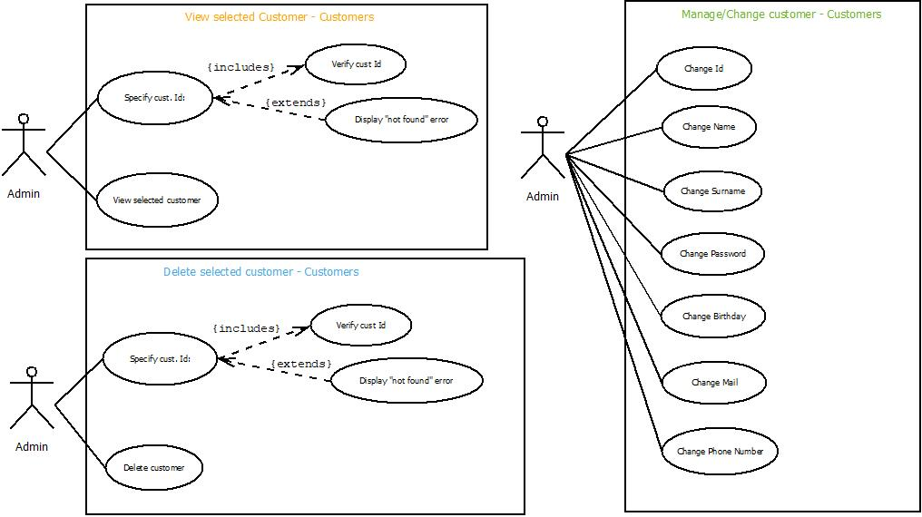

Image: c1 (View, Manage and Delete customer)

      - Workers:
        - View all workers
        - New worker (with Use Case)
          - Enter required data: idTrabajador (PK), name, surname, password, age, mail, phone number, occupation, salary.

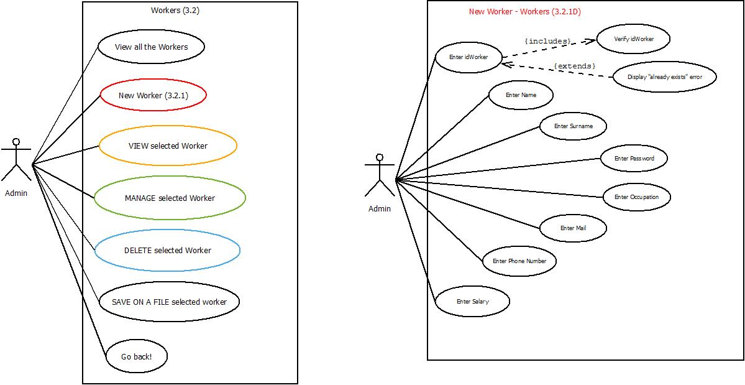

Worker’s options | Workers / New Worker’s procedure

        - View selected worker:
          - Enter desired worker’s id to view his data. (w1)
        - Update/manage selected worker
          - Enter desired worker’s id and manage it. (w1)
        - Delete selected worker
          - Enter desired worker’s id and delete it. (w1)
        - Save on a new file the desired worker
          - Enter desired worker’s id and save his data on a new file

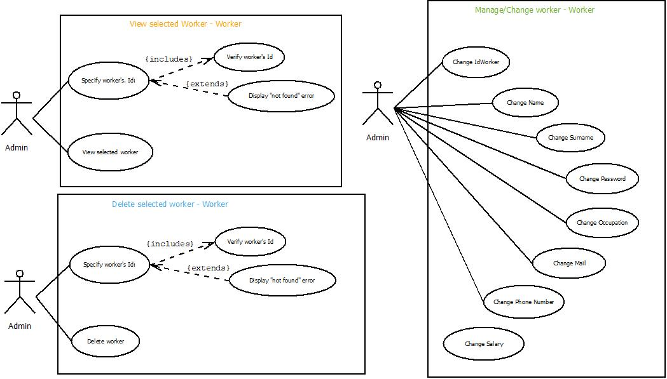

Image: w1 (View, Manage and Delete worker)

- Java: in regards to Java’s application, taking a look of the following use case diagram, we will be able to see how it works.

The application has different functions depending on what type of worker is using the application. On the one hand, we have the called “normal workers”, with a basic access to application. This access allows the worker to see some general information about the garage (textual and graphical reports).
On the other hand, we find the one we call “Administrator”. There is only one of this type of worker in the whole garage, so he has the power of updating/changing some data (specifically on the normal worker’s salary). To do it, the administrator will have to log in.

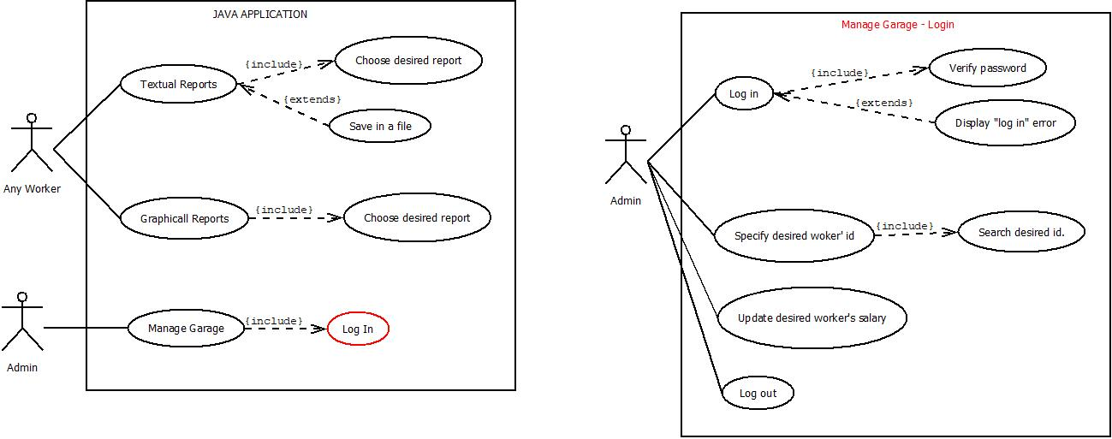

As expected, the administrator can also to use the options granted to normal workers. Finally, to summarize the application’s “Textual Reports” section, we can advance some examples of how and which these reports can be:
- Basic worker: view textual and graphical reports.
- Administrator (worker): view textual and graphical reports, log in, and manage basic worker’s salary.

- Web use-cases:
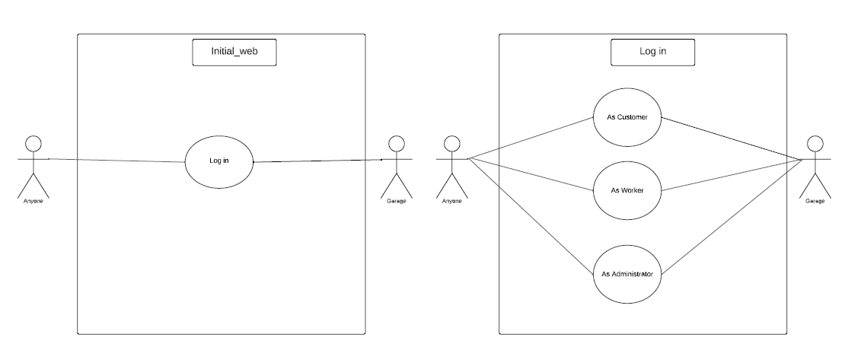

Initial web | Login
Initial web | - Customer
Initial web | - Worker
Initial web | - Admin

Customer’s section:
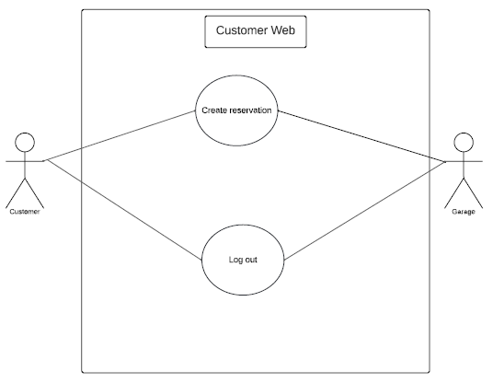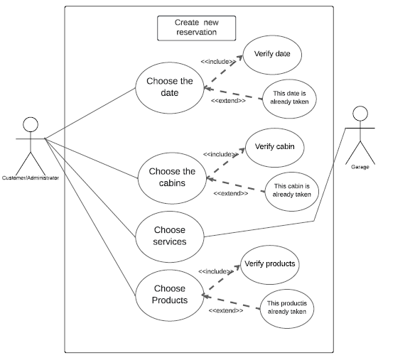

Worker’s section:
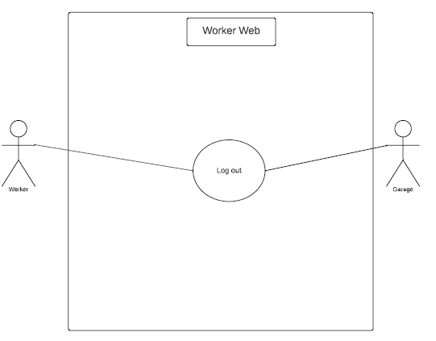

Admin’s section:
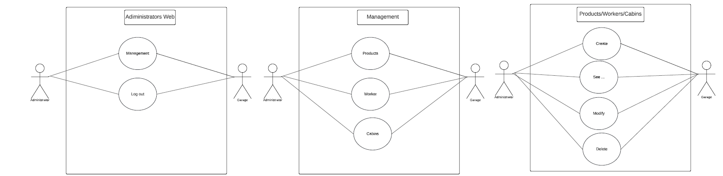

Class diagram:
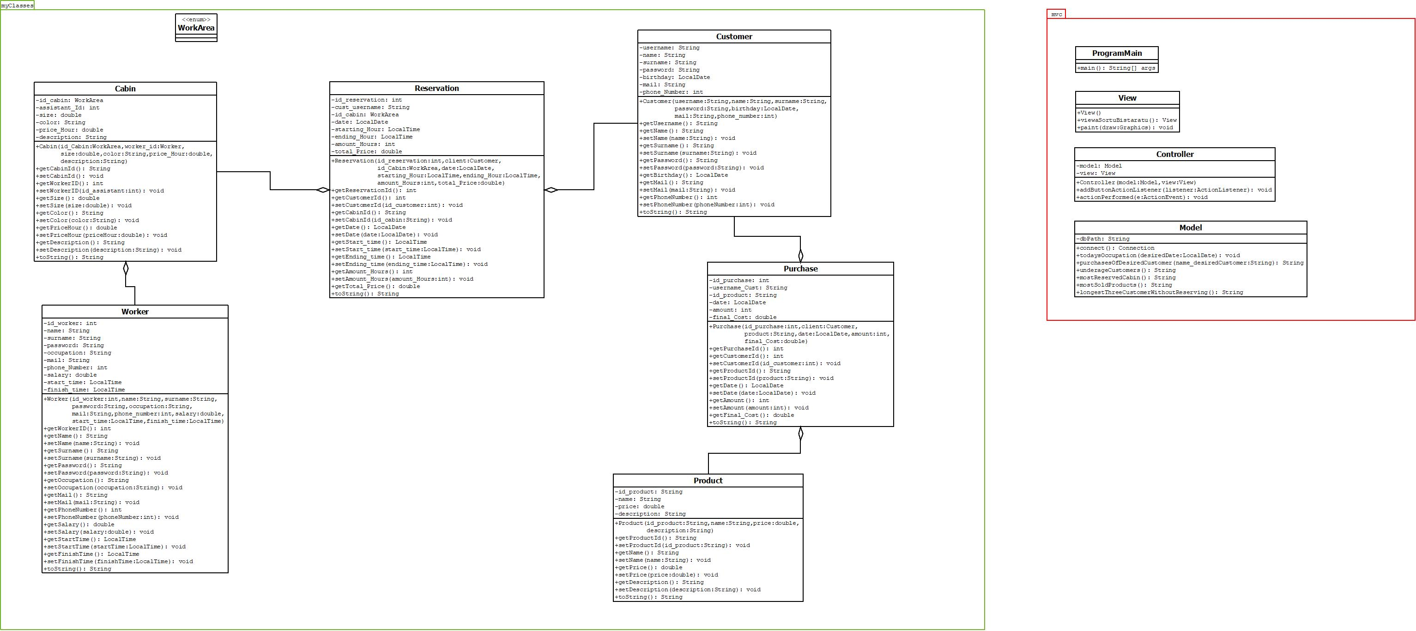

Database design:
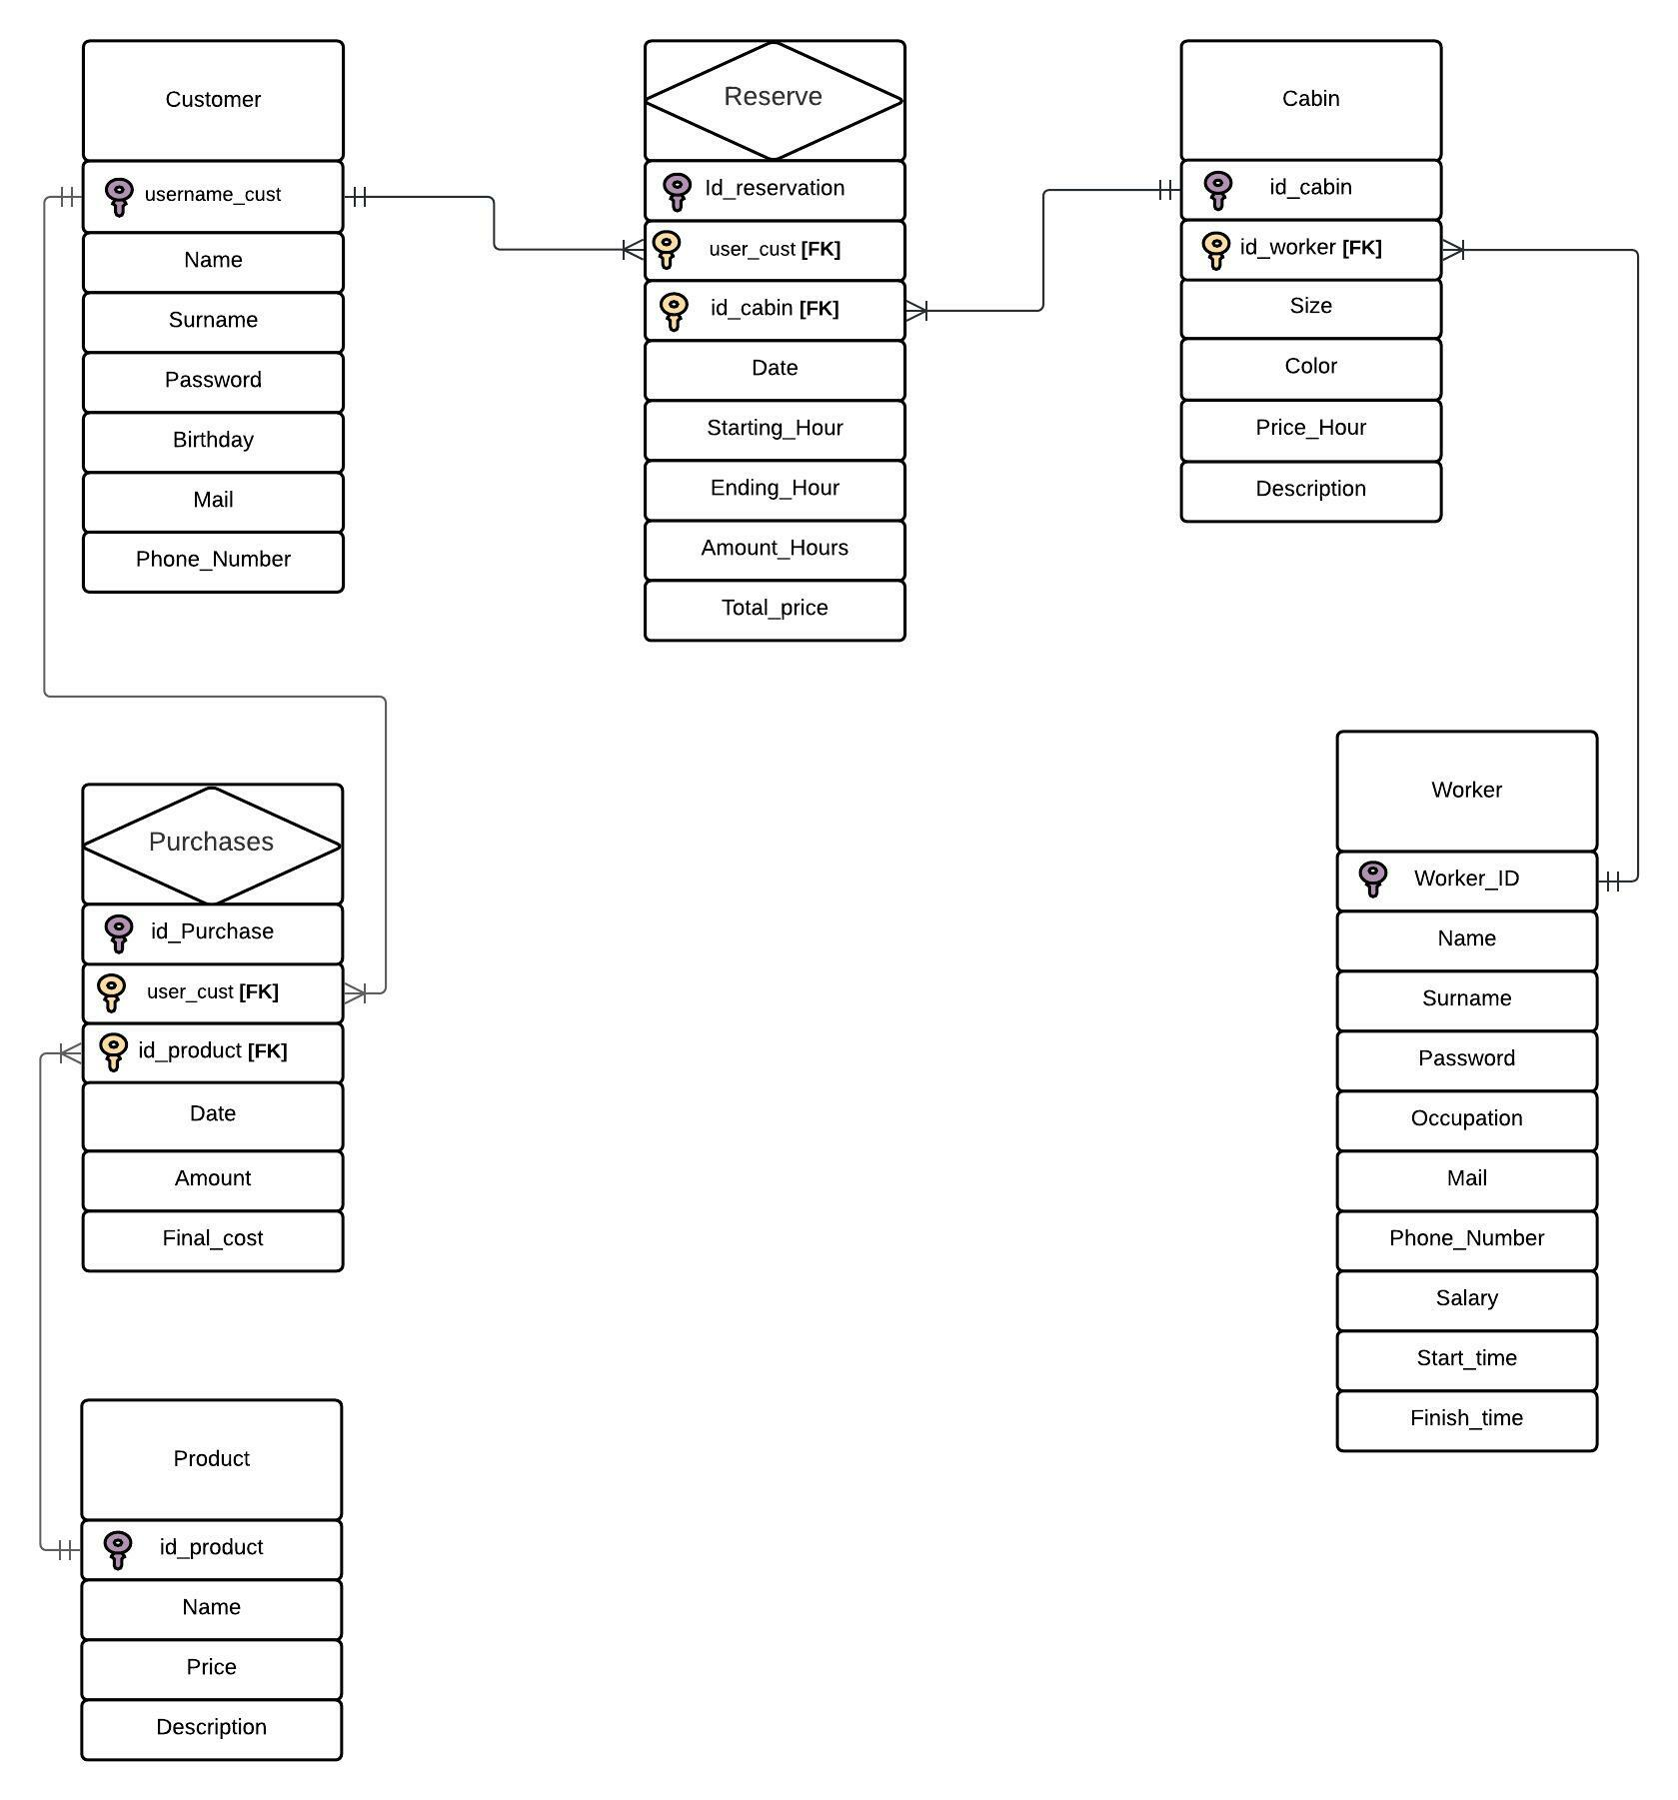

continue

