TITLE

Authors: Hodei Olivas, Arkaitz Maiora,
Leire Renedo, Adrian Arceredillo
Date: 2022/03/22

INDEX

1 PROJECT CONTEXT: 3
2 APPLICATION ANALYSIS 3
3 APPLICATION DESIGN 6
3.1 Use Case Diagram 6
3.2 Class diagram: 14
3.3 Database design: 15
4 TASK TABLE: 16
5 SOFTWARE APPLICATION IMPLEMENTATION / INSTALLATION 17
6 USERS GUIDE 18
7 THOUGHTS 20
8 BIBLIOGRAPHY 20

PROJECT CONTEXT:
First, we can say that the main goal of this project is to enable different customers to make repairs to their vehicles. To do this, we will facilitate them multiple amenities. These are the main ones:
- Rent garage’s cabins to the customers
- Offer variable bookings (checking date and time)
- Make purchases of one only product of an extended catalog
In short, as we get there, we will get to work on the reason for your reservation. The garage will have four cabins, which will follow the rules of a timetable. In addition, it will be possible to view garage statistics and internal data through reports (staff only).

APPLICATION ANALYSIS
Considering all the factors that can be involved, we have divided the general operation of the garage into three main areas.

- Website application: Through the garage’s website, both customers and staff will make sense of the garage. Needless to say that there will be different capacities between customers and employees.
  - Staff: garage’s details and data (daily earnings, all staff, all the bookings, etc.)
  - Customers: they will be able to make reservations and purchases. From the services offered by the garage, they will choose as many as they want. In addition, they will have the option of making purchases of the products contained in there.

- Java application: we thought it was important to see or follow the evolution of the garage in some way; so we decided to save the data we get over time in different types of reports.
In one hand, we have the textual reports; which are focused on data that are more specific. Those are the textual reports:

  - Monthly occupation: it is like a filter, which receives the name of the different months in which a reservation has been made, and then counts how many reservations are made on each month. In addition, it gets the total amount of money earned in that/each month. (this report has table view)

  - Underage customers: the program will return a report, which contains a list of all underage customers; showing basic data of each of them. (this report has table view)

  - Desired customer’s purchases: this report’s main goal is to let the user of the GUI know how many purchases did the specified customer. To do this, the user of the GUI has to specify a certain customer, and then the program will automatically show in a list, all the purchases that this customer did.
The user will be able to see and check all the information/data about every single purchase of the list. (This report has table view)

  - Morning / afternoon: this report ranks the cabins based on how many reservations were made on each cabin. There will be a separation of the amount of reservations made in the morning, with the amount of the reservations made at afternoon. (this report has NO table view)

  - Best sellers: This report orders the products of the catalog based on how much money got the garage with the sale of this ones. In addition, the report shows the user how many units of each product have been sold, and in how many purchases does each of them appear. (this report has table view)

  - Three least frequent customers: This report shows the user the three customers who have not made a reservation for the longest time. The report shows the date of the last reservation of each of them, their name/surname, and the amount of days passed since the last reservation. (this report has table view)

As if that were not enough, the Textual Reports Section allows the user to download exclusive data of the garage. To do that, the user has to show that is a worker or an administrator; so the user will need to enter a name, surname and password of a worker account. Once the worker has logged in, he will find four buttons that allow downloading information.

On the other hand, we have the Graphic Report’s Section. Here, we will find the whole data of the garage but represented in a more compact way. These graphs can be considered as the statistic of the garage. Here is a brief explanation of these:

- Best two customers: this graphic report gathers the main data of the two customers who spent the most money (in reservations) at the garage. The graphic shows the following data:
  - Number of reservations of each of the two customers
  - Total money paid by each customer
  - The time they spent on reservations (in Hours)
  - The price of the best reservations of each of them
To make the reading of this report more enjoyable, we decided to give the user the option to choose whose customer wants to see now. (This report has table view)

- Monthly occupation: this report classifies the months based on the amount of the reservations that have been made on during each of them. We did not want to classify the month the same way as the textual report’s one; so we decided to build a pyramid divided into parts.
Each piece of the pyramid represents the amount of the reservations that can be inside of it.

To know if a month will go into one part or another of the pyramid, we will have to check and compare the number of reservations for that month, with the limits of reservations of each piece of the pyramid.

Finally, the piece, which contains more number of months, will indicate what the monthly reservation’s average is. (This report has table view)

- Sort by age: this report shows in a pie graphic, the proportion of underage to adult customers. (this report has NO table view yet)

- Python: the python application brings together all the concepts mentioned so far into a compact application to manage the different classes made. The classes are the following ones:

  - Reservation
  - Product
  - Person (super class)
    - Customer (class inheritance)
    - Worker (class inheritance)

As you use the application, you will find some cool options to save and manage data like saving objects into files. Then the user will be able to read, update and delete the content of these files.

APPLICATION DESIGN

Use Case Diagram
- Python: a menu with different options will represent this application. All the menu’s options will be related to something specific. We tried to do and program the menu as intuitive as possible. This is how the main menu looks like (with Use Case Diagram):
  - Main menu + Use Case:
    - Reservations
    - Products
    - Customers
    - Workers

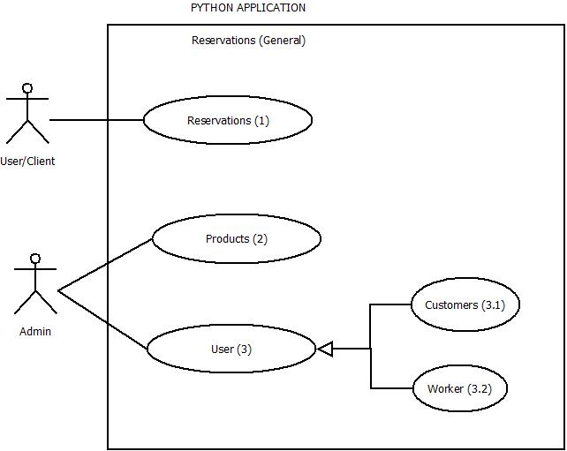

  - Submenu and use-case diagram of each of the main menu’s options.

    - RESERVATIONS:
      - View all the products
      - New Reservation (with Use Case)
        - Enter required data to create a new reservation. ID Reservation (PK), date, cabin, service, products.

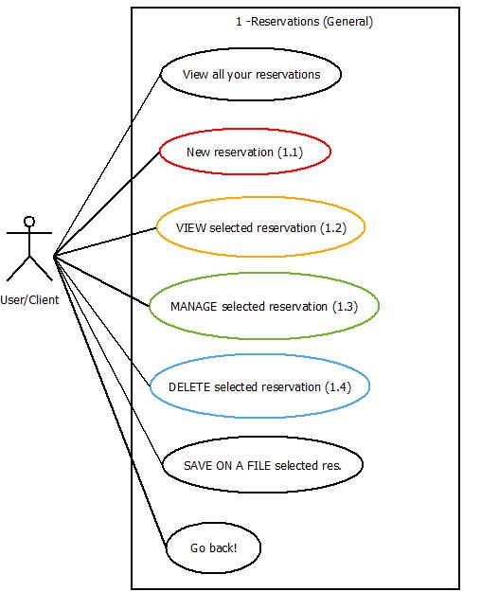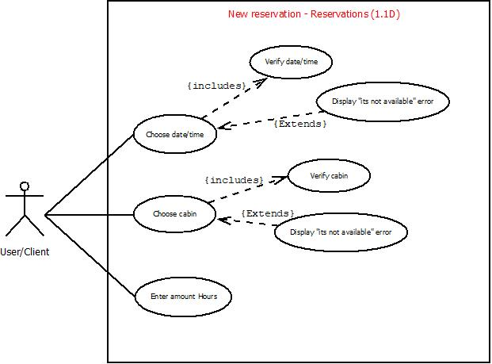

Reservation’s options | Reservations / New reservation procedure

      - Update/manage selected reservation
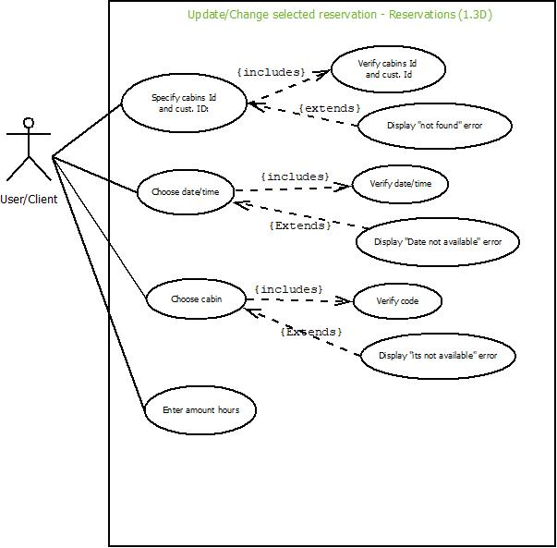

Reservation’s options | Reservations / Update res. procedure

      - View selected reservation (r1)
      - Delete selected reservation (r1)
      - Save on a new file the desired reservation (no Use Case)

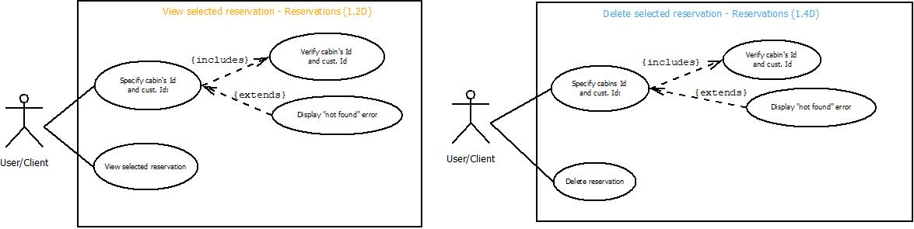
Image: r1 (View and Delete Reservation)

    - PRODUCTS:
      - View all the products
      - New product (with Use Case)
        - Enter required data to create a new product. Id (PK), name, price, description.

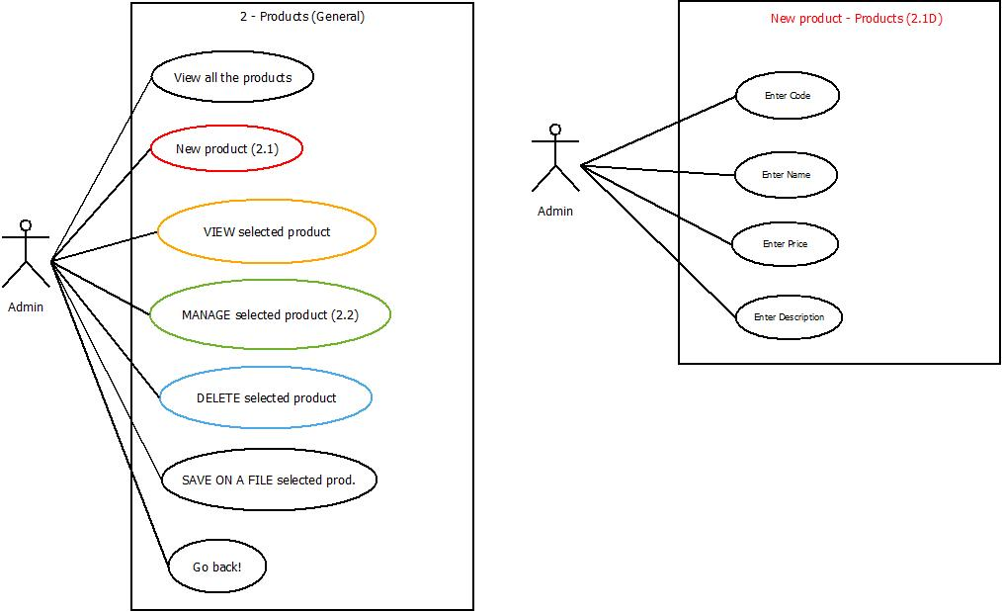

Products’ options | Products / New product’s procedure

      - View selected product (p1)
      - Update/manage selected product (p1)
      - Delete selected product (p1)
      - Save on a new file the desired product

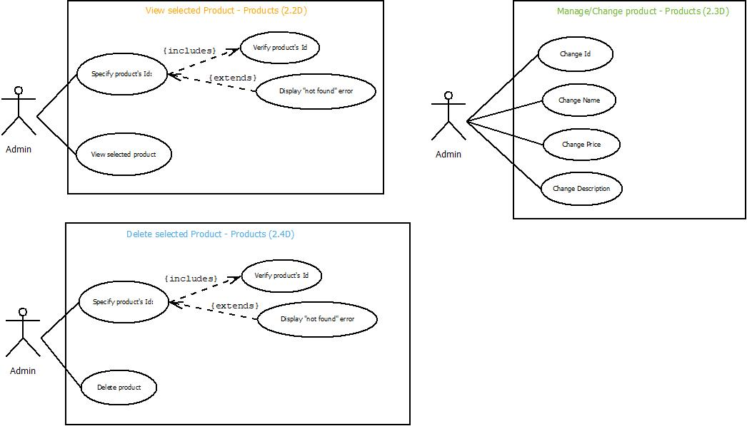

Image: p1 (View, Manage and Delete product)

    - USERS:
      - Customers:
        - View all customers
        - New customer (with Use Case)
          - Enter required data: username (PK), name, surname, password, age, mail, phone number.

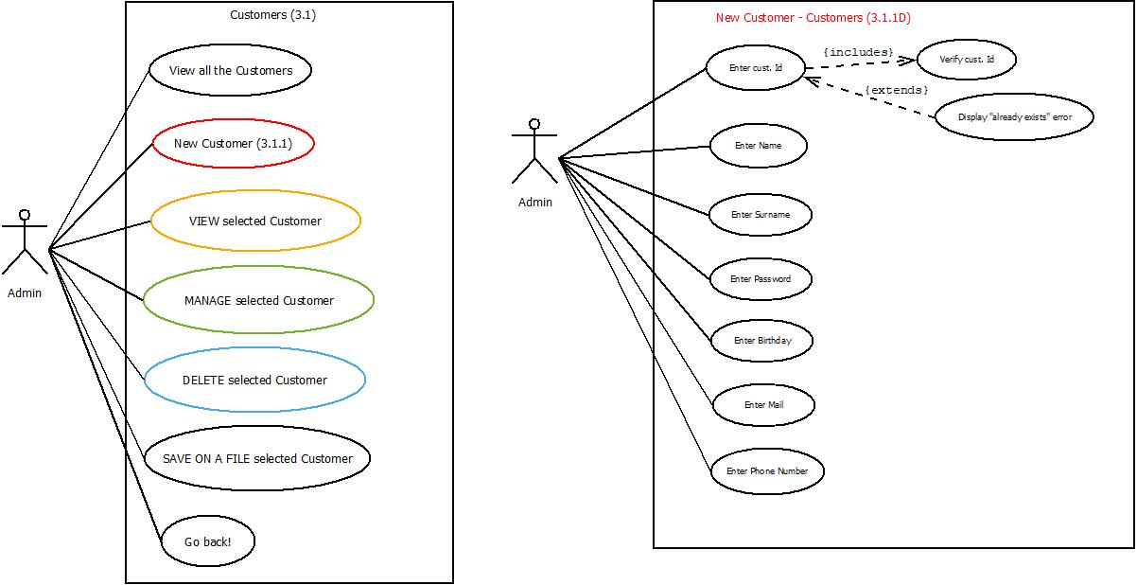

Customer’s options | Customers / New Customer’s procedure

        - View selected customer
          - Enter desired customer’s matriculation and view all his data. (c1)
        - Update/manage selected customer
          - Enter desired customer’s matriculation and mange it. (c1)
        - Delete selected customer
          - Enter desired customer’s matriculation and delete it from the Customer’s history. (c1)
        - Save on a new file the desired customer

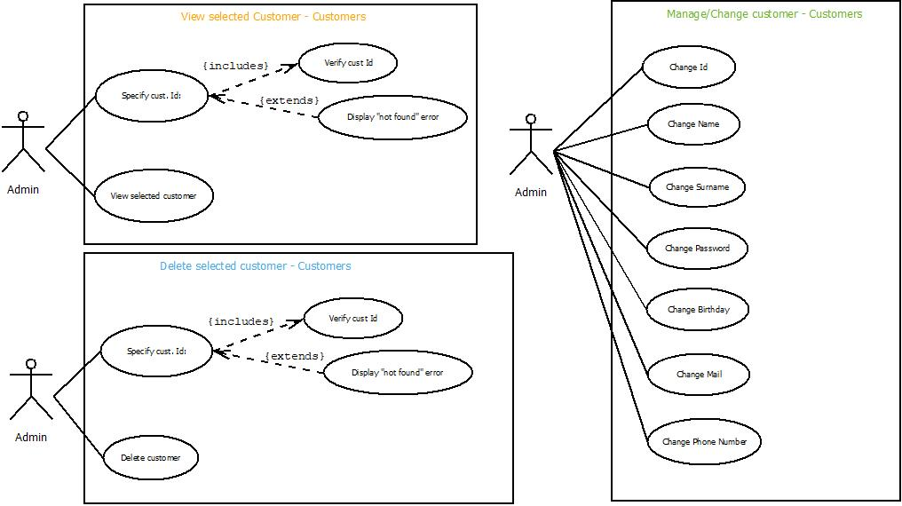

Image: c1 (View, Manage and Delete customer)

      - Workers:
        - View all workers
        - New worker (with Use Case)
          - Enter required data: worker ID (PK), name, surname, password, age, mail, phone number, occupation, salary.

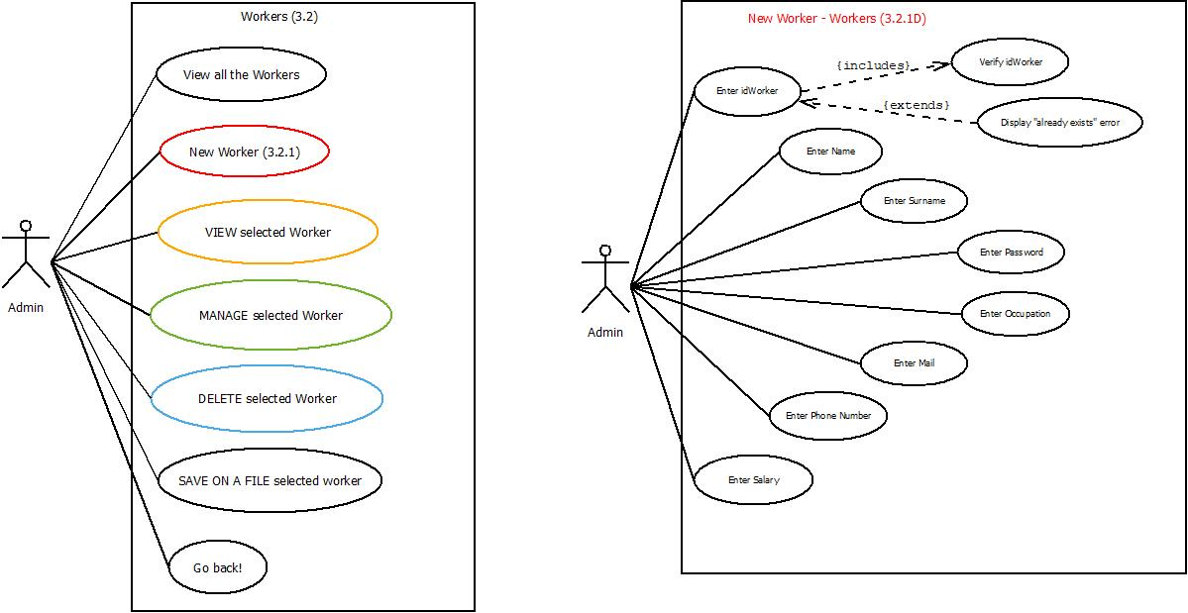

Worker’s options | Workers / New Worker’s procedure

        - View selected worker:
          - Enter desired worker’s id to view his data. (w1)
        - Update/manage selected worker
          - Enter desired worker’s id and manage it. (w1)
        - Delete selected worker
          - Enter desired worker’s id and delete it. (w1)
        - Save on a new file the desired worker
          - Enter desired worker’s id and save his data on a new file

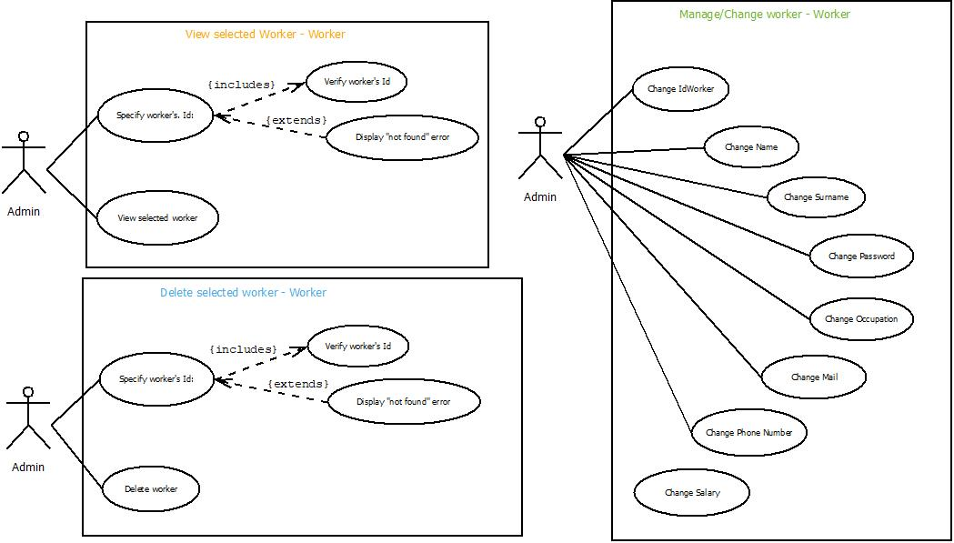

Image: w1 (View, Manage and Delete worker)

- Java: in regards to Java’s application, looking at the following use case diagram, we will be able to see how it works.
The application has different functions depending on what type of worker is using the application.
On the one hand, we have the reports called “Textual Reports. Any user can use these ones. Nevertheless, if a user wants to download garage’s information or save data into a file, the user will need to log in with a worker account.
On the other hand, we find the Graphic Reports. These ones show the user the statistics of the garage’s progress. These reports can’t be saved on files.

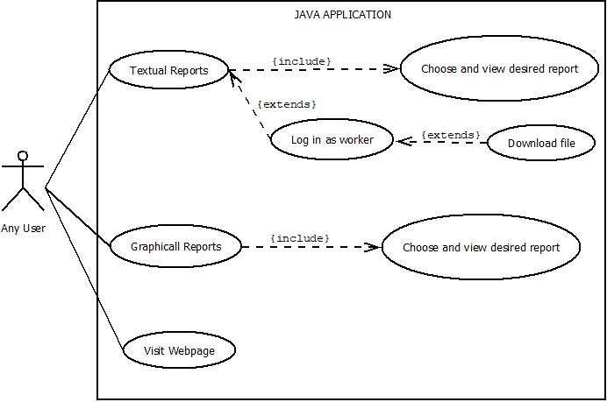

Class diagram:
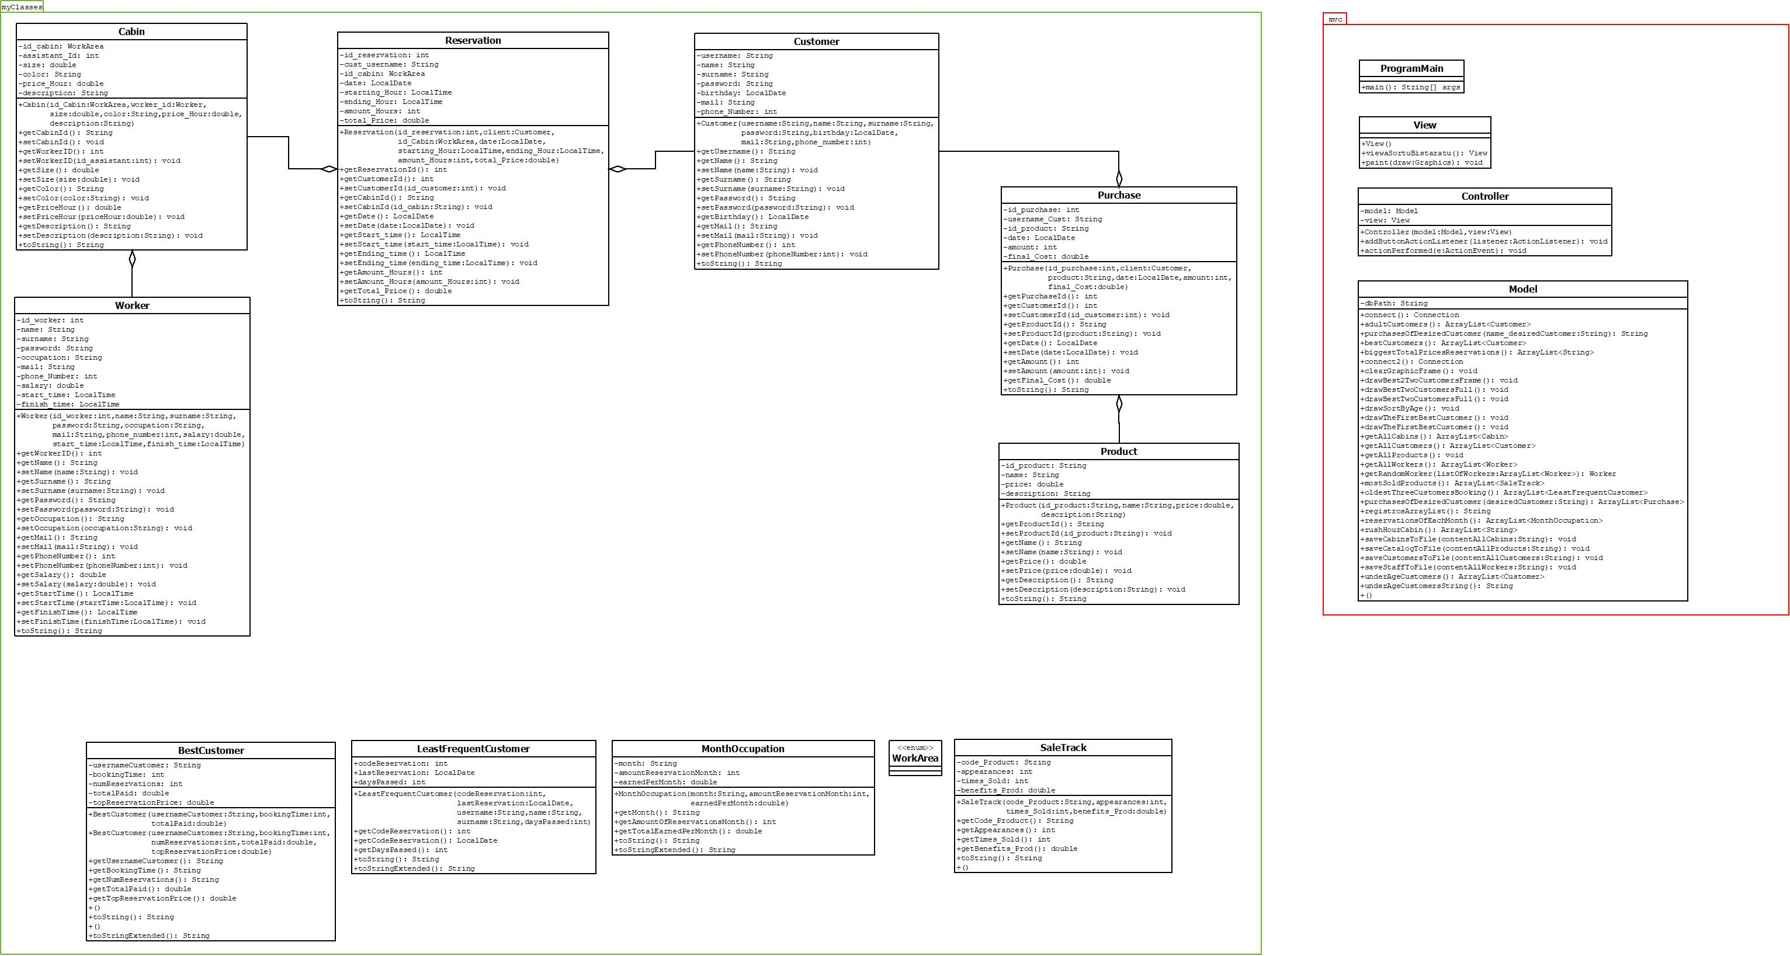

Database design:

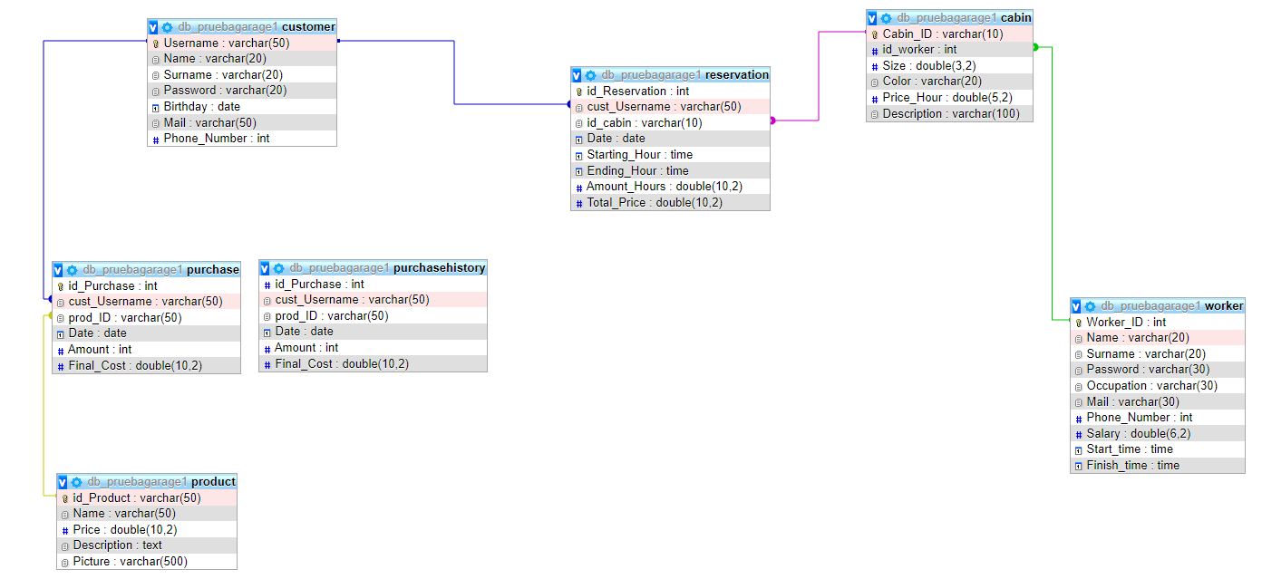

TASK TABLE:

 | Duration (hours) | Beginning date | Finishing date | Responsible
Task1- agrees on a Python menu between everyone. | 4 | 2022/03/21 | 2022/03/22 | Adrián, Arkaitz eta Hodei
Task1.1- each member of the group program Python’s menu’s two options. | 4 | 2022/03/21 | 2022/03/25 | Adrián, Arkaitz eta Hodei
Task2 – agree on a Webpage together. | 6 | 2022/03/21 | 2022/03/24 | All of us
Task2.1- each member program an option of the menu | 4 | 2022/03/21 | 2022/03/24 | Adrián, Arkaitz eta Hodei
Task3- individual diagram of the database | 8 | 2022/03/23 | 2022/03/25 | Adrián, Arkaitz eta Hodei
Task4- list of Java’s textual reports | 5 | 2022/03/23 | 2022/03/25 | Adrián, Arkaitz eta Hodei
Task5- diagrams of Python’s application | 7 | 2022/03/22 | 2022/03/25 | Adrián, Arkaitz eta Hodei
Task6- sketches of the webpage | 4 | 2022/03/23 | 2022/03/25 | Adrián, Arkaitz eta Hodei
Task7- sketches of Java's graphical interface | 7 | 2022/03/24 | 2022/03/28 | Adrián, Arkaitz eta Hodei
Task8- Datu Basearen kontrako SQL funtzioak planifikatu | 3 | 2022/03/25 | 2022/03/28 | Adrián eta Hodei
Task9- work safety basics | 5 | 2022/03/17 | 2022/03/28 | Leire, Arkaitz eta Hodei
Task10- collective diagram of the database | 4 | 2022/03/28 | 2022/03/29 | Leire, Arkaitz, Adrián eta Hodei
Task11- union of all use cases: Java, Python, Webpage | 3 | 2022/03/28 | 2022/03/29 | Adrián, Arkaitz eta Hodei
Task12- webpage’s all sketches together | 3 | 2022/03/28 | 2022/03/29 | Adrián, Arkaitz eta Hodei
Task13- class diagram of the applications | 3 | 2022/03/30 | 2022/03/31 | Adrián, Arkaitz eta Hodei
Task14- systems: technical proposals | 4 | 2022/03/29 | 2022/03/01 | Leire, Arkaitz eta Hodei
Task15- individual PHP server | 6 | 2022/04/04 | 2022/04/07 | Leire, Arkaitz eta Hodei
Task16- list of graphic reports (java) | 20 | 2022/04/25 | 2022/05/6 | Adrián, Silvan eta Hodei
Task17- program graphic reports | 25 | 2022/04/25 | 2022/05/13 | Adrián
Task18- study the security of the PHP server | 2 | 2022/04/25 | 2022/04/27 | Leire, Arkaitz eta Hodei
Task19- FOL usual damage for each type of danger | 1 | 2022/04/25 | 2022/05/25 | Leire, Arkaitz eta Hodei
Task20- encode the webpage and present it as a group | 10 | 2022/04/25 | 2022/04/29 | Silvan, Adrián eta Hodei
Task21- encode python and everyone explain their own | 10 | 2022/05/03 | 2022/05/10 | Adrián eta Hodei
Task22- create the final Python application | 20 | 2022/05/06 | 2022/05/13 | Adrián
Task23- arrange/fix the PHP server individually | 10 | 2022/05/05 | 2022/05/18 | Adrián Leire eta Hodei
Task24- study and check as a group the server’s security | 3 | 2022/05/11 | 2022/05/17 | Leire eta Hodei
Task25- analyze the foreseen dangers | 4 | 2022/04/25 | 2022/04/02 | Leire eta Hodei
Task26- prevention actions | 3 | 2022/05/05 | 2022/05/09 | Leire eta Hodei
Task27- present as a group a trigger made by each one | 5 | 2022/05/10 | 2022/05/16 | Adrián eta Hodei
Task28- united webpage | 15 | --- | ---- | Silvan, Adrián eta Hodei

SOFTWARE APPLICATION IMPLEMENTATION / INSTALLATION
To be able to execute/run the different applications of the project, you will need some specific requirements. Not all of these have the same impact on the main project.
Here is a brief explanation of what you need to be able to run each application:

  - Java:
    - Java editor installed (used in this project: Apache NetBeans IDE)
    - Class diagram with the structure of the database
    - Connection to the Database
    - Libraries for graphics, frames…

  - Python:
    - Python editor installed (used in this project: PyCharm Community Edition)
    - Use-Case diagrams to build a structure for the main program.
  - Web design:
    - HTML, PHP editor installed (used in this project: Visual Studio Code)
    - XAMPP server (Apache and MySQL)
  - Systems:
  - Ubuntu web server
  - Install LAMP server on Ubuntu
  - Install Apache
  - Install MySQL
  - Configure MySQL
  - Install PHP
  - Install PHP My Admin
  - Others:
    - GitHub repository to upload there the daily progression of the project.

USERS GUIDE
At this point, the only thing we have to know is the basic operation of the applications that we are going to launch / run on the performance of the project.

- Java: the very first thing the user finds when running the application, is a basic menu with three main options.
First Option – Textual Reports: once the “Textual Reports” option selected, the user will find an interface in which he can manage a list of six different reports. Depending on which report the user chooses, the program will return on a text area the wanted information. Five of the six reports, have the option to view the data on an emergent table.

Besides that, if the current user is a worker of the garage, he will have the possibility to download certain information/data about the garage’s progress. To do that, the user (worker) will need to log in with his worker account. The downloaded data will saved in a specific path.

  - Second Option – Graphic Reports: entering this section, the user will find an interface in which three disabled possible options appear. First, as in most applications, everything starts by pressing the “Start” button. With this, the program allows the user to select the desired graphic report.
In addition to the graphic draw of the selected report, this section shows also the data written on a text area. The text area’s content is an extra information or explanation of the graphic. As in the textual report’s section, the user could see two of the three graph’s result represented in a table.

  - Third Option – Link to Website: Finally, we have the option of visiting the garage’s website. This could be very useful if the user wants to manage something about our services (reservations or purchases).
Note: Despite opening a tab with the web page, the application isn’t closed, so if any changes are made on the database from the web page, it will be necessary to close the Java application to apply the changes. When the application is running again, the changes will appear correctly applied when the user runs the graphic.

- Python: we could say that this application is easier to use and understand than Java’s application. The main goal of this is to save objects in a file to have a “backup” of them. These are the objects used in this application:
  - Customer
  - Worker
  - Reservation
  - Product
For each object, the program gives the user the option to create a new one, save it on a file, read file’s content, delete object from the file, ask for a certain object, and update it. The best thing is that even if we stop running the application, the objects are saved in the files.

- Systems: this server is very easy to use. To enter it, all you have to do is log in at the following site: “https://cloud.uni.eus/login”.
When you logged in, if the server shared with you, it will appear on the website mentioned above. After pressing the “Start” button, and once the server started, you need to select the option “View” in the browser. Doing this, the server will open on your computer, and you will be able to enter it if you have the access codes.
Once you are inside it, you can use the server as if you were a normal user. On the other hand, there is also the option to log in to the server as an administrator.
Admin’s session is used to carry out procedures and prepare settings for the current users.

THOUGHTS
In general, we found this project a good opportunity to learn a little more about the needs and task involved in managing a company from the point of view of a programmer.
In addition, the knowledge obtained can be very useful when looking for solutions to problems related to this sector.
Once the difficulties and problems appear, the effort made to solve them, has become training, generally translated into mental agility and a source of new concepts. All this new knowledge helped us to realize that it can be very useful in order to solve problems or even generate improvements in future projects.
In terms of programming, as we were achieving objectives, we have been setting ourselves more and more ambitious goals. Moreover, although due to a matter of time we have not achieved the 100% of these new goals, we have carried out a large part.
In conclusion, we could say that despite having not too much time, it’s a project from which much can be learned.

BIBLIOGRAPHY
These are some of the main pages we visited to check information:

- HTML, PHP, J Query…
  - https://getbootstrap.com/
  - https://www.w3schools.com/
- Consult doubts and contrast ways of implementing concepts
  - https://es.stackoverflow.com/
- Platforms to host the project’s progress (files, versions…)
  - https://github.com/
  - https://drive.google.com/
- Online software to draw Diagrams:
  - https://www.lucidchart.com/
- Task calendar (online):
  - https://trello.com/
- Others:
  - https://httpd.apache.org/
  - https://docs.oracle.com/en/

