This was the initial level design Idea using a 2D scene however the lack of a third axis made implanting a jump method too much of a problem to make it usable

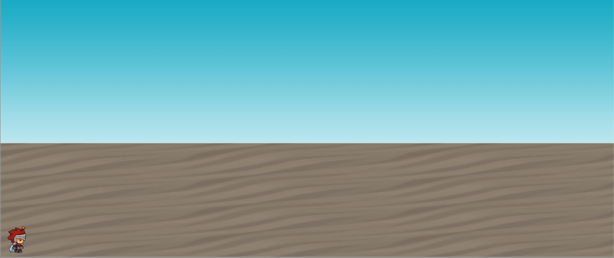

This was our first attempt at creating a 2.5D scene in a 3D space which ended up working pretty well and was the design that we based most of our level on:

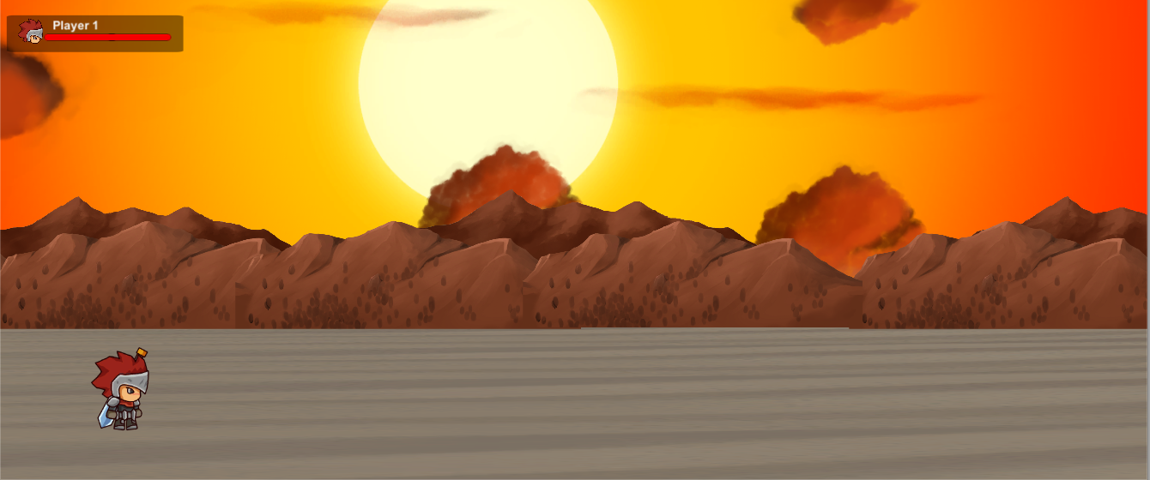

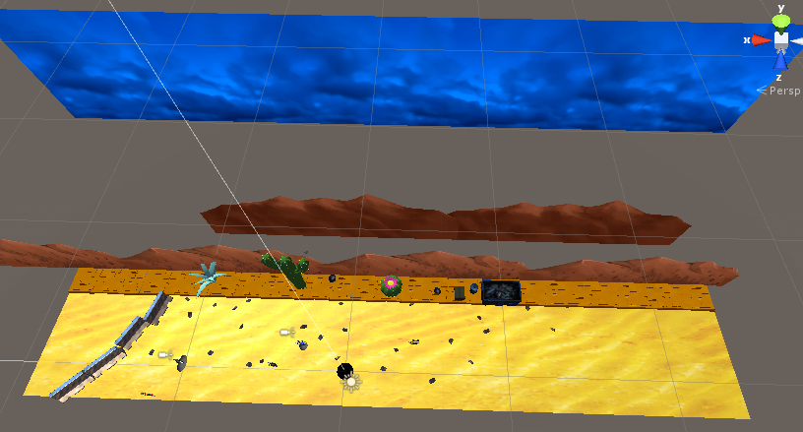From there we refined our level design a bit more adding more to the level to make it clear where the player could move:

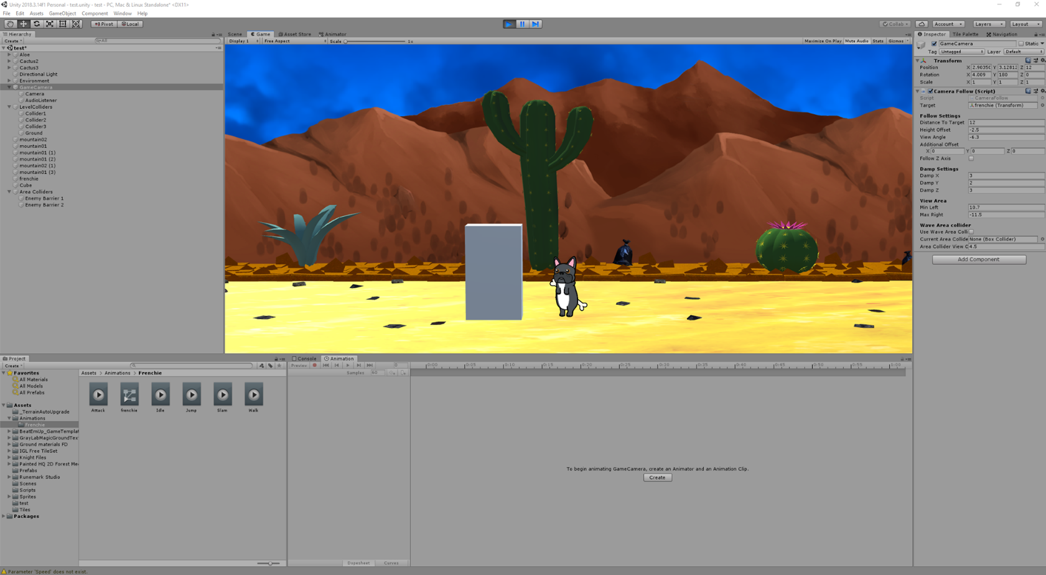After reaching this stage we started adding our own sprites and working on adding an enemy(a cube to begin with) that would follow the player:

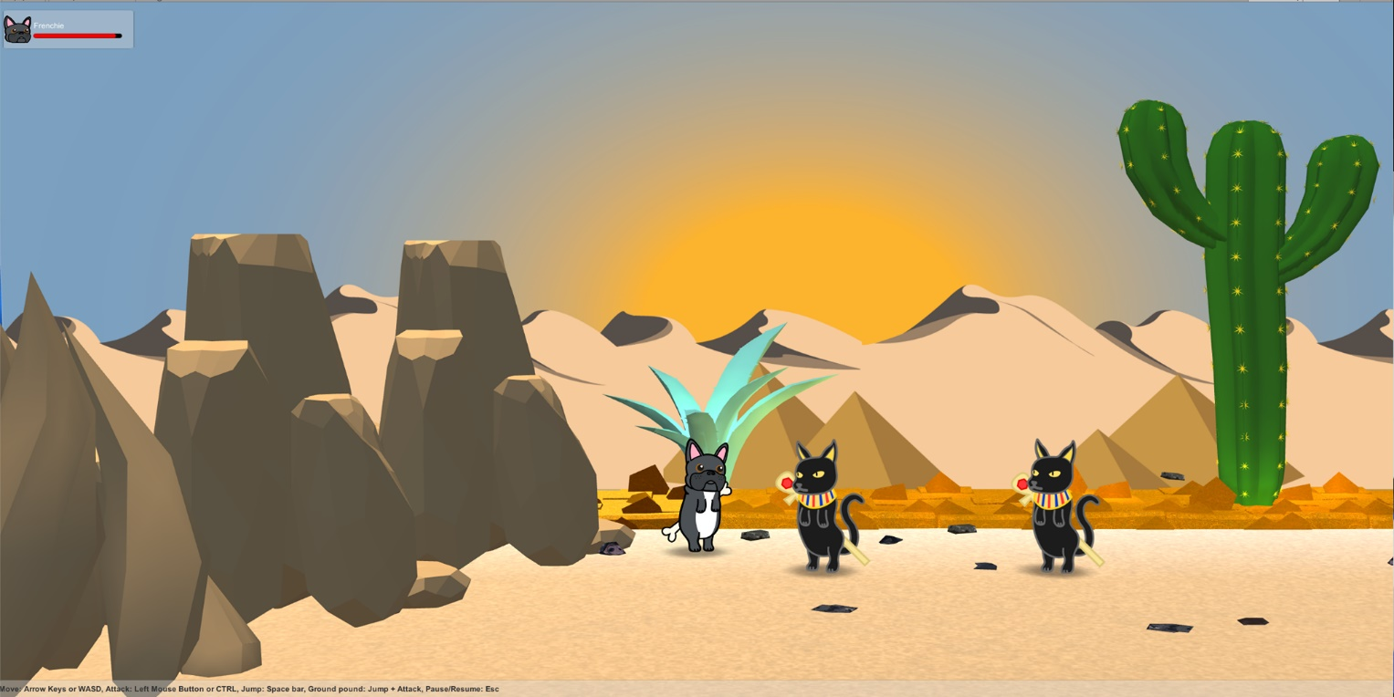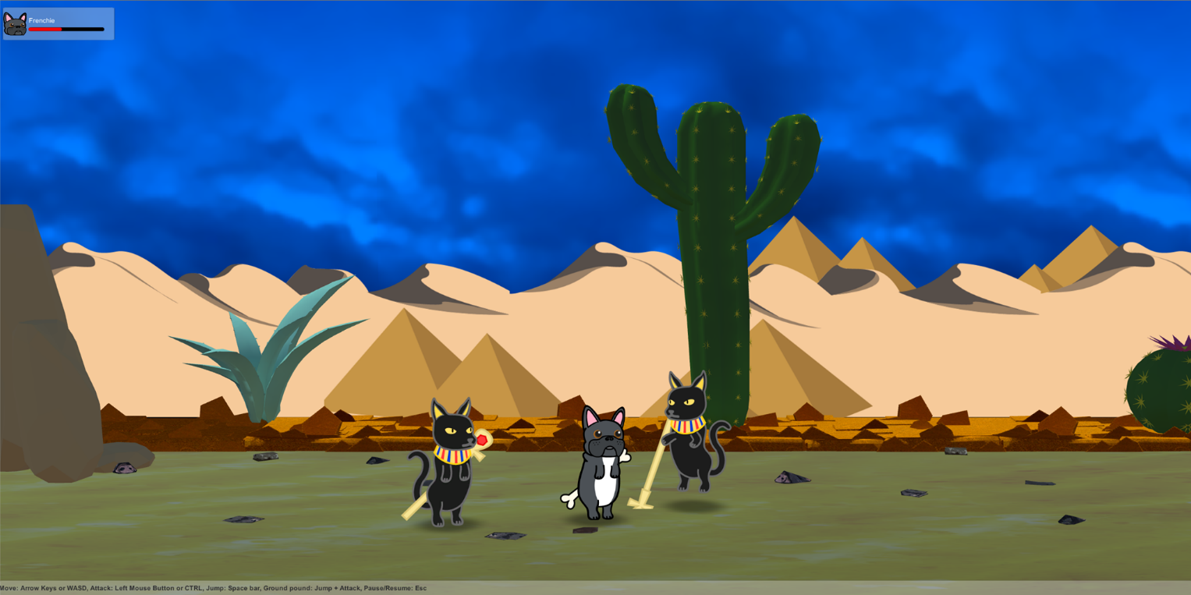Finally we added the rest of our sprites and backgrounds along with implementing all the scripts we needed to get movement, combat and the health system working along with a simple UI: