NWEN304 Final Project (Group 17)
Online Book Store
Link: https://nwne304-group-17.herokuapp.com

Zane Rawson
Huaiqu Cai 300434600

1. Using the system:
- Login and SignUp
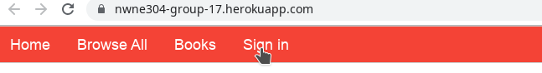
There is a Sign in button on the navigation bar, just click it to jump to the login page. The login page contains functions like directly login for a registered user, or users can login with their Google account. For a new user, it can simply jump to the sign up page from the login page. Same as the password reset. After login, the page will jump to the home page.
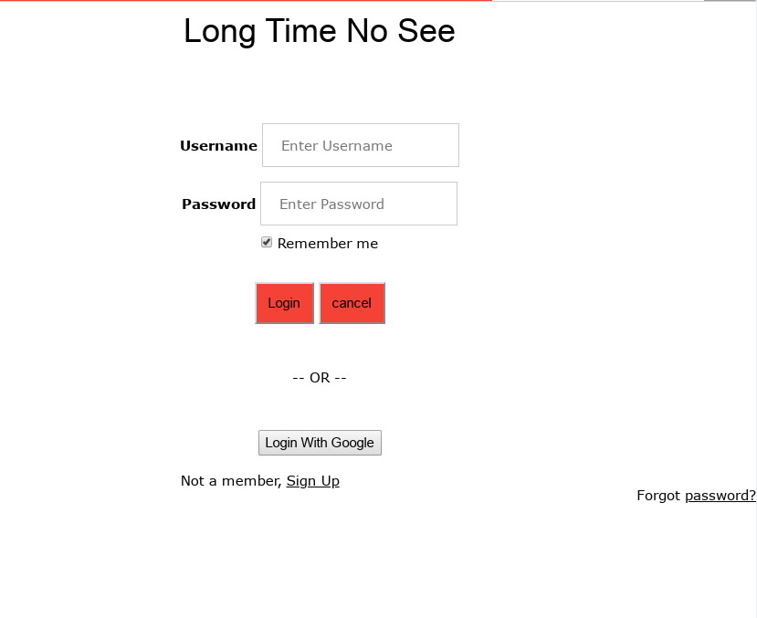
- Recommend, Category and Search.
The home page will display the top three books of the sold rank. In the top navigation bar, users can go to the Browse All page to view all books or go to Books and choose one of the category.
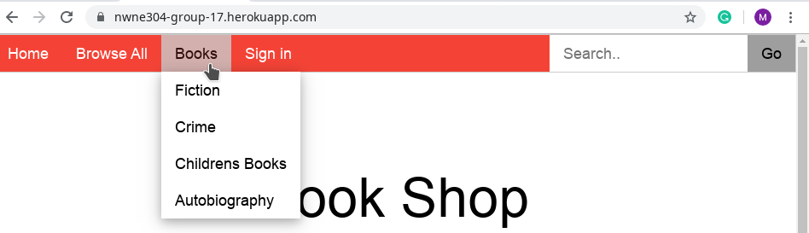
At the right hand side of the navigation bar, there is a Search Bar for user to search books. It will display all books with the key words input by user.
- Add to Cart and Purchase
---------------------

-===========

2. RESTful interface
The database of this project has two tables, books and users.
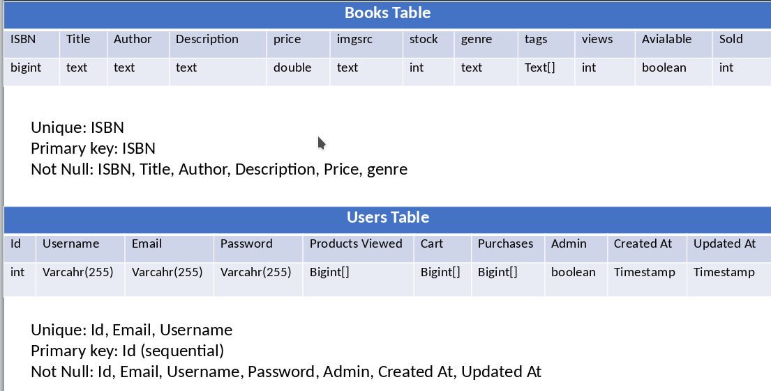
The RESTful API we have got:
GET: (‘/’) (‘/browse’) (‘/Product.html’)(‘/book’)(‘/recommend’)(‘/getCart’)(‘/logout’)

POST: (‘/login’) (‘/signUp’)

PUT: (‘/passReset’) (‘/addToCart’) (‘/buyBook’) (‘/passReset’) (‘/forgetPass’)

DELETE: clean the cart or delete user?

3. Error handing
For most of functions of this application, it will simply catch the error as it happens and send the error to the console. For some functions like login, sign up, once users input unexpected words, there will be an alert to notice user that what is wrong and the page will stay there for user to input correct words.

4. List of CURL commands

could have a look at the bananas’.

5. Summary of the system and database access/management code
This website works similar to most online shopping websites. Users could create an account, log in and buy books. We have many pages to display different contents like different category of books, or recommend books. For each user, there is a cart where stores the book they put. And in the page of each book, there is a buy button for user jump to the purchase page to order their books.

