# **Algorithm and Standard Flowchart for Tkinter SymPy Calculator**

**Author: Hodo Charles  
© 2025 Hodo Charles. All rights reserved.**

## Algorithm

1. Start

2. Initialize Tkinter main window

3. Set default theme (dark)

4. Create and configure GUI elements: title, input fields, output area, buttons, keypad

5. Bind menu items and keyboard shortcuts

6. Wait for user input (expression)

7. If user selects 'Simplify', call compute_simplify() and display result

8. If user selects 'Differentiate', call compute_differentiate() and display result

9. If user selects 'Integrate', call compute_integrate() and display result

10. If user selects 'Factor', call compute_factor() and display result

11. If user selects 'Newton-Raphson', get initial guess, call compute_newton_raphson() and display result

12. If user selects 'Solve', call compute_solve() and display result

13. If user selects 'Limit', ask for point, call compute_limit() and display result

14. If user selects file operations (Open/Save), perform respective actions

15. If user toggles theme, switch colors accordingly

16. Loop until user closes application

17. End

Language Used: Python (pydroid 3)

Note: the app is still in development and further suggestions and contribution will be appreciated. Please ensure to get proper permission before contribution will be merged.

## Standard Flowchart

This flowchart uses standard shapes: terminators, processes, decisions, and input/output symbols.

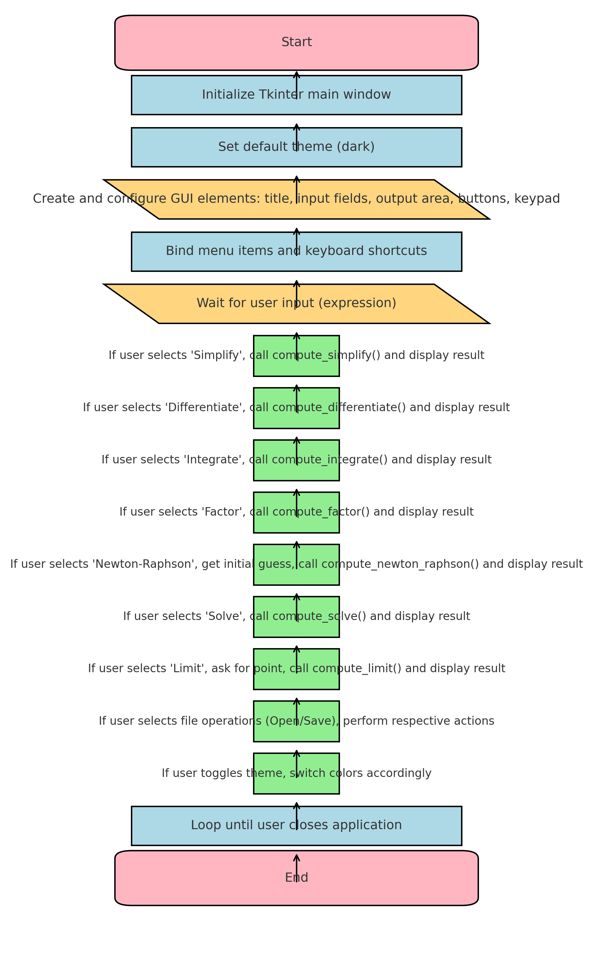l