Micro-processing Systems

Laboratory Report

Final Lab – Mai Nguyên Hoàng – ITITIU21208

Github Repository: https://github.com/HoenMike/MPS_LabFinal_MNHoang_ITITIU21208

# Question 1:

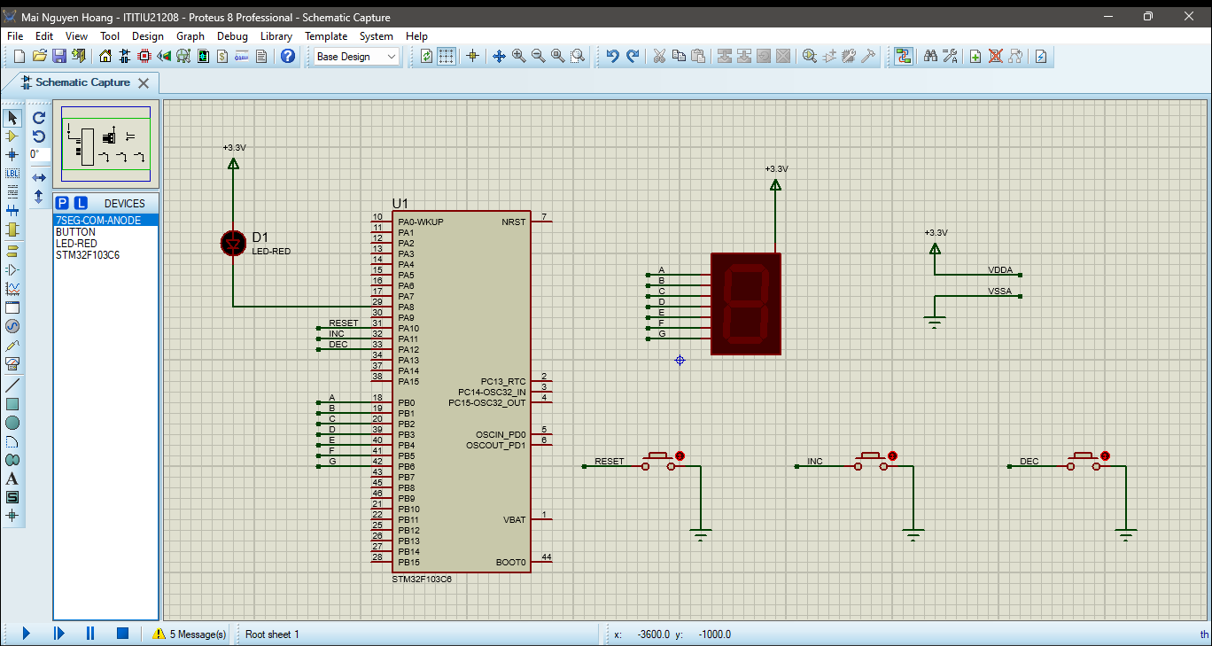

# Question 2:

# Question 3 + 4:

# Question 5:

