Specification of TASCAR file format

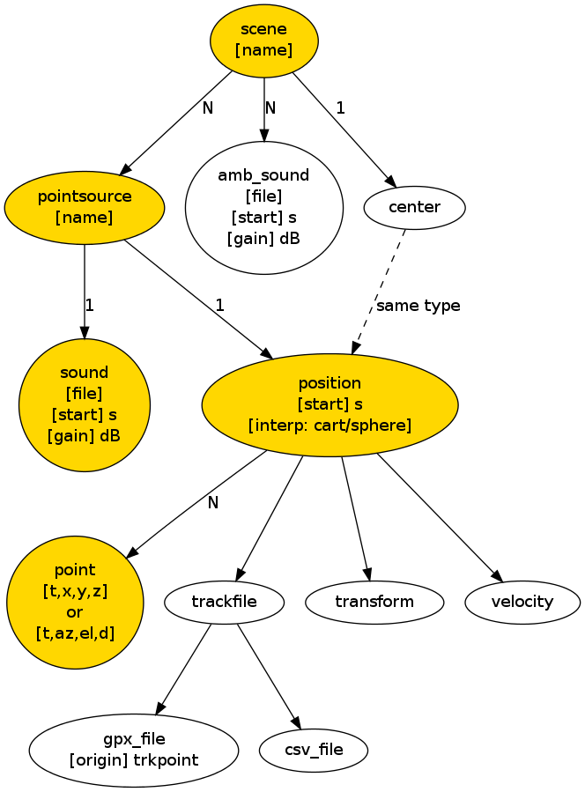
yellow: available in all clients
List of elements:
<scene name=””>...</scene>
<pointsource name=””>...</pointsource>
<sound file=”” start=”0” gain=”0”/>
<position start=”0” interp=”cart”>...</position>
<point t=”0” x=”1” y=”0” z=”0”/>
<point t=”0” az=”0” el=”0” d=”1”/>

