Plan of action

Spark! Living Lab

Spark! Living Lab Conditioned Goods

Version 0.8



**Authors:**

|  |  |  |
| --- | --- | --- |
| Name | Student number | Email |
| Tim Imming | S1132262 | S1132262@student.windesheim.nl |
| Thijs Mansveld | S1127391 | S1127391@student.windesheim.nl |
| Sjoerd van de Kerkhof | S1129492 | S1129492@student.windesheim.nl |
| Gerard Wesseling | S1131366 | S1131366@student.windesheim.nl |
| Berat Guzel | S1127994 | S1127994@student.windesheim.nl |

**Version control**

|  |  |  |  |
| --- | --- | --- | --- |
| Version | Date | Who | What |
| V0.1 | 3-2-2021 | Thijs, Tim, Gerard, Berat, Sjoerd | Initial setup, Workshops |
| V0.4 | 11-2-2021 | Thijs, Tim, Gerard, Berat, Sjoerd | Introduction & background, Product definition, Methodology, Management strategies, Competence compliancy matrix, planning, project definition, project management organisation |
| V0.6 | 17-2-2021 | Thijs, Tim, Gerard, Berat, Sjoerd | Scope, chapters have been supplemented |
| V0.8 | 18-2-2021 | Thijs, Tim, Gerard, Berat, Sjoerd | Spelling, grammar and layout check |
|  |  |  |  |
|  |  |  |  |

**Distribution**

|  |  |  |  |
| --- | --- | --- | --- |
| Version | When | Addressee | Reason |
| V0.8 | *19-2-2020* | *Maxime Bouillon* | *Stakeholder review* |

**Approval**

|  |  |  |
| --- | --- | --- |
| Signature | Date | Name |
|  | 4/06/2021 | Maxime Bouillon |

Table of contents

1 Introduction & background 4

2 Project definition 5

2.1 Context 5

2.2 Problem Statement 5

2.3 Goal 5

2.4 Assumptions 6

2.5 Prerequisites 6

2.6 Scope 6

3 Project product definition 7

3.1 Product decomposition 7

3.2 Product flow diagram 8

3.3 Product description 9

3.4 Definition of done 11

4 Methodology 12

4.1 Scrum 12

4.2 OIAm 12

4.3 MoSCoW 13

4.4 TMap 13

5 Project management organisation 14

5.1 Stakeholder analysis 14

5.1.1 The stakeholders 14

5.2 Team structure and roles 15

6 Management strategies 16

6.1 Risks 16

6.2 Quality 17

Four-eyes principle 17

Documentation 18

Proof of Concept 18

6.3 Version control 18

6.4 Communication 19

Team 19

Client/mentor 19

6.4 Security agreements 19

7 Planning 0

7.1 Gantt chart 0

7.2 Main phases 0

7.2.1 Project initiation phase 0

7.2.2 Realisation phase 0

7.3 Milestones 0

8 Personal learning goals 1

8.1 Attending workshops 1

8.2 Personal Learning goals 1

8.2.1 Thijs 1

8.2.2 Tim 2

8.2.3 Sjoerd 2

8.2.4 Gerard 3

8.2.5 Berat 3

9 HBO-ICT competence compliance matrix 4

10 Client expectations 5

11 References 6

12 Appendix 7

# Introduction & background

Special cooled transport, or a so-called cold chain, is used to transport certain temperature-sensitive goods. These cold chains ensure that a product is always sufficiently cooled during transport from start to finish. Companies that offer a cold chain solution to a customer must comply with a customer service level agreement (SLA). Most of the time, the SLA contains a section about the different factors that could impact transport goods like temperature and humidity. Sometimes sensors are placed on products in the cold chain to monitor the environmental factors. But how do you know these readings have not tampered with? That is what the project is all about.

Lamb Weston is one of the world’s largest processors of potato products founded in Weston, Oregon with over 1300 employees [1] [2]. They produce frozen fries and other potato products in all shapes and sizes for any occasion. Lamb Weston wants to produce fries in a sustainable way by using methods such as sustainable cultivation, smart processing of their products and supply chain innovation [1].

Spark! Living Lab Supply Chain 4.0 is a project to improve traditional supply chains with a more data-driven version. The project aims to co-create business, research, and education. The analysis is performed on applications that ensure more sustainable and circular supply chains utilising blockchain and the internet of things [3]. Spark! is researching methods together with Lamb Weston to store the data measurements of a cooled transport package so it cannot be changed and thus proves goods have been transported as agreed in the SLA. Research performed by a previous project group has shown that storing sensor data using blockchain can result in information with integrity.

The project aims to prove that this data storage method and sharing are possible and feasible for Lamb Weston. After a feasibility study, which will include validating the earlier blockchain data storage solution, a proof of concept (POC) will be designed to determine if the solution works as intended and is fit for this purpose. Validation of the research will be the first step of the project as this will significantly impact the project. If the validation research concludes that blockchain data storage from the cold chain is impossible, the group must change the project scope.

# Project definition

## Context

Companies that need their cargo cooled during transport make use of a ‘cold chain’. A cold chain is a temperature-controlled supply chain, where the cargo is cooled throughout the chain [4]. When a customer purchases a cold chain service, both parties' conditions and quality are agreed upon; this is stated in a Service Level Agreement (SLA) [5]. There is a chance of a cold break in the cold chain, which means an undetermined time that the cargo was not cooled. This cold chain is arranged traditionally. There is minimal insight into the delivery times, conditions, and origin of the goods within the chain. The traditional way is documenting events on paper. Which means that the customer has no concrete evidence that the provider has met the SLA.

## Problem Statement

Companies that provide services in a cold chain to customers agree upon its quality. Therefore, conditioned goods have an SLA [5] attached to them. This SLA is a commitment between a service provider and a client. The quality, availability, and responsibilities are stated within. The SLA between a service provider and client is one thing, but to provide unalterable evidence that the provider has met the conditions is not possible as it stands. Now we have come to the problem that has led to this project. Lamb Weston uses a cold chain to cool their fries during transport. This cold chain starts at the factory of Lamb Weston where the fries are produced. After frying the fries, they are cooled to -7 degrees Celsius in their factory. These fries are then transported to another location where they are cooled to -18 degrees Celsius. Lamb Weston wants to measure the temperature during the transport from their factory to the cold store to guarantee that the fries are cooled correctly, and the conditions are as stated by the provider for the cold chain’s entirety. These sensor data need to be stored without any entity being able to alter the information.

## Goal

This project aims to provide a solution that monitors and captures the temperature of the fries during transport from Lamb Weston’s factory to the cold store. All this data must have the integrity to provide the needed information to confirm that the SLA has been met. To make sure that the data stays unaltered, blockchain will be used. The final goal is a prototype in the form of a proof of concept.

## Assumptions

* As this project is a follow-up project, it can be assumed by the group that research, that the previous project has performed, is of a high enough level and can therefore be used as a foundation for this project. It should be safe to assume that the previous research is correct with little validation.
* The blockchain subject will be hard to understand. Therefore, we assume that help from experts on this matter is needed to succeed.
* The supply chain, which will mainly be worked with, is a cold-chain.
* The company that is providing the sensor will be Innotractor.
* Insight into all technical documentation of external products related to this project must be provided to get the best understanding of this product. Understanding the product will lead to a deliberate choice of whether the product will add value to the project.

## Prerequisites

* A testing area must be available to make a proof of concept.
* Regarding the difficult subject and the warning from the previous project group, the group is dependent on experts or individuals with a clear understanding of this subject to guide us in this project where needed.
* The previous project research outcomes must be of a high enough level. If these results are not good enough, the group must perform new research to determine a suitable blockchain solution. That will result in a change of scope.
* The project owner must give feedback, validation, and approval to validate that the products meet the expected standards to bring the project to success.
* For the entirety of the project, guidance must be present. The project owner or the stakeholder must provide this guidance.

## Scope

The team will collect and investigate requirements in the requirement analysis. Based on this analysis and the product owner's priorities, requirements will be ranked in importance. The team will use MoSCoW to accomplish this. The group will discuss any additional requirements or changes from the project owner because they significantly impact the project's flow.

To validate the previous group's research, the team will perform additional research to confirm their findings. This research will display if Hyperledger fabric is the best tool for this project.

The Proof of Concept (POC) is a realisation of the initial idea to demonstrate its feasibility. Because it is a POC, it does not have to be a fully completed product. The team will try to implement as many functionalities as possible but cannot guarantee the implementation of all functionalities.

The team will only develop the project's blockchain side, storing data in the blockchain and possibly the interface to retrieve the data. The team will not implement the communication between the sensor data and the blockchain. If there is any remaining time at the end of the project, the team will consider implementing it.

# Project product definition

For the project to succeed, several subproducts will be developed. These subproducts will support the final product. Each subproduct supports the final product in a different way. What is included in these subproducts can be found in chapter 3.1. You can find a brief explanation of the different subproducts in chapter 3.2. A more in-depth explanation of the different subproducts can be found in chapter 3.3.

## Product decomposition

The product decomposition (Figure 3-1) displays the different subproducts the team will make in this project and what is included in the subproducts.

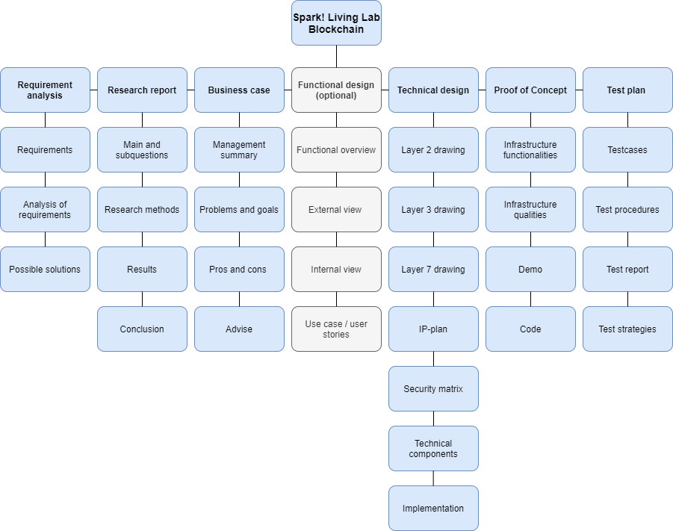

Figure 3‑1: Product decomposition

## Product flow diagram

The product flow diagram (Figure 3-2) displays how different products will be made. The focus is on the Proof of Concept because it has the highest priority. Several products will be made simultaneously to realise this goal quickly. The first being a requirement analysis. This product will focus on the requirements determining the final product's features. Based on these requirements and previous research, a feasibility study will be performed to determine if this project is feasible. This study will consist of a research report and a business case. Depending on the feasibility study results, a Proof of Concept (POC) will be created, simultaneous with a technical design. The POC will show if the designed and researched product will work in practice. Finally, the POC will be tested using test cases; these are included in a test plan. After the POC, the functional design will be made. The POC findings will be incorporated into the functional design and technical design. A discussion with the product owner will be held to see if these features should be included in the POC.

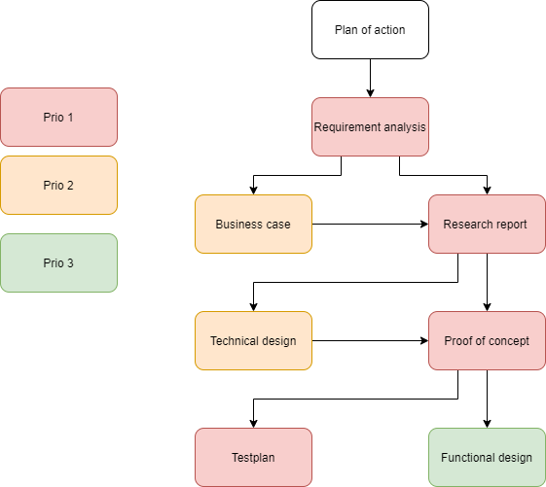

Figure 3‑2: Product flow diagram

## Product description

You can find a description of the to-be-delivered products in the following paragraph, including the quality requirements and goals they must achieve.

Table 3‑1: Product description of all products

|  |  |
| --- | --- |
| Product: Requirement analysis | |
| Description | This product will determine the final product features while considering the various stakeholders' potential conflicting requirements. |
| Goal | The goal of this product is to produce a document containing requirements that are actionable, measurable, testable, traceable, related to identified business needs or opportunities, and defined to a level of detail sufficient for system design. |
| Quality requirements | The document must contain requirements that are actionable, measurable, testable, traceable, related to identified business needs or opportunities, and defined to a level of detail sufficient for system design. The requirements should not be conflicting and are approved by the product owner. These requirements will be prioritised using the MoSCoW method.  The product must contain all components displayed in the product decomposition structure. |

|  |  |
| --- | --- |
| Product: Research report | |
| Description | In this product, the group will perform research to validate if Hyperledger fabric is the right tool to achieve Spark! Living Lab's end goal. Previous research documents and requirements acquired in the requirement analysis will be used in this research. |
| Goal | This product aims to produce a document containing research that can validate if Hyperledger fabric is the proper tool to achieve Spark! Living Lab's end goal. |
| Quality requirements | After the product is finished, the main question is answered. This answer is based on the conclusions of the sub-questions. Sub-questions only cite topics directly related to the main question. The product must contain all components displayed in the product decomposition structure. |

|  |  |
| --- | --- |
| Product: Business case | |
| Description | In this product, research will be performed to see if this project is feasible for Lamb Weston, Innotractor, and supply chains. |
| Goal | This product aims to deliver a document containing this project's advantages and disadvantages. Based on these advantages and disadvantages, advice will be formed about this project's feasibility. |
| Quality requirements | All advice must be substantiated. The product owner must decide if the project is viable based on the business case. |

|  |  |
| --- | --- |
| Product: Functional design | |
| Description | This product will contain a design that describes a clear picture of the final product's functionalities. The functionalities will be based on the requirements acquired in the requirement analysis and on the POC findings. |
| Goal | This product aims to create a high-level overview of the final product's functionalities. |
| Quality requirements | The 'must haves' and 'should haves' from the requirement analysis are included and designed. The document should be readable for stakeholders without a technical background. The product must contain all components shown in the product decomposition structure. |

|  |  |
| --- | --- |
| Product: Technical design | |
| Description | This product contains all functionalities the final product should have, described in technical terms. |
| Goal | This product aims to create a clear picture of the technical implementations that need to happen to make the final product. |
| Quality requirements | The 'must haves' and 'should haves' from the requirement analysis are included and technically designed. An individual with experience with building blockchains could create the final product using this design. The product must contain all components shown in the product decomposition structure. |

|  |  |
| --- | --- |
| Product: Proof of Concept | |
| Description | This product is a prototype of the concept; the final product realised for Spark! Living Lab. |
| Goal | The aim is to gain insight if the concept works. |
| Quality requirements | The Proof of Concept should clearly show if the product works. The workings are presented in a demo. All functionalities introduced in the demo are discussed with the product owner. |

|  |  |
| --- | --- |
| Product: Test plan and test report | |
| Description | This product will contain the tests that will be performed to validate the final product's workings (Proof of Concept). The tests will be in line with the requirements. |
| Goal | This product aims to validate the workings of the final product. |
| Quality requirements | The product includes test cases. These test cases consist of what is being tested and the expected result. The results and areas of improvement should also be listed. The product must contain all components shown in the product decomposition structure. |

## Definition of done

The Definition of Done (DOD) is a checklist of requirements that a user story in the sprint backlog should meet. When a user story complies with the DOD, it is considered finished. The DOD consists of:

* The functional design should be updated with the latest design of the functionality in the form of user stories, including:
  + Acceptation criteria
  + Edge cases
  + (Screen design)
* The technical design should be updated with the functionalities' latest technical translation.
* The written code has been explained with comments if necessary.
* At least two team members have reviewed the written code.
* The project group tests the code with the described strategy; this is documented in a rapport.
* The group tests the infrastructure with the described strategy, and the result has been documented in a rapport.
* While writing code, the developer uses the agreed-upon code conventions.
* The written documentation has been checked and meets the requirements drawn up in chapter 6.2 Documentation.

# Methodology

In this chapter, the project team will elaborate on the approaches or methods used to accomplish this project.

## Scrum

For this project's realisation phase, the development team will use Agile. To be exact, the team will adopt multiple aspects of Scrum. Further details on these aspects are given in the upcoming paragraphs.

Every day the team starts with a daily stand-up. In this meeting, the team will discuss the previous day's accomplished result, what the team member will do today, and if he needs any assistance to obtain their daily goal.

When a new sprint starts, the team will begin with sprint planning. The team will hold a meeting at the beginning of a sprint. This meeting aims to discuss which requirements or user stories are being realised by the development team in this sprint. The sprint has a duration of two weeks. If desired, the team will also estimate the number of story points (an estimation of effort or size) a requirement or user story is worth. That is done by using a gamified technique called scrum poker or planning poker. These story points are used to generate a burndown chart. With the burndown chart, the team can make certain conclusions about the previous sprint to improve in the upcoming sprint.

There will be a sprint retrospective and a sprint review after each sprint. In the sprint retrospective, the team discusses what went well, what could have gone better and what the group will improve in the next sprint. The group uses the sprint review as a demo moment. In this demo, the team will present the increment in functionality to the product owner. This meeting aims to collect user feedback to enhance the accomplished results.

One of the significant advantages of Scrum is that it is flexible. That benefits the development team by making it easier to react to unexpected changes. That means the team can respond without rewriting all the affected documentation (which is the case in the waterfall method). The benefit comes from how documentation is written when Scrum is used. Instead of writing documentation upfront, Scrum requires the team to write documentation of a requirement within the sprint. Each sprint, these requirements will be implemented. Therefore, the team has a better chance to adjust to changes.

## OIAm

Aspects of OIAm will be used in the functional design and technical design. The method will be used as a guideline. Open Infrastructure Architecture method (OIAm) is an open standard for designing infrastructure. OIAm is based on a repository of standardised infrastructure functions. Common infrastructure services are included in generic patterns. These generic patterns are used to create applied patterns. Applied patterns are specified for the environment.

## MoSCoW

The MoSCoW method is a method used for prioritisation of requirements. This method can be used to understand the importance of requirements. That will be accomplished in collaboration with the stakeholders. MoSCoW will be used to analyse the different requirements provided by the stakeholders.

MoSCoW is an acronym for:

* **Must-have:** these requirements are a must in the final project to deliver a successful product.
* **Should have:** these requirements should be implemented in the final product.
* **Could have:** these requirements are not necessary to finish the product. They are implemented when time permits it.
* **Won't have:** these requirements will not be implemented in the final project. The implementation of these requirements is not worth the time.

## TMap

A test methodology is needed to test the POC. The method that will be used is Tmap. Tmap is used to test different POC aspects and show that the stakeholders' requirements are met. The exact variety of Tmap will be decided depending on the specific requirements. These varieties will be explained further in the test plan.

# Project management organisation

## Stakeholder analysis

Each project has the stakeholders involved. Each stakeholder has a certain degree of influence and interest. In this chapter, these impact and interests are analysed. The communication strategies will be adopted by the group accordingly.

### The stakeholders

This project has primary and secondary stakeholders. The primary stakeholders directly affect the project approach or result; secondary stakeholders indirectly affect the project approach or outcome.

Table 5‑1: Primary and secondary stakeholders

|  |  |  |
| --- | --- | --- |
| Primary | Name | Role |
|  | Mathijs Tomeij | Lamb Weston contact person | |
|  | Frank Hermans | Innotractor contact person | |
|  | Lamb Weston | Supply chain owner | |
|  | Maxime Bouillon | Spark! Living Lab use case manager | |
|  | Christiaan Verhoef | Spark Living Lab use case manager | |

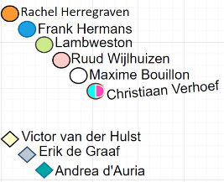

|  |  |  |
| --- | --- | --- |
| Secondary | name | Role |
|  | Victor van der Hulst | Spark Living Lab program manager |
|  | Erik de Graaf | TNO developer |
|  | Andrea d'Auria | TNO developer |
|  | DLG | Logistics partner of Lamb Weston |
|  | Lineage | Cold store partner of Lamb Weston |

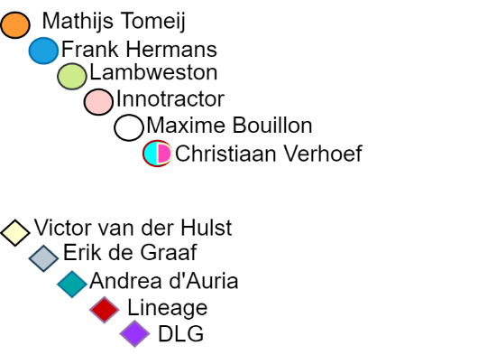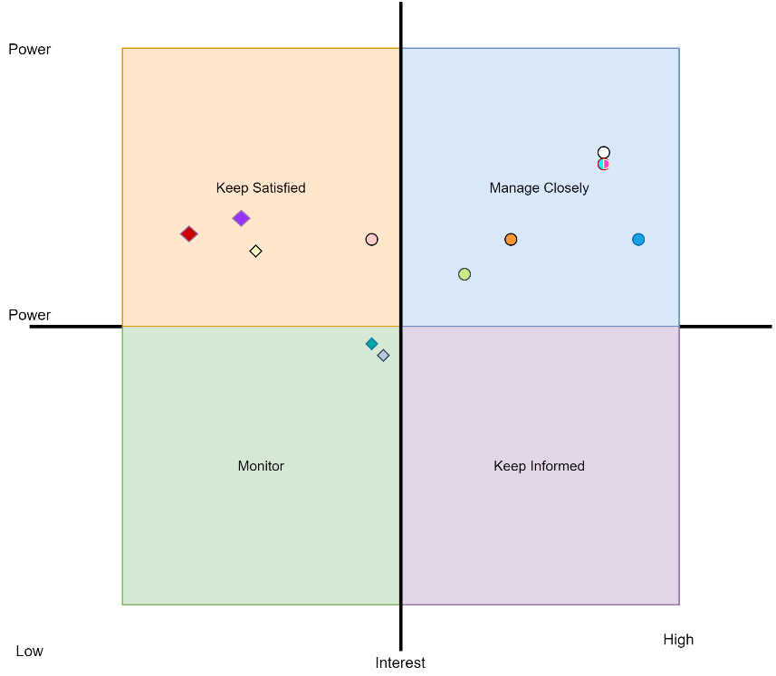

Figure 5‑1: Stakeholder matrix

**Matrix**  
In the quadrants in the matrix on the right, the stakeholders are classified. Each stakeholder is classified based on impact and interest.

## Team structure and roles

In the table below, you can find the team structure for the project:

Table 5‑2: Team structure

|  |  |  |  |
| --- | --- | --- | --- |
| **Individual** | **Type** | **Organisation** | **E-mail** |
| Bram van der Ploeg | Mentor | Windesheim | *aq.vanderploeg@windesheim.nl* |
| Berat Guzel | Project Member | Windesheim | S1127994@student.windesheim.nl |
| Gerard Wesseling | Project Member | Windesheim | S1131366@student.windesheim.nl |
| Sjoerd van de Kerkhof | Project Member | Windesheim | S1129492@student.windesheim.nl |
| Thijs Mansveld | Project Member | Windesheim | S1127391@student.windesheim.nl |
| Tim Imming | Project Member | Windesheim | S1132262@student.windesheim.nl |
| Maxime Bouillon | Project Manager | Spark! Living Lab | Mfy.bouillon@windesheim.nl |
| Mathijs Tomeij | Lamb Weston contact person | Lambweston | Mathijstomeij@lambweston.eu |
| Frank Hermans | Sensor supplier  contact person | Innotractor | Frank.hermans@innotractor.com |
| Diana van Zielst | DLG contact person | DLG | Diana.van.Zielst@dlg-logistics.com |
| Marijn Timmermans | Lineage contact person | Lineage | MTimmermans@lineagelogistics.com |

In the table below, the roles of the project members can be found:

Table 5‑3: Team roles

|  |  |  |  |
| --- | --- | --- | --- |
| **Individual** | **Type** | **Organisation** | **Role In Group** |
| Berat Guzel | Project Member | Windesheim | Project Member |
| Gerard Wesseling | Project Member | Windesheim | Project Member |
| Thijs Mansveld | Project Member | Windesheim | Project Member |
| Sjoerd van de Kerkhof | Project Member | Windesheim | Project Member |
| Tim Imming | Project Member | Windesheim | Project Leader |

# Management strategies

This chapter will outline the risk factors and the management strategies used to minimise the risks' likelihood and impact.

## Risks

Table 6‑1: Chance/Influence matrix

Influence

|  |  |  |  |  |  |
| --- | --- | --- | --- | --- | --- |
|  | Small | Mediocre | Moderate | Serious | Disastrous |
| Very likely | 5 | 10 | 15 | 20 | 25 | |
| Probably | 4 | 8 | 12 | 16 | 20 | |
| Possible | 3 | 6 | 9 | 12 | 15 | |
| Unlikely | 2 | 4 | 6 | 8 | 10 | |
| Very unlikely | 1 | 2 | 3 | 4 | 5 | |

Chance

Table 6‑2: Project risks and measures

|  |  |  |  |  |  |
| --- | --- | --- | --- | --- | --- |
| ID | Risk | Chance | Influence | Risk value | Measure |
| 1 | Files get corrupt | Very unlikely | Disastrous | 5 | If files become corrupt, the team will try to find a solution. The client and mentor will be informed. When necessary, they are involved in finding a solution. |
| 2 | A personal problem | Possible | Moderate | 9 | When a team member cannot complete their work due to personal circumstances, the others will evaluate how much work is left and how they can divide this up to achieve the deadline. The team will also inform the mentor and client about the problem. |
| 3 | Missed deadlines | Possible | Moderate | 9 | If the team misses a deadline, then the team will discuss with the client/mentor whether the deadline is postponable or not. When postponing the deadline is not an option, they will discuss what else can be executed to finish the project properly. |
| 4 | Content of the delivered documents do not meet the requirements | Unlikely | Disastrous | 10 | When documents do not meet the client/mentor's requirements, the team will ask for more time to improve these documents. |
| 5 | corona brings down motivation | Very likely | Mediocre | 10 | The team will hold suitable team-building activities to keep motivation as high as possible. |
| 6 | Insufficient resources | Unlikely | Disastrous | 10 | The client must ensure that the project team has all the necessary resources. If necessary, provide alternative means. |
| 7 | Failed communication with stakeholders | Possible | Serious | 12 | When there is a problem with communicating with the stakeholders, the team will contact the stakeholders three more times by sending them an e-mail or calling them. In the case the problem still occurs, the group will inform the mentor. |
| 8 | The client does not uphold integrity with his promises | Possible | Serious | 12 | If the client does not uphold his promises, the team will indicate this to the client and supervisor. If this does not solve the problem, the team will complete the project with the available resources. |
| 9 | The client is constantly changing the scope | Possible | Serious | 12 | The team will advise the client not to change the scope because this will take time away from development and completing other requirements. If there is time left at the end of the project, the team will consider implementing the new requirements. |
| 10 | Quarrel among team members | Possible | Serious | 12 | When the team argues among themselves, the team will try to solve it. That could, for example, be achieved by using the escalation ladder. |
| 11 | One of the involved party does not want to be involved anymore | Possible | Serious | 12 | Whenever there is a party that does not want to be involved with the project anymore, the team will discuss with their mentor and client the impact that this will have on the project and how to minimize it. Possible solutions could be finding a new party to replace the old one or finding a different approach to achieve the end goal without that party. |
| 12 | Long-lasting (corona) leave | Possible | Moderate | 15 | On the off chance that a team member cannot be present for an extended period, the rest of the team will evaluate how much work is left and how they can divide this up to achieve the deadline. The group will also inform the mentor and client about this problem. |
| 13 | The supply is chain not available anymore | Possible | Disastrous | 15 | Whenever the supply chain is not available anymore, the team will discuss with their mentor and client different solutions to finish their project. Possible solutions could be finding a different supply chain to replace the previous one or making up a generic supply chain to continue working without dependencies. |

## Quality

### Four-eyes principle

During the project, the four-eyes principle will be followed. This principle aims to check each other's work to guarantee quality. For every team member, there are two other team members (four eyes) who review their work; The two team members who review the work must consist of a Software Engineer (SE) and Infrastructure design & security (IDS) Student. The composition of who checks who are listed below:

Tabel 6‑3: Four-eyes principle

|  |  |
| --- | --- |
| **Work made by:** | **Is checked by:** |
| Tim | Gerard, Sjoerd |
| Thijs | Berat, Tim |
| Gerard | Sjoerd, Berat |
| Sjoerd | Thijs, Gerard |
| Berat | Tim, Thijs |

### Documentation

Before a document can be completed, it must comply with the following requirements:

* The document contains correct grammar and spelling.
* The information inside the document is complete and correct.
* The document contains a table of contents, page numbering, and proper layout.
* The document is compliant with the requirements of the client and Windesheim.
* Every member of the team checks the document on all the above points.

### Proof of Concept

Before the Proof of concept can be completed, it must meet the following requirements:

* The Proof of Concept is compliant with the client and Windesheim requirements.
* The Proof of Concept is tested based on the test documentation.
* Every team member checks the Proof of Concept on all the above points.

## Version control

At the beginning of all documents, there will be version control; this aims to improve document management, preventing team members from working with wrong versions of the product.

Below you can find a table containing requirements that the document must comply with before changing its version. You can find the version number in the first column. You can find the version's requirements in the second column.

Table 6‑4 version requirements

|  |  |
| --- | --- |
| version | requirement |
| V0.2 | Contains Introduction and chapters with a rough estimate of what to include in the chapters. |
| V0.4 | Half of all chapters have been filled in. |
| V0.6 | All chapters are entirely elaborated. |
| v0.7 | The layout has been checked for requirements from the project group. The document complies with IEEE guidelines and Spell Check. |
| V0.8 | The first complete and controlled setup, not yet approved by the stakeholders. |
| V1.0 | The stakeholders have approved the document. |

## 6.4 Communication

The team has drawn up communication agreements to ensure that communication between the team, client, and mentors runs as smoothly as possible. The forms of communication are listed below.

### Team

The team will be using WhatsApp, Microsoft Teams, Discord, and Trello. WhatsApp will be used to communicate with each other in writing. The group will use Microsoft Teams and Discord to work together and hold a meeting with the client and or mentor; this will be done through voice/video call. The group will also use Teams to store documents, notes, and video recordings. Discord will be a place where we can formally communicate with other teams and or workers from Spark! Living lab. Trello helps manage the planning; it also helps with safeguarding and mapping the team's progress and tasks.

### Client/mentor

Every week there will be an appointment of at least one hour with the client/mentor; this meeting is intended to discuss the team's progress, problems, and or questions. Before every meeting, the team will send an e-mail to the client/mentor containing the talking points during the meeting, the team's progression, and a list of possible questions/problems. An e-mail will be sent to the client/mentor if more questions arise after the meeting. It is also possible to schedule a new appointment when the questions are too complex to be answered through e-mail.

### Lamb Weston/Andrea/Innotractor

Whenever there is a need for information or help with the project, the team will write an email containing the question/request to the according party. If a question/request is too complicated to be answered or when there are too many questions/requests to be answered through email, the team will request a meeting with the according party. The meeting should be well prepared by the team so that all the questions/requests are clear and can be answered.

## Security agreements

To ensure that data correlating to the project is secure, the group must comply with the following:

* No important and or sensitive data/files may be shared in the Discord server.
* Company information stays within the team and is not communicated to others.
* Responsible handling of data keeps the data in the agreed places unless they are secured with encryption.
* If conversations/meetings are recorded, first ask for permission. These are stored in Teams.
* Data provided/researched must be used for the exact purpose the provider or researcher originally intended.
* Do not send sensitive files without encryption.
* Do not store sensitive information in unsecured folders (everything in Teams).
* When there is no more prolonged need for sensitive data regarding customer information or other such purposes, the group must delete it.

# Planning

The following chapter will explain the project's planning, the phases, and milestones of this project.

## Gantt chart

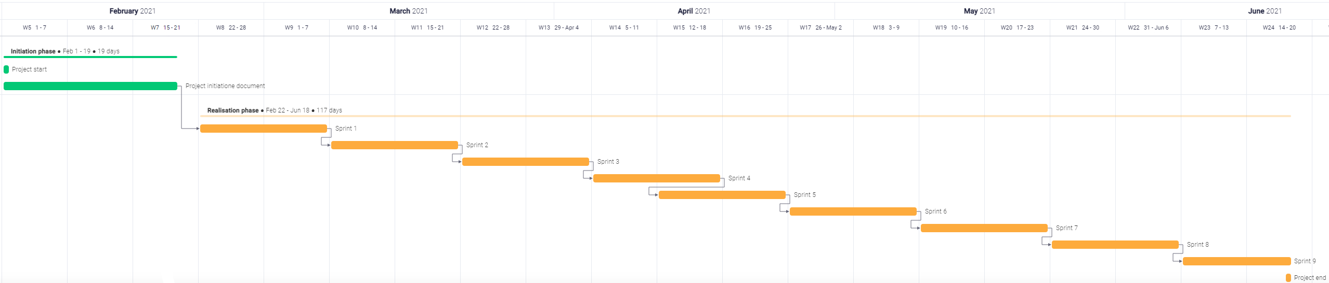The Gannt chart below is a visual representation of this project's planning.

Figure 7‑1: Gantt chart

## 

## Main phases

The project has two different phases. These phases will be the project initiation phase and the realisation phase.

### Project initiation phase

The project initiation phase encapsulates all the critical components to create the project's vision and describes how to turn that vision into a reality. The project group will make the first contact with stakeholders in this phase. This phase will also help team members to understand the why's, how's, and scope of the project.

Table 7‑1: Project initiation phase

|  |  |  |
| --- | --- | --- |
| **Start** | **End** | **What** |
| 1-2-2021 (Week 1) | 19-2-2021 (Week 3) | Project initiation document, Contact with stakeholders |

### Realisation phase

In the Realisation phase, the project's products will be researched, designed, build, and tested. The group will execute sprints in this phase; each sprint is two weeks. The work to be performed will be split and divided over all sprints in this phase. The group redistributes remaining work at the beginning of each sprint.

Table 7‑2: Realisation phase

|  |  |  |
| --- | --- | --- |
| **Start** | **End** | **What** |
| 22-2-2021 (Week 4) | 18-6-2021 (Week 19) | Research, design, build and test the Proof of concept |

## Milestones

The table below contains all the milestones of the project. The group will demo and hold a retrospective at the end of a sprint.

Table 7‑3: Project milestones

|  |  |  |
| --- | --- | --- |
| **Nr** | **Milestone** | **Date** |
| 1 | Hand in Project initiation document | 19-2-2021 (Week 3) |
| **2** | End of the project initiation phase | 19-2-2021 (Week 3) |
| **3** | End of sprint 1 | 7-3-2021 (Week 5) |
| **4** | End of sprint 2 | 21 -3-2021 (Week 7) |
| **5** | End of sprint 3 | 4-4-2021 (Week 9) |
| **6** | End of sprint 4 | 18-4-2021 (Week 11) |
| **7** | End of sprint 5 | 2-5-2021 (Week 13) |
| **8** | End of sprint 6 | 16-5-2021 (Week 15) |
| **9** | End of sprint 7 | 30-5-2021 (Week 17) |
| **10** | End of sprint 8 | 13-6-2021 (Week 19) |
| **11** | End of sprint 9 | 18-6-2021 (week 19) |
| **12** | End of the Realisation phase | 18-6-2021 (Week 19) |

# Personal learning goals

## Attending workshops

Windesheim offers several workshops students following the Security Engineering minor could attend. These workshops aim to provide additional information or skills that the group members could use during the project. Table 8-1 shows the workshops each project member will attend.

Table 8-1: Attending workshops

|  |  |  |  |  |
| --- | --- | --- | --- | --- |
| Sjoerd van de Kerkhof | Gerard Wesseling | Tim Imming | Thijs Mansveld | Berat Guzel |
| *Project management* | Project management | Project management | Project management | Project management |
| *Research Set-Up* | Research Set-Up | Research Set-Up | Research Set-Up | Research Set-Up |
| *Consultancy* | Consultancy | Consultancy | Consultancy | Consultancy |
| *Interview training* | Interview training | Interview training | Interview training | Interview training |
| *Presentation skills* | Design tinkering | SCRUM | Presentation skills | Presentation skills |
| *SCRUM* | Growth hacking |  | SCRUM | SCRUM |
|  |  |  | Strategy | Advanced SCRUM |
|  |  |  | Design thinking | Planning |
|  |  |  |  | Estimation & Business Value |

## Personal Learning goals

Each team member formulated two personal learning goals they want to achieve during this project. You can find These personal learning goals in the next paragraph.

### Thijs

**Creating synergy, "The whole is greater than the sum of the parts".**

During this project, I want to produce innovative solutions while maximising the utilisation of diverse knowledge from every project member. This project team contains individuals with different specialisations and every individual has their way of executing a project. This diversity can be a weakness when not managed properly, but I want to make this diversity our strength. At the end of this project, I want to be able to look back and see that the different working methods have merged into one encapsulating method suited for this project. That with this method, quality products to be proud of have been produced. Because this is the first project for me with a multidisciplinary team, I want to start learning how to use it to its full potential from the start.

**Keeping the saw sharp:**

During this project, I want to put time and effort into keeping motivation, energy, and school balanced. To achieve this goal, I want to spend more time on myself. This balance is disturbed as it results in either lack of energy or poor mental health and often both. Once I have achieved this balance, sustainable employment is achieved with it. To achieve this balance, I need to set boundaries for school hours; I will not do any school-related work on the weekends. With this boundary, I create an opportunity where I can de-stress and recharge for the upcoming week.

### Tim

**During the project, I want to learn to confront others when I feel the need, thus improving team members' trust.**

I find it hard to confront others during the project about behaviour that I dislike as I am sometimes worried it might be too harsh or cause unnecessary conflict. While following the personal leadership courses, I learned that trust is the most important factor within a team, determining all members' openness and honesty. Because I am the team manager, I want to use it during this project. By doing team building and other activities outside of the project (probably gaming), I want to build trust with all team members to improve the products we deliver.

**During the project, I want to learn to become better at decision making and worry less about the choices I make, thus improving the team's efficiency.**

I find making decisions hard most of the time. That is especially true when I do not know the outcome of choices and decide for multiple people. I want to become better at choosing and want to be less indecisive by making the choices faster and learning from the outcome. Supported by teammates' opinions, I will try to make the decisions quicker and be sure I have most of the team's support. Even when the decision has a negative outcome, the whole group agreed.

### Sjoerd

**I want to be more 'comfortable' with my own opinions and stand by them**When I disagree with someone, often, I would just accept their opinion and disregard my own. I am inclined to accept others' opinions because I am not always self-confident in my own opinion. That results in me having less input in the project. To prove this learning goal, I can show at the end of the semester; that at least five decisions were made by me after arguing with someone about it. I want to achieve this learning goal by the end of the project.

**I want to get better at receiving feedback.**Because I am not the most self-confident person, I want to be better at receiving feedback. Sometimes when someone gives feedback to me, I feel somewhat personally attacked. In this project, I want to change this. Instead of a personal attack, I want to think about feedback positively. That would allow me to improve myself more easily. To prove this learning goal, I can show that I have improved on feedback that my teammates gave me. I want to achieve this learning goal by the end of the project.

### Gerard

**I want to be less vocal in discussions.**

I have noticed that I have a strong/ sharp opinion in past discussions. That means I am always one of the people that argues the most. In this project, I want to do that less because I have observed that it takes away other people's chance to give their opinion on the matter. Most of the time, they have valid opinions or arguments on the subject. Unfortunately, this disappears to the background because other people, including myself, are just too vocal. That happens because I am passionate about the project, which is not bad. But it is a little bit if it stops other people from contributing to the conversation. At the end of the project, I will ask my team members to give me feedback on this subject. With this feedback, I can observe if I improved and accomplished my learning goal.

**I want to take more time to solve complex issues.**

That is an observation I made in past projects. That I take less time to design a solution for complex issues; this did not affect the result's quality. But it could increase how quickly I can solve a complex problem. I have started working on this a bit in my last project by writing pseudo code for algorithms. But in this project, I want to take this a step further while still using pseudo code techniques. I want to achieve this by writing pseudo code and designing more diagrams and other visual tools to accomplish the best solution. That could be a good asset in solving advanced matters like blockchain.

### Berat

**Begin with the end in mind.**

When I start a project, I already have specific objectives/actions to do before I can finish the project. Still, I never think about whether those objectives are beneficial to the project or not. Sometimes they are, but most times, they are unneeded. That is why I want to think about whether my action merits the project's end goal or not before actually performing those actions. At the end of this project, I will confidently say that I can comfortably work on a project while also keeping the end goal in mind for every action I perform.

**Do not be afraid of new or challenging things; embrace them.**

I have been quite unsure about my abilities as an ICT professional in the past, comparing myself with other people who are way more talented than I am. This weirdly enough made me afraid of trying different things to improve my perspective as an ICT professional, like not trying a foreign coding language. I was worried that I could not help others because of my inexperience. But I want to change that; when something new/challenging arises, I will do those things. I do not want to afraid of those; I want to embrace them and make them my own. My goal is to have tried new/challenging things to feel more confident about future projects at the end of this project.

# HBO-ICT competence compliance matrix

You can find the HBO-ICT competence compliance matrix in table 9-1. The matrix lists all the project products and correlated HBO-ICT competences.

Table 9-1: HBO-ICT Competence Matrix

|  |  |  |  |  |  |
| --- | --- | --- | --- | --- | --- |
| **Competence** | **Analyse** | **Advise** | **Design** | **Manage** | **Realise** |
| Project initiation document | **X** |  |  | **X** |  |
| Research report | **X** | **X** |  |  |  |
| Business case | **X** | **X** |  | **X** |  |
| Functional design | **X** | **X** | **X** |  |  |
| Technical design | **X** | **X** | **X** |  |  |
| Proof of Concept | **X** | **X** |  |  | **X** |
| Test plan/test report | **X** |  | **X** | **X** |  |
| Requirement analysis | **X** | **X** |  |  |  |

# Client expectations

You can find the client expectations in table 10-1. According to the product owner, the table lists rank the most important aspects of a successful project. Halfway through the project and end, the product owner is asked to review if these expectancies were met.

Table 10-1: Client expectations

|  |  |  |  |
| --- | --- | --- | --- |
| **What are the most important aspects of a successful project?** | **Expectations Priority (use unique numbers)** | **The client's halfway score** | **Client's final score** |
| Develop a working prototype of the project proposal (Lamb Weston service working with the sensors, blockchain, and supply chain) | 1 | Contour van engelachtig gezicht met effen opvulling | Contour van engelachtig gezicht met effen opvullingContour van verwarrend gezicht met effen opvullingContour van boos gezicht met effen opvulling |
| Making the use case solutions replicable | 2 | Contour van engelachtig gezicht met effen opvulling | Contour van engelachtig gezicht met effen opvullingContour van verwarrend gezicht met effen opvullingContour van boos gezicht met effen opvulling |
| Generic analysis of data-sharing technologies in the cold chain and a feasibility study. | 3 | Contour van engelachtig gezicht met effen opvulling | Contour van engelachtig gezicht met effen opvullingContour van verwarrend gezicht met effen opvullingContour van boos gezicht met effen opvulling |
| Overall score | | Contour van engelachtig gezicht met effen opvulling |  |

# References

|  |  |
| --- | --- |
| [1] | Lamb Weston, "Our Story," Lamb Weston, [Online]. Available: https://lambweston.eu/emea/about-us/our-story. [Accessed 17 March 2021]. |
| [2] | Lamb Weston, "Lamb Weston Meijer," Lamb Weston, [Online]. Available: https://www.linkedin.com/company/lamb-weston-meijer/. [Accessed 17 March 2021]. |
| [3] | Spark!, "Spark! Living lab supply chain 4.0," Spark! Living lab, 2020. [Online]. Available: https://sparklivinglab.nl/. [Accessed 7 2 2021]. |
| [4] | Wikipedia, "Cold chain," Wikipedia, 25 1 2021. [Online]. Available: https://en.wikipedia.org/wiki/Cold_chain. [Accessed 4 2 2021]. |
| [5] | wikipedia, "Service level agreement," wikipedia, 23 13 2020. [Online]. Available: https://en.wikipedia.org/wiki/Service-level_agreement. [Accessed 4 2 2021]. |

# Appendix

This document contains no annexes.