Please note: version is still in alpha-state.

Explanation GUI

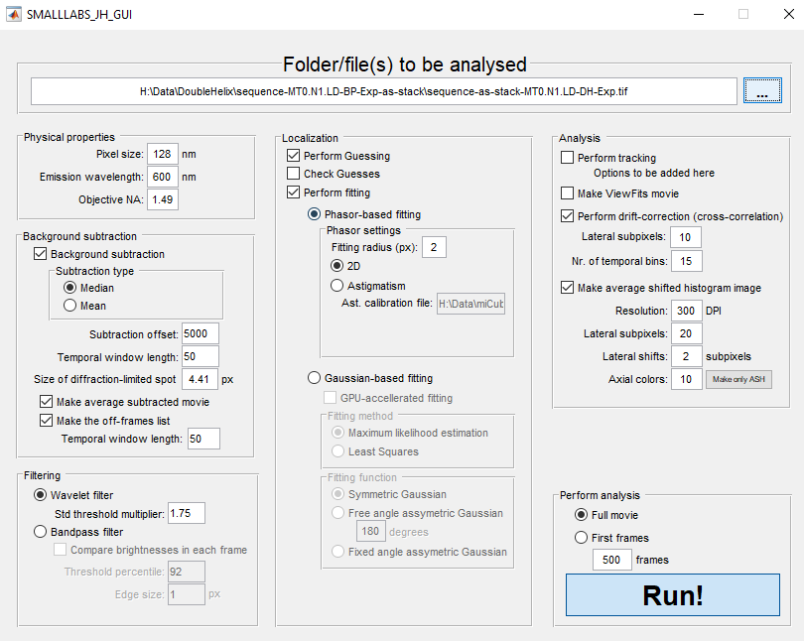

We’ve created a GUI to make using SMALL-LABS more user friendly.

Quick rundown

**Overall**

* In principle, the ‘Run’ button just calls SMALLLABS_main with all possible parameters. The value of all parameters is determined by the inputs in the GUI.
  + All added features can also be run without GUI
* During closing or running the GUI, all parameters are stored in .mat file (‘StoredSettings.mat’)
* During opening of the GUI, all parameters in StoredSettings.mat are loaded.

**Physical properties**

* User-defined pixel size, emission wavelength, and objective NA. Currently only has effects on size of diffraction-limited spot (calculated automatically upon editing) and scale-bar for average shifted histogram

**Background subtraction**

* I believe all options present in the normal SMALL-LABS software. All options work as expected

**Filtering**

* I’ve added a wavelet filter (B-Spline), taken from Ries’s software. I added this because this is our go-to filter in ThunderSTORM. I normally take a std threshold multiplier value of 1.5 – 2.
* Bandpass filter works as well

**Localization**

* Option to perform/check guesses
  + Checking guesses or performing fitting naturally doesn’t work if “Perform Guesses” isn’t selected. Still need write error message.
* Option to perform fitting
  + Gaussian-based fitting has all necessary options
    - Didn’t include parameters for deciding when it’s a ‘goodfit’
  + Added phasor fitting in 2D and 3D (astigmatism)
    - I normally take a radius of 2-3 pixels.
    - Same methodology as published (Martens et al., 2018, JCP)
    - Current required astigmatism calibration file needs to be created with ThunderSTORM (.yaml file) – will change this to matlab-based in the near future
    - If 3D is used, the ‘guesses’-structure will get another sub-structure: ‘zpos’ (alongside row, col). This gives the z-position in nm. Currently, this is not yet implemented for tracking, but is implemented for average-shifted-histogram

**Analysis**

* Tracking, making ViewFits movie work, but no parameters added yet in GUI (probably especially necessary for tracking, will do that before release)
* Drift-correction in 2D works via redundant cross-correlation (Wang, ... Huang et al., 2014, Optics Express)
  + Drift-correction also works in 3D, via non-redundant cross-correlation
  + Drift-corrected localization structure is saved as new .mat file
  + Subpixels = lateral zoom (default ~10)
  + Nr. of temporal bins = number of cross-correlations made (default ~10)
* Average shifted histogram can be made if wanted (same principle as in ThunderSTORM). It shows a sub-pixel-defined 2D average-shifted histogram, colour-coded on z-position (if available)
  + Resolution is for image saving (using fig_export; default ~300-600)
  + Lateral subpixels = optical zoom (default ~10-15)
  + Lateral shifts = size of xy shifts (needs some tweaking; default ~2)
  + Axial colours = ‘number of z-bins’ (default ~10-50).
  + Included a ‘Make only ASH’ button to only make the image. Will ask for an input file containing fitted results.

**Perform analysis**

* Basically only contains the ‘Run’ button, calling SMALLLABS_main.
* Has an option to only analyse the first X frames if you want to check some settings. It does however read the full TIFF or MAT file.