Machine Learning Engineer Nanodegree Capstone

Digit-Level House Number Recognition

Using Convolutional Neural Network

Peter Lai
October 31st, 2016

I. Definition

Overview
Vision-based recognition system is fundamental in building modern AI agent. Information in pixel is far more abundant than any other kinds of carriers. To teach computer to see is one of the coolest challenges nowadays. The most popular method people use in building a visual cognitive system is to train deep convolutional neural networks on various datasets.

In this project I will use the Street View House Number or SVHN datasets to build a natural digit recognition model using convolutional neural network. House number recognition is essential in automatic map making and intelligent travel technologies like self driving car. It can also be seen as an introduction to word-level text recognition and interpretations.

The data used in this project are images of cropped house number digits captured in daily street view. Detailed information on the datasets will be discussed in part II.

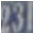
Problem Statement
This project will focus on the single digit recognition. Given a cropped part of a door plate, the model should be able to recognize what number it is (from 0-9). For example, for a cropped image like Fig. 1, the model will return 3 because 3 is center aligned in the image.

Fig. 1
The model can be represented as

d = argmax F(X)

Given a image X, model F should return a vector of probability, the prediction digit d is the index
where give the highest probability.

The ideal solution is obtained when d == y (the label) is satisfied for every image in the test set and a better solution is the one that makes more correct classification on the test set.

To obtain the solution, the strategy is to minimize the softmax cross entropy on the output of a convolutional neural network using Stochastic Gradient Descent. These can be easily implemented using Google’s open source deep learning framework, TensorFlow.

In TensorFlow, nodes have both forward-propagation and back-propagation functionalities. Loss function and iterative optimizer are provided as training agents in a computational graph, which holds all the nodes and operations in a network. All the data is flowing in these nodes according to the rules set by operations and simultaneously optimizing the parameters against the cross entropy.

An architecture worth trying is LeNet-5, the architecture is shown in Fig. 2. However, the SVHN data is more complicated, therefore increasing the convolutional layers’ depth might be necessary. In addition, the model’s output layer should be modified to be a softmax then argmax layer.

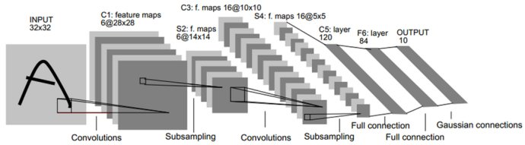
Fig. 2 (source: www.

Metrics
1. Accuracy (to maximize), is the ratio of how many labels the model correctly recognizes in the dataset.

2. Precision and Recall (to maximize), will be presented in a confusion matrix. For predictions pointing to a certain class, precision is the ratio of how many images that truly belong to this class. For images belong to a certain class, recall is the ratio of how many images that are successfully recognized. The confusion matrix for the problem looks like Table 1. In convenience, I just show the precision and recall for 0 and 3.

Prediction  Class | 0 | 1 | 2 | 3 | 4 | 5 | 6 | 7 | 8 | 9 | Recall
0 | 200 | 3 | 8 | 3 | 2 | 12 | 1 | 3 | 41 | 3 | 0.72
1 | 3 | * | * | 2 | * | * | * | * | * | * | *
2 | 5 | * | * | 1 | * | * | * | * | * | * | *
3 | 6 | 5 | 2 | 130 | 4 | 4 | 2 | 2 | 1 | 2 | 0.82
4 | 8 | * | * | 4 | * | * | * | * | * | * | *
5 | 3 | * | * | 6 | * | * | * | * | * | * | *
6 | 0 | * | * | 7 | * | * | * | * | * | * | *
7 | 2 | * | * | 0 | * | * | * | * | * | * | *
8 | 1 | * | * | 1 | * | * | * | * | * | * | *
9 | 3 | * | * | 3 | * | * | * | * | * | * | *
Precision | 0.87 | * | * | 0.83 | * | * | * | * | * | *

Table 1

3. Cross Entropy, also known as Softmax loss (to minimize) the loss function used in training, measuring how close the model is from the ideal model. The cross entropy can be represented as :

Cross_Entropy = (Σ_{i} ln(e^{F(x)(y)}/Σe^{F(x)}))/n

where i is the index for images, n is the number of images and F(x)(y) is the probability for the image X to belong to class y.
The cross entropy is not the a metric in evaluate the model. It is the method of calculating the loss in training.

II. Analysis

Data Exploration and Visualization

1. Data Format :
Data was downloaded from http://ufldl.stanford.edu/housenumbers/. The website has two
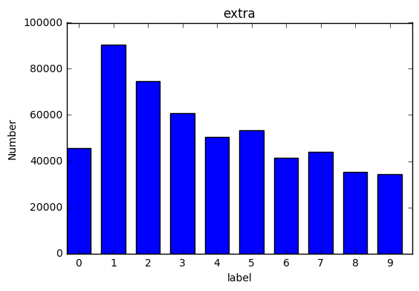
categories of data. The dataset used in this project was stored in .mat files, named as "train.mat", "test.mat" and "extra.mat". Two ndarrays will be returned by reading each file using Scipy.io.loadmat() function.

The first ndarray one (name it X) stands for the images, the second (name it y) contains the class labels correspond to X with 0 marked as 10 (MATLAB style).
X is of shape :
(pixel width, pixel height, number of channels, number of items)
y is of shape :
(number of items, )

Table 2 shows the number of images in each file.

File Name | train_32x32.mat | test_32x32.mat | extra_32x32.mat
Number of Record | 73257 | 26032 | 531131

Table 2
The images in this dataset is in same size 32x32x3, where 3 represent RGB channels.

2. Distribution :
In the Jupiter notebook model/preprocess_mat.ipynb, the first few cells will explore the data and plot the distributions of the class labels in all three datasets using function
peek_distribution in model/display_center.py

See Fig. 3.1, 3.2, 3.3 :
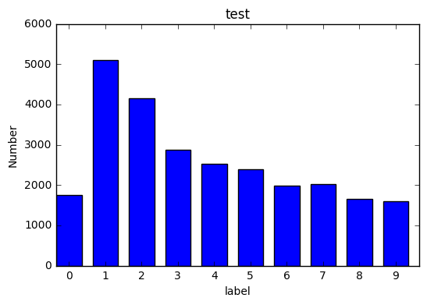
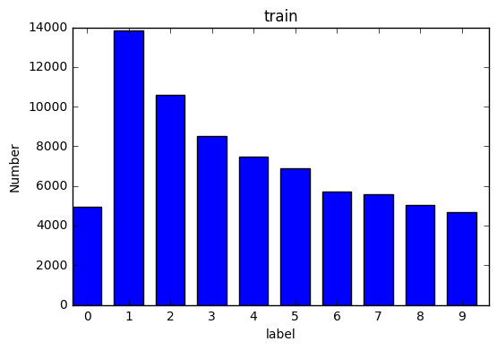

Fig. 3.3
Fig. 3.1
Fig. 3.2

Algorithms and Techniques

Frameworks and Tools

- The core scripts are presented in Jupyter Notebook using python.
- Scientific Computation & Visualization : Numpy, Matplotlib.
- scikit-learn: A machine learning library that implements classic machine learning algorithms.
- Tensorflow: This is a framework that help users to build computational graph with various kinds of nodes that have functionality of both forward and backward propagating computation, which make it easier to construct deep learning architecture.

Mathematics

- Convolution Neural Network

a. Feature Extractor
Convolution Neural Networks(Fukushima, 1980; LeCun et al., 1988) are neural networks that contain convolution layer. Intuitively, convolution layers are layers that divides a image into small pieces by a windows which moves both horizontally and vertically by a certain stride of pixels. Each piece is seen as a feature, for example, the sharp head of the letter ‘A’. Those feature, as group of pixel values, will then be dot product with a group of weight and become a value for the next layer. See Fig. 4
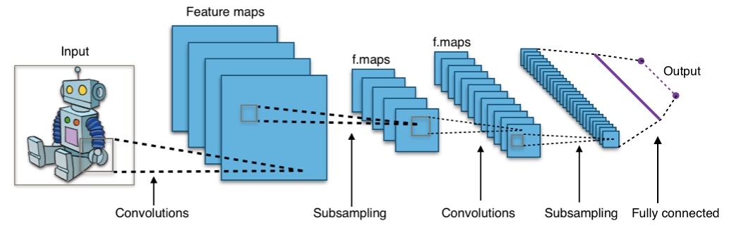
Fig. 4
source: https://en.wikipedia.org/wiki/Convolutional_neural_network#/media/File:Typical_cnn.png
the idea of convolutional neural networks is to extract features

b. Activation Function
Activation is an important step for neural network. It should stop the propagation when a neuron is not activated, which is simply whether the numbers is positive. There are lots of activation functions, like step, sigmoid and tanh, but most of them have various problems. In practice, people use rectified linear unit, ReLU right behind convolution. This unit or its improved version are popular because it’s easy to both forward-propagate and back-propagate. See Fig. 5, the blue line represents the rectified linear unit.
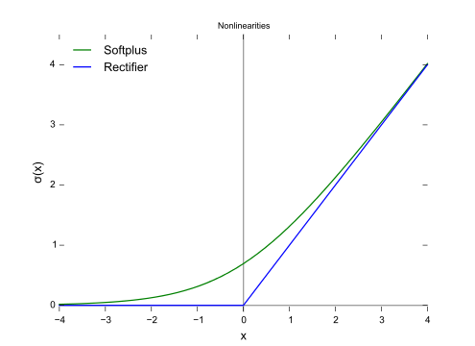
Fig. 5
https://en.wikipedia.org/wiki/Rectifier_(neural_networks)

c. Pooling and Connecting to Fully Connected Layers
Convolution layers gives output in unfriendly image like shape. Before taking it as the input to create one hot encoding vector, they should be flattened into stripe like vectors. But the output could be very large when images with many depths are flattened. Usually, people apply a method called pooling. Like feature extraction, a small window was moving horizontally and vertically on the image and simply take an average or maximum inside the window. Pooling can help reduce the number of weights to train in the architecture because pooling doesn’t need any parameter.

- Training

Training a deep neural network with convolution layers take more techniques than traditional fully connected neural networks. For me there are two basic ideas should be kept in mind: first is to make the information flow efficiently, second is when you are trying to go to the global minimum, adjust your pace according to the terrain.

a. Initialization of Weights
The rule “make it random small” no more applies to deep neural networks. This is very intuitive: if you make all the weights random small, when the information, or numbers are back-propagating, the minus power is accumulating, therefore the numbers could become zero when it arrive some deep neurons and stop the back-propagation, which means the upstream layers will never be trained. In this project, I simply increase the standard deviation of the distribution from upstream to downstream to avoid the issue.

b. Dropout
Dropout is to block the numbers flowing forward and backword in some neuron randomly. It can be seen as an ensemble technique, because in every step, only a part of the network is trained. However, dropout is not implemented in validation and test. It’s the equivalence to combine those partial model. And most of the cases, this technique will give more accuracy.

c. Stochastic Gradient Descent
When it comes to large dataset, it would be too heavy for computer to use all the data in one iteration. One solution is to use Stochastic Gradient Descent **** cite **** Basically, we take a mini batch of the dataset and feed it to the network. It may take more iteration for the model to converge, but in works in practice.

d. Update and Learning rate
Basically, the update space is a bowl shape with steep and smooth directions. In this project, I applied Adam update(Kingma and Ba, 2014), which make the update more on the steep direction.
In this project, exponential learning rate is applied.

- Logging and Visualization

In experiment, I simply use print function to dynamically see the numerical value of the loss and the accuracy.

When the model is satisfactory, I used Tensorflow built-in TensorBoard to visualize the architecture and the tracing the loss and accuracy.

III. Methodology

Data Preprocessing

I took roughly four steps to preprocess the data in model/preprocess_mat.ipynb :

1. Reshape the Data
The data is not friendly for Numpy, so I just made the index of items the first dimension.
The shape after this step:
(number of items, pixel width, pixel height, number of channels)
(number of items, 32, 32, 3)

2. Transfer the Images in Grayscale
Since the task is to recognize the digits’ profile, grayscale is enough. I applied mean grayscale in this project.

grayscale_val = (R + B + G) / 3

3. GCN the Images
Global contrast normalized the images. The approach I apply is the same as what this describes : http://dp.readthedocs.io/en/latest/preprocess/
For each image, I subtract the mean of the pixels’ gray scale. Then I divide every pixel by the standard deviation across the grayscale values.
After the GCN method, the data become zero-means and the values are scaled down.
Here is an example of a image before and after the GCN transformation:

before :
[[[ 33.66666667 19. 17. ..., 64.33333333 72. 75.66666667]
[ 34. 20.33333333 17. ..., 43. 59. 73.66666667]
[ 39.66666667 21.66666667 18.66666667 ..., 32.33333333 40.33333333 64.66666667]
...,
[ 80.66666667 80. 75.33333333 ..., 98.33333333 96.66666667 95.33333333]
[ 78. 79. 76.66666667 ..., 99. 98.66666667 98.66666667]
[ 80.33333333 81. 77. ..., 100.66666667 100. 96. ]]

after :
[[[-1.28437269 -1.91528671 -2.00132044 ..., 0.03481117 0.36460714 0.52233565]
[-1.27003373 -1.85793089 -2.00132044 ..., -0.88288195 -0.19461211 0.43630191]
[-1.0262715 -1.80057507 -1.92962567 ..., -1.34172851 -0.99759359 0.04915013]
...,
[ 0.73741997 0.70874206 0.50799669 ..., 1.49738459 1.42568981 1.36833399]
[ 0.62270833 0.6657252 0.56535251 ..., 1.5260625 1.51172354 1.51172354]
[ 0.72308102 0.75175893 0.57969147 ..., 1.59775727 1.56907936 1.3970119 ]]

before :
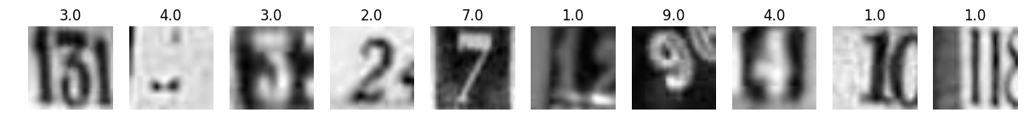

after :
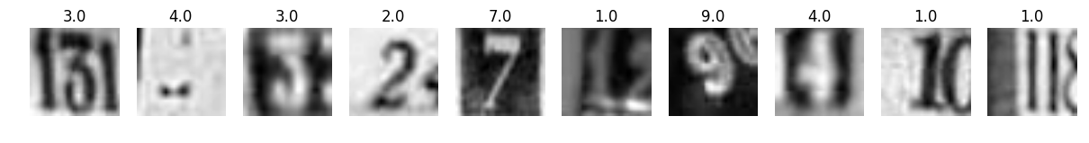

4. Collect a Normal Distributed Training Set and Validation Set
As the data exploration shown, real world data has more 1s and 2s than other numbers.
In training, the model should have equal chance to meet all ten labels. Therefore, I collect data from both train_32x32.mat and extra_32x32.mat to build my own training dataset of normal distribution. I also collect a normal distributed validation set, using the method shown in this paper

5. Shuffle the Data
I simply randomize the index and recollect the data.

Benchmark

A benchmark model I consider is the [ Conv. Maxout + dropout ] architecture used by Goodfellow et al.. Concretely, the model consists of three convolution & maxout layers and a fully connected maxout layer, followed by a fully connected softmax layer. The best accuracy on the test set the team achieved then was 97.53%. (link: https://arxiv.org/pdf/1302.4389v4.pdf)

Implementation

(Note: conv means conv followed by relu, fc means fully connected)

Due to hardware limitation, my strategy to gradually scale up my model from a single conv-fc
network.

In this project I use Stochastic Gradient Descent to do the update. I equally slice the shuffled dataset into mini batches and use them sequentially. The update strategy is Adam update
(Kingma and Ba, 2014).

The implementation workflow is shown in model/cnn_mat.ipynb

Refinement
Here are some architecture I’ve tried :

1. The Original Model :

IV. Result

Model Evaluation and Validation

Justification

V. Conclusion

Free-Form Visualization

Reflection

Improvement

