警示 《中山大学授予学士学位工作细则》第八条：“考试作弊者，不授予学士学位。”

------------以下为试题区域，共四道大题，总分100分,考生请在答题纸上作答------------

**一、概念题（共 10 小题，每小题 3 分，共 30 分）**

Please explain the following concepts or technologies in details on the meaning, functions, basic design idea and/or operations. （请详细解释以下概念或者技术的意思、功能、基本设计思想或者操作方法。）

1. ARP Protocol 2. BGP protocol 3. DHCP Protocol 4. CSMA/CA

5. DNS 6. HTTPS protocol 7. CDMA 8. Packet Switching

9. Congestion control 10. Protocol multiplexing and demutiplexing

**二、问答题（共 3 小题，1、2题各6分，3题9分，共 21 分）**

1. Please explain the design of the Ping program. 请解释Ping程序的设计。

2. Figure 1 shows a simple network consisting of two subnets interconnected by a router. The IP address and MAC Address are marked for each network interface. The subnet IP is 111.111.111.0/24 for the subnet on the left side, 222.222.222.0/24 for the subnet on the right side respectively. Suppose now the host 111.111.111.111 wants to send an IP datagram to the host 222.222.222.222. Please explain how each host or network component in the Figure 1 reacts to fulfill the above task. 图1显示了由一个路由器连接的2个子网形成的网络。它标志了每个网络接口的IP地址和MAC地址。111.111.111.0/24 子网在左边，222.222.222.0/24 在右边。现在假设主机111.111.111.111 要发送IP数据包给主机222.222.222.222。 请解释图1中的每个主机或者网络设备如何工作以完成前续任务。

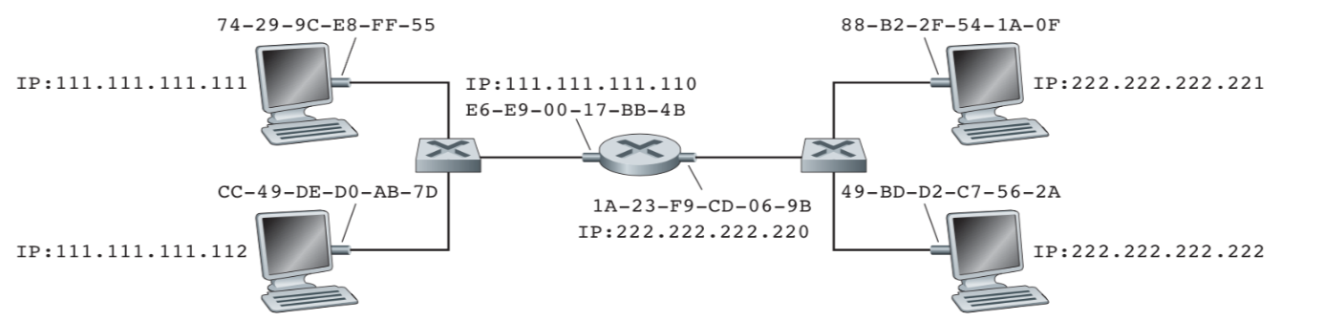

Figure 1 Two subnets interconnected by a router （图 1 由一个路由器连接的2个子网）

3. Consider the following plot of TCP congestion window size as a function of time. (20 points)。Assuming TCP Reno is the protocol experiencing the behavior below. Answer the following questions （**In all cases, you should provide a short discussion justifying your answer!）** 下图是TCP阻塞窗口大小随时间变化的函数。假设此图采用TCP Reno 版本。 请回答以下问题（对所有问题的回答都应该提供简单的讨论以说明回答的正确性。

Figure 2 Evolution of TCP's congestion window 图 2 TCP阻塞窗口大小的变化

* 1. Identify the intervals of time when TCP slow start is operating. 找出TCP 处于慢启动的时间段；(1分)
  2. Identify the intervals of time when TCP congestion avoidance is operating. 找出TCP 处于阻塞避免的时间段；(1分)
  3. After 13th transmission round, is a segment loss detected by a triple duplicate ACKs or by a timeout? 在第13发送阶段，丢包是由3个重复ACKs还是一个计时到触发检测到的？ (1分)
  4. After 22th transmission round, is a segment loss detected by a triple duplicate ACK or by a timeout? 在第22发送阶段，丢包是由3个重复ACKs还是一个计时到触发检测到的？(1分)
  5. What is the Threshold value at the 20th retransmission round? 在第20发送阶段，Threshold值是多少？(1分)
  6. What is the Congestion-window size at the 20th retransmission round? 在第20发送阶段，Congestion-window大小是多少？ (1分)
  7. What is the Threshold value at the 28th retransmission round? 在第28发送阶段，Threshold值是多少？(1分)
  8. During what transmission round is the 70th segment sent?第70个数据段是在第几个发送阶段发送出去的？ (2分)

**三、计算、解释题（共 4 小题，每题6分，共 24 分）**

1. Consider a router that interconnects four subnets: Subnet 1, Subnet 2, Subnet 3, and Subnet 4. Suppose all interfaces in each of these four subnets are required to have the IP subnet prefix 222.200.192.0/18. Also suppose that Subnet 1 and Subnet 2 are each required to support up to 2000 interfaces, and Subnet 3 and Subnet 4 are each required to support up to 1000 interfaces. Provide four network addresses (of the form a.b.c.d/x) that satisfy these constraints. 假设一个路由器将Subnet 1, Subnet 2, Subnet 3, 和Subnet 4四个互联网子网连接起来。这四个子网的所有网络接口都必须设置成互联网的前缀IP地址222.200.192.0/18。 假设子网Subnet 1 和 Subnet 2需要支持最多2000个网络接口，子网Subnet 3 和Subnet 4 需要支持最多1000个网络接口。 请设计这4个子网的IP地址（采用a.b.c.d/x格式）满足以上要求。

2. Consider the following network topology in Figure 3. With the indicated link costs, use Dijkstra’s shortest-path algorithm to compute the shortest path from x to all network nodes. Show how the algorithm works. 图3是一个网络拓扑图，每个链路的权重如图所示。请采用Dijkstra最短路径算法计算从节点x到所有的节点的最短路径。请提供计算过程。

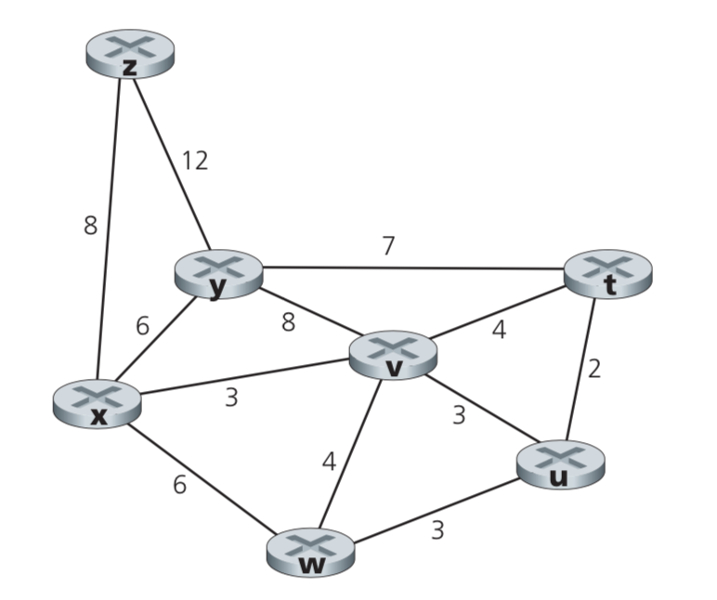

Figure 3 A network topology 图 3：一个网络拓扑图

3. Consider a CRC code using a 6-bit generator, G=111011, and suppose that D has the value 11101010101. What is the value of R? Please show how you get the result. 考虑采用6位生成器（G=111011）的CRC码。 给定一个D值11101010101， 请计算其R值并展示计算过程。

4. Consider a network shown below in Figure 4. Suppose AS3 and AS2 are running OSPF for their intra-AS routing protocol. Suppose AS1 and AS4 are running RIP for their intra-AS routing protocol. Suppose eBGP and iBGP are used for the inter-AS routing protocol. Initially suppose there is no physical link between AS2 and AS4. Please answer following questions：请看图4所示部分互联网络拓扑图。假设AS3和AS2自治系统内运行OSPF路由协议， AS1和AS4自治系统内运行RIP协议。 自治系统间的路由协议采用BGP（包括eBGP 和 iBGP）。 假设AS2和AS4之间没有直接相连的物理链路。 请回答以下问题：

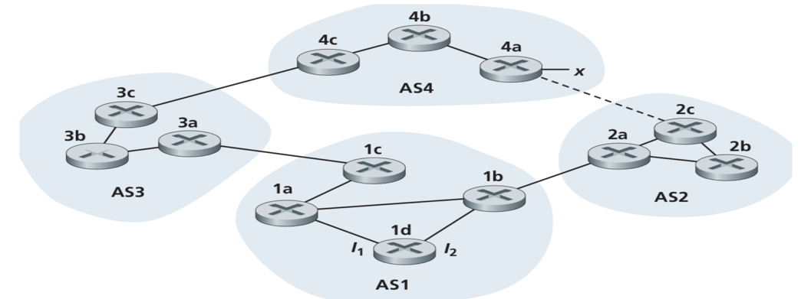

Figure 4 An interconnect network topology （图 4 一个互联网络拓扑图）。

1. Router 3c learns about prefix x from which routing protocol: OSPF, RIP, eBGP, or iBGP?

3c 路由器采用以下哪个路由协议获得子网x的可到达信息？

1. Router 3a learns about x from which routing protocol?

3a 路由器采用哪个路由协议获得子网x的可到达信息？

1. Router 1c learns about x from which routing protocol?

1c 路由器采用哪个路由协议获得子网x的可到达信息？

1. Router 1d learns about x from which routing protocol?

1d 路由器采用哪个路由协议获得子网x的可到达信息？

**四、综合题（共 3 小题，1~2 小题 各 8 分，3小题 9分，共 25 分）**

1.5CM

The next version of the Hypertext Transfer Protocol (HTTP) is likely to use UDP as the transport layer. The IETF is creating a version of HTTP (Http3.0) that uses QUIC ("Quick UDP Internet Connections."), previously referred as HTTP-over-QUIC or HTTP/QUIC. Please answer the following questions for the design of the new HTTP protocol. 下一版本的HTTP协议有可能采用UDP作为传输层协议。 IETF正在建立一个采用QUIC（快速UDP互联网连接）的新版本HTTP (Http3.0)，此前也称为HTTP-over-QUIC 或者 HTTP/QUIC。 请就此新HTTP协议的设计回答以下问题：

1. What are the advantages if Http3.0 uses UDP instead of TCP as the transport layer?

如果Http3.0采用UDP而非TCP作为传输层协议，它将有什么优点？

1. What are disadvantages if Http3.0 uses UDP instead if TCP as the transport layer?

如果Http3.0采用UDP而非TCP作为传输层协议，它将有什么缺点？

3. Please explain in sufficient details the additional design items that must be done for Http3.0 if it uses UDP as the transport layer.

如果Http3.0采用UDP作为传输层协议，请提供足够详细的描述说明Http3.0必须增加的相关设计项。