- Security: we should make sure all the data we have is properly secured. For example, RLS settings in Supabase should be configured. Also, we need to take retroactive actions to prevent any attacks.

- How is the selection of questions (flags) in the onboarding done? The same set of flags for everyone, or does it vary from one person to another? When I did onboarding, one of the questions had only 2 options instead of 4.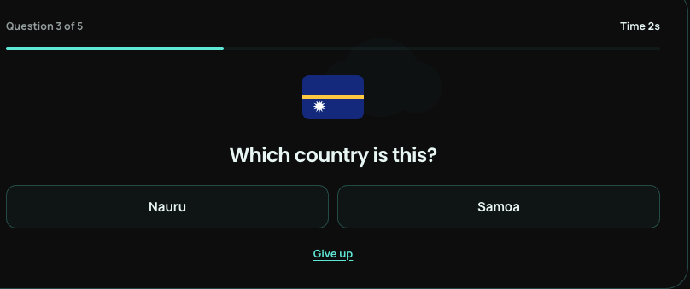

- NFC tags: let’s create 2-3 services and order NFC tags for them so we can test.

- Sitemap for Google Search Console. We need to create one with the tabs we have on the landing page, so we can upload it to the Google Search Console.

- The box looks empty; what if we show some daily tasks like “Log in every day and play the daily game to get 20 points” or “Complete your profile to get 50 points”, or “Invite a friend to get 100 points”. They should appear one by one and change like every 15 secs. The text size should be big enough and fit the box size. Let’s make sure the backend is properly configured for this.
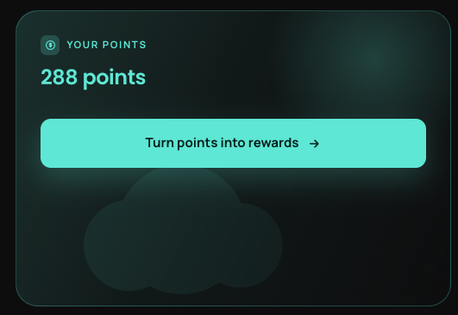

- Let’s name the big one a “Daily game” which will rotate every day. After that, all the games, including the “daily game”. Let’s put Bird Flight on top (let’s rename " Squawk’s Flight ", cuz the word seems too hard to pronounce), and Memory Match. Another note: if the user is registered in Uzbekistan, we need to show him “ World Builder - English and Russian” no need to show Polish one.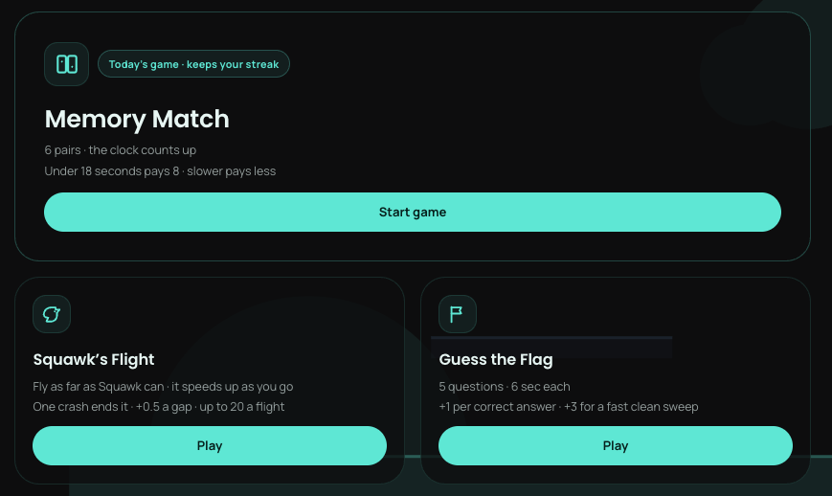

- Let’s just leave “My country” and “Everyone” filters in the leaderboard.


- We need to make sure the service logos display properly. We might need to upload them into the database in a proper format.

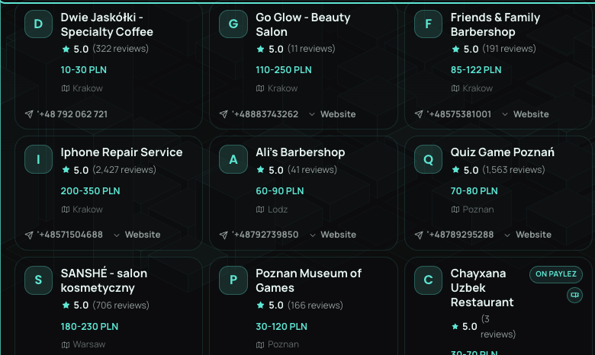

- Let’s clarify where the data comes from and how often it refreshes. I have this file where we have live exchange rates: Exchange rates. We can connect it to Supabase so the data refreshes at least twice a day. Not sure how much of integrations credits we might need for this; let’s clarify this as well.

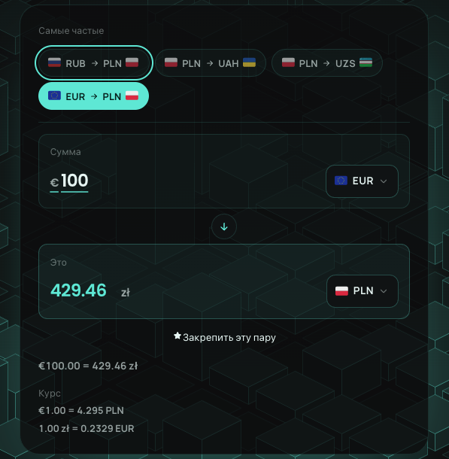

- Two things here: First, let’s put a “Back to Paylez” button in the top-left corner and change the font color so it is more visible. Second, make sure one sentence sits on one line, so it should be

Yangi davlat.
Yusta savol.
Bitta yo‘riqnoma.

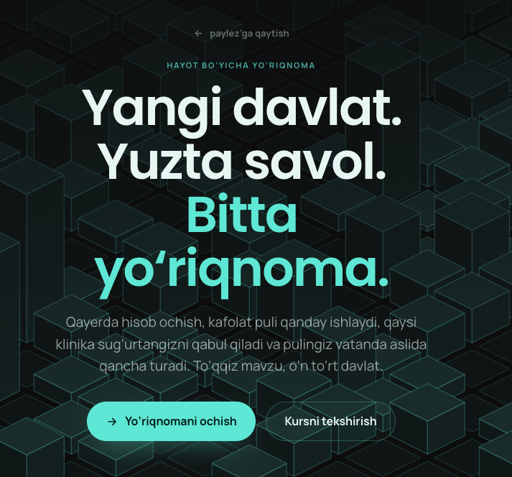
- Let’s add an unhide password button

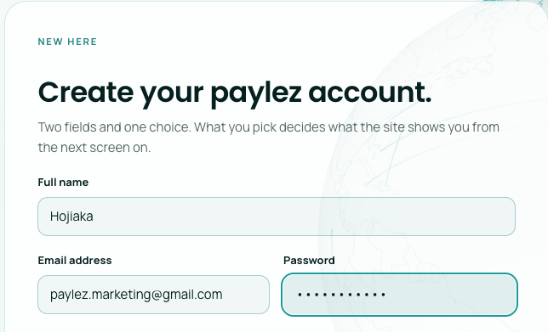

- Don’t we have OTP verification for new users? I think we need to add that; no matter what type of email is used Gmail or iCloud- we should have OTP verification.

- Make “show me on the leaderboard” active by default; everyone should be visible.

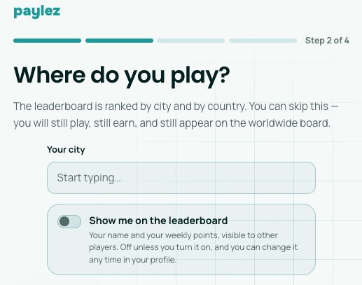

- Make sure the game and options are available in the language that was chosen by the user

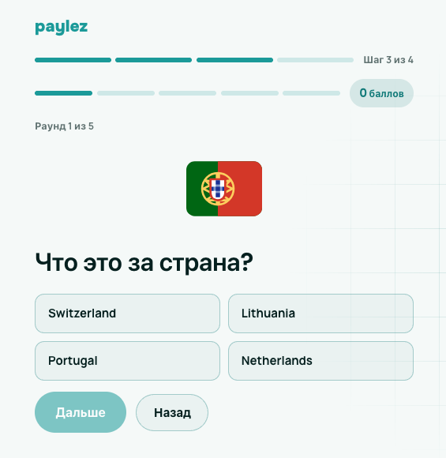

- “Сначала заполните профиль” button does not work. Let’s just leave two buttons: “ Start playing” and “ Complete profile”. Also mention that we give 50 points for completing the profile.

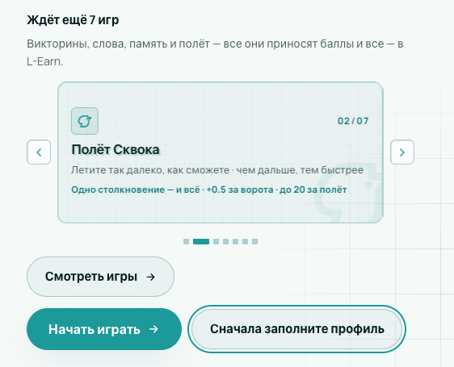

- We need to ask the user to agree to our terms and conditions somewhere before we let him sign up.

- Sharing the profile with the service should be active by default; no need to ask the user to activate it.
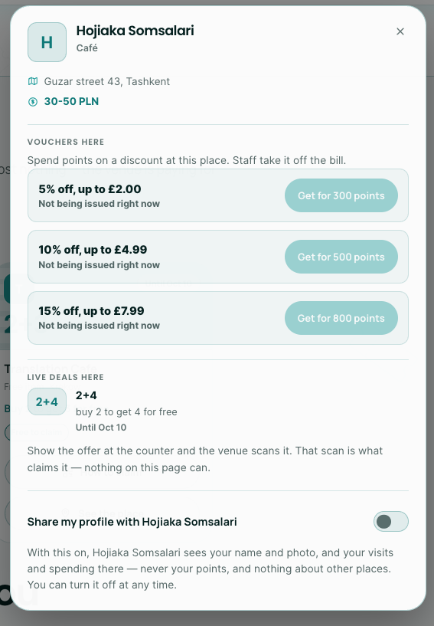

- Even though another language is chosen, the games are in English; all translations are available in the “quiz_items” entity in Supabase.
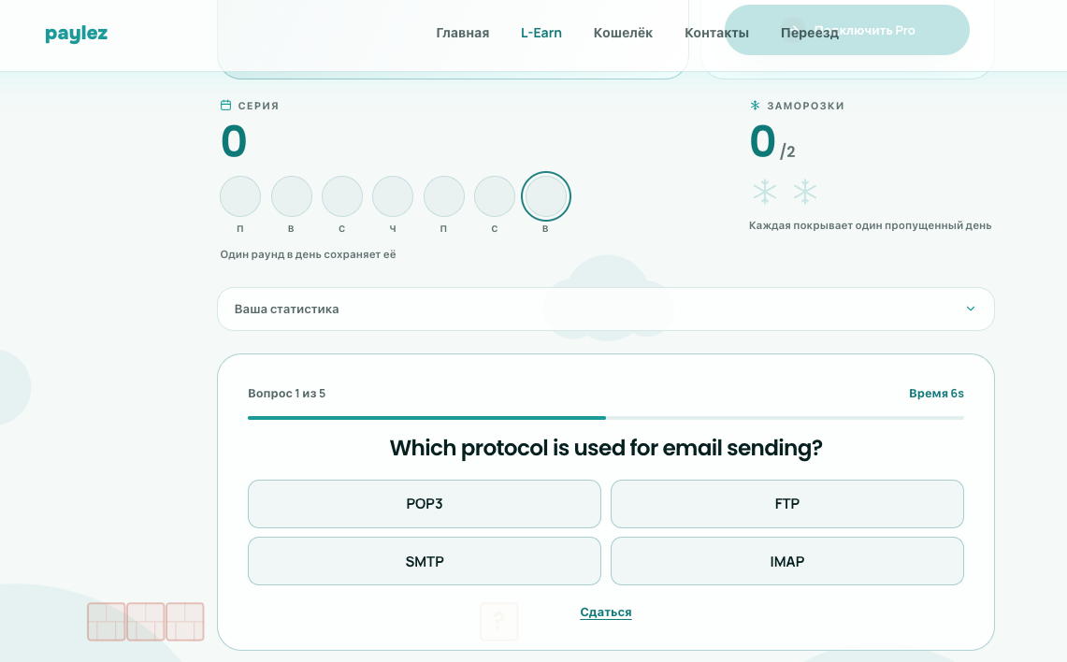

- Word builder database looks empty. Check the “word_bank” entity in Supabase; I can share the dataset if needed.

- Text does not fit the size of the sidebar
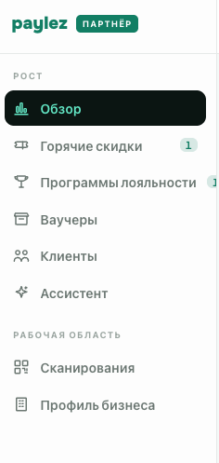

- We need to create a separate folder filter for currency; the language selector should not affect the currency.
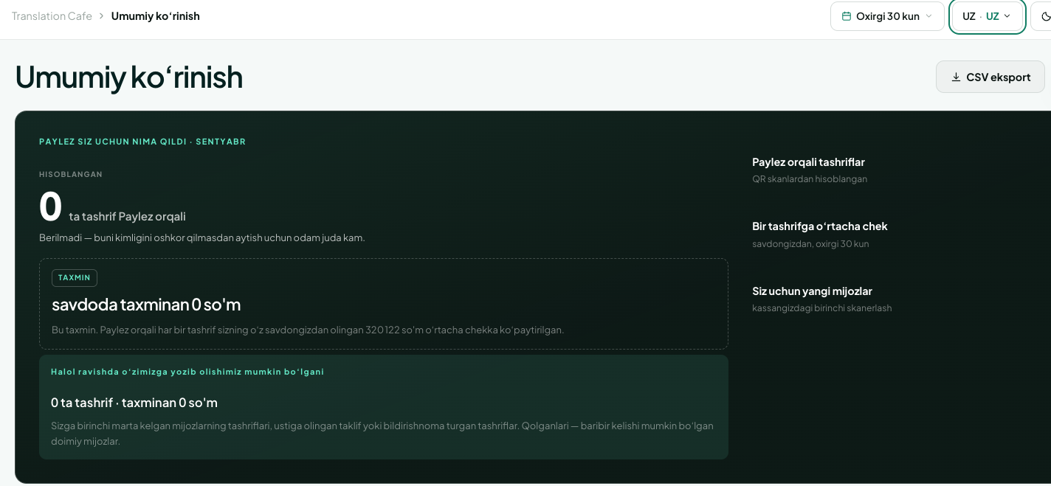
- There is no limit on voucher redemptions, which is not correct; the list of vouchers is not being shown to the partner in the dashboard. Let’s discuss this on a call. We will need to add one more page in the dashboard.

- Formatting seems off here
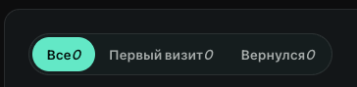

- We need to be able to control which subscription tier to give to our partners and users from the admin page.

- Let’s add subscription plan info and options where he can check and compare plans for the business partner in business profile page. This info should be also accessable when partner clicks on this box.
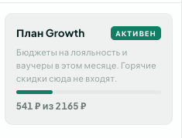

- Let’s update the style of the table in light mode; it seems too greyish. On the Hot Deals page. Borders are barely visible.
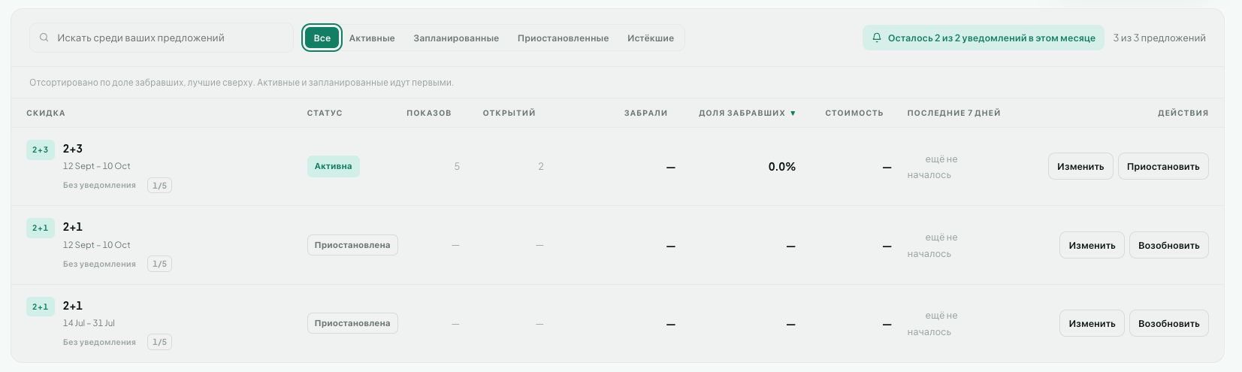

Instead, let’s make it like this
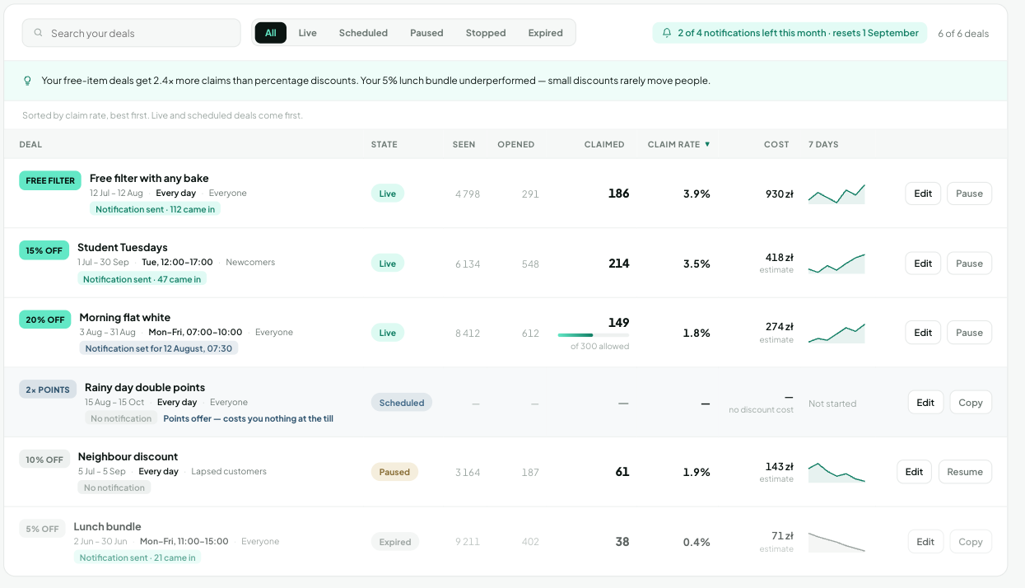

Creating hot deal, campaigns side bars have same issue, too greyish, where borders are not clearly visible.
