- Security: we should make sure all the data we have is properly secured. For example, RLS settings in Supabase should be configured. Also, we need to take retroactive actions to prevent any attacks. (BACKEND)

- NFC tags: let’s create 2-3 services and order NFC tags for them so we can test.
(BACKEND)

- When the voucher is redeemed, the notification is sent to the manager or staff, depending on whether there is a device or not (includes all the info) (BACKEND)

- Send the invite link to email only when you add a new staff member (BACKEND)

- Google sign-in should be fixed (requires clicking it twice before it proceeds) (BACKEND)

- New games to be built (Candy Crush, Zuma, snake game, bounce ball, food ninja, doodle jump, 2048, canon numbers) - priority order: 2048, Food Cross (Candy Crush), Food Ninja (BACKEND)

- Referral system logic refinement. Make sure it works across all devices (desktop, mobile) (BACKEND)

- Push notifications (BACKEND)

- Earning points refinement (MIRKHAKIM)

- Gift card engine and management tool, let’s build this in the admin page (BACKEND)

- AI integration so our assistants work properly (BACKEND)

- Partner subscription tiers + model (MIRKHAKIM)

- Sitemap for Google Search Console. We need to create one with the tabs we have on the landing page, so we can upload it to the Google Search Console. (BACKEND)

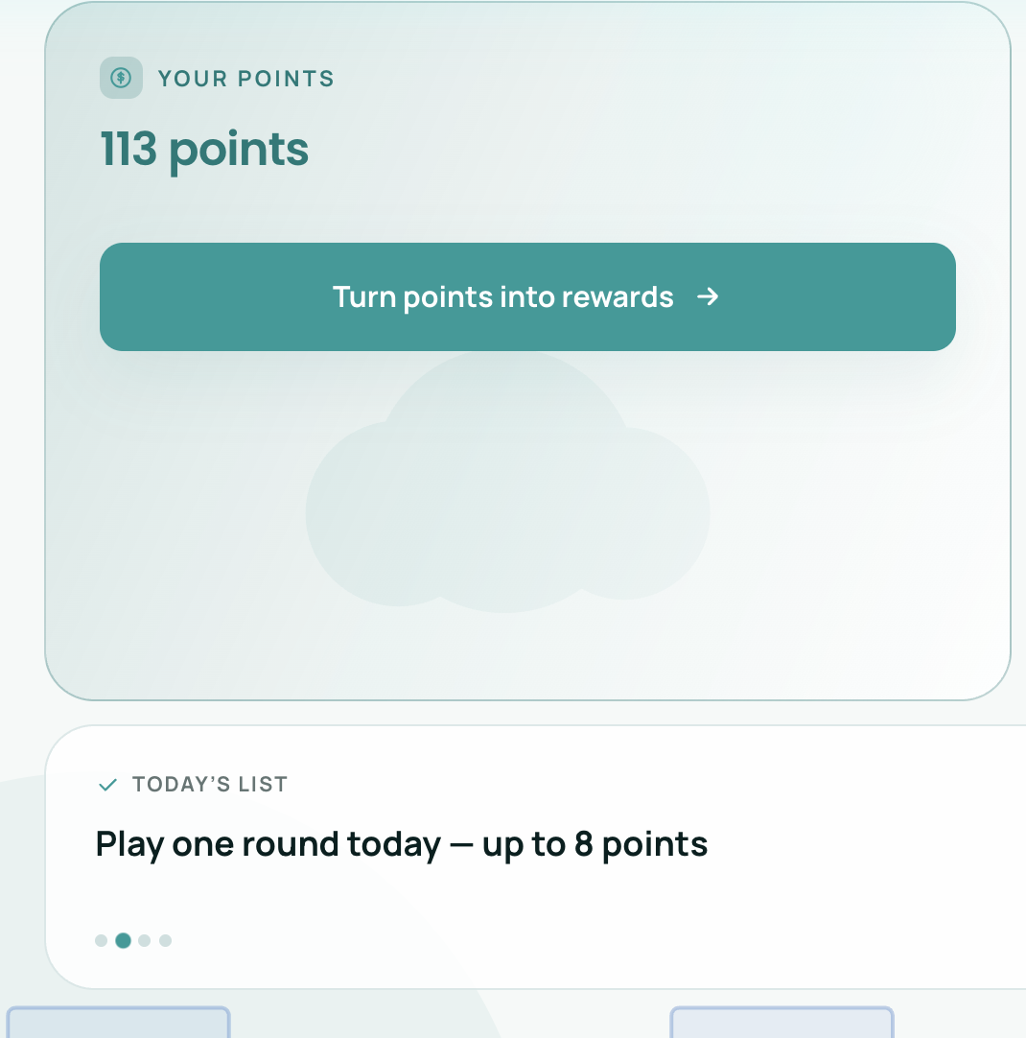
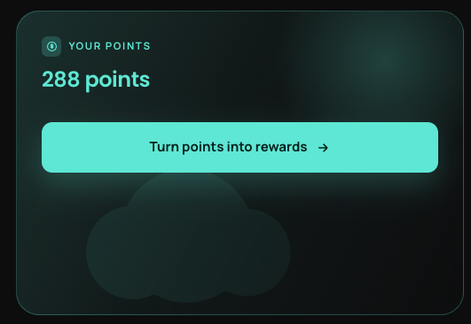
- No need to create a separate box like “Today’s list.” Those reminders should be inside “Your points” box. The box looks empty; what if we show some daily tasks like “Log in every day and play the daily game to get 20 points” or “Complete your profile to get 50 points”, or “Invite a friend to get 100 points”. They should appear one by one and change like every 15 secs. The text size should be big enough and fit the box size. Let’s make sure the backend is properly configured for this.

- Let’s rename “brain games” into “Play & Earn”(DONE)
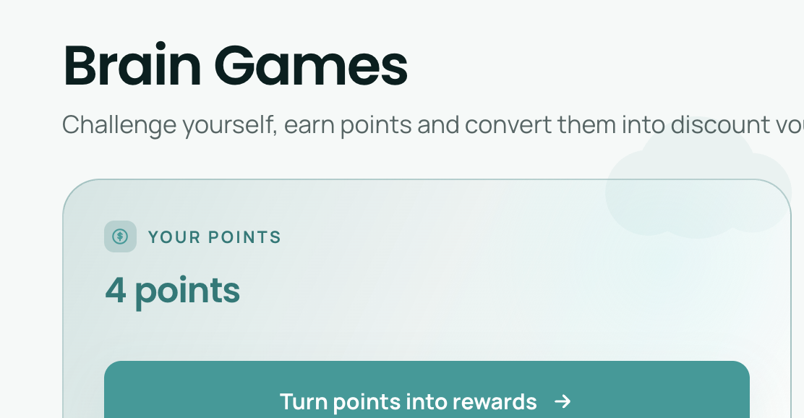

- When you hover over the game card, some of them don’t fit the size of the box; can we fix it somehow? I think when it is hovered we can remove the game icon and and “Daily game…” text, this should fix our problem.(DONE)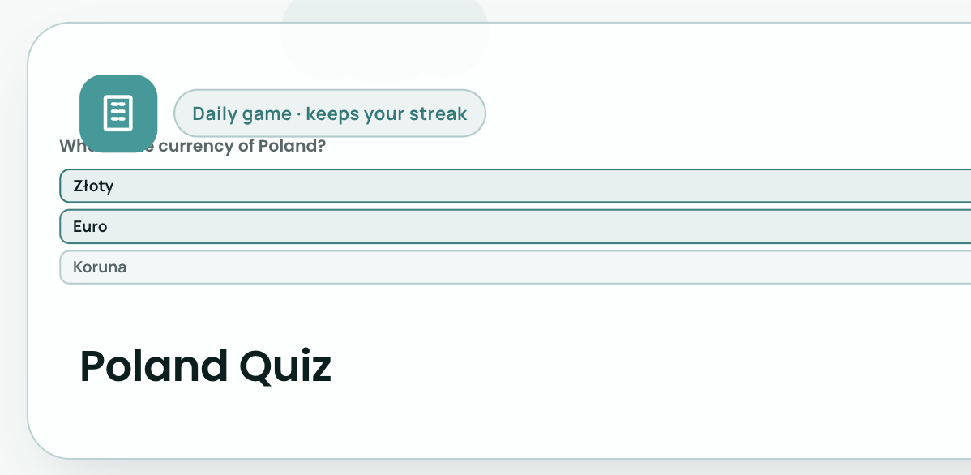

- We need to make sure the service logos display properly. We might need to upload them into the database in a proper format. (BACKEND)

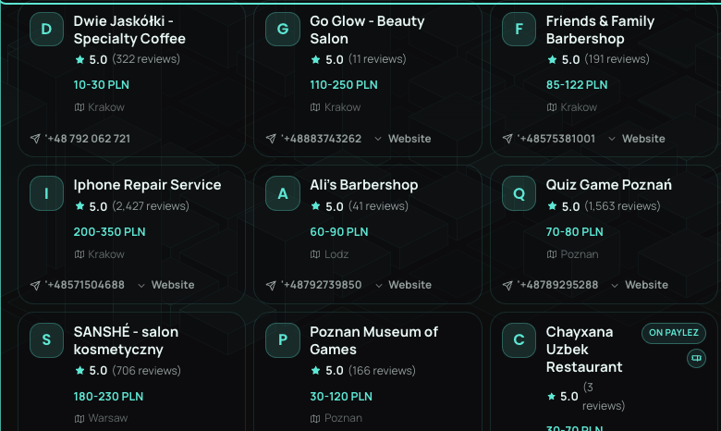

- Let’s clarify where the data comes from and how often it refreshes. I have this file where we have live exchange rates: Exchange rates. We can connect it to Supabase so the data refreshes at least twice a day. Not sure how much of integrations credits we might need for this; let’s clarify this as well. (BACKEND)

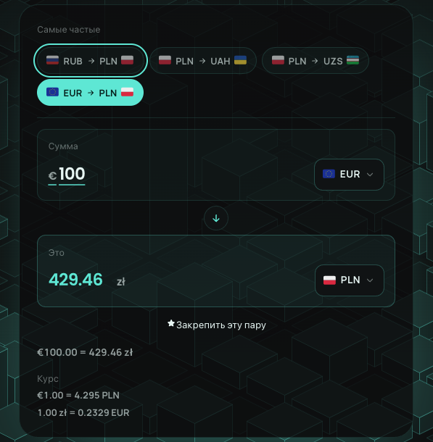

- Don’t we have OTP verification for new users? I think we need to add that; no matter what type of email is used Gmail or iCloud- we should have OTP verification. (BACKEND)

- Make sure the game and options are available in the language that was chosen by the user. IS IT FIXED? COULDN’T VERIFY ON MY OWN (DONE)

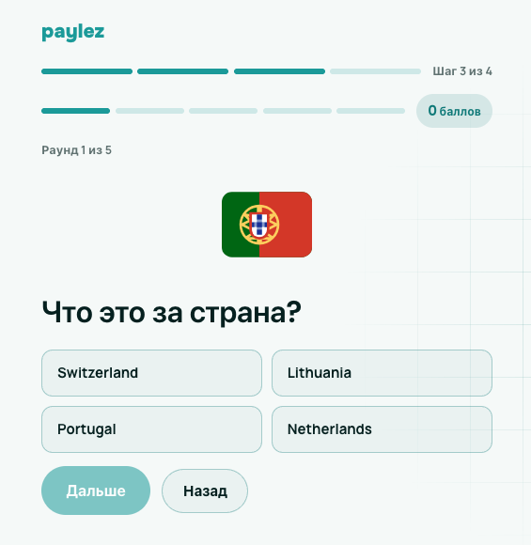

- “Сначала заполните профиль” button does not work. Let’s just leave two buttons: “ Start playing” and “ Complete profile”. Also mention that we give 50 points for completing the profile. IS IT FIXED? COULDN’T VERIFY ON MY OWN (DONE)

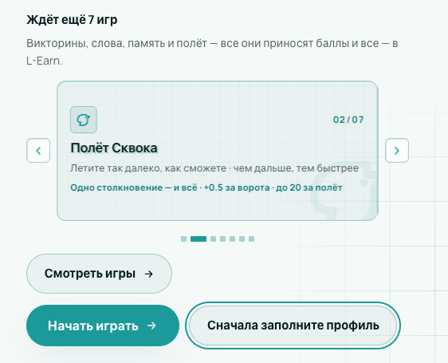

- We need to ask the user to agree to our terms and conditions somewhere before we let him sign up. IS IT FIXED? COULDN’T VERIFY ON MY OWN (DONE)

- Sharing the profile with the service should be active by default; no need to ask the user to activate it. (DONE)
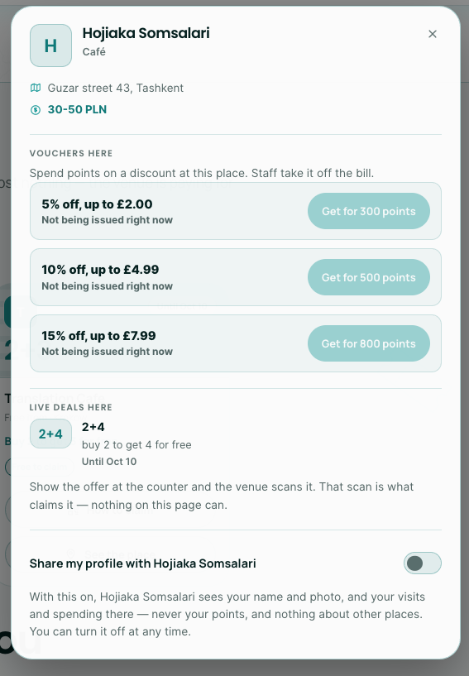

- Most of the games are corrected, but the world builder is still not fully correct.(DONE)
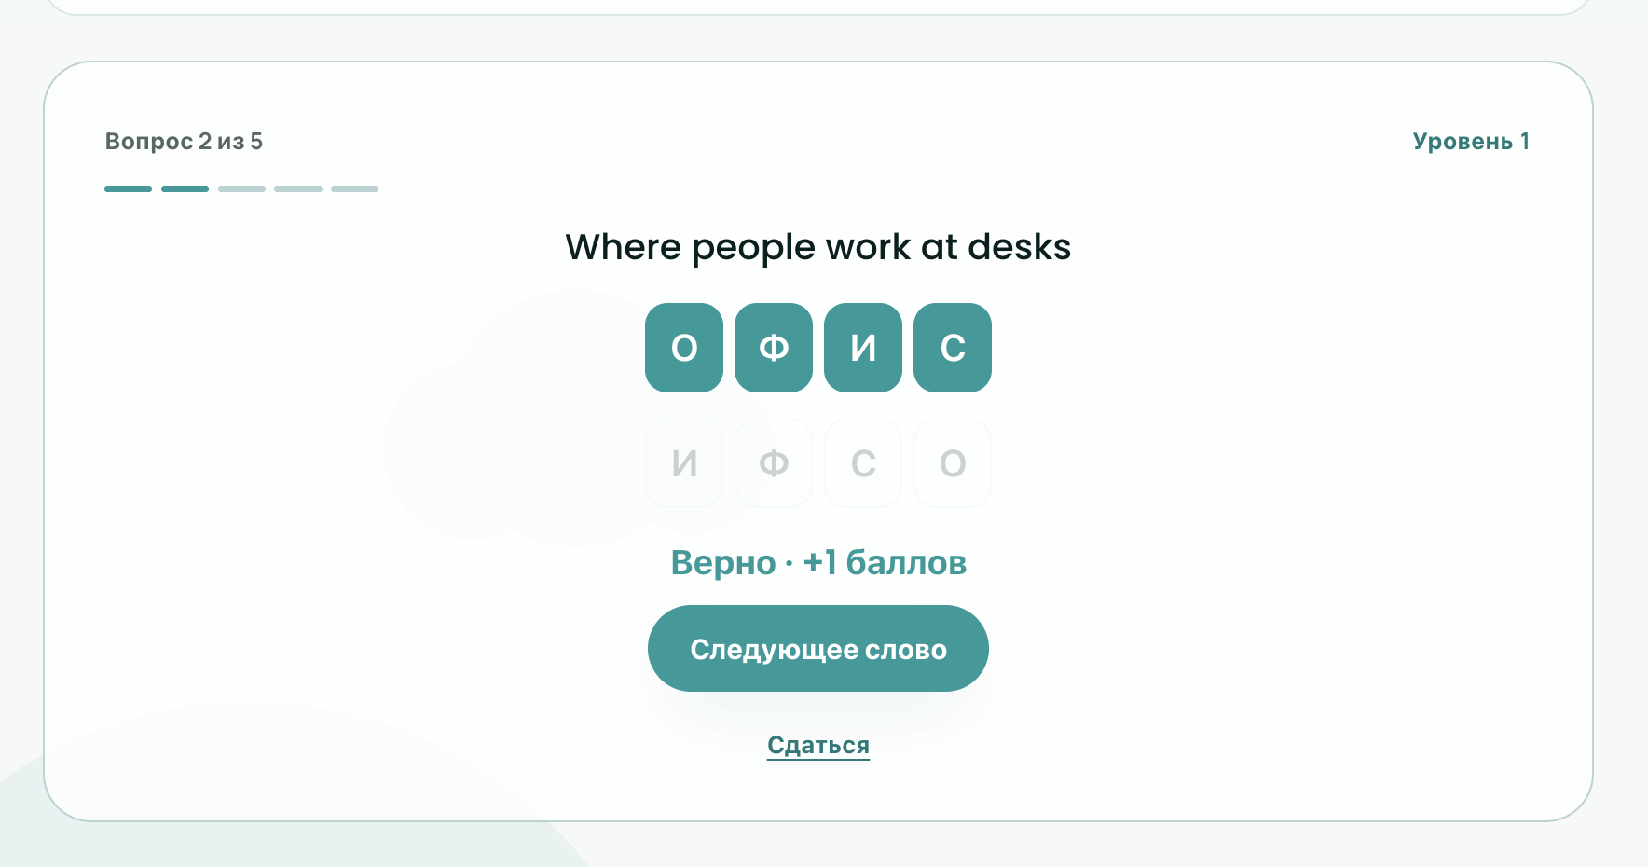

- We don’t need a currency filter on all pages; we can just leave it in the dashboard and remove the rest. (DONE)

- There is no limit on voucher redemptions, which is not correct; the list of vouchers is not being shown to the partner in the dashboard. Let’s discuss this on a call. We will need to add one more page in the dashboard.(BACKEND)

- Let’s rename this to “Birds Flight” (DONE)
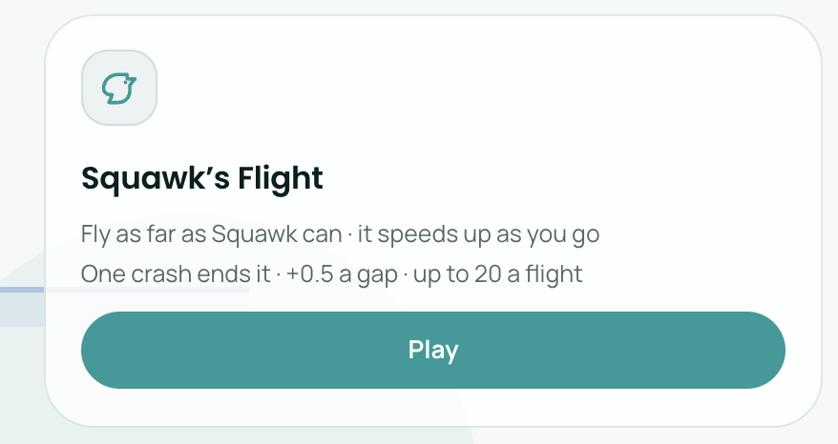

- The dashboard design has been completely changed; please use the design I have built for reference.

- Let’s update the header names and order when no one is signed in: we can hide the “Contact” page, which can be accessed via the “Support” button in the footer.(DONE)
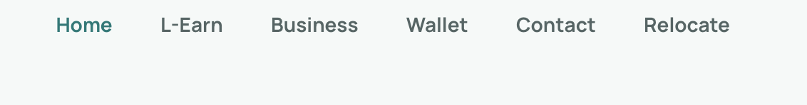
- Home
- Business
- L-earn => Earn
- Wallet
- Relocate

When signed in as a user:
Everything stays as is; just rename “L-earn” to “Earn”


When signed in as a partner:
- Business
- Analytics
- Contact
The rest you can hide and not show to partners (DONE)

- Instead of “talk to sales”, let’s say “Become a partner” When the user clicks on it, he should be directed to the sign-up page (no need to ask him to choose between “individual” or “business” in this case, as we do for all other users when they just click the sign-in button. (DONE)
