**Gemini**

The CSS box model represents each element as a box composed of four parts:

1. **Content:** The area containing the element's actual content (text, images, etc.).
2. **Padding:** The space between the content and the border.
3. **Border:** The outline surrounding the content and padding.
4. **Margin:** The space outside the border, separating the element from other elements.

**Understanding the Box Model:**

---------------------------------------

| Margin (Outer) |

---------------------------------------

| Padding (Space around content) |

---------------------------------------

| Border (Outline) |

---------------------------------------

| Content (Actual content) |

---------------------------------------

**Example HTML Layout**

HTML

<!DOCTYPE html>

<html>

<head>

<title>Box Model Example</title>

<style>

.box {

width: 200px;

height: 200px;

border: 2px solid black;

padding: 20px;

margin: 20px;

background-color: lightblue;

}

</style>

</head>

<body>

<div class="box"></div>

</body>

</html>

Use code [with caution.](/faq#coding)

**Explanation:**

* The .box class defines a div element with a width, height, border, padding, margin, and background color.
* The width and height properties set the dimensions of the content box.
* The border property creates a 2-pixel solid black border around the content and padding.
* The padding property adds a 20-pixel space between the content and the border.
* The margin property creates a 20-pixel space between the border of this element and the surrounding elements.

**Visual Examples**

**Changing Padding:**

[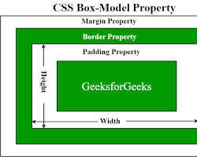Opens in a new window [](https://www.geeksforgeeks.org/css-box-model/)www.geeksforgeeks.org](https://www.geeksforgeeks.org/css-box-model/)

box with increasing padding values

**Changing Margin:**

[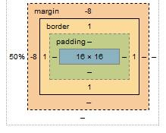Opens in a new window [](https://stackoverflow.com/questions/11495200/how-do-negative-margins-in-css-work-and-why-is-margin-top-5-margin-bottom5)stackoverflow.com](https://stackoverflow.com/questions/11495200/how-do-negative-margins-in-css-work-and-why-is-margin-top-5-margin-bottom5)

box with increasing margin values

**Changing Border:**

[Opens in a new window [](https://www.brucebrotherton.com/blog/box-model-borders/)www.brucebrotherton.com](https://www.brucebrotherton.com/blog/box-model-borders/)

box with different border styles, widths, and colors

By understanding and manipulating the components of the box model, you can effectively control the layout and spacing of elements on your web pages.