Embedded Security Door System

***High Level Design (HLD)***

2013

1. Ghada Mansour
2. Mahmoud Helal
3. Marian Melad
4. Momen El-Masry
5. Waleed El-Nagar

Table of Contents

System Diagram 3

System Components 4

System constraints 4

Pins connections 4

# System Diagram

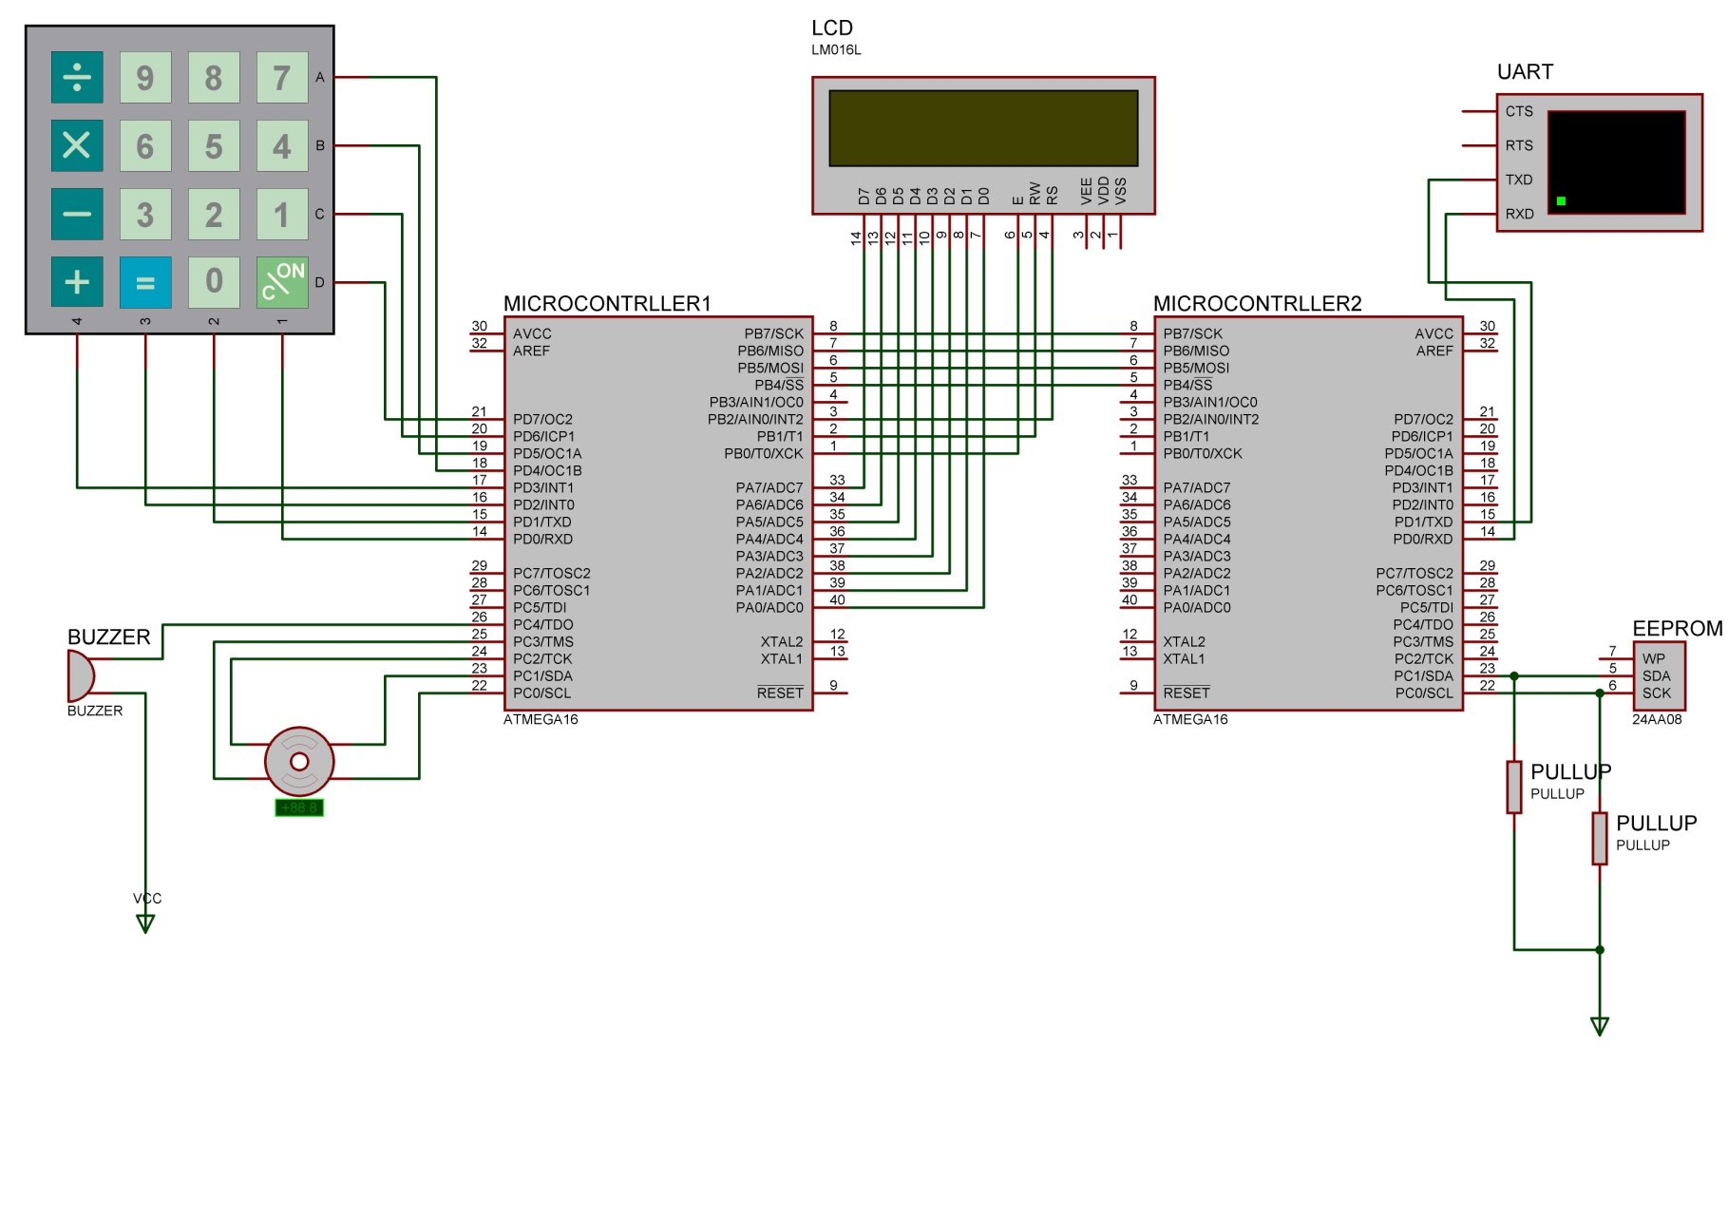

# System Components

1. 2 AtMega16 microcontrollers
2. 4X4 Keypad
3. 2X16 LCD character
4. Stepper motor
5. Buzzer
6. EEPROM
7. UART
8. Pull-up resistors

# System constraints

1. Username and password are integers only
2. Max length for Username and password is 10 char
3. Max number for username and passwords is 10 users

# Pins connections

|  |  |  |  |  |
| --- | --- | --- | --- | --- |
| **#** | **Component** | **Microcontroller** | **Port(Pin)** | **Comment** |
| 1 | KeyPad | MC1 | PortD | 4 pins In – 4 pins out |
| 2 | LCD | MC1 | PortA – PortB(0:2) | PortA for data – PortB for control |
| 3 | Stepper Motor | MC1 | PortC(0:3) |  |
| 4 | Buzzer | MC1 | PortC(4) | 1 pin out |
| 5 | EEPROM | MC2 | PortC(0:1) |  |
| 6 | UART | MC2 | PortD(0:1) | PortD(0) In Rx - PortD(1) Out Tx |
| 7 | SPI | MC1 - MC2 | PortB(4:7) |  |