Hwang’s mlspline

Choi TaeYoung

2019 11 30

#’ generate simulated response for multilevel splines #’ #’ Generates simulated response for multilevel splines #’ #’ @importFrom stats coef glm lm rbinom rnorm vcov #’ @param J number of ‘data’ intervals #’ @param mod underlying model; either lm or glm #’ @param x_sigma design matrix sigma #’ @param e_sigma error variance - around the mean function; data level. #’ @param z_sigma error variance around my surface; structural level. #’ @param N_s the minimum sample size for each interval. #’ @param N_m the maximum sample size for each interval; default = 200. #’ @return returns a list described above. #’ @format list(x_list = x_list, y_list = y_list, e_list = e_list, true_mu = mu, z = z) #’ \describe{ #’

{x_list}{the length-J list of design matrices. The nrow of each element is between N_s and N_m} #’

{y_list}{the length-J list of response vectors. The length of each element is between N_s and N_m.} #’

{e_list}{the length-J list of error vectors. The length of each element is between N_s and N_m.} #’

{true_mu}{the true mu vector of length J} #’

{z}{the grid vector of length J} #’

generate_response <- function(J, mod, e_sigma = 1, x_sigma = 1, z_sigma = 0.5, N_s, N_m = 200) {  
  
 # currently the data interval (z interval) is set to be between -3 and 3.  
  
 n <- sample(N_s:N_m, J, replace = TRUE)  
  
 # smooth surface: z is the grid sequence and mu is the generated smooth function.  
 z <- seq(from = -3, to = 3, length.out = J)  
 mu <- z^2 - 10 * cos(2 * pi * z) # "true" surface.  
  
 beta_1 <- mu + rnorm(J, 0, z_sigma) # slope  
 beta_0 <- 0 # intercept  
  
 x_list <- lapply(n, rnorm, mean = 0, sd = x_sigma)  
 e_list <- lapply(n, rnorm, mean = 0, sd = e_sigma)  
  
 # outcome generation function; gives 'y' list given e, beta_0, beta_1, and  
 # x (design matrix)  
 # for glm: logit link binary p(y = 1) = 1/(1 + exp(-beta_0 - beta_1 * x - e)  
 # for lm: ordinary linear model structure y = xb + e  
 if (mod == "glm") {  
 y_list <- mapply(function(x, e, b, beta_0 = 0)  
 rbinom(length(x), 1, 1/(1 + exp(-beta_0 - b * x - e))),  
 x = x_list, e = e_list, b = beta_1)  
 }  
 if (mod == "lm") {  
 y_list <- mapply(function(x, e, b, beta_0 = 0)  
 beta_0 + b * x + e, x = x_list, e = e_list, b = beta_1)  
 }  
 list(x_list = x_list, y_list = y_list, e_list = e_list, true_mu = mu, z = z)  
}

#’ Builds `granular'' data #' #' obtains the regression slope and its variance #' certainly not optimal but this step shouldn't take long regardless #' @param x_k design matrix #' @param y_k response vector #' @param mod underlying model; eitherlmorglm` #’ @export

granular <- function(x_k, y_k, mod) {  
 # summarizing the regression part  
 if (mod == "glm")  
 fit_lm <- glm(y_k ~ x_k, family = "binomial")  
 if (mod == "lm")  
 fit_lm <- lm(y_k ~ x_k)  
  
 kth_beta_hat <- coef(fit_lm)[2]  
 kth_var <- diag(vcov(fit_lm))[2]  
 grain_out <- list(kth_beta_hat, kth_var)  
 grain_out  
}

#’ Generates kerel matrix #’ #’ Generates kernel matrix of J by J, where J = length(z) for multilevel splines #’ certainly not optimal but this step shouldn’t take long regardless. #’ Used the formulation from Reinsch (1967). #’ @param z Mid-interval value vector, it is safe to assume this to be equi-distant, but in principle it doesn’t have to be. it’s not tested though. #’ @export

make_K <- function(z) {  
 J <- length(z)  
 Del <- matrix(0, nrow = J - 2, ncol = J)  
 W <- matrix(0, nrow = J - 2, ncol = J - 2)  
 h <- diff(z)  
 for (l in 1:(J - 2)) {  
 Del[l, l] <- 1/h[l]  
 Del[l, (l + 1)] <- -1/h[l] - 1/h[(l + 1)]  
 Del[l, (l + 2)] <- 1/h[(l + 1)]  
 W[(l - 1), l] <- W[l, (l - 1)] <- h[l]/  
 6  
 W[l, l] <- (h[l] + h[l + 1])/3  
 }  
 K <- t(Del) %*% solve(W) %*% Del  
 K  
}

#’ Main EM function #’ #’ Running EM for multilevel splines #’ certainly not optimal… #’ @param beta_hat_vec data vector of length J #’ @param V covariance matrix of size J by J #’ @param K kernel matrix from make_K #’ @param lambda tuning parameter #’ @param maxit maximum iteration number #’ @export

main_EM <- function(beta_hat_vec, V, K, lambda, maxit = 500) {  
  
 # parameter initilization  
 eps <- 1000 # convergence tracker  
 tol <- 1e-05 # convergence threshold  
 sigma2_m <- mean(diag(V))  
 J <- length(beta_hat_vec)  
 mu_m <- rep(mean(beta_hat_vec), J)  
 I <- diag(J)  
 iter <- 1  
  
 while (eps > tol & iter <= maxit) {  
 # .. EM starts here  
 mu_m_old <- mu_m  
 sigma2_m_old <- sigma2_m # current sigma^2  
  
 Vst <- solve(solve(V) + (1/sigma2_m) * diag(J)) # Vst  
 D_m <- Vst %*% solve(V) #D_m <- part_cov %*% V  
 mu_m <- solve(D_m + lambda * K) %*% D_m %*% beta_hat_vec  
  
 S_lambda <- solve(I %*% D_m %*% I + lambda * K) %*% I %*% D_m  
 effective_df <- sum(diag(S_lambda))  
  
 sigma2_m <- mean((beta_hat_vec - mu_m)^2)  
 eps <- sum(abs(mu_m - mu_m_old)) + abs(sigma2_m_old - sigma2_m)  
 iter <- iter + 1  
 if (iter == maxit) {  
 cat("for lambda =", lambda, "max iteration reached; may need to double check \n")  
 }  
 } # end of EM .. convergence reached.  
  
 BIC <- sum((beta_hat_vec - mu_m)^2)/(J^(1 - effective_df/J))  
 GCV <- sum((beta_hat_vec - mu_m)^2)/(J - effective_df)^2 * J  
  
 EM_out <- list(mu = mu_m, S_lambda = S_lambda, sigma2 = sigma2_m, BIC = BIC, GCV = GCV)  
 EM_out  
}

#’ Naive strawman #’ #’ Running naive splines #’ @param beta_hat_vec data vector of length J #’ @param K kernel matrix from make_K #’ @param lambda tuning parameter #’ @export

naive_ss <- function(beta_hat_vec, lambda, K) {  
  
 J <- length(beta_hat_vec)  
 I <- diag(J)  
 S_lambda <- solve(I + lambda * K)  
 f_hat <- S_lambda %*% beta_hat_vec  
  
 eff_df <- sum(diag(S_lambda))  
  
 GCV <- sum((beta_hat_vec - f_hat)^2)/(J - eff_df)^2 * J  
 BIC <- log(mean((beta_hat_vec - f_hat)^2)) + eff_df * log(J)/J  
  
 out <- list(mu = f_hat, S_lambda = S_lambda, BIC = BIC, GCV = GCV)  
 out  
}

#’ Generates simulated response for multilevel splines – test function #2 #’ #’ @importFrom stats coef glm lm rbinom rnorm vcov #’ @param J number of ‘data’ intervals #’ @param mod underlying model; either lm or glm #’ @param x_sigma design matrix sigma #’ @param e_sigma error variance - around the mean function; data level. #’ @param z_sigma error variance around my surface; structural level. #’ @param N_s the minimum sample size for each interval. #’ @param N_m the maximum sample size for each interval; default = 200. #’ @return returns a list described above. #’ @format list(x_list = x_list, y_list = y_list, e_list = e_list, true_mu = mu, z = z) #’ #’ @export

generate_response_smooth <- function(J, mod, e_sigma = 1, x_sigma = 1, z_sigma = 0.5, N_s, N_m = 200) {  
  
 # currently the data interval (z interval) is set to be between 0 and 1  
  
 n <- sample(N_s:N_m, J, replace = TRUE)  
  
 # smooth surface: z is the grid sequence and mu is the generated smooth function.  
 z <- seq(from = 0, to = 1, length.out = J)  
 mu <- sin(12*(z + 0.2)) / (z + 0.2) # "true" surface.  
  
 beta_1 <- mu + rnorm(J, 0, z_sigma) # slope  
 beta_0 <- 0 # intercept  
  
 x_list <- lapply(n, rnorm, mean = 0, sd = x_sigma)  
 e_list <- lapply(n, rnorm, mean = 0, sd = e_sigma)  
  
 # outcome generation function; gives 'y' list given e, beta_0, beta_1, and  
 # x (design matrix)  
 # for glm: logit link binary p(y = 1) = 1/(1 + exp(-beta_0 - beta_1 * x - e)  
 # for lm: ordinary linear model structure y = xb + e  
 if (mod == "glm") {  
 y_list <- mapply(function(x, e, b, beta_0 = 0)  
 rbinom(length(x), 1, 1/(1 + exp(-beta_0 - b * x - e))),  
 x = x_list, e = e_list, b = beta_1)  
 }  
 if (mod == "lm") {  
 y_list <- mapply(function(x, e, b, beta_0 = 0)  
 beta_0 + b * x + e, x = x_list, e = e_list, b = beta_1)  
 }  
 list(x_list = x_list, y_list = y_list, e_list = e_list, true_mu = mu, z = z)  
}

## simulation model

ag2 <- generate_response_smooth(J=50, mod="glm", e_sigma=2, N_s=50)  
ag22 <- generate_response_smooth(J=50, mod="glm", e_sigma=2, N_s=100)  
ag4 <- generate_response_smooth(J=50, mod="glm", e_sigma=4, N_s=50)  
ag44 <- generate_response_smooth(J=50, mod="glm", e_sigma=4, N_s=100)  
ag8 <- generate_response_smooth(J=50, mod="glm", e_sigma=8, N_s=50)  
ag88 <- generate_response_smooth(J=50, mod="glm", e_sigma=8, N_s=100)  
  
al2 <- generate_response_smooth(J=50, mod="lm", e_sigma=2, N_s=50)  
al22 <- generate_response_smooth(J=50, mod="lm", e_sigma=2, N_s=100)  
al4 <- generate_response_smooth(J=50, mod="lm", e_sigma=4, N_s=50)  
al44 <- generate_response_smooth(J=50, mod="lm", e_sigma=4, N_s=100)  
al8 <- generate_response_smooth(J=50, mod="lm", e_sigma=8, N_s=50)  
al88 <- generate_response_smooth(J=50, mod="lm", e_sigma=8, N_s=100)  
  
  
bg2 <- generate_response(J=50, mod="glm", e_sigma=2, N_s=50)  
bg22 <- generate_response(J=50, mod="glm", e_sigma=2, N_s=100)  
bg4 <- generate_response(J=50, mod="glm", e_sigma=4, N_s=50)  
bg44 <- generate_response(J=50, mod="glm", e_sigma=4, N_s=100)  
bg8 <- generate_response(J=50, mod="glm", e_sigma=8, N_s=50)  
bg88 <- generate_response(J=50, mod="glm", e_sigma=8, N_s=100)  
  
bl2 <- generate_response(J=50, mod="lm", e_sigma=2, N_s=50)  
bl22 <- generate_response(J=50, mod="lm", e_sigma=2, N_s=100)  
bl4 <- generate_response(J=50, mod="lm", e_sigma=4, N_s=50)  
bl44 <- generate_response(J=50, mod="lm", e_sigma=4, N_s=100)  
bl8 <- generate_response(J=50, mod="lm", e_sigma=8, N_s=50)  
bl88 <- generate_response(J=50, mod="lm", e_sigma=8, N_s=100)

### Example 1  
  
## GLM_2_50  
ag2 <- generate_response_smooth(J=50, mod="glm", e_sigma=2, N_s=50)  
# generation  
beta_hat <- NULL  
for(i in 1:50){  
 results <- granular(unlist(ag2$x_list[i]), unlist(ag2$y[i]), mod = "glm")  
 beta_hat <- rbind(beta_hat,results)  
}  
  
K <- make_K(ag2$z)  
  
# multilevel  
  
GCV_vec <- NULL  
lambda <- seq(0.00005, 0.00012, by = 1e-6)  
for(i in 1:length(lambda)){  
 EM_out <- main_EM(beta_hat_vec = unlist(beta_hat[,1]), V = diag(unlist(beta_hat[,2])), K = K, lambda[i])  
 GCV_vec <- rbind(GCV_vec,EM_out$GCV)  
}  
  
plot(lambda, GCV_vec)

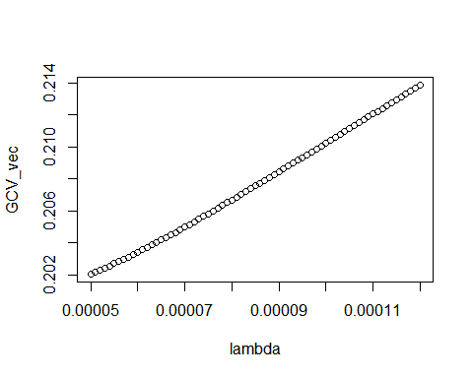

EM_out <- main_EM(beta_hat_vec = unlist(beta_hat[,1]), V = diag(unlist(beta_hat[,2])), K = K, lambda = 0.0001)  
  
RMSE_Multilevel <- sqrt((1/50)*t(ag2$true_mu-EM_out$mu)%*%(ag2$true_mu-EM_out$mu))  
  
# naive  
  
GCV_vec <- NULL  
lambda <- seq(0.00016, 0.00017, by = 1e-7)  
for(i in 1:length(lambda)){  
 naive_out <- naive_ss(beta_hat_vec = unlist(beta_hat[,1]), lambda = lambda[i], K = K)  
 GCV_vec <- rbind(GCV_vec,naive_out$GCV)  
}  
  
plot(lambda, GCV_vec)

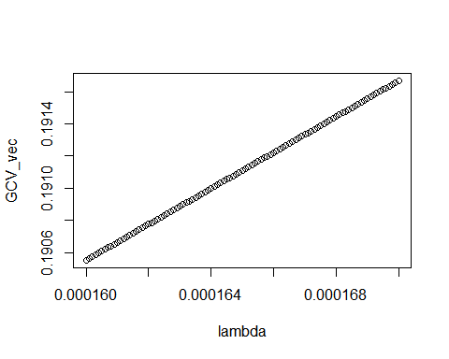

naive_out <- naive_ss(beta_hat_vec = unlist(beta_hat[,1]), lambda = 0.000168, K = K)  
  
RMSE_Naive <- sqrt((1/50)*t(ag2$true_mu-naive_out$mu)%*%(ag2$true_mu-naive_out$mu))

### Example 2  
  
## GLM_2_50  
bg2 <- generate_response(J=50, mod="glm", e_sigma=2, N_s=50)  
  
# generation  
  
beta_hat <- NULL  
for(i in 1:50){  
 results <- granular(unlist(bg2$x_list[i]), unlist(bg2$y[i]), mod = "glm")  
 beta_hat <- rbind(beta_hat,results)  
}

## Warning: glm.fit: fitted probabilities numerically 0 or 1 occurred  
  
## Warning: glm.fit: fitted probabilities numerically 0 or 1 occurred  
  
## Warning: glm.fit: fitted probabilities numerically 0 or 1 occurred  
  
## Warning: glm.fit: fitted probabilities numerically 0 or 1 occurred  
  
## Warning: glm.fit: fitted probabilities numerically 0 or 1 occurred

K <- make_K(bg2$z)  
  
# multilevel  
  
GCV_vec <- NULL  
lambda <- seq(0.000195, 0.0002, by = 1e-7)  
for(i in 1:length(lambda)){  
 EM_out <- main_EM(beta_hat_vec = unlist(beta_hat[,1]), V = diag(unlist(beta_hat[,2])), K = K, lambda[i])  
 GCV_vec <- rbind(GCV_vec,EM_out$GCV)  
}  
  
plot(lambda, GCV_vec)

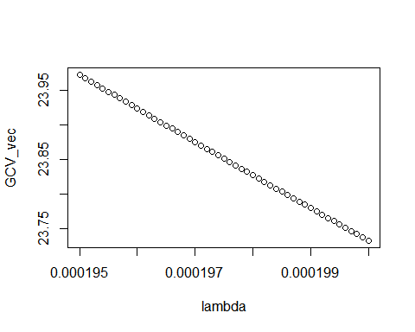

EM_out <- main_EM(beta_hat_vec = unlist(beta_hat[,1]), V = diag(unlist(beta_hat[,2])), K = K, lambda = 0.000197)  
  
RMSE_Multilevel <- sqrt((1/50)*t(bg2$true_mu-EM_out$mu)%*%(bg2$true_mu-EM_out$mu))  
  
# naive  
  
GCV_vec <- NULL  
lambda <- seq(15.37, 15.375, by = 0.0001)  
for(i in 1:length(lambda)){  
 naive_out <- naive_ss(beta_hat_vec = unlist(beta_hat[,1]), lambda = lambda[i], K = K)  
 GCV_vec <- rbind(GCV_vec,naive_out$GCV)  
}  
  
plot(lambda, GCV_vec)

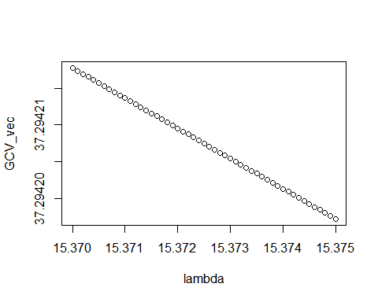

naive_out <- naive_ss(beta_hat_vec = unlist(beta_hat[,1]), lambda = 15.374, K = K)  
  
RMSE_Naive <- sqrt((1/50)*t(bg2$true_mu-naive_out$mu)%*%(bg2$true_mu-naive_out$mu))

## problem

Setting : Model GLM, $τ=2, N_{min}=50$

We can get $RMSE$ s multilevel approach suffers under GLM. $RMSE_{1}=3.21.(λ=0.00023), RMSE_{2}=3.05(λ=0.000395),RMSE_{3}=3.43(λ=0.00062), RMSE_{4}=2.98(λ=0.000508), RMSE_{5}=3.04(λ=0.000197)$

We can get $RMSE$ s naive approach suffers under GLM. $RMSE_{1}=12.9(λ=46.4), RMSE_{2}=16.3(λ=54.3), RMSE_{3}=76.8(λ=93.465), RMSE_{4}=7.2(λ=11.2) ,RMSE_{5}=22.6(λ=394.54)$