RETAIL SALES & CUSTOMER ANALYTICS
Power BI Portfolio Case Study
Sales performance • Customer behaviour • Product profitability • Business insights
Tools: Excel | Power Query | Power BI | DAX
BY
YUSUFF SULIAT ADENIKE

1. Project Overview
This project analyzes a retail sales dataset to understand revenue performance, profitability, customer behaviour, product performance, sales channels, geographic performance, and changes in sales over time. The analysis follows an end-to-end business intelligence workflow from data preparation through modelling, DAX, dashboard development, and recommendations.

2. Business Problem
A retail business needs a clear view of sales performance to identify its strongest products, sales channels and locations, customer purchasing behaviour, and profitability drivers. Without a consolidated analytical view, management may struggle to identify where revenue and profit are coming from or where growth opportunities exist.

3. Business Questions
- Which sales channels generate the highest revenue?
- Which products generate the highest revenue and profit?
- Which products have the strongest profit margins?
- Which locations generate the highest revenue and profit?
- How many customers are there and how frequently do they purchase?
- What proportion of customers are repeat customers?
- How does revenue change over time?
- How is revenue growth changing from month to month?

4. Dataset
The portfolio dataset contains 8,500 order records, 1,200 customers, 27 products, 12 locations, and a supporting data dictionary. It represents a Nigerian retail business with categories including Fashion, Bags, Beauty, Shoes, and Accessories.
Table | Records | Purpose
Customers | 1,200 | Customer demographics and registration information
Products | 27 | Product, category, brand, cost and selling price information
Orders | 8,500 | Transaction-level sales, quantity, cost, profit, channel and payment data
Locations | 12 | City, state and region reference data
Data Dictionary | — | Business definitions for dataset fields

5. Data Cleaning & Preparation
Data preparation was performed before analysis to improve consistency and reliability. The cleaning process used Power Query so the transformations could be reproduced.
- Standardized inconsistent payment method capitalization, including 'Bank Transfer' and 'Bank transfer'.
- Removed leading whitespace from SalesChannel values.
- Standardized inconsistent city capitalization, including 'Abuja'/'abuja' and 'Lagos Island'/'lagos island'.
- Reviewed the dataset for duplicate and structural issues before modelling.

6. Data Modelling
A star-schema approach was used. Orders acts as the central fact table, while Customers, Products, Locations and DateTable provide analytical dimensions.
- Customers (1) → Orders (*)
- Products (1) → Orders (*)
- Locations (1) → Orders (*)
- DateTable (1) → Orders (*)
Single-direction relationships were used from dimensions to the Orders fact table to support reliable filter propagation and reduce ambiguity.

7. DAX & KPI Development
Reusable DAX measures were created so KPIs respond dynamically to slicers and visual filter context.
Measure | Purpose
Total Revenue | SUM of transaction sales amount
Total Cost | SUM of transaction cost amount
Total Profit | SUM of transaction profit
Total Quantity | SUM of units sold
Total Orders | Distinct count of OrderID
Profit Margin % | Profit divided by revenue
Average Order Value | Revenue divided by orders
Total Customers | Distinct count of CustomerID
Revenue per Customer | Revenue divided by customers
Average Orders per Customer | Orders divided by customers
Repeat Customers | Customers with more than one distinct order
Repeat Customer Rate % | Repeat customers divided by total customers
Revenue Share % | Channel revenue divided by overall revenue
Previous Month Revenue | Revenue shifted one month backward
Revenue Growth % | Current revenue compared with previous month

8. Dashboard Structure
Page | Purpose
Executive Summary | High-level KPIs, monthly revenue trend, revenue by location, revenue by sales channel, and top products by profit.
Profit Dashboard | Profitability performance by relevant business dimensions.
Revenue Dashboard | Revenue performance and channel/category analysis.
Product Dashboard | Product revenue, profit, quantity and margin analysis.
Customer Dashboard | Customer counts, repeat behaviour and customer-level performance.

9. Key Findings
- Total revenue was approximately ₦339 million.
- Total profit was approximately ₦116 million.
- Overall profit margin was approximately 34%.
- Pleated Skirt was the highest-revenue product and also the highest-profit product.
- Leather Loafers recorded the highest product profit margin at approximately 49%.
- The analysis identified approximately 1,200 customers, of which 99.25% were classified as repeat customers based on multiple distinct orders.
- Average orders per customer were approximately 7.08.
- Average order value was approximately ₦39.93K.
- Lagos Island was the highest -revenue city by revenue
- Walk-in was the highest-revenue sales channel

10. Business Recommendations
- Prioritize inventory planning for high-performing products such as Pleated Skirt to reduce stock-out risk.
- Investigate the cost structure and customer demand behind high-margin products such as Leather Loafers and identify similar opportunities.
- Prioritize sales channels that consistently contribute strong revenue while monitoring profitability.
- Use customer purchase behaviour to develop retention, cross-selling and repeat-purchase strategies.
- Review geographic performance to identify locations with strong revenue and potential for further growth.
- Use monthly revenue and growth trends as ongoing management KPIs rather than relying only on cumulative totals.

11. Skills Demonstrated
- Data cleaning and transformation
- Power Query
- Star-schema data modelling
- Power BI dashboard development
- DAX and filter context
- Customer and product analytics
- Time intelligence
- KPI development
- Business insight generation
- Data storytelling

12. Conclusion
This project demonstrates an end-to-end approach to retail analytics, from data preparation and modelling through DAX-based analysis and interactive dashboard development. The resulting dashboard provides a consolidated view of revenue, profit, customers, products, sales channels, locations and trends, while translating findings into potential business actions.

13. Portfolio Evidence
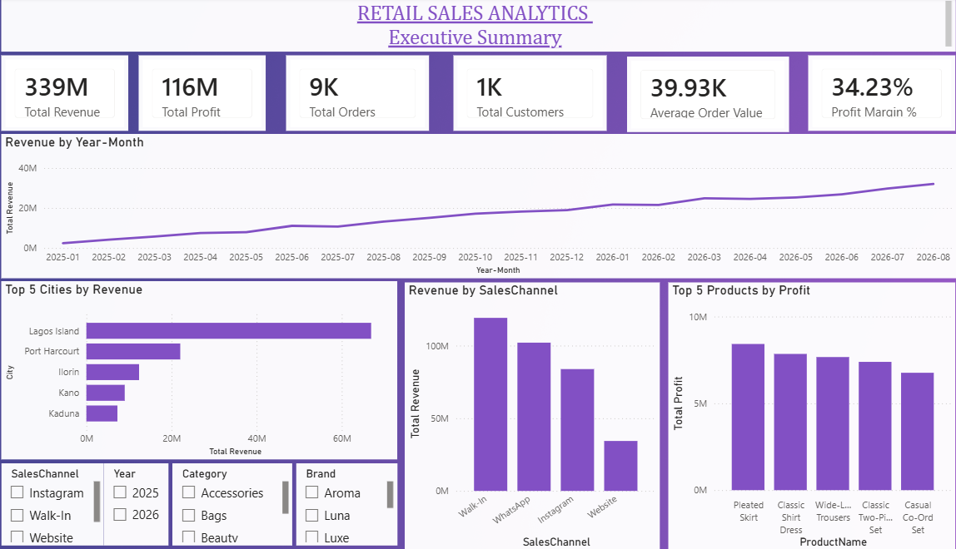

PRODUCT DASHBOARD
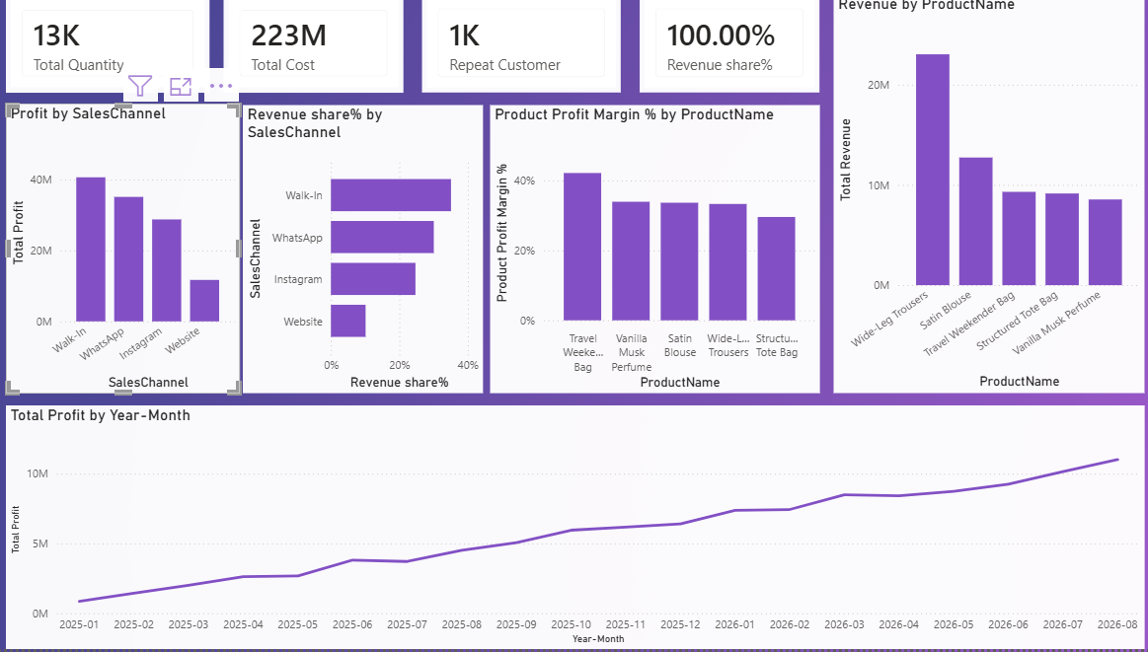

CUSTOMER DASHBOARD
