Fireworks vs SageMaker vs Prime Intellect — User Observation Record
2026-10-03 · four identical experiments · 2 SFT + 2 RL (GRPO) · three platforms

1. Steps
# | Step
1 | Set up Fireworks account + SDK (fireworks-ai 1.2.19). One API key.
2 | Listed the training API surface.
3 | Checked SFT-tunable vs RL-tunable models.
4 | Built datasets: GoEmotions (text), ORena (vision).
5 | Uploaded datasets.
6 | Built a reward evaluator (Python) + uploaded it. Hit a build error; fixed with .tar.gz upload.
7 | Launched 4 jobs: 2 SFT + 2 RL (GRPO), 1 epoch each.
8 | Polled jobs. Collected loss + reward curves.
9 | Sent the same config to the SageMaker team.
10 | Put all results in one repo.

2. Fireworks — what came back
Experiment | Job | State | Final metric | Cost
1. ORena SFT | etia90sh | COMPLETED | train loss 0.354 | $1.47
2. ORena RL (GRPO) | fs-or1-orena-rl | COMPLETED | exact_match 0.191 → 0.282 | null*
3. GoEmotions SFT | ktcdqquf | COMPLETED | train loss 0.313 | $2.84
4. GoEmotions RL (GRPO) | fs-or1-ge-rl | COMPLETED | micro_f1 0.175 → 0.377 | null*
* Managed RL returned no per-job cost. Likely free under 16B params — to confirm on the dashboard.
- Block: qwen3p5-9b is not RL-tunable → switched ORena RL to qwen3-vl-8b-instruct.
- Block: evaluator build failed (BUILD_FAILED) → upload as one .tar.gz, not loose files.

3. Results — charts
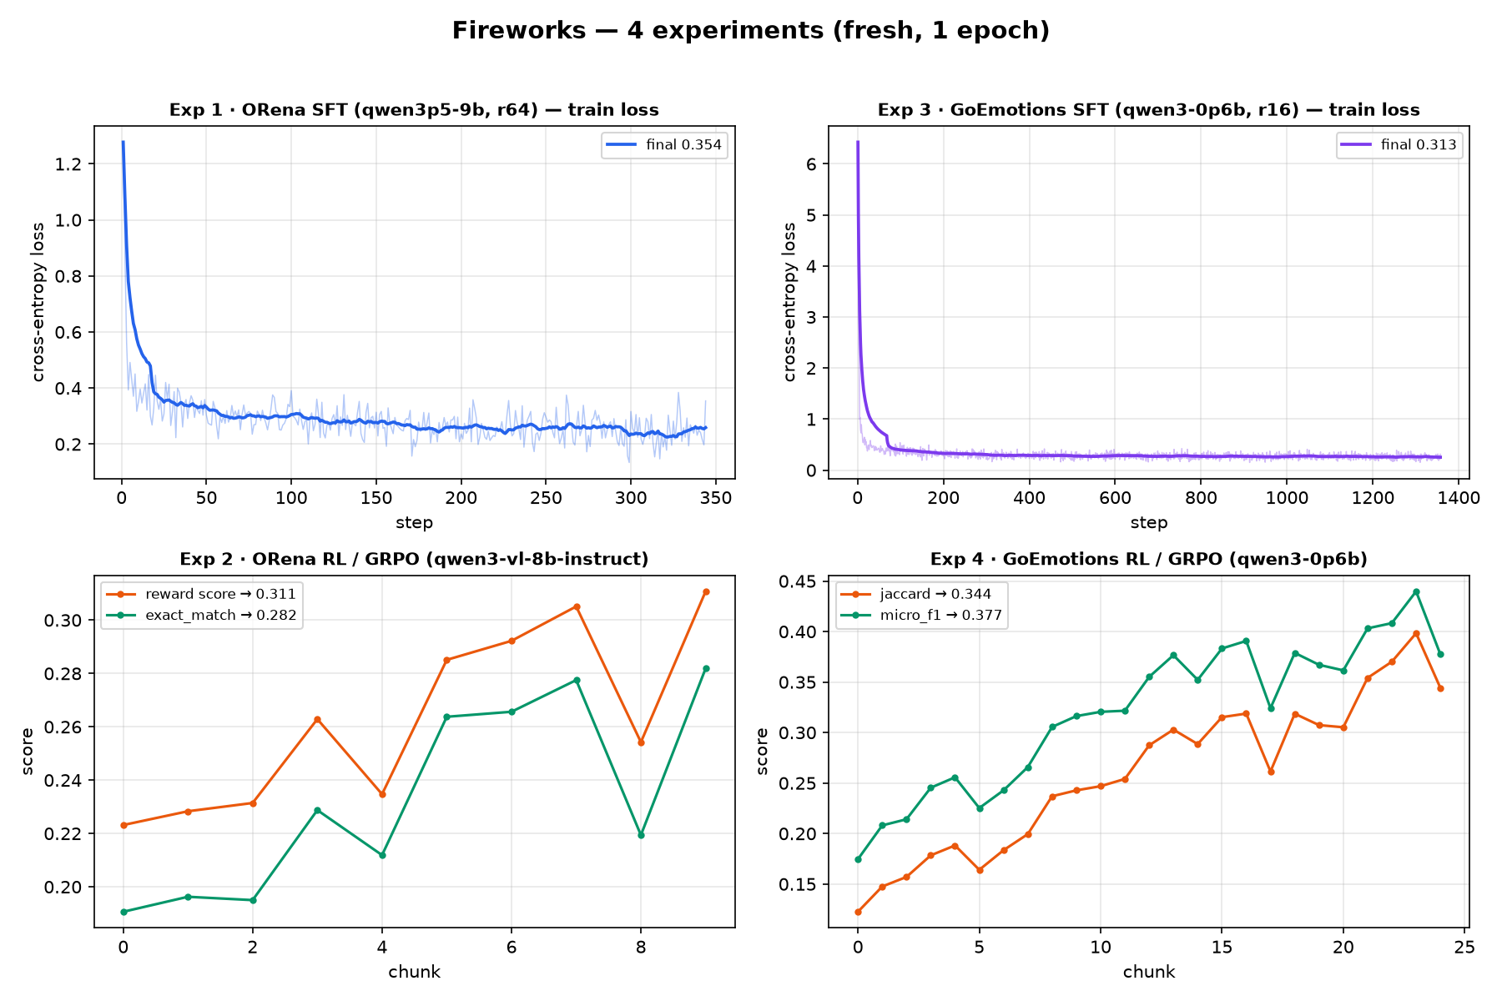
Figure 1 — all four experiments: SFT loss (top), RL reward (bottom).
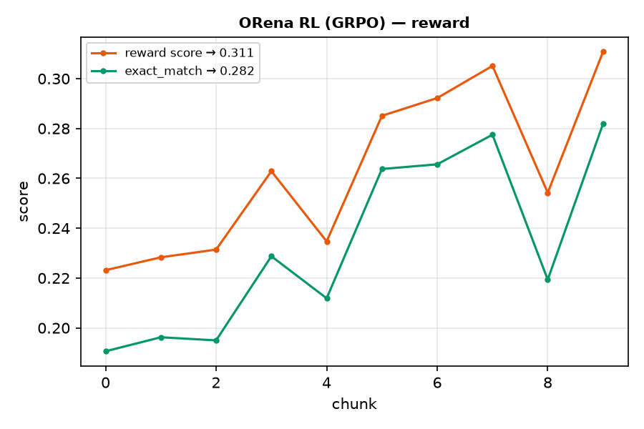
Figure 2 — ORena RL: reward score and exact_match.
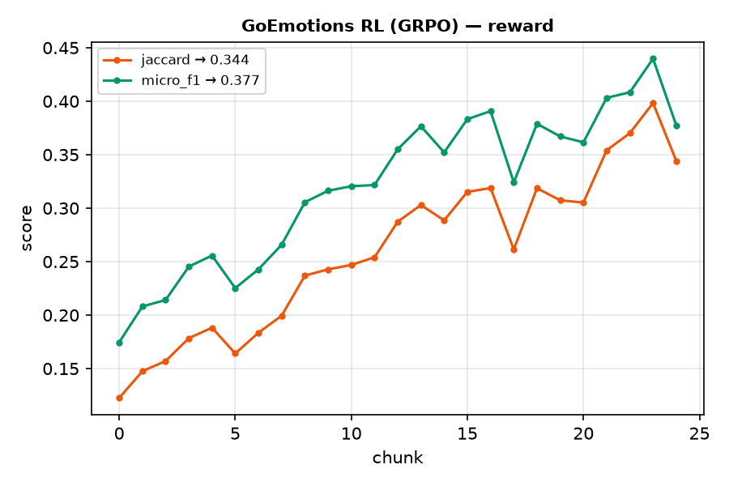
Figure 3 — GoEmotions RL: jaccard and micro_f1.

4. SageMaker — results
Experiment | Fireworks | SageMaker | Note
1. ORena SFT | loss 0.354 | InProgress | GPU class differs
2. ORena RL | exact_match 0.282 | InProgress | base model differs
3. GoEmotions SFT | loss 0.313 | loss 1.54 | 5k vs 43k samples, ctx 512 vs 8192
4. GoEmotions RL | micro_f1 0.377 | InProgress | rollouts 8 vs 4
Not like-for-like: SageMaker used smaller GPUs (T4/A10G), fewer samples, shorter context, different optimizer. 3 of 4 jobs still running.

5. Prime Intellect — results
Experiment | Model | State | Note
1. ORena SFT | Qwen3.5-9B | not started | data pending
2. ORena RL (GRPO) | Qwen3.5-9B | not started | PI can RL the 9B (Fireworks cannot)
3. GoEmotions SFT | Qwen3-0.6B | RUNNING | loss 5.79 → 0.25 over 60 steps
4. GoEmotions RL | Qwen3-0.6B | not started | —
Headless path only: CLI + API, self-run prime-rl on an on-demand A100 40GB ($1.99/hr). Wallet $48.79, $1.22 spent. No final metrics yet.
- Volatile GPU inventory — on-demand offers go stale in minutes (5 create attempts).
- Passphrase-protected SSH key broke automation (2 pod recreations).
- Config schema drift — pod image ships an older prime-rl than the docs.
- No managed dashboard for pods — pod work shows nothing in the Jobs view.

6. Why use Fireworks over SageMaker
Fireworks gives | SageMaker requires (observed)
Managed RL (GRPO) with a custom reward evaluator as code | Write TRL GRPO yourself: IAM, instances, reward script
Serverless fine-tuning (per-token billing) | Provision instances (g4dn/g5)
Train + serve on the same stack (instant deploy, KL < 0.01) | Separate training and hosting
Multi-LoRA on one base model | Limited
One API key | IAM role + trust + policy + ECR + S3 + estimator
B200/H200 on demand | g4dn/g5 (T4/A10G) in our account
4 jobs at once, no quota | 1 concurrent instance per type
- Faster: all four jobs finished in under one hour.
- Less operations: no GPU, no container, no IAM to manage.
- For a company like Cursor: focus engineers on the model, not on infrastructure.
- Prime Intellect sits between: raw GPU pods for control, but self-run — no managed RL.

7. Screenshots to add
[ADD] Fireworks dashboard — the four jobs and metrics.
[ADD] Fireworks model catalog — SFT-tunable vs RL-tunable.
[ADD] SageMaker console — training jobs + quota error.
[ADD] Prime Intellect — pod create flow / empty GPU list.
[ADD] Fireworks pricing — per-token training / RL.
[ADD] SageMaker pricing — g4dn/g5 vs B200/H200 rates.

Sources
- https://fireworks.ai/
- https://fireworks.ai/training/rl-rollouts
- https://fireworks.ai/blog/train-past-the-frontier-training-api-now-generally-available
- https://docs.fireworks.ai/fine-tuning/reinforcement-fine-tuning-models
- https://fireworks.ai/blog/aws-sagemaker
- https://stack.tools/tool/fireworks-ai
- https://primeintellect.ai/
- https://docs.primeintellect.ai/

