Fine-tuning and RL observation record
Fireworks, SageMaker, Prime Intellect | 2026-10-03 | ORena (vision) + GoEmotions (text) | 2 SFT + 2 RL (GRPO) per platform

1. Fireworks

Steps
# | Step
1 | Set up a Fireworks account and SDK (fireworks-ai 1.2.19). One API key.
2 | Listed the training API: SFT, DPO, RL jobs, datasets, evaluators, deployments.
3 | Checked which models are SFT-tunable and RL-tunable.
4 | Built datasets: GoEmotions (text), ORena (vision).
5 | Uploaded datasets.
6 | Built a reward evaluator in Python. The upload failed. Fixed it with one .tar.gz file.
7 | Launched 4 jobs: 2 SFT + 2 RL (GRPO), 1 epoch each.
8 | Polled the jobs. Collected loss and reward curves.
The brief that started the run.

Results
Experiment | Model | Final metric | Cost | Wall
ORena SFT | qwen3p5-9b | train loss 0.354 | $1.47 | 28 min
ORena RL (GRPO) | qwen3-vl-8b-instruct | exact_match 0.191 to 0.282 | null | 37 min
GoEmotions SFT | qwen3-0.6b | train loss 0.313 | $2.84 | 50 min
GoEmotions RL (GRPO) | qwen3-0.6b | micro_f1 0.175 to 0.377 | null | not logged
RL cost is null. Managed RL (GRPO) returned no per-job cost on the Fireworks side.

Screenshots
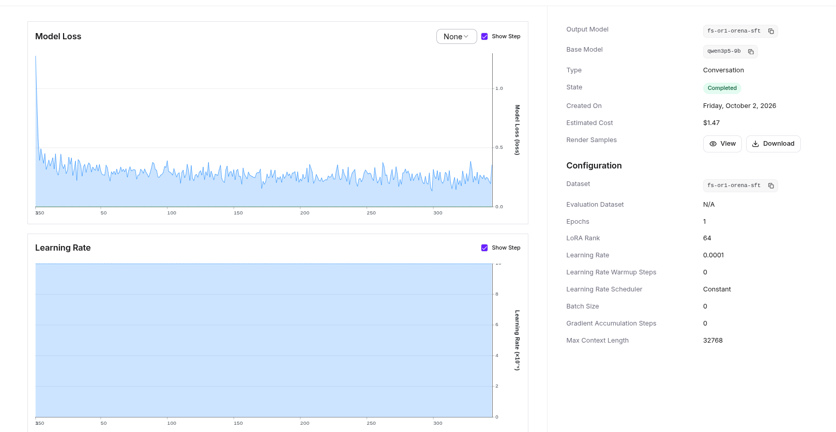
ORena SFT job page. Base model qwen3p5-9b. Estimated cost $1.47.
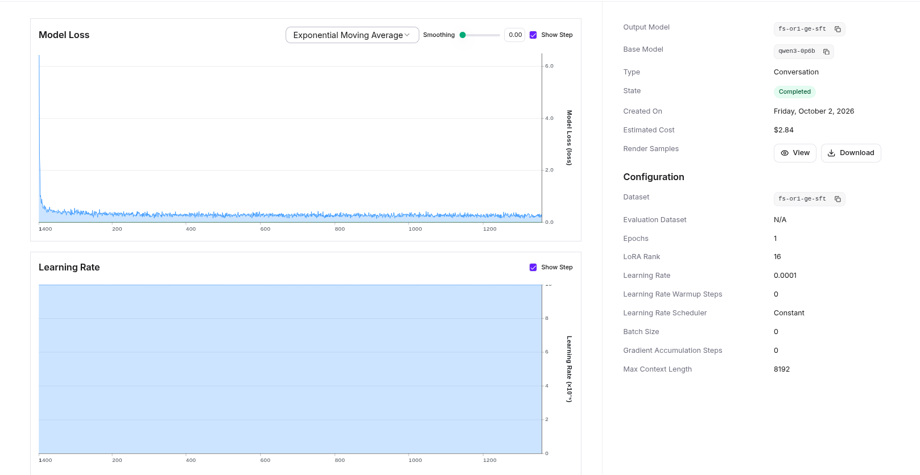
GoEmotions SFT job page. Base model qwen3-0.6b. Estimated cost $2.84.
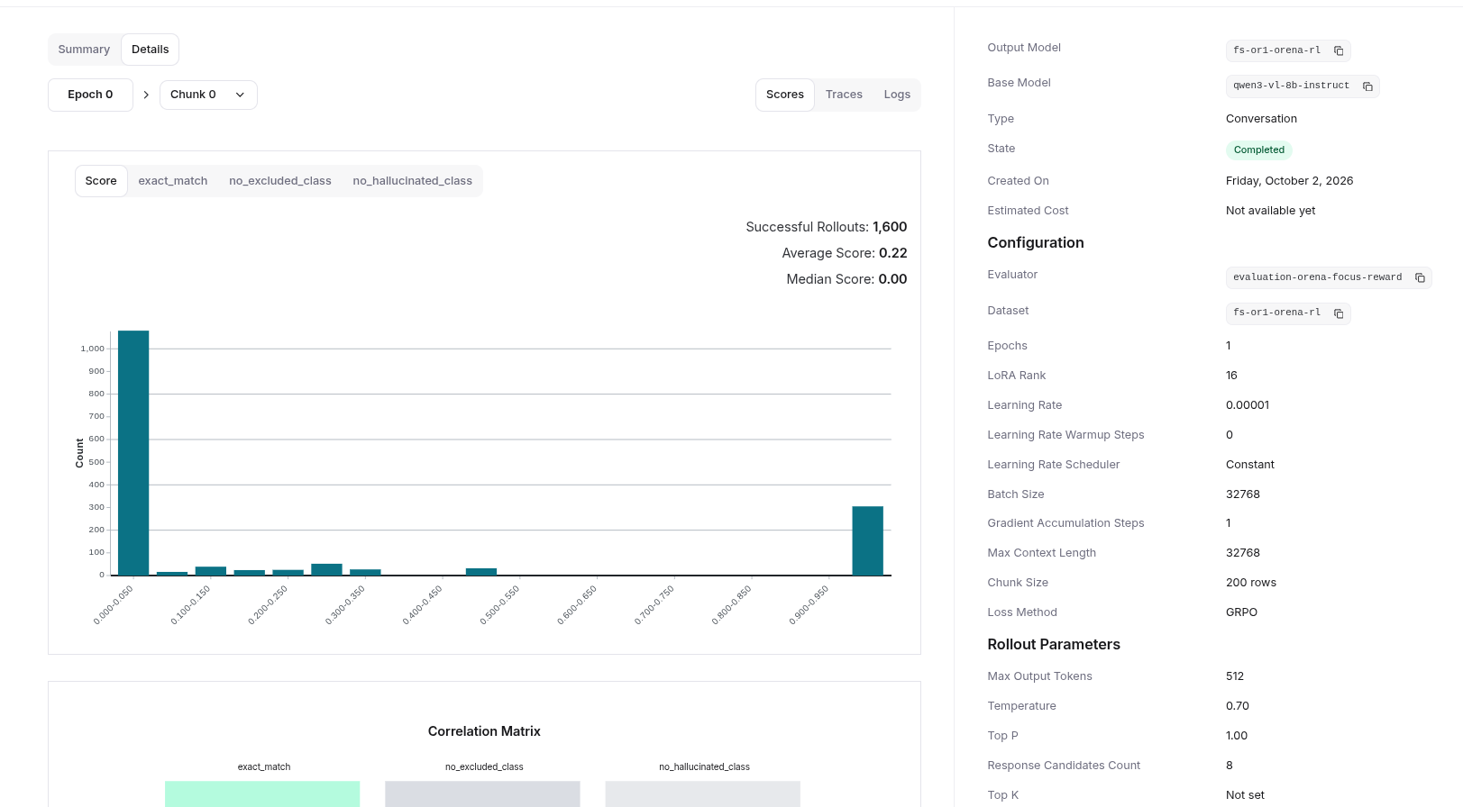
ORena RL job page. Base model qwen3-vl-8b-instruct. Scores: exact_match, excluded_class, no_hallucinated_class.
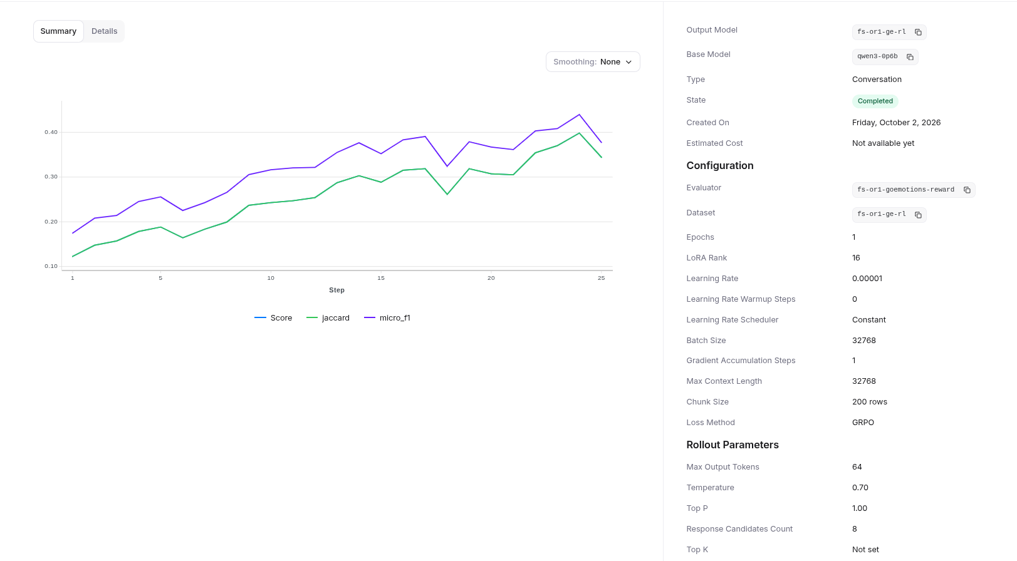
GoEmotions RL job page. Reward evaluator fs-or1-goemotions-reward.
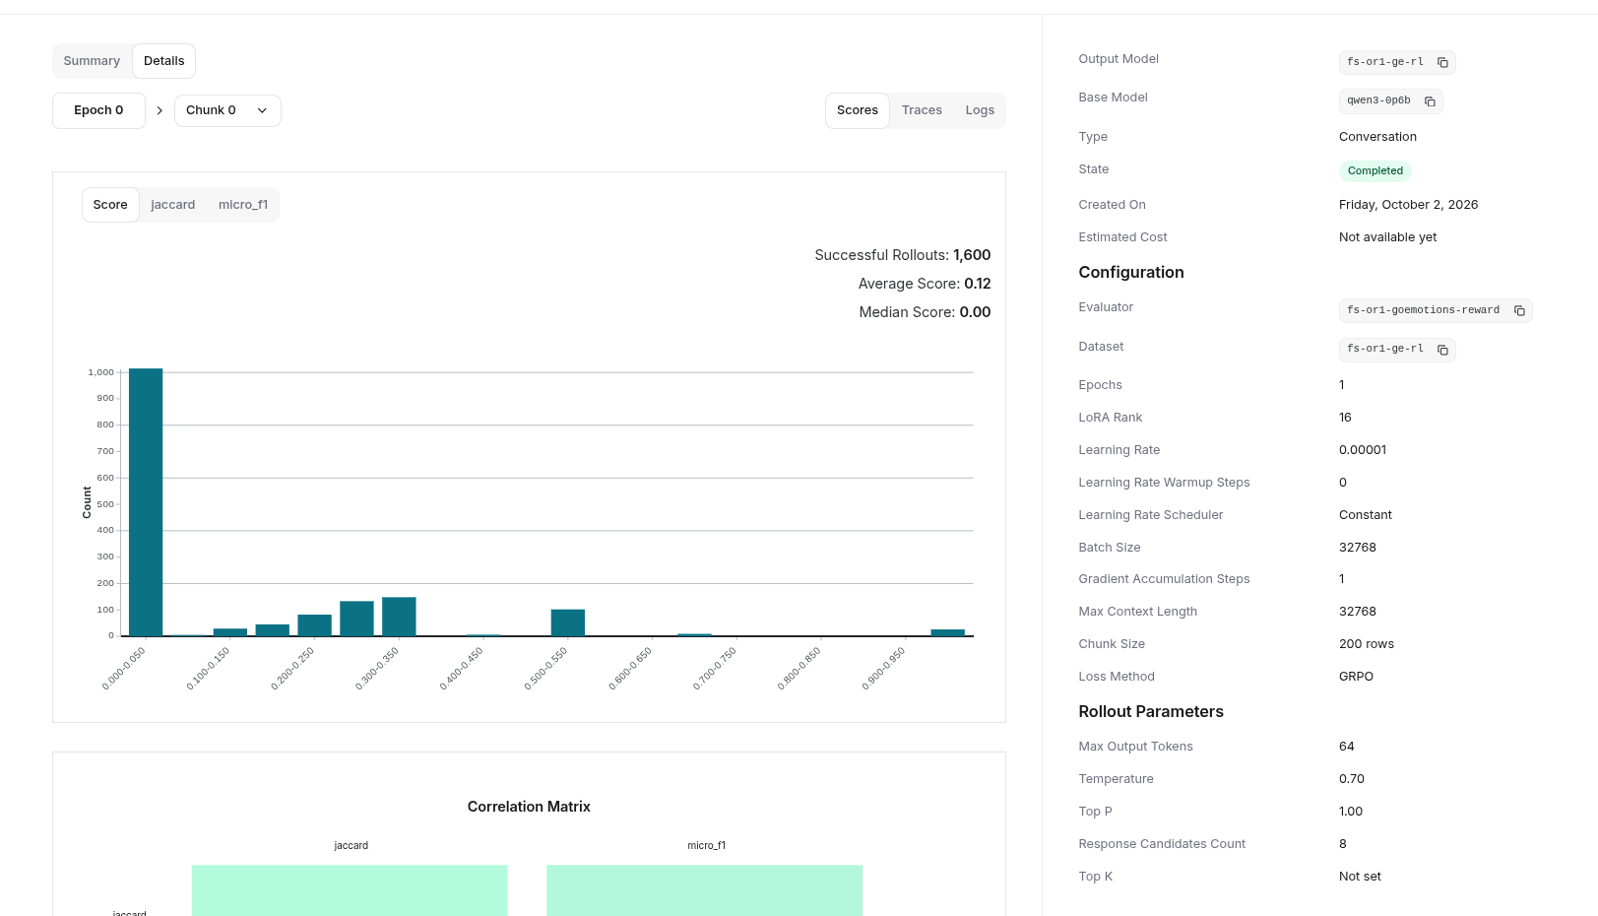
GoEmotions RL scores. jaccard and micro_f1. 1,600 successful rollouts.
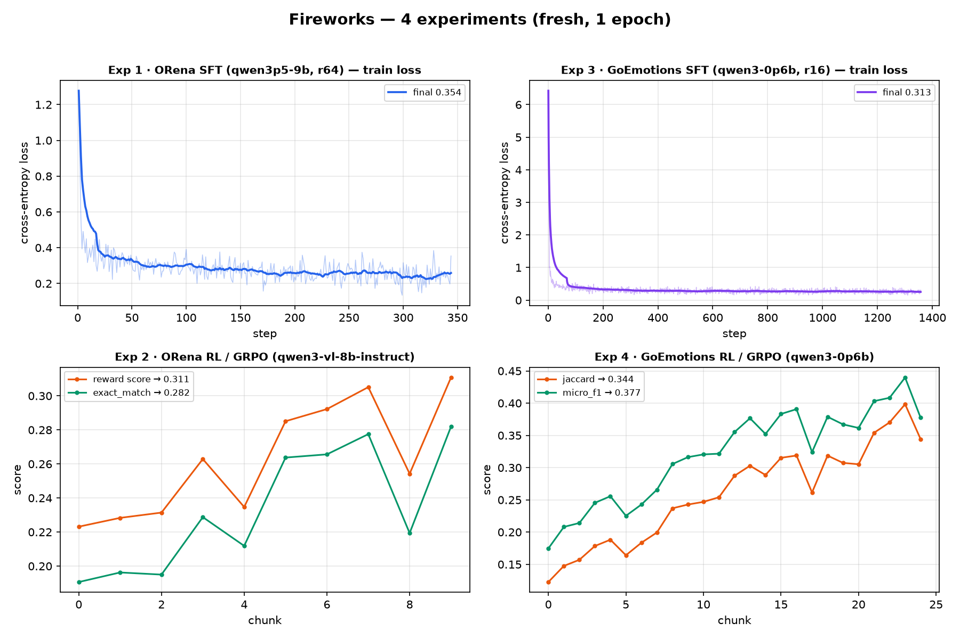
All four Fireworks jobs. SFT loss on top. RL reward below.
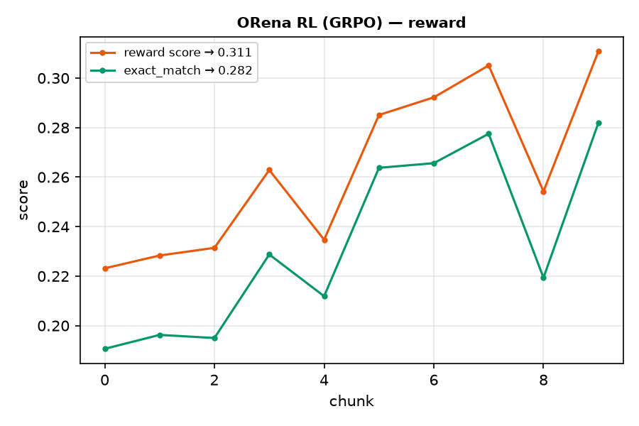
ORena RL: reward score and exact_match.
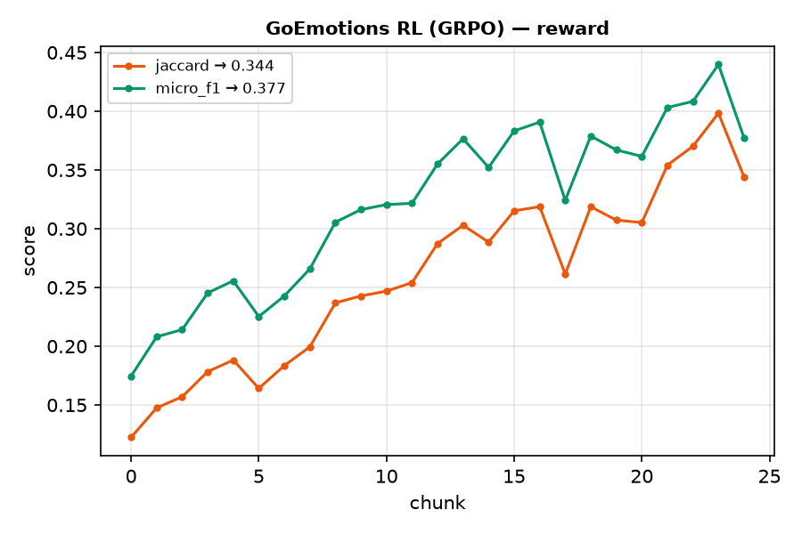
GoEmotions RL: jaccard and micro_f1.

Observations
- qwen3p5-9b is not RL-tunable. ORena RL switched to qwen3-vl-8b-instruct.
- The evaluator build failed (BUILD_FAILED). It must be one .tar.gz file, not loose files.
- All four jobs finished in under one hour.
- Managed RL returned no per-job cost.

2. SageMaker

Steps
# | Step
1 | Wrote an IAM execution role (trust = sagemaker.amazonaws.com) and a scoped policy.
2 | Prepared S3 data: ORena frame files + parquet index, GoEmotions JSONL.
3 | Wrote 4 script-mode entry points (PyTorch 2.5.1, transformers 5.18.0, trl 1.14.1).
4 | Launched 4 estimator jobs on g4dn/g5 (T4/A10G).
5 | Polled to completion. ORena SFT needed 4 attempts.
6 | Collected final metrics and raw logs.

Results
Experiment | Model | Instance | Final metric | Wall | Cost
ORena SFT | Qwen3.5-9B | g5.12xlarge | train loss 1.494 | 787 s | $1.24
ORena RL (GRPO) | Qwen3.5-9B | g5.2xlarge | score 0.0 | 1747 s | $0.59
GoEmotions SFT | Qwen3-0.6B | g4dn.xlarge | train loss 1.54 | 1174 s | $0.17
GoEmotions RL (GRPO) | Qwen3-0.6B | g5.xlarge | jaccard 0.0 | 1605 s | $0.45
All four jobs completed. Dataset caps were 256 to 5000 samples (demo budget), not the full set Fireworks used.

Observations
- ORena SFT 9B bf16 did not fit one 24 GB A10G. Three failed attempts. It fit after LoRA rank 64 to 32 and expandable_segments.
- Both RL jobs completed with reward 0. Qwen3/3.5 thinking mode exhausted max_completion_length. Fireworks disabled thinking. This launch did not.
- One concurrent training instance per instance type (account quota).
- Script mode: no Docker and no ECR. Dependencies install at job start.

3. Prime Intellect

Steps
# | Step
1 | Created a Prime Intellect account and wallet ($50).
2 | Installed the prime CLI (0.9.1) and used the REST API.
3 | Tried hosted training. LoRA SFT is gated. Full fine-tune showed an empty GPU list.
4 | Switched to on-demand pods: create an A100 40GB, ssh in, run prime-rl.
5 | Fetched GoEmotions from Hugging Face (800 train / 200 dev).
6 | Ran a GoEmotions SFT smoke job. Loss 5.79 to 0.25 over 60 steps.
7 | Paused. ORena data and the RL jobs are pending.

Results
Experiment | Model | State | Note
ORena SFT | Qwen3.5-9B | not started | data pending
ORena RL (GRPO) | Qwen3.5-9B | not started | PI can RL the 9B directly
GoEmotions SFT | Qwen3-0.6B | running | loss 5.79 to 0.25 over 60 steps
GoEmotions RL (GRPO) | Qwen3-0.6B | not started | pending
On-demand A100 40GB at $1.99/hr. Wallet $48.79, $1.22 spent. No final metrics yet.

Observations
- Volatile GPU inventory. On-demand offers go stale in minutes. Five create attempts.
- A passphrase-protected SSH key broke automation. Two pod recreations.
- Config schema drift. The pod image ships an older prime-rl than the docs.
- No dashboard for pods. Pod work shows nothing in the Jobs view.

4. Repo record
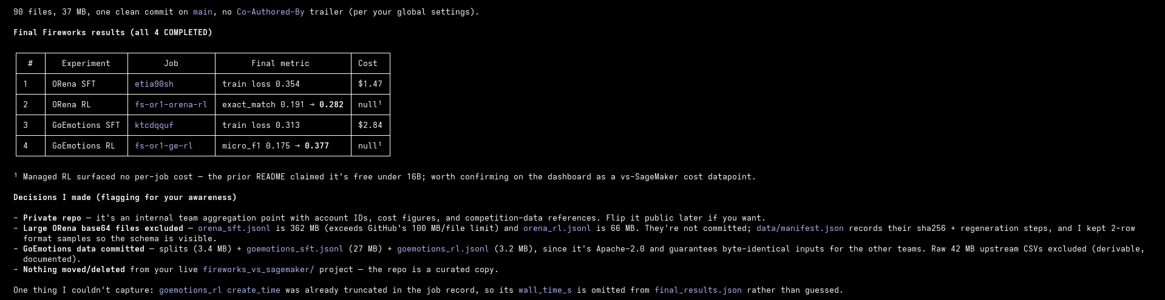
Final Fireworks results committed to the repo.
- One repo holds all three platforms: fireworks/, sagemaker/, prime-intellect/.
- Each platform folder holds config, scripts, logs, and metrics in one schema.

Sources
- https://fireworks.ai/
- https://fireworks.ai/training/rl-rollouts
- https://docs.fireworks.ai/fine-tuning/reinforcement-fine-tuning-models
- https://aws.amazon.com/sagemaker/
- https://primeintellect.ai/
- https://docs.primeintellect.ai/

