

|  |
| --- |
| CS 371M App Project – Meet Poll |
|  |
| **Authors:** Otis Brower, Syngjin Shin, Ryan Spiegelman  **UTEIDs:** odb234, ss54544, rs47796  **File name:** Meet_Poll_Specfications.vp  **Version** 1.0 |

|  |
| --- |
| Site Map |

01. Site Map / Meet Poll

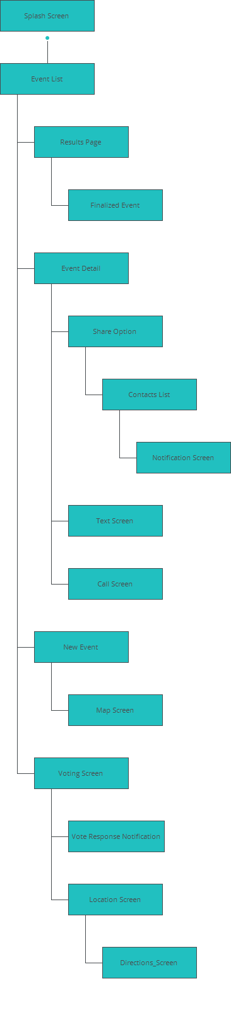

02. Screens / Meet Poll

Splash Screen

|  |
| --- |
|  |

The splash screen will display on startup showing the app name and some sort of logo or artwork. From here the user will be taken to their event list.

Interactions

|  |  |
| --- | --- |
| 1 | **on Page Load:** goes to 'Event List' 🡪 |

02. Screens / Meet Poll

Event List

|  |
| --- |
|  |

After startup, the main activity shown will be the current event list screen. This will show users all the upcoming events that they have created or been invited to. Events will be listed by pending first, showing any events they have created but not finalized or events they have been invited to but not yet responded. Below will be all future events that have been finalized, these will be sorted in chronological order by the soonest event.

Interactions

|  |  |
| --- | --- |
| 2 | **on Click:** goes to 'Results Page' 🡪 |
| 3 | **on Click:** goes to 'Event Detail' 🡪 |
| 4 | **on Click:** goes to 'New Event' 🡪 |
| 5 | **on Click:** goes to 'Voting Screen' 🡪 |

02. Screens / Meet Poll

New Event

|  |
| --- |
|  |

New Event creation screen. Here users will be able to start creating a new event. Users will be able to define a search area by location, either a specific address/intersection or their current GPS location, and a radius of search from that location. Setting a time and date for the event, this will be saved and forwarded along with the information to invitees. Finally, the user will be able to define certain parameters for meeting location including: venue type, venue theme, and price (if applicable).

Interactions

|  |  |
| --- | --- |
| 6 | **on Click:** goes to 'Event List' with effect: flip horizontal 🡪 |
| 7 | **on Click:** goes to 'Event List' with effect: flip horizontal 🡪 |
| 8 | **on Click:** goes to 'Map Screen' 🡪 |

02. Screens / Meet Poll

Map Screen

|  |
| --- |
|  |

The map screen will display the first ten locations that fit the search parameters entered on the event creation screen. Here the user can preview the locations and area found for the event. If the locations are not suitable for some reason (ie. wrong area or type) the user can return to the event creation screen with the back button to edit the event details and adjust the search parameters.

Interactions

|  |  |
| --- | --- |
| 9 | **on Click:** goes to 'Contacts List' with effect: flip horizontal 🡪 |

02. Screens / Meet Poll

Contacts List

|  |
| --- |
|  |

After the event locations have been previewed, the user will be sent to their contacts list. From here the user can select who they would like to invite to the event. On later releases options will be expanded to include friends from user's Facebook and Google+ friend lists. Filter options will be available through user's contacts information if any filters are already create for work, friends, family, etc..

Interactions

|  |  |
| --- | --- |
| 10 | **on Click:** goes to 'Notification Screen' 🡪 |

02. Screens / Meet Poll

Notification Screen

|  |
| --- |
|  |

Push notifications will be displayed when invites are sent to users. The notifications will be sent as both in app push notifications that each user will receive as app specific notifications and as SMS messages that will either link to the app if the user has it installed on their device or for full release to the Google Play Store to download and install the app.

Interactions

|  |  |
| --- | --- |
| 11 | **on Click:** goes to 'Voting Screen' 🡪 |

02. Screens / Meet Poll

Voting Screen

|  |
| --- |
|  |

On the Voting screen, invitees will be able to view the locations found by the event creator. This screen will primarily allow users to select their preference on meeting location and that selection will be sent back to the event creator to be tallied with all other responders. Users will also be able to tap each location to view the details and specific location for each item on the list.

Interactions

|  |  |
| --- | --- |
| 12 | **on Click:** goes to 'Event List' 🡪 |
| 13 | **on Click:** goes to 'Vote Response Notification' 🡪 |
| 14 | **on Click:** goes to 'Location Screen' 🡪 |

02. Screens / Meet Poll

Location Screen

|  |
| --- |
|  |

Location Screen, users directed here will either select a possible location on the voting screen or from the Event List screen to view a location’s details. From this screen the user will also be able to use Google Maps options for directions to the location.

02. Screens / Meet Poll

Results Page

|  |
| --- |
|  |

The results page will be viewable only by the host or event creator. This screen will show the number of votes for each location that was sent to the invitees. Across the top of the screen, the progress bar will show the number of responses relative to the total number of people invited to the event. This will allow the host to determine how many people have responded. The event creator will be able to make a selection. Once the creator has selected a location and sent a response to all the invitees, the poll will be closed and the location will be saved for the event. Once an event is locked then each invitee will be sent a follow-up notification that the event has been finalized and a new event will be added to their event list and will be viewable on the Event List screen.

Interactions

|  |  |
| --- | --- |
| 16 | **on Click:** goes to 'Event List' 🡪 |
| 17 | **on Click:** goes to 'Finalized Event' 🡪 |

02. Screens / Meet Poll

Vote Response Notification

|  |
| --- |
|  |

When an invitee responds to an event, the event creator will receive a response notification that someone has voted. When the notification is selected, the user will be taken directly to the results page to see how the voting has changed.

Interactions

|  |  |
| --- | --- |
| 18 | **on Click:** goes to 'Results Page' 🡪 |

02. Screens / Meet Poll

Finalized Event

|  |
| --- |
|  |

Finally, when an event has been confirmed by the host, invitees will be sent notifications that the event has been finalized.

Interactions

|  |  |
| --- | --- |
| 19 | **on Click:** goes to ‘Event Detail' 🡪 |

02. Screens / Meet Poll

Event Detail

|  |
| --- |
|  |

The Event Detail activity will show the details for a finalized event. The screen will have a map of the location, time and date details. For invitees, the screen will also have the contact links to the event creator so the user can easily call the creator or send an SMS regarding the event. From here the user can also share the event information.

Interactions

|  |  |
| --- | --- |
| 20 | **on Click:** goes to 'Share Option' 🡪 |
| 21 | **on Click:** goes to 'Text Screen' 🡪 |
| 22 | **on Click:** goes to 'Call Screen' 🡪 |

02. Screens / Meet Poll

Share Option

|  |
| --- |
|  |

Preferably the share button will be an optional link that will be set active by the event creator, allowing invitees to send the event details to people not on the original invite list.

02. Screens / Meet Poll

Call Screen

|  |
| --- |
|  |

The telephony service will be provided by the user’s preferred app. The intent will be implicit so the user will be free to use the phone app of their choice.

02. Screens / Meet Poll

Text Screen

|  |
| --- |
|  |

For the Alpha release, the SMS service will be sent to an existing SMS service already on the device. For future release, there would be an integrated SMS service in the app that would create group messages linked to specific events. This would create an inclusive environment that would help users keep event conversations organized and stay within the sphere of the application.

02. Screens / Meet Poll

Directions_Screen

|  |
| --- |
|  |

The directions screen shown here will not be a service of the app but within the app the user will be able to send a request to an existing map service for directions to event locations.

03. Scenarios / Meet Poll

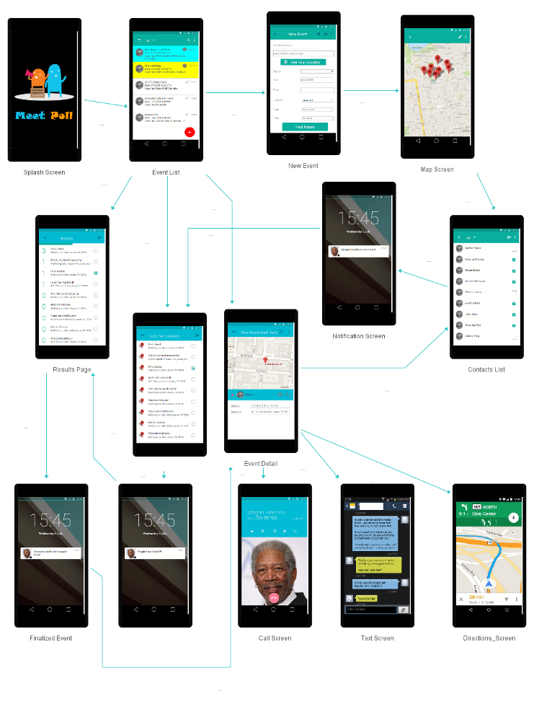

04. Release Schedule / Meet Poll

Alpha Version:

Initial user activities and map integration.

Features:

* Splash Screen
  + Start up and loading screen. Will be viewable for a few seconds before users enter the app.
* Event List
  + Main activity screen for the app.
  + Chronological ordering of saved events
  + Color coding of pending, waiting and confirmed events
* Event Creator
  + Users will be able to create an event.
  + Determine search options: Location, venue type, save time and date information.
  + Determine search area based on entered address or device GPS location
* Map Search
  + Map integration for venue search.
  + Useable Google Maps API integration.

Beta Version:

Complete app life cycle for event creation, invite and voting notifications, vote tallying, and detailed event viewer.

Features:

* Backend interface
  + Set up backend notification server for pushing invite and voting notification to users.
  + Must be able to support data storage for voting response and location lists.
* Voting Response
  + Users will be able to return selected options to the originator for tallying
* Voting Results
  + Hosts of events will be able to see progress for number of responders vs. invitees
  + Results screen will be able to total voting results and display results in order of most votes
* Events Detail
  + Full detail view of events from event list.
  + Will display mini map of location, host contact links for SMS and telephone.
  + Map will link to Map service for directions
* Telephone and SMS
  + Events will be linked to host contact information.
  + Telephone and SMS links will be available directly from the app but supported by outside app for permissions.

04. Release Schedule / Meet Poll

Future Release:

Increase internal functionality and support for third-party apps.

Features:

* Increase venue options
  + Wider range of search criteria including bar/club, library, entertainment, and religious locations
  + Support for custom search criteria.
* Calendar Integration
  + Event linking to internal calendar
* In app SMS / Messenger
  + Integrated SMS service with group SMS linked directly to individual events.
  + Integration for Facebook Messenger to decrease need for outside apps for communication.
  + Invite/Response list for Host and Invitees to see who is invited and who responded.
* Facebook / Google+
  + Increased user base through Facebook and Google+ sign in credentials.
  + Event creation that will link to Facebook and Google+ event managers.
* Third-Party App integration
  + Freemium upgrade to link to third-party app for easier event planning.
* Opentable
  + restaurant reservation service
* Foursquare
  + Location check-in
  + Business ratings and review service
* Yelp
  + Restaurant ratings and reviews service
* Zagat
  + Restaurant ratings service.

Use Cases:

* User can easily track the preferred meeting location of multiple people without resorting to individual phone or SMS services.
* Application can be scalable to larger group events for businesses or professional event planners.
* Users will have a central location for seeing all upcoming events that they are planning or have been invited to.
* .