Lab Exercise – Protocol Layer

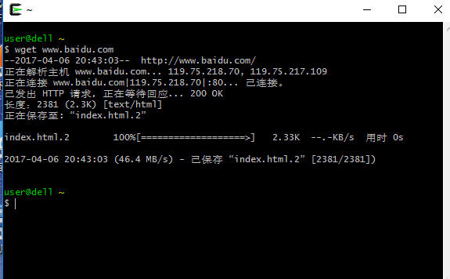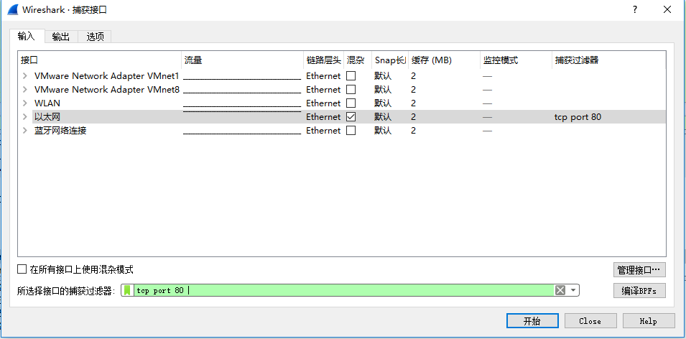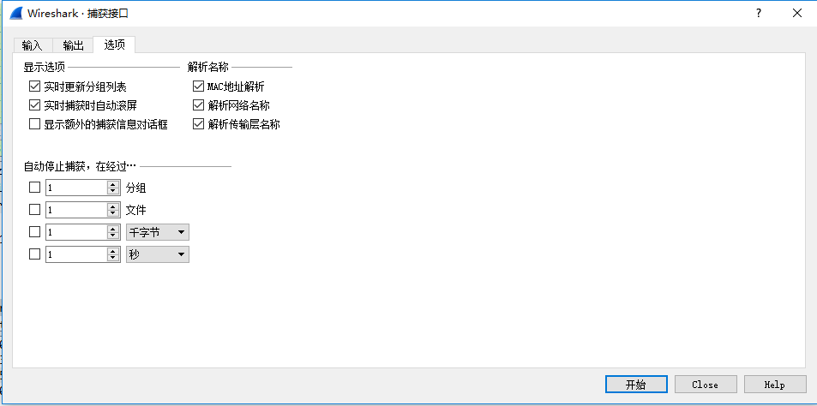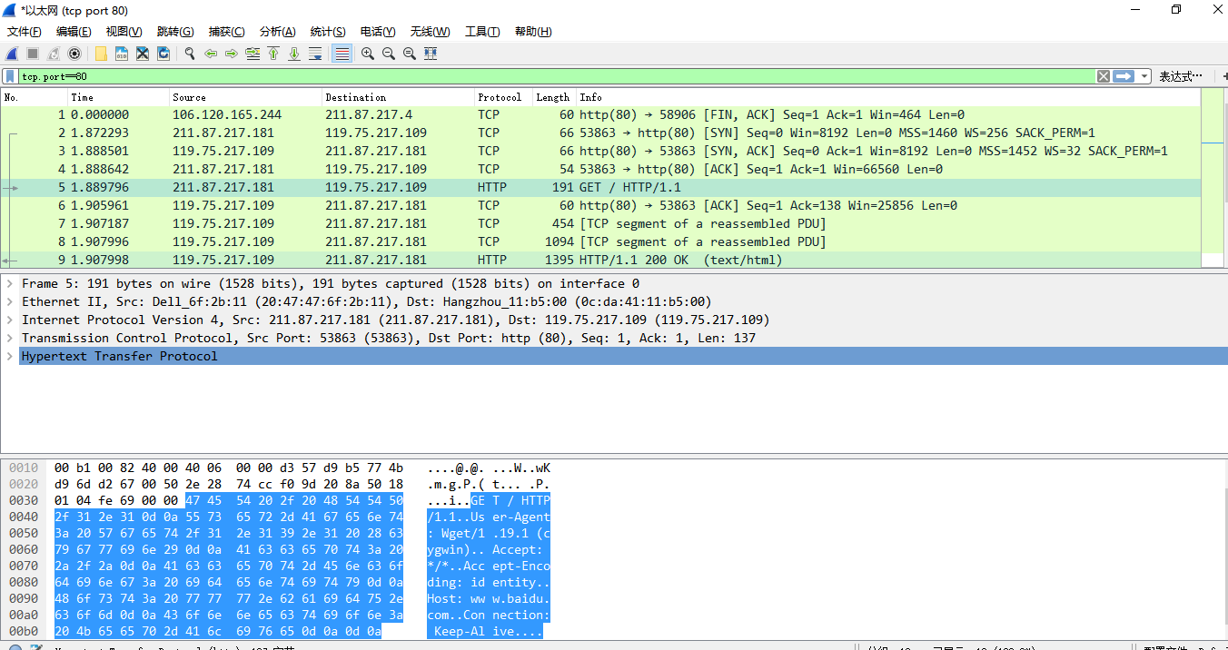

|  |  |  |  |
| --- | --- | --- | --- |
| Ethernet | IP | TCP | HTTP |

0 14 34 54 192

Ethernet header Ethernet payload

IP header IP payload

Protocol overhead:

Packet2:

Ethernet: 14 bytes  
IP header: 20 bytes

TCP header: 32 bytes

Packet3:

Ethernet: 14 bytes  
IP header: 20 bytes

TCP header: 32 bytes

Packet4:

Ethernet: 14 bytes  
IP header: 20 bytes

TCP header: 20 bytes

Packet5:

Ethernet: 14 bytes  
IP header: 20 bytes

TCP header: 20 bytes

Http: 137 bytes

Packet6:

Ethernet: 20 bytes  
IP header: 20 bytes

TCP header: 20 bytes

Packet7:

Ethernet: 14 bytes  
IP header: 20 bytes

TCP header: 20 bytes

Data: 400 bytes

Packet8:

Ethernet: 14 bytes  
IP header: 20 bytes

TCP header: 20 bytes

Data: 1040

Packet9:

Ethernet: 14 bytes  
IP header: 20 bytes

TCP header: 20 bytes

Data: 1341 bytes

Packet10:

Ethernet: 20 bytes  
IP header: 20 bytes

TCP header: 20 bytes

Packet11:

Ethernet: 14 bytes  
IP header: 20 bytes

TCP header: 20 bytes

Packet12:

Ethernet: 14 bytes  
IP header: 20 bytes

TCP header: 20 bytes

Packet13:

Ethernet: 20 bytes  
IP header: 20 bytes

TCP header: 20 bytes

其中 packet7 和packet8 是将一个网页分两部分传送的,packet9是将两部分合起来的结果.

传输的packet的Ethernet, IP, and TCP header 的总的字节数是9*54+60*3=666 bytes,传输的有效数据是137+400+1040=1577 bytes

有效数据所占的比重是1577/(1577+666)=0.73, overhead 所占的比重0.27, 所以可以看出头确实占了很大的比重。

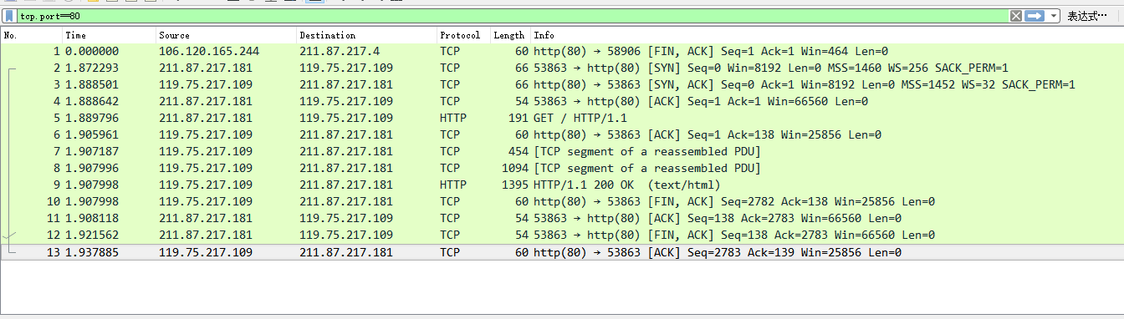

Step5: Demultiplexing Keys:

*1. Which Ethernet header field is the demultiplexing key that tells it the next higher layer is IP?  
What value is used in this field to indicate “IP”?*

Answer. The demultiplexing key for Ethernet is the Type field. It holds 0x800 when the higher  
layer is IP and the key is the last two bytes.

*2. Which IP header field is the demultiplexing key that tells it the next higher layer is TCP? What  
value is used in this field to indicate “TCP”?*

Answer: The demultiplexing key for IP is the Protocol field. It has value 0x06 when the higher layer is TCP and it is in the tenth byte of the header.